Cost-Benefit Analysis
of an Automatic Car Wash System
for White Rock Honda

for
Mark Chambers
Service Manager
White Rock Honda
Surrey, BC

by
Money Dhaliwal
English 301 Student

August 1, 2020

Table of Contents
Abstract 3
Introduction 4
Data Section 5
Comparison of Key Measures 5
Cost 5
Speed 6
Quality 6
Customer Preferences 6
Value of Car Wash 6
Preference of Car Wash Method 7
Conclusion 8
Summary and Interpretation of findings 8
Recommendations 8
References 9

Figures and Tables
Figure 1 6
Figure 2 7
Figure 3 7

Abstract

Introduction

Operating a car dealership requires careful moderation of costs to maintain profitable margins. Washing customers’ cars is one such cost. If dealerships choose to wash cars themselves, they have two options to choose from, hand washing or an automatic car wash.

The purpose of this report is to analyze differences in cost, speed, quality, and customer preferences to determine the feasibility of an automatic car wash.

There are multiple limitations to this study. Firstly, the sample size of the surveys is limited to only 10 participants. The sample size for the employee interviews is also limited with only 2 participants. This makes the data hard to extrapolate to the general population. Another limitation is the distribution method of the surveys. They were sent to mainly younger adults which may not be an accurate representation of dealership clientele.

The scope of this inquiry includes the following:
1. Estimated annual cost comparison between automatic versus hand car washes
2. Survey of customer views on automatic car washes
3. Interview of employees to determine speed and quality of current hand wash system

This report concludes that an automatic car wash is a viable option financially and preferred by customers.

Data Section

Comparison of Key Measures
The differences in cost, speed, and quality of the wash needs to be considered when deciding to install an automatic car wash system.

Cost –The upfront cost to install and the cost to operate.

To estimate cost, only factors that will be different between the two was methods will be looked at. For example, chemical and water costs will not be analysed and will assumed to be similar or negligent differences between automatic versus hand washes.

Hand Washing Labour Cost Estimate

Based on interviews done with two current lot attendants at White Rock Honda, there are 25 to 35 cars washed per day at White Rock Honda. The lot attendants also say that they can wash a car in 10-20 minutes. Assuming there is 1 lot attendant to solely wash cars, 24 to 48 cars could be washed in a shift. It can be assumed that the dealership must have 1 lot attendant at all time to wash cars everyday. However, dealerships usually will have more than one lot attendant since car washes are not evenly spread out throughout the day. During busy times there may be much more cars to be washed than possibly by one lot attendant. Therefore, one extra lot attendant will be assumed to be required. An hourly wage of $15 will be used with a 1.2x multiplier to determine true cost. This leaves an estimated hourly cost per lot attendant at $18. Following are the calculations to determine the estimated annual labour costs of manual car washing

(Hourly cost) x (number of lot attendants) x (days worked per year) = (estimated annual labour cost)

$18 x 2 lot attendants x 252 days = $9,072

Automatic Washing Initial Cost + Annual Cost

According to Just Better Soap Industries the equipment cost for a single automatic car wash system is between $31,000 to $49,000. For our approximation we will use the mid point of $40,000 (ADD SOURCE).

A (ADD INFO ON AUTOMTIC OPERATING COSTS)
Speed – The amount of time it takes to wash a single car.’

Hand washing a car varies greatly. The lot attendants interviewed noted a range of 10-25 minutes per car depending on the size, shape and dirtiness.

In contrast, an automatic wash takes a few minutes (ADD SOURCE).

Quality – The cleanliness and the safety of the wash.

Both lot attendants say that they would prefer an automatic wash rather than having a dealer hand was their cars. The main reasons being that White Rock Honda does not use the two-bucket method. Meaning, a single bucket is used to both rinse the brush and to soap and lather the car. This increases risk of rocks or other objects being stuck in the brush and micro scratching the paint.

Another issue with hand washing is that spots can be missed due to human error. This leads to cars being sent back and upset customers. Automatic car washes can also struggle with certain stains, but they are much more consistent and can simply be run through twice to ensure cleanliness.

Customer Preferences

Value of Car Wash

Respondents were asked how important a car wash is when taking their car in for service. Response were on a 1-5 scale. More than half the respondents rated “4” or above on the scale.
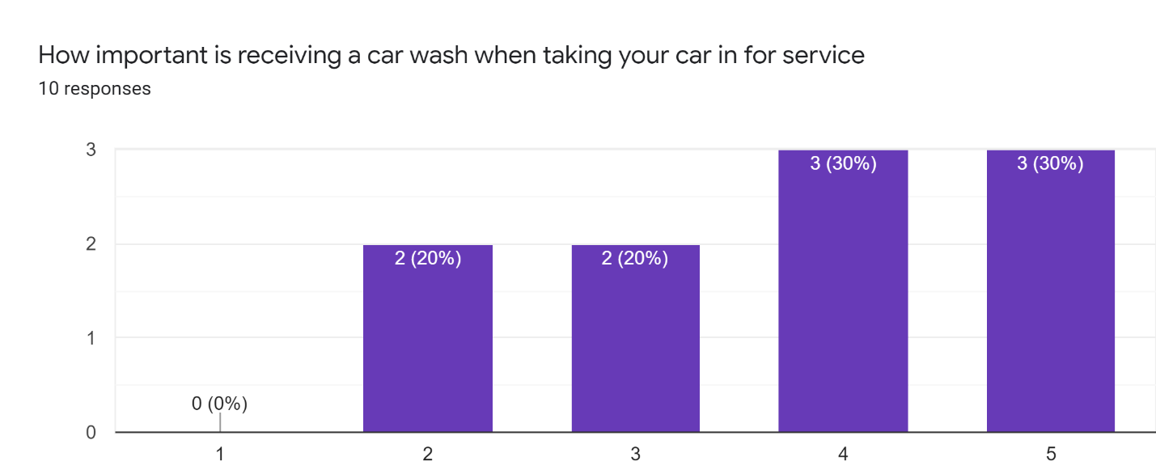
Figure 1 – Respondents were asked on the importance of having their car washed

Preference Between Car Wash Methods

Out of the 10 individuals surveyed only 1 response indicated a preference for hand washing over any other method. Five respondents indicated a preference for automatic washes. The remaining 4 respondents did not indicate a preference. Figure 2 below shows the data.
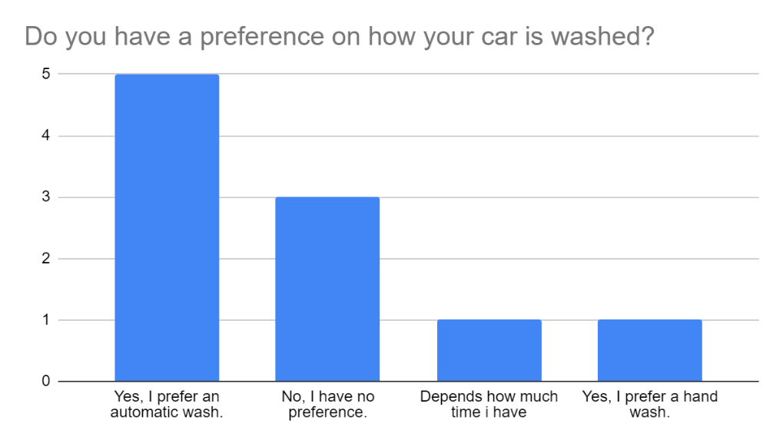
Figure 2 – The majority of survey respondents prefer automatic washes over hand washes

Additionally, figure 3 below shows that only 6 of the 10 respondents have received an automatic car wash. In contrast, 9 respondents have gotten a hand wash. Despite this, we see in figure 1 above that automatic washes are strongly favored.

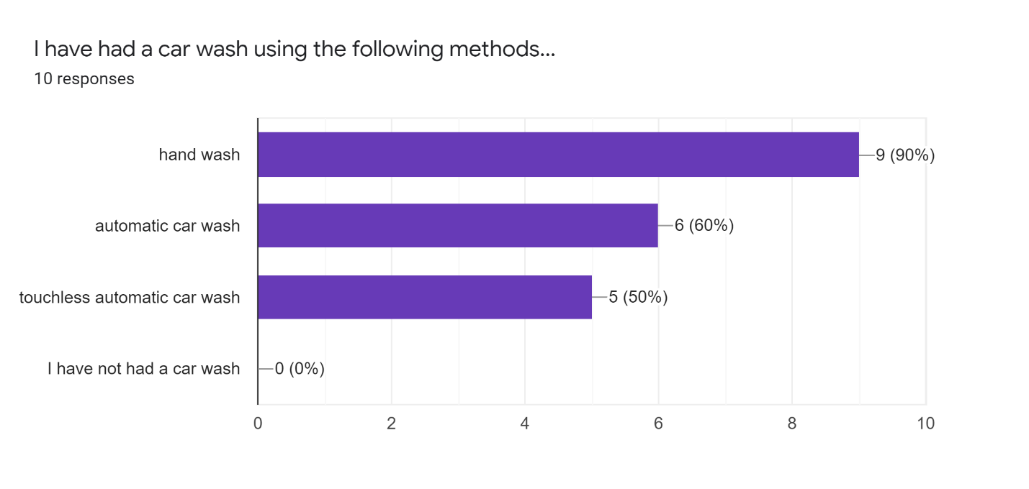
Figure 3 – Nearly all survey respondents had received a hand wash but only 6 had received an automatic w
Conclusion

Summary and Interpretation of Findings

An automatic car wash is much faster at washing cars than a human. This makes it ideal if most cars need to washed during concentrated time period s rather than spread out through the day. Using an automatic wash is also more consistent and leads to less quality issues. This increases efficiency by limiting cars that get returned for rewashing and gives customers an overall positive experience.

Based on survey results, customers strongly prefer automatic car washes over hand washes. This is even considering that more individuals had actually received a hand wash than automatic wash.

Recommendations

This report has highlighted a few areas of improvement. The following are some suggestions based on the data collected.
- Assuming space is available on the lot, an automatic car wash should be strongly considered for the dealership. This is especially true if speed, quality and consistency are of high value.
- Customers value car washes and they should continue to be provided.
- The best automatic system would be a tunnel system as it allows multiple cars to be washed and untrained users to wash the car.
- If not changing wash systems, then a two-bucket method should be used instead of the current one bucket method

References

(FORMAT LATER)
https://jbsindustries.com/starting-car-wash/#:~:text=The%20average%20price%20for%20a,car%20wash%20is%20nearly%20%241%2C500.

