|  |
| --- |
| January |
| 2013 |

|  |  |  |  |  |  |  |
| --- | --- | --- | --- | --- | --- | --- |
| Sunday | Monday | Tuesday | Wednesday | Thursday | Friday | Saturday |
|  |  | 1 | 2 | 3 | 4 | 5 |
|  |  | Resistance 1  30 minute treadmill run: 60-70% HR max | Resistance 1  30 minute treadmill run: 60-70% HR max | Rest day | Resistance 1  30 minute treadmill run: 60-70% HR max | Long run day: 7km |
| 6 | 7 | 8 | 9 | 10 | 11 | 12 |
| Active rest day | Resistance 1  30 minute treadmill run: 60-70% HR max | Resistance 1  30 minute treadmill run: 60-70% HR max | Rest day | Resistance 1  30 minute treadmill run: 60-70% HR max | Rest day | Long run day: 7km |
| 13 | 14 | 15 | 16 | 17 | 18 | 19 |
| Active rest day | Rest day | Resistance 1.1  30 minute treadmill run: 60-70% HRmax | Resistance 1.1  30 minute treadmill run: 60-70% HRmax | Resistance 1.1  30 minute treadmill run: 60-70% HRmax | Rest day | Long run day: 8km |
| 20 | 21 | 22 | 23 | 24 | 25 | 26 |
| Active rest day | Resistance 1.1  30 minute treadmill run: 60-70% HRmax | Rest day | Resistance 1.1  30 minute treadmill run: 60-70% HRmax | Rest day | Resistance 1.1  30 minute treadmill run: 60-70% HRmax | Long run day: 8km |
| 27 | 28 | 29 | 30 | 31 |  |  |
| Active rest day | Resistance 1.1  30 minute treadmill run: 60-70% HRmax | Rest day | Resistance 1.1  30 minute treadmill run: 60-70% HRmax | Rest day |  |  |
|  |  |  |  |  |  |  |

*Days in gym based around Joanne’s schedule

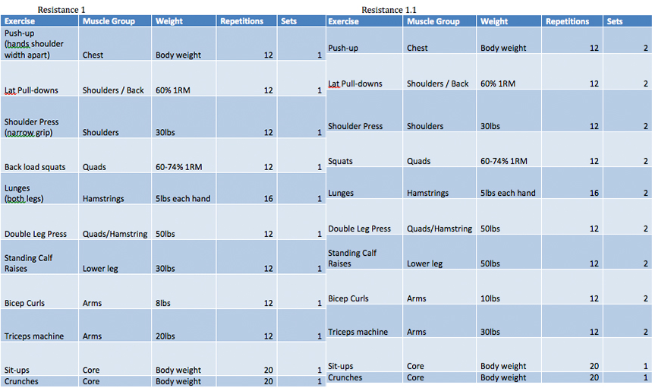

This is the training program for the initial two weeks of the program (resistance 1). Developed to introduce Joanne to specific workouts and workloads. Beginning with low sets and high repetitions. This workout should be completed 3 days a week on top of prescribed running on days off. Each work out period will also consist of a 30 minute run with an intensity of 75-84% of predicted heart rate max. Week 3 and 4 (resistance 1.1) allow for progression and to increase the tempo as our client becomes accustomed to the exercises.