Mike Friesen June 23rd, 2017

Applied Design, Skills and Technology in Secondary Automotive

In the wake of a curriculum change in British Columbia, many subjects in their respected grades have been evaluated and reformed by a panel of education professionals, to allow for the best education for todays students. In the interest of my teachable of technology education, I will be focusing on the implementation of applied skills, design and technologies (ADST), in the subject area of secondary automotive; which has yet to have its new curriculum released. The key points that I will be highlighting are the comparisons between the 2001 and 2016 curriculum around secondary automotive, what content makes up an secondary automotive class, and what technologies can be implemented in an secondary automotive classroom that are currently available in schools and the automotive industry. Around these three points I hope to develop some critical ideas that will refocus the secondary automotive classroom to include ADST.

Let us first examine the currently practiced 2001 secondary automotive curriculum. Immediately upon opening the PDF file to view this document, you will see a well laid out package, with a table of content and links to access each section. You will also find 106 heavily worded pages of curriculum for automotive 11 and 12. A number that doesn’t seem to unreasonable in theory, when you think about how complex vehicles systems are. Putting numbers aside, lets look at the content, the stuff that really matters. The 2001 curriculum is broken down into 6 categories under the title of *Prescribed Learning Outcomes* (PLO’s): “Self and Society, Safety, Shop Practices, Powertrain, Body and Chassis and Electrical/Electronic System” (BCME, 2001). Now, out of 106 pages these important categories take up 24 pages of the curriculum package. I am not implying that the other 82 pages do not matter, rather they provided supplemental information (assessment and grading etc.) to the 24 pages of PLO’s that are to be taught.

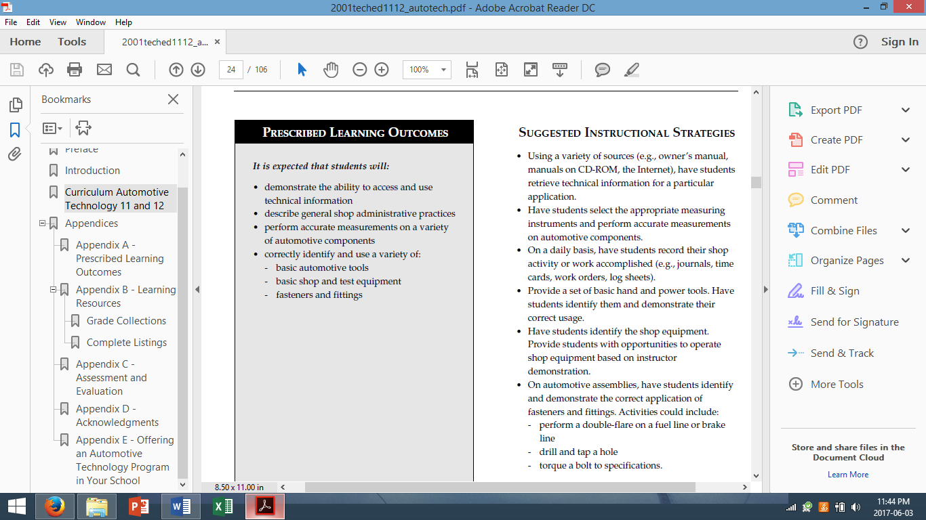

Figure 1: (An example from page 26 of the automotive 11/12 curriculum under Shop Practices, 2001)

Within these PLO’s, they present tasks of what students are expected to be able to complete when defined by an action. These PLO lists were aided by an accompanying column of *Suggested Instructional Strategies* for the instructor to potentially follow to complete the list of PLO’s. These strategies, as seemingly helpful and supportive, had made the outcome for student learning very ridged, unalterable and dated to the automotive industry (Thurlow, 2014). Another point to mention from page 25 of the 2001 curriculum, conveyed the idea that students were being trained for direct placement in the work force by this *Assessment Strategy* below,

* “Invite students to role play various shop activities

and positions (e.g., shop supervisor, parts person,

tool room attendant, customer). Observe and note

the extent to which they:

- demonstrate and understand the importance of

productivity

- describe the implications of an employee being

late or absent

- handle a customer’s vehicle complaint.”

This dated curriculum from 2001, disables any student inquiry or thought process outside the realm of a mechanic of vehicles system’s, components, tools and shop environment, unless initiated by a confident and competent automotive instructor that would be willing to step away from the suggested learning outcomes.

However, as instructors are welcoming the new 2016 curriculum, we see comparable differences in many areas of automotive. The first being the size of the document. The new curriculum separates each grade and subject into its own document but if we combined both automotive 11 and 12, we have a total of 4 pages of curriculum with an additional 4 pages of elaborations combine. This is substantially different, yet, beneficial to an instructor as this document is now easier to decipher and can be used as a daily reference guide if needed. Additionally, this new curriculum can be broken down into 4 main parts, similar to the 2001 curriculum but completely reinvented. *Big Ideas* headline the document and consist of 3 major objectives of the course curriculum that falls below. This is followed by *Curricular Competencies*, different then the PLO’s of the 2001 curriculum but still arranged with categories of what students will be able to do: “Defining, Ideating, Prototyping, Testing, Making and Sharing” (BCME, 2016). Furthermore, with the new curriculum, “Applied Design, Skills and Technologies” have been added to the *Curricular Competencies* as well (BCME, 2016). These categories flow between all subjects but are defined in ways to focus content to a specific grade and subject. The *Curricular Competencies* are linked to the next section of *Content.* This subject specific column of *Content* is where the curriculum highlights what the students are expected to know by the end of the course.

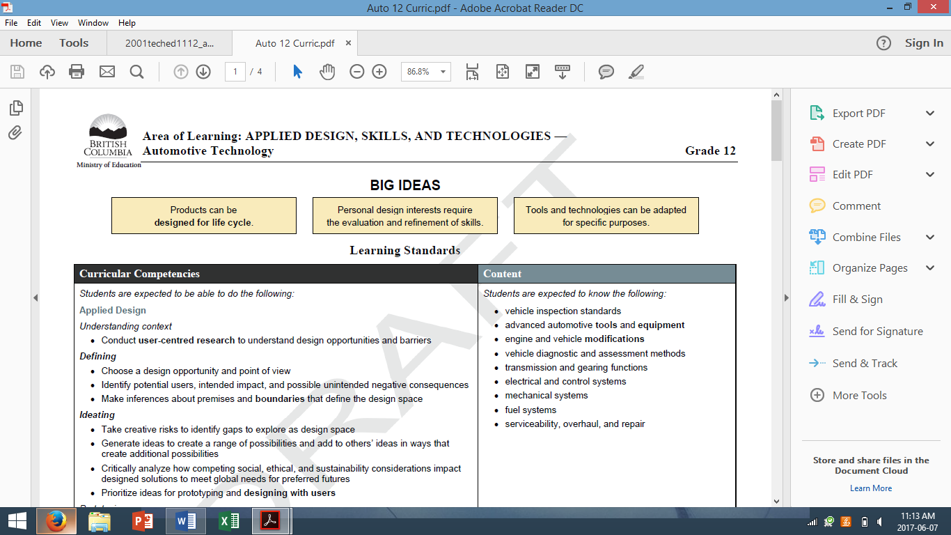

Figure 2: (An example of *Content* for the 2016 automotive 12 curriculum)

Finally, there are 2 pages of elaborations that allow this shorter document to be used as a quick reference by give definitions and clearer understanding of what keywords mean. For example, when the word “tool” is used, it could refer to a “charging analyzer, timing light, fuel pressure gauge, separating tool” (BCME, 2016). For a more in depth look to both curriculums, a quick search on British Columbia Ministry of Education web page, will allow anyone to access the PDF documents.

Now that we have recognized some differences that separate both curriculums of secondary automotive course, what lessons, labs and activities are currently being practiced that could be influenced by ADST? Like every technology class, safety is always addressed first. Once students have been lectured and tested for safety, labs and tool demos, vehicle system lectures can begin. This is followed closely with student lab work and possibly customer vehicle repair. While instructing an automotive 11 class, I would cover a wide range of vehicle systems, trouble shooting and repair procedures, making sure to target all the PLO’s. During this time, I would often branch out and highlight key ideas about the automotive industry and its effects on the environment, humans as consumers and new technologies. These additional teaching moments will be my segue to enable and adapt the new curriculum and ADST to my automotive course.

While the categories of big ideas and content of the new curriculum match the majority of what I have been teaching, I now turn my attention to integrating the ADST portion of the new curricular competencies into my future automotive classes. Below I give the new curriculums definitions of what each of the ADST components mean and any elaborations to support them. I also have provided some ideas I may implement into my automotive courses.

As it reads in the new curriculum for automotive, *applied design* enables students to “Conduct user-centred researchto understand design opportunities and barriers” (BCME, 2016). By looking at this definition, it is very vague to what can be done for a student to demonstrate during the course. However, there is an elaboration that can provide a much clearer picture. User-centred research is defined as **“**research done directly with potential users to understand how they do things and why, their physical and emotional needs, how they think about the world, and what is meaningful to them” (BCME, 2016). This concentrates what the students are expected to be able to do, into a teachable concept.

My thoughts for applied design in automotive would be continued around my lessons about the environmental impacts of vehicles today and what is being done to support clean energy. Lessons and projects, both individual or paired, can be developed around companies like Tesla, who are world leaders in battery technology and electric vehicle (EV) design. However, where there are positive lessons, there are always negative aspect as well. Lessons can be further developed around what could be done to support change. For example, the Volkswagen emissions scandal of 2015 which recalled 11 million vehicles, with use of a “defeat device” (BBC News 2015). In addition, this applied design concept can continue over to an EV program, as there is no specific curricular content for it. I believe with the advancements made every year in EV technology, current and future automotive technicians (possibly my future students) will either be forced to adapt to the changing technology or simply become component exchangers in a developing field of electronically controlled vehicles.

Applied skills allow students to “demonstrate an awareness of safety issues for themselves, co-workers, and users in both physical and digital environments” as well as “identify and evaluate their skills and skill levels, in relation to their project or design interests, and develop specific plans to learn or refine their skills over time” (BCME, 2016). I have found in my teaching practice that students are aware, confident and more knowledgeable around the content of a procedure and their surroundings when they must explain or teach a micro-lesson to the class.

The number of weeks in an automotive course falls short to the amount of systems that can be taught. The application of community learning makes up this difference. During my 10-week long practicum, I found that my sponsor teacher was already doing this community learning by assigning his students a system, machine or component to understand, explain and demonstrate to their class. This enabled the students to be responsible for gaining the knowledge and practicing safety, while also having to educate their class as a micro-lesson. This method has been shown to prove results where “learners expecting to teach recalled more material correctly, they organized their recall more effectively, and they had better memory for especially important information” (Nestojko, et al 2014).

For a senior level automotive class, continuing with the same concept but take it one step further, the students can create a video tutorial. This would produce the same quality of micro-lessons that were presented to the class, however these videos, keeping the students anonymous and safe, with all forms of permission, could be downloaded to a school YouTube page. Video tutorials like these would not only educate and assist their fellow classmates, but they could assist the public towards real community learning; which can be very successful and helpful. A sample of these videos can be found by searching ‘FrankHurtAuto’ on YouTube.

Applied technologies are defined by three points from the automotive curriculum:

* “Explore existing, new, and emerging tools, technologies[“things that extend human capabilities”], and systems and evaluate their suitability for their design interests
* Analyze the role and impact of technologies in societal change, and the personal, social, and environmental impacts, including unintended negative consequences, of their choices of technology use
* Analyze how cultural beliefs, values, and ethical positions affect the development and use of technologies” (BCME, 2016).

So long as vehicles have been on the road they have needed to have parts replaced because of damage or failure. Advancements in technology have shown us great improvements in quality, differing material usage and are yet still cost effective. Many of these cost-effective parts are supplementary components of a vehicle and are now forms of plastic. It begs me to question, can we possibly 3D print the parts we need in our very own classroom, without picking up the phone to the local automotive parts supplier. A part of me believes yes this is plausible, because we do have the 3D printing capabilities in schools, however, liability comes into practice. In fact, a company call Stratasys has been developing, testing, modifying and preforming with 3D printed parts, tools and molds for some years now and have shown they can go from a “design studio to the factory floor in a fraction of the time it takes other development processes” while highlighting “speed and efficiency” (Stratasys, 2017).

Now, this company is not making direct parts to replace components on a vehicle but who is to say that the future is not going in that direction. This would be a great opportunity for some cross curricular learning, where automotive students could take a vehicle component, design it on a computer assisted drafting (CAD) system and then print it to see if the component fits and preforms. From another point of view, lets look at 3D printings environmental impact. From using electricity for several hour prints, prototype after prototype of wasted material, to the toxins that are made airborne from melting the filaments, a simple 3D printer can have a negative environmental foot print in the automotive shop as well. Though, how do students best learn in a technology class, they learn by doing. No matter what technology classroom you choose, there will always be material consumption and some form of an environmental impact. The difference is acknowledging and educating how to reduce it. I believe 3D printing will eventually have a lasting impact in the automotive industry and secondary automotive classroom. Therefore, with the support of an adaptable curriculum, why not introduce a new concept to students who could be part of the development of this new technology by encouraging their creativity.

The development from a structured curriculum with little to no room for experimental education has now taken the shape of a simplified and redesigned curriculum that supports deeper, interdisciplinary, student engaged learning. Focusing on the addition of ADST in secondary automotive, there are many possibilities to continue the basics and fundamentals of the trade, and yet open the course to new content. By reaching out and implementing new technologies, digital media and spatial learning, students can further their knowledge to adapt to an ever-changing world as a life long learner.

**References**

British Columbia Ministry of Education. (2016) *Applied Design, Skills and Technologies. BC’s New Curriculum*. Accessed at: <https://curriculum.gov.bc.ca/curriculum/10-12>

British Columbia Ministry of Education. (2001) *Technology Education 11 and 12: Automotive Technology* Accessed at: <http://www2.gov.bc.ca/gov/content/education-training/k-12/teach/curriculum/english/applied-skills/technology-education-11-and-12-automotive-technology-2001>

Hotten, R. (2015, December 10). Volkswagen: The scandal explained. *BBC News*. Retrieved from <http://www.bbc.com/news/business-34324772>

Nestojko, J. F., Bui, D. C., Kornell, N., & Bjork, E. L. (2014). Expecting to teach enhances learning and organization of knowledge in free recall of text passages. *Memory & Cognition, 42*(7), 1038-1048. doi:10.3758/s13421-014-0416-z

Solutions for Automotive. (2017). *Stratasys*. Retrieved from <http://www.stratasys.com/en/Automotive>

Thurlow, A. (2014, May 19). Sputtering auto education leads to skills breakdown. *Automotive News*. Retrieved from <http://www.autonews.com/article/20140519/RETAIL05/305199975/sputtering-auto-education-leads-to-skills-breakdown>