**Jointer**

Fence Tilt Adjustment

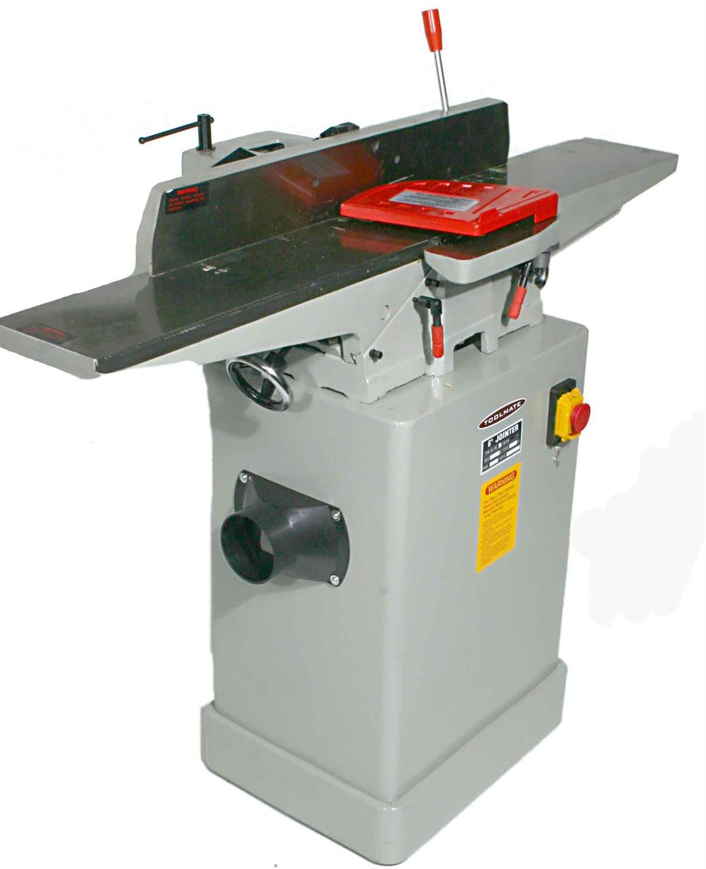

Table Adjustment handle (Both sides)

On/Off Switch

Table Locks

Cutter head Guard

Fence

Outfeed Table

Infeed Table

Fence and tilt Lock

**Safety Points**

* **PPE** – Eye Protection, Hearing Protection
* **NO** Loose Clothing (hoodie strings), Jewellery and Hair
* No boards **LESS THAN** 12 inches long and ½ inches thick shall be cut on the Jointer
* Joint **ONLY ONE SIDE** and **ONE EDGE** of a board. **NEVER** joint the end of the board
* The jointer cut is adjustable from 1/16th (1.5mm) to 1/8th (3mm) inch for each pass, **NEVER EXCEED** 1/8th (3mm) inch.
* The **INFEED** table is adjusted for depth of cut, **A STUDENT IS NEVER TO ADJUST THE OUTFEED TABLE SETTING**
* Adjust the table height and make sure all locks are tight **BEFORE** the jointer is turned on.
* **ALWAYS** ensure to joint a board with the direction of grain
* Keep board **FIRMLY** against the table and fence when cutting
* **NEVER** allow fingers to come close to cutting head and material over the cutting head
* **ALWAYS USE A PUSH STICK** for cutting the face of a board and **USE** a **PUSH STICK** when cutting the edge of board when **LOWER** then the fence height
* **NEVER** remove the safety guard from cutting head
* Position yourself to the left of the machine so you will not be injured in case of kickback