Preparing Stock by Machine

(Stock Breakout)

**\*\*Reminders Before Continuing\*\*** 

* PPE **MUST** be worn while operating and while around power equipment.
* Safety tests and machine demonstrations **MUST** be to date.
* **NO** **PHONES** or **MUSIC DEVICES** are to be in used at or around lined safety areas of power equipment.

Step 1 (Wood Defects)

Determine if the wood has any defects as shown below. These defects can cause problems with machining and should be addressed before the first cut. Follow instructions given by instructor during the demonstration.

 

Also, check wood for nails, staples and glue. This can cause damage to the machine and could cause injury to operator.

Step 2 (Rough Length Cross Cuts)

Measure out length(s) of wood needed for project one piece at a time.

* Leave an extra 1/2” – 3/4” inch on the length of material for final machining.

Use the **Radial Arm Saw** for rough length cross cuts.

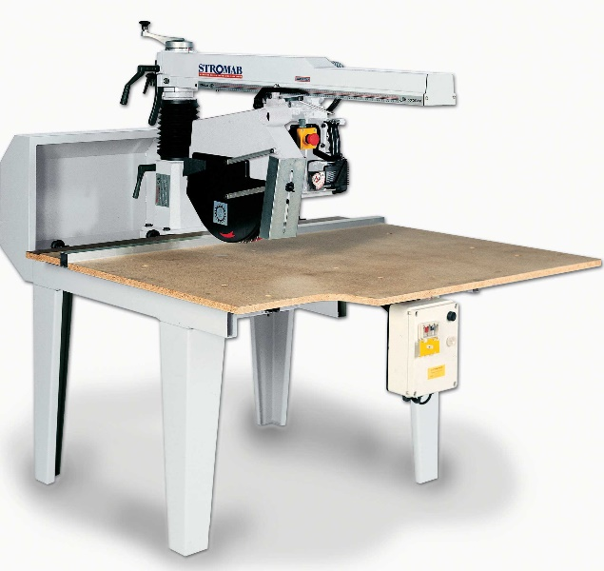

* The saw blade makes a 1/8” cut, called a Kerf, so make sure blade is on the waste side when ready to cut.
* Pay attention to wood defects (cups, twists and springs) as they determine how wood is placed on table, against fence and cut.
* Remember to cut **SLOW** and keep control

Step 3 (Rough Width Cuts)

As like the rough length cut, measure out the rough width, while adding

1/2” – 3/8” to final measurement for machining.

Use a **Band Saw** for all rough width cuts

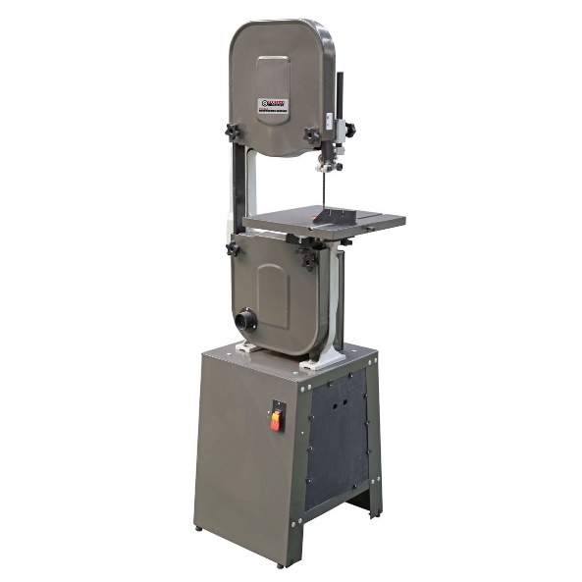

* Remember to keep fingers away from blade. **USE PUSH STICKS** and an assistant when wood is longer then 2’ feet.
* Cut on waste side and cut **SLOW**.

**FETWEL**

Step 4 (Reference **F**ace)

Machine a face on your wood feeding the wood with the grain not against the grain.

Use a **Jointer** for the reference face and edge

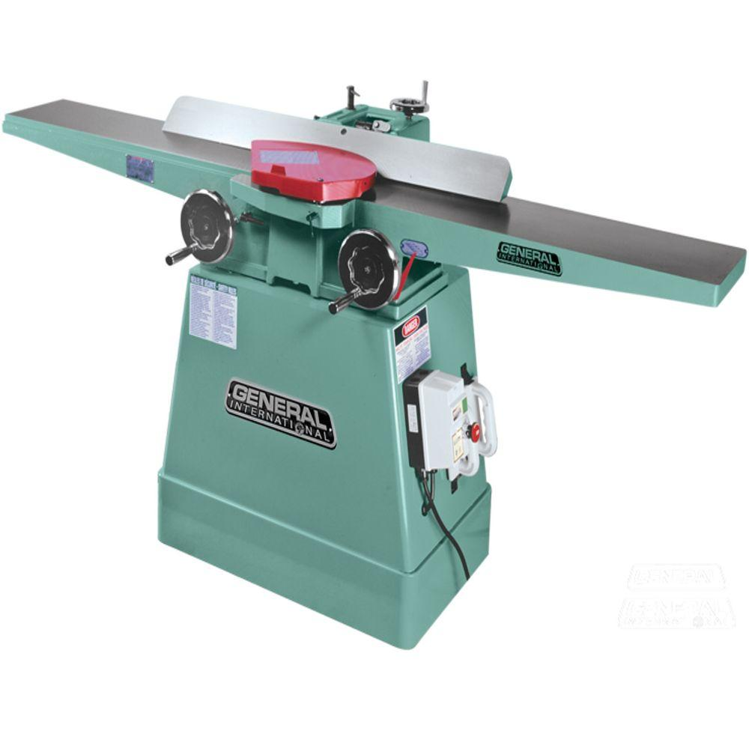

**Remember to mark reference face and edge**



* Look for consistent finish across face of material while using push stick to hold material against the table and fence

Step 5 (Reference **E**dge)

 

Grain Direction



* Make sure fence is set to 90° to tables.
* Feed material with grain and not against the grain.

Step 6 (Final **T**hickness)

Use the **Thickness Planer** using multiple passes

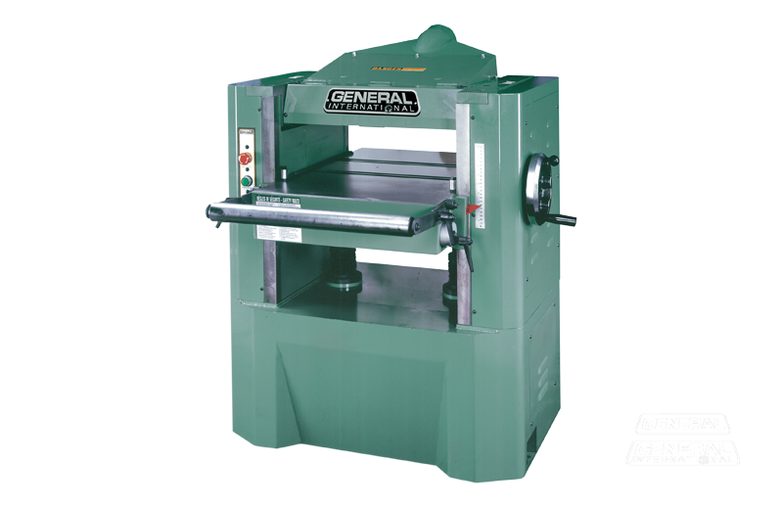

* Feed material with grain or rough surface and ripping will occur.
* Raise table max 1/8” per pass and remember to pass multiple boards together before raising table.
* Leave 1/16” inch extra thickness for laminated boards or 1/32” for finish sanding.

Step 7 (Final **W**idth/Ripping)

Use a **Table Saw** for final Width

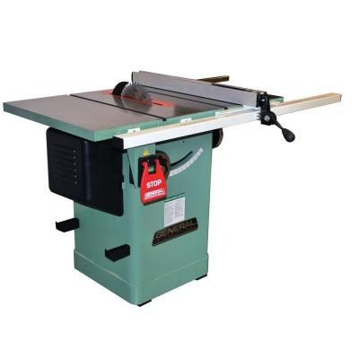

** Use a guard, push stick, splitter and anti kick back fingers



* Preform cut with reference face on table and reference edge against fence.
* Make sure to leave 1/32” for sanding or 1/16” or more material if laminating multiple pieces of material together.
* Use a **Guard**, **Push Sti**ck, **Splitter** and **Anti-Kickback Fingers** for Ripping

Step 8 (Square First **E**nd/ Cross Cutting)

Use a **Table Saw** with a **Mitre Gauge** or **Sled**

 

* Cut slowly to ensure a clean cut.
* **NEVER** double fence.
* Make sure a cross cut blade or combination blade is installed for the cut.
* Cut as little as possible to allow for choice for final length cut
* This operation can also cut specific angles.

Step 9 (Final **L**ength/ Cross Cutting)

Use the **Table Saw** like step 8 or use **Mitre Saw**



* Firm placement of material against table and fence, keeping fingers at least 6” away from blade path.
* Remember to cut on waste side.
* Never change material position while blade is running.
* This operation can also cut specific angles.

**You have just machined and trued a piece of wood for your project. You will repeat this procedure many time over the course of you project(s) so it would help to remember these steps. If you have any questions at any time, STOP and ASK an instructor.**

**Happy Woodworking!**

Name: _________________________________ Block: _____________

**Stock Breakout Assignment /20**

Each student is to preform the steps of stock breakout, individually, on a piece of pine.

The GOAL of this assignment is to use safe woodworking practices, learned over your safety tests and teacher demonstrations to produce a finished piece of lumber with finished measurements of 16” (length) x 4-1/2” (width) x 5/8” (thick).

* Start by determining any defects in the length of pine and cut an appropriate piece of pine on the Radial Arm Saw at 17”.
* Sketch and label any defects below.

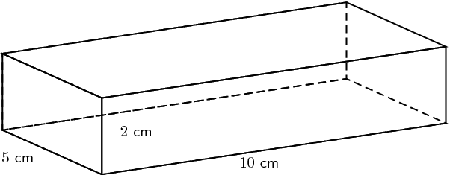

* Once you have sketched your pine sample, proceed with all the steps of stock breakout. **REMEMBER** - Use all personal safety equipment were needed and safe machine practices during all operations when completing your stock break out.
* A light sand is appreciated to break the sharp edges only.

Once complete, make sure to mark your name on the sample, wrap this sheet around your sample with an elastic band and hand in your sample for marking.

**Stock Breakout Marking Criteria /20**

Name: __________________________

Completed Sketch ----------------------------------------------------------------------------------------------- /1

Final Length ------------------------------------------------------------------------------------------------------- /3

Final Width --------------------------------------------------------------------------------------------------------- /3

Final Thickness --------------------------------------------------------------------------------------------------- /3

Face Reference Mark ------------------------------------------------------------------------------------------- /3

Edge Reference Mark ------------------------------------------------------------------------------------------- /3

Sanded Edges ---------------------------------------------------------------------------------------------------- /2

90° (Square) Corner on Reference Edges ----------------------------------------------------------------- /2

**Stock Breakout Marking Criteria /20**

Name: __________________________

Completed Sketch ----------------------------------------------------------------------------------------------- /1

Final Length ------------------------------------------------------------------------------------------------------- /3

Final Width --------------------------------------------------------------------------------------------------------- /3

Final Thickness --------------------------------------------------------------------------------------------------- /3

Face Reference Mark ------------------------------------------------------------------------------------------- /3

Edge Reference Mark ------------------------------------------------------------------------------------------- /3

Sanded Edges ---------------------------------------------------------------------------------------------------- /2

90° (Square) Corner on Reference Edges ----------------------------------------------------------------- /2

**Stock Breakout Marking Criteria /20**

Name: __________________________

Completed Sketch ----------------------------------------------------------------------------------------------- /1

Final Length ------------------------------------------------------------------------------------------------------- /3

Final Width --------------------------------------------------------------------------------------------------------- /3

Final Thickness --------------------------------------------------------------------------------------------------- /3

Face Reference Mark ------------------------------------------------------------------------------------------- /3

Edge Reference Mark ------------------------------------------------------------------------------------------- /3

Sanded Edges ---------------------------------------------------------------------------------------------------- /2

90° (Square) Corner on Reference Edges ----------------------------------------------------------------- /2

**Stock Breakout Marking Criteria /20**

Name: __________________________

Completed Sketch ----------------------------------------------------------------------------------------------- /1

Final Length ------------------------------------------------------------------------------------------------------- /3

Final Width --------------------------------------------------------------------------------------------------------- /3

Final Thickness --------------------------------------------------------------------------------------------------- /3

Face Reference Mark ------------------------------------------------------------------------------------------- /3

Edge Reference Mark ------------------------------------------------------------------------------------------- /3

Sanded Edges ---------------------------------------------------------------------------------------------------- /2

90° (Square) Corner on Reference Edges ----------------------------------------------------------------- /2