**Table Saw**

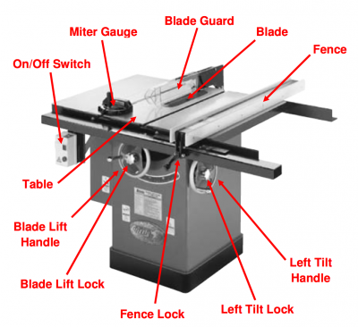

**Anti-Kick back fingers and splitter**

**Safety Points**

* **PPE** – Eye Protection, Hearing Protection
* **NO** Loose Clothing (hoodie strings), Jewellery and Hair
* All Guards must be in place to operate the Table Saw. The **ONLY** exception is with the instructor’s permission and supervision.
* Give the Table Saw your **FULL** attention when operating it. **KEEP YOUR EYES ON THE BLADE**.
* When adjusting the Table saws set up, getting your hands close to the blade in any way or entering the dust bin in the bae of the machine, **THE ISOLATION SWITCH MUST BE SWITCHED OFF OR THE MACHINE MUST BE UNPLUGGED**.
* **No** **TALKING** while operating the Table Saw.
* The sawblade should be adjusted so **NO MORE THAN 1/4"(6mm)** of the blade is exposed above the wood.
* Check the **PROPER** mounting of saw blade and guards.
* All adjustments are to be made with the saw at a **COMPLETE STOP**.
* Free hand cuts are **NEVER** allowed on a table saw.
* To prevent injury in case of kickback, **ALWAYS** stand tot the left side of the blade.
* **NEVER REACH ACROSS** the blade to retrieve a piece of wood you have cut.
* When tilting the blade, check to make sure the blade is **NOT HITTING** any guards or the throat plate before turning the Table Saw on.
* When starting the Table Saw and something does not sound right, **SHUT IT OFF IMMEDIATELY**.
* All special set ups **MUST** be removed immediately after they are used.
* **ASK** permission before using the Table Saw.

RIPPING (Definition – Cutting wood WITH or along the grain direction)

* Use the **RIP FENCE** to guide the wood when ripping.
* **MINIMUM 12 inches (305mm)** minimum length for ripping
* Boards **WIDER** then **4 inches (100mm)** can be pushed through the table saw by HAND
* Boards **NARROWER** then **4 inches (100mm) MUST** be pushed through with a **PUSH STICK**
* **3/8 inch (10mm)** is the **NARROWEST** board that can be ripped on the Table Saw.
* Edge of wood touching the rip fence **MUST** be straight and smooth (Reference Edge)
* Check the fence and make sure it is **LOCKED** in before turning the Table Saw on.
* **ALWAYS** place the part of the board to be **KEPT** between the fence and the blade.
* Wood should **NEVER** be left between the fence and the blade.

CROSSCUTTING (Definition – Cutting wood ACROSS the grain direction)

* USE the **MITRE GAUGE**, **MITRE BOX OR SLED** to guide the wood when crosscutting.
* Fingers should **NEVER** be closer to the blade than 4 inches (100mm).
* Set **PROPER** angle to be cut and lock it in place before turning the Table Saw on.
* If cutting 90°, **ALWAYS** check the **MITRE GAUGE** with a **SQUARE** before cutting.
* Rip Fence must be **CLEAR** away from work area.
* **NEVER USE A RIP FENCE AND A MITRE GAUGE AT THE SAME TIME! DOUBLE FENCING**
* All work to be cut must be held **FIRMLY** against Mitre Gauge
* When cutting several pieces, the same length, **FASTEN** a clamp to the Mitre Gauge
* **NEVER** remove scrap wood from around the saw while it is running.

