Squid Dissection – Procedure
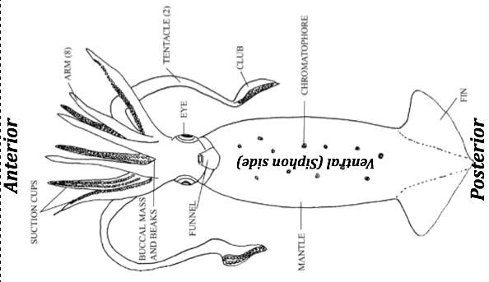
1. Locate the siphon. The siphon is found on the ventral side of the squid between the two eyes. The siphon is used in jet propulsion and locomotion. Water is brought into the mantle and pushed out the siphon allowing the squid to move quickly and change direction instantly.
2. The tentacles and arms are attached to the head of the squid. Locate and compare the two. Examine the suckers on the end of the tentacles. The two feeding tentacles are longer and only the ends have suckers on thicker areas called clubs. These allow the squid to quickly grab prey and bring it towards the arms for holding while eating.
Stop and Complete External Question 1
3. Find the two large eyes on the head of the squid. Snip open the cornea, the soft covering of eyes and use your fingers or foreceps to search for the only hard part of the eye, the lens.
4. Locate the body, which is covered by the mantle, and fins. The body is covered by tiny spots known as chromatophores that can change color & allow the squid to camouflage itself.
5. Spread apart the tentacles and use a probe to locate the mouth at the base of the tentacles. The beak can be felt inside the mouth and is a dark color.
6. Using tweezers, carefully remove the round, muscular encasing around the beak known as the buccal mass. When the buccal mass is removed as a long tube may be attached, this is the esophagus that connects to the stomach. Students may remove buccal mass from around the beak. The beak has two halves and is much like a parrots beak. The beak tears food into small pieces before it is swallowed.  Radula: Each half the beak can be removed and tongue with a toothed ribbon known as the radula will be found. The radula shreds the small pieces of foods to be easily digested. | 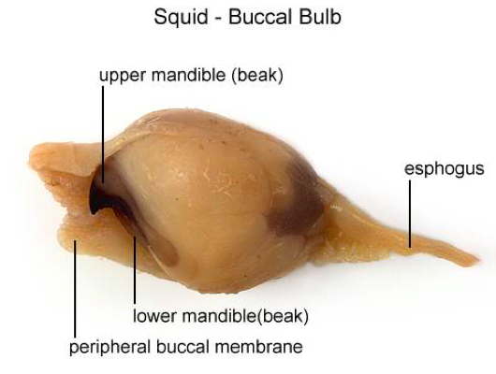

Stop and Complete External Question 2
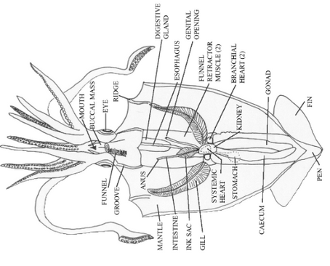
Internal Anatomy
- Turn the squid ventral side up. Lift the mantle up above where the siphon is; it should be loose and easy to pull up. Use scissors to make one long incision from the bottom of the mantle, above the siphon, to the tip of the mantle next to the fins. Open the mantle to expose the structures inside.

I Suggest labeling your diagram and showing Mr. Pletsch the five parts now, before any more cutting happens.
2. Find the esophagus, this is best found by looking into the mouth and seeing where it leads, use a probe to carefully poke into the mouth.
3. To find the stomach, follow the esophagus toward the posterior end of the squid.
4. Locate the gills, these are feathery structures on either side of the mantle cavity that may be hidden under other organs.
5. Follow the gills toward the interior to find an enlarged structure at the base of each gill, this is the gill heart. The gill hearts pump blood to the gills to be oxygenated before being pumped to the systemic heart to be moved all around the body.
6. In between the gill hearts is the systemic heart – locate this. It is larger and it’s job to pump blood all over the body.
Stop and answer Internal Question 1
6. The most prominent structure on the inside of the squid is its reproductive system. All the way toward the fin is a whitish or yellowish structure, this is the reproductive gonad. The male gonad is generally white; the female gonad is usually more yellow to clear & may contain eggs.
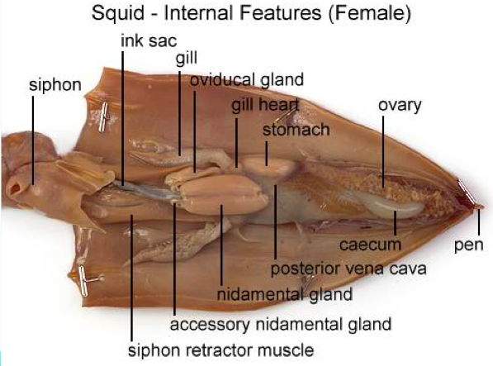 | 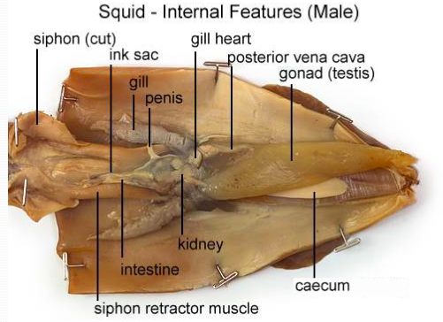
Stop and answer Internal Question 2
7. Find the hard point at the end of the fin and gently grip it with forceps pulling away from the squid. In this way you should be able to remove in one piece the pen. The pen is the only remains of an ancient shell found in cephalopod ancestors. The pen supports the mantle and is a site for muscle attachment.
Stop and answer Internal Question 3
8. Find the ink sac; this is a small dark, silvery sac near the siphon attached to intestine. BE CAREFUL AS THE INK WILL STAIN YOUR CLOTHING! Squids may squirt the ink from its body through its funnel, the water surrounding the squid turns black, camouflaging the squids from its predator, confusing the predator and allowing it to escape. The squid’s body will change to the color of the ink when it is released into the water.
Either remove it by using the scissors and cutting either end or carefully open it in place, dip the pen in it, and write a note!
9. Brain: Explain to students that the brain in squids is highly developed, same as it’s relative the octopus. They are considered the most intelligent invertebrates. The brain is located right between the eyes and consists of many bundles of nerves fused together. It is surrounded by a “skull” made of cartilage and surrounds the esophagus. Students will have to carefully cut in between the squids eyes through the protective cartilage of the brain case, the brain will then be obvious. Many large nerves radiate out from the brain through the mantle wall.

