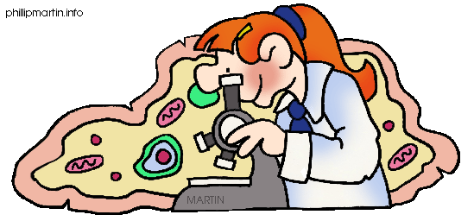

Science 8
Course Outline and Expectations

Teacher: Mr. S. Hayes Email: hayes_s@surreyschools.ca TC: Mrs. B. Truss brajala@surreyschools.ca
Office: Room N104 Phone: 604 - 597 – 5234

Course Information: blogs.ubc.ca/mrstruss/

Course Outline:
Unit | Topics | Chapter
The Scientific Method | - | -
Optics | Wave model of Light  Optical Systems  Human Vision | 4  5  6
Cells and Systems | Cells  Human Body Systems  The Immune System | 1  2  3
Fluids and Dynamics | Fluids and the KMT  Forces and Fluid Properties  Fluid Systems | 7  8  9
Water Systems on Earth | The Water Cycle  Oceans  Water and Living Organisms | 10  11  12

Textbook: BC Science 8 (McGraw-Hill)
- You are responsible for your textbook. You must return the book that corresponds to the number in the records. You will be fined if you lose or damage the text book. Write your name in the front of the textbook.

Course Materials: to be brought to each class
- Textbook - Binder
- Lined paper - Unlined paper
- Pen/Pencil - Calculator
Classroom Expectations:
- No food in the classroom, only sealed drink containers allowed
- If a test or presentation is missed, you must bring a note from your parents when you return to class
Work Habits:
- You are expected to be safe, respectful, responsible, organized, engaged and productive.
- You are expected to adhere to the guidelines our classroom agreement
Marks:
- You will be evaluated based on how well you meet the learning outcomes for the course. Work habits will be evaluated separately. Marks will be assigned as follows:

Classroom Marks: Overall Marks:
Tests/Quizzes 50% Classroom Mark 80%
Projects 30% Final Exam 20%
Labs/Assignments 20%

Extra Help:
I am available for extra help after school. Mrs. Truss will also be available before school on Tuesdays and Wednesdays. Come to see me as soon as you realize you are having difficulty. The longer you wait, the harder it will be to catch up. Do not wait until you have failed a test to come for help.

