Law of Reflection Review: Answer Key
- How does the size of the angle of incidence compare to the angle of reflection?

They are equal

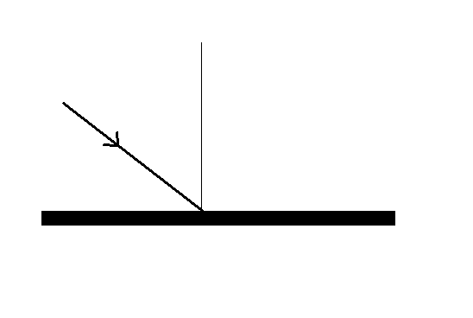
- Measure the angle of incidence with your protractor. ________________
Use this angle to complete the reflected ray.

- Use what you know about the Law of Reflection, your protractor and ruler to complete the ray diagrams.

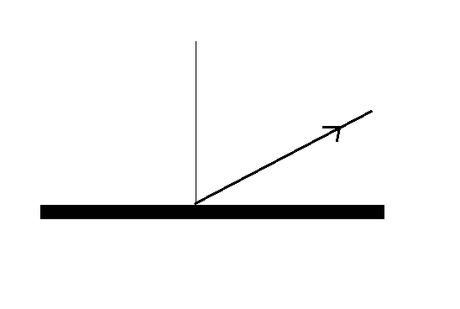
Angle of Incidence: ________ Angle of Reflection: ___________

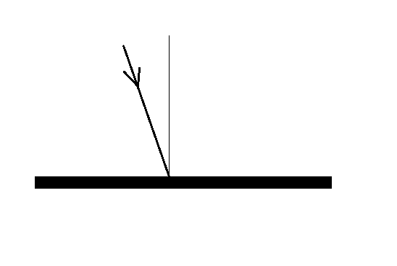
Angle of Incidence: ________ Angle of Reflection: ___________

- The following diagram shows a light ray coming through an opening and being directed towards 2 mirrors and a heart. Use what you know about the Law of Reflection, your ruler and your protractor to draw the light ray as it bounces from mirror to mirror.

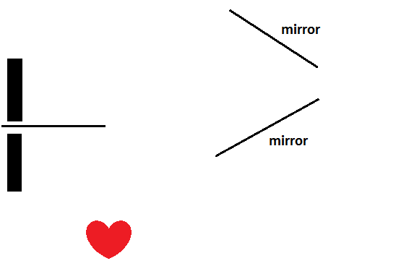

Bonus: What would happen to the light ray if the mirrors were shaped like this?

or

