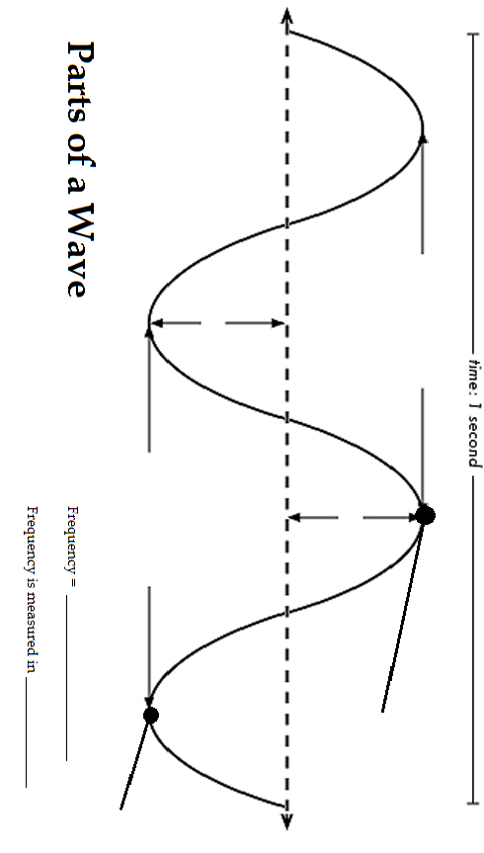

Hertz

Wavelength / Seconds

Trough

Crest

Amplitude

Amplitude

Wavelength

Wavelength