**Viruses**

Label the diagram

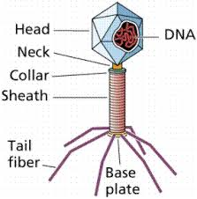

Describe the lytic reproductive cycle of a virus.

**The virus injects its DNA into host cell, virus uses host cell materials to replicate virus, virus reassembles its parts creating many new viruses, host cell lyses and releases new viruses**

Describe the lysogenic reproductive cycle of a virus.

**The virus injects DNA into host cell, it becomes spliced with host DNA, viral DNA is replicated with host cell, creating many copies over several generations, under certain conditions, host cell now enters lytic cycle, copies of virus are assembled and the host cell lyses releasing new viruses**

Describe the role of the host cell in each of these reproduction cycles.

**The host cell allows the virus to incubate. It replicates the virus using its own DNA and replication process. Virus is able to use all features of host cell to replicate itself.**