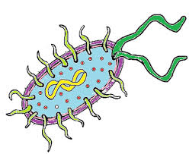

**The Littlest Organisms**

1. Define **Prokaryote:**

* **Single celled organisms that lacks a nucleus and membrane bound organelles**

1. Create a Venn Diagram of Eubacteria and Archaea

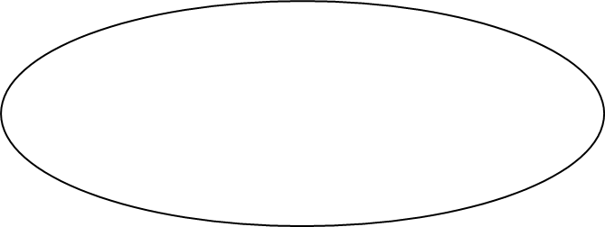Eubacteria Archaea

**-cell wall of complex carbs - prokaryotic - cell wall, missing carb**

**- live almost everywhere - single cell - different composition of**

**- similar shapes membrane and ribosomes**

**- found in harsh environments**

1. Identify and draw the 3 basic prokaryotes cell shapes

* **Spiral, rod and sphere (bacilli, cocci and spirilla)**

1. Aside from shape, how else can we identify prokaryotes?

* **Cell wall, movement, obtaining energy**

1. Describe Gram staining and how it is used to identify cell wall components.

* **Using 2 different dyes (crystal violet and safranine) to determine the compostion of prokaryotic cell walls. Gram positive (takes up crystal violet) bacteria have one cell wall layer, gram negative bacteria (took up safranine) have 2 outer cell layers**

1. What feature allows a bacteria to move?

* **Flagella**

1. List 4 verbs used to describe bacteria movement.

* **Lash, snake, spiral, glide**

1. Explain how the following types of bacteria acquire energy.

Photosynthetic autotrophs – **create their own energy by trapping sunlight**

Chemotrophic autotrophs – **produce energy from inorganic molecules**

Chemotrophic heterotrophs -  **obtain energy from breaking down organic molecules**

Phototrophic heterotrophs – **acquire energy from the sun, but need organic molecules for nutrition**

1. Compare fermentation to respiration. What types of organisms perform each of these processes?

* **Fermentation = energy production without oxygen (obligate anaerobes and facultative anaerobes)**
* **Respiration = energy production with oxygen ( obligate aerobes and facultative anaerobes)**