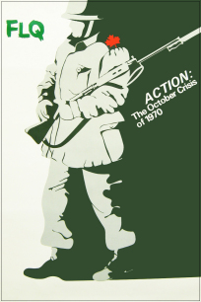
ACTION: The October Crisis of 1970
Response Qs
- Consider the term “political terrorism”. What does the term convey to you? How would you define terrorism?

- Can you think of any situations where violence as a means of effecting political change could ever be justified?

- Could such actions ever be justified in the Canadian situation?

- Why might someone in Quebec in 1970 believe that political violence was the only means available to achieve the goal of independence?

- How could the October Crisis happen in a country like Canada?

- Why was the October Crisis of 1970 such a significant and tragic event in Canadian history?

- What do you think were its most important causes?

- What roles were played by the main political figures involved? What significant consequences followed from this event?

- How has this history informed your understanding of

  - the struggle for Francophone recognition, rights, and parity with English Canada
  - issues in the multiplicity of Canadian identities

Extended research option:
Compare the Trudeau government's invoking of the War Measures Act in 1970 to the passage of the Anti-Terrorism Act by the Chrétien government in 2001.
NOTE ON HISTORICAL TERMS:
THE IDENTITY CRISIS OF “THE OCTOBER CRISIS”
The Cuban Missile Crisis of 1962 is sometimes referred to by historians as “the October Crisis”. Properly, the October Crisis belongs to the history of Quebec, but is informally referred to as “the FLQ Crisis” occasionally.

Robin Spry. National Film Board of Canada. 1973.
http://www.cbc.ca/archives/teachers/lesson-plan/what-was-the-october-crisis.html

