Biography for David Hancock, Edmonton-Whitemud
http://www.assembly.ab.ca/net/index.aspx?p=mla_bio&rnumber=46&leg=28
What does the biography tell us about David Hancock’s term as Premier?
What has David Hancock completed while interim Premier?

PC Leadership race: Sept 6th 1st vote
Who are the candidates?

PRENTICE INTERVIEW
https://ca.news.yahoo.com/blogs/canada-politics/alberta-pc-brand-still-salvageable-175442699.html

What are the platforms of each?

Ric MCIVER
http://www.ricmciver.com/about/
JIM
http://www.jimprentice.ca/support/?gclid=CjwKEAjw4PCfBRCz966N9pvJ4GASJAAEdM_KG-wJ44hvgNH34XRe_GhkWABw2H7Gq_EXyAwY5zVXnhoCccTw_wcB

What happened to Thomas Lukaszuk ?.

http://www.cbc.ca/news/canada/edmonton/thomas-lukaszuk-apologizes-for-20k-cellphone-bill-1.2746345
PRENTICE TRUTHINESS
http://www.huffingtonpost.ca/susan-wright/jim-prentice-free-memberships_b_5686411.html

Interview with Jim Prentice
Why does Jim Prentice support the temporary foreign workers?

TIMS MERGER
http://www.cbc.ca/news/business/tim-hortons-burger-king-agree-to-merger-deal-1.2746948?utm_content=buffer70f8d&utm_medium=social&utm_source=facebook.com&utm_campaign=buffer&cmp=fbtl

EMPLOYMENT STANDARDS
http://work.alberta.ca/occupational-health-safety/13934.html

RESEARCH CATHY OLESEN
QUESTIONS TO ASK CATHY

http://www.statcan.gc.ca/pub/89-638-x/2010003/article/11077-eng.htm

PC STATEMENT OF PRINCIPLES
http://www.pcalberta.org/about/statement-of-principles/

LONGEST SERVING GOVERNMENT IN HISTORY
https://ca.news.yahoo.com/blogs/canada-politics/alberta-pcs-become-longest-serving-government-canadian-history-192629637.html

Chart 4
Proportion of persons living below the before-tax low income cut-off by Aboriginal identity group and sex, Edmonton, 2005

http://www.statcan.gc.ca/pub/89-638-x/2010003/c-g/11077/c-g4-eng.htm
. 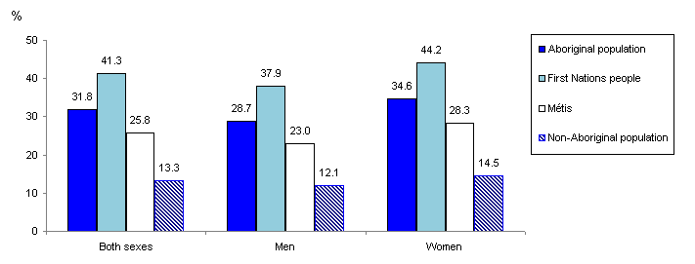

Chart 2
Percentage of Aboriginal and non-Aboriginal people 25 to 34 and 35 to 64 years of age with a university degree, Edmonton, 2006
Description
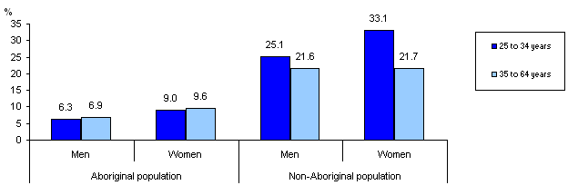
Source(s): Statistics Canada, Census of Population, 2006.
http://www.statcan.gc.ca/pub/89-638-x/2010003/c-g/11077/c-g2-eng.htm

