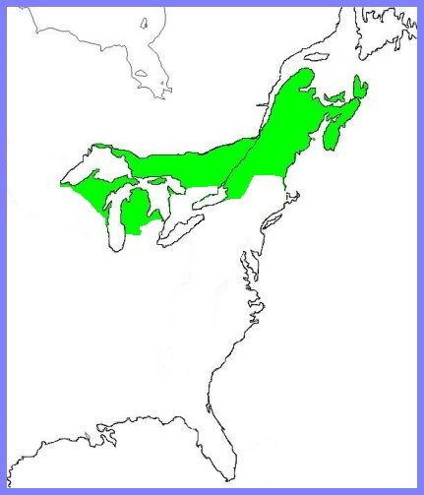
CORRECTLY LABEL THIS MAP WITH THE FOLLOWING:
- Ottawa
- Quebec City
- Montreal
- Toronto
- The Great Lakes (name them)
- Halifax
- Louisbourg
- Attawapiskat
- Churchill
- Boston
- New York
- Detroit
- New Orleans
- Chicago
- The Mississippi River (you must draw the river)

