- Fahd Mirza
  - He moves here 8 years ago with his parents (this was written 14 months after he came to Canada).
  - He came from Pakistan. They came here for a better quality of life.
  - There is less stress of survival.
  - He found it important that Canadian society welcomed him and helped integrate him and gave him opportunities for work and education.
  - He wants to pay back Canadian society by volunteering.
  - It gives him “personal satisfaction” (if you know what I mean).
  - The most important lesson he learned was how to live together.

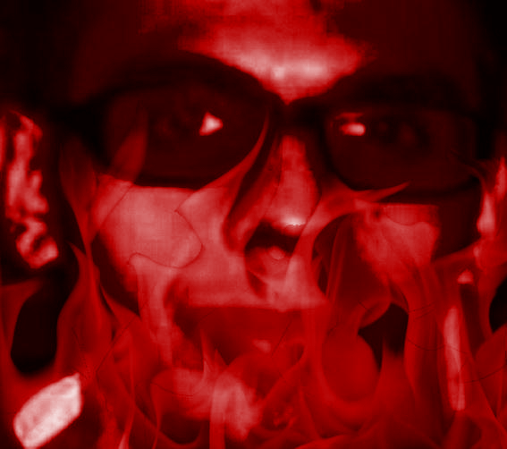

- Refugees
  - One of the categories of immigrants established under the Immigration and Refugee Protection Act is refugees.
  - Canada signed the U.N. Convention Relating to the Status of Refugee in 1951.
  - During the 50’s and 60’s, Canada offered shelter to refugees in response to world crises.
  - In 1976, Canada made refugees one of its immigration categories. This meant Canada let refugees steadily in, instead of crisis by crisis.

- The Refugee Protection Act of 2002
  - The objectives were:
    - save lives and offer protection to people who are displaced and persecuted.
    - fulfill and affirm Canada's international commitments to protect refugees.
    - grant fair consideration to people who claim to be persecuted, as an expression of Canada’s humanitarian ideals.
    - offer refuge to people facing persecution because of race, religion, political opinion, etc.

- Nick’s story: When my dad was 10 he moved to canada with his family from Brunei when it before it left the united kingdom. when they moved to canada they lived in fort mcmurray and because my grandfather’s post secondary did not transfer he was not able to have as good of a job as he had in Brunei. he had to work in edmonton for the longest time and then eventually they all moved to edmonton. my grandparents have been in the same house since.

- Cade’s story: I moved here from Red Deer when I was, like, 2. I don’t remember Red Deer at all.

