Reflection paper tanya winship epse 307/308 barbara weber december 9, 2013
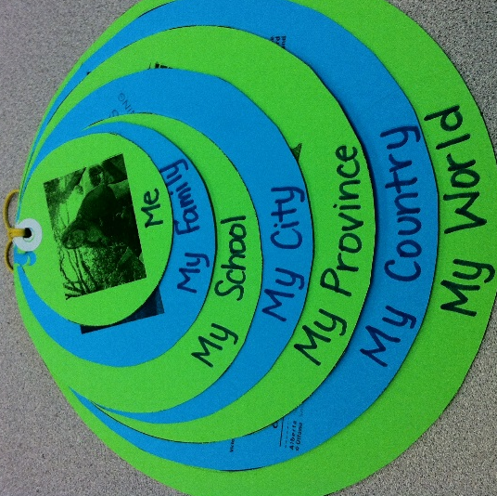
Who am I? How did I get here? What support do I have? These are the questions I explored in my auto-geography. In order to explore these themes, I created a “community nest” or “support network.” This is a collection of circles which gradually become larger as my networks expand. Each circle represents one community or one support network. On the front of the circles is a picture or number of pictures that illustrate my connection and on the back of each circle is a written description of the community and how I fit into it. It all starts with “me.” The smallest circle is who I am, the second, my family and how they play an important role in my own identity and continuing support, and the third, my school, including with this my classmates, professors, faculty advisor, and school advisors. From there, the communities become more abstract, turning to focus on what each community can give me, my province, my country, my world. The world is a particularly interesting concept, as it can be seen as very general, but my focus was on my role in the world, bringing the project back to identifying who am I.

The project as a whole is actually something I have adapted for the purpose of this course. I created the original concept (with help from online resources) and created these community nests with my own students in my practicum. In that project, students were asked to describe the communities that they are a part of, identifying the name, location, and uniqueness of each community. This project was part of their Social Studies curriculum in a unit on community. The lesson, originally created for grade 4/5, has since been adapted for both grade 6 and 7 students as a focus on identity. And, as I illustrated in this assignment, it can be adapted for use in a Teacher Education program.

While I had created a similar project as a model for my class, recreating or adapting the project for this class was an interesting task. I was forced to reflect on deeper meanings rather than superficial details. For example, when I made the nest the first time, my description of “My World” was “My world is planet Earth. Earth is the third planet from the Sun. It is the only planet in our solar system that we know of that is hospitable and capable of sustaining human life.” These superficial details, while useful for the classroom context, was obviously not applicable for this assignment. Instead I chose to focus on how I fit into the world, reflecting on how global issues impact me, what good I can do in this profession, and where I would like to go (both physically and metaphorically).

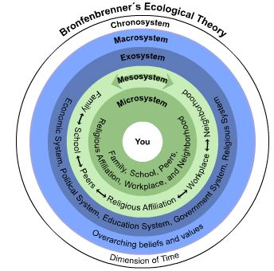
I was also surprisingly able to connect this concept to the theoretical aspect of this course. Upon reflection, it occurred to me that this directly correlates with Bronfenbrenner's Ecological Model. The communities or support networks are microsystems, mesosystems, exosystems, and macrosystems. My evolution, although not explicitly shown in the project, occurs over time, representing the chronosystem. In fact, the diagram of these systems actually names several of these communities. Even the circular shape is comparable. I’m not sure if I was inspired by Bronfenbrenner or if it was a coincidence that the ideas are similar. I’m inclined to imagine that it was a combination of both, that perhaps I was subconsciously influenced by the theoretical implications.

As I mentioned above, my own students completed a similar assignment, albeit not at this scale. I think completing this assignment with my students has provided a good moment of reflection. The connection to my teaching style expands beyond the literal meanings of my community nest. As a teacher, my students will form part of my support network just as I will (hopefully) be part of theirs. The same may be true for their parents and the interrelationships presented within these communities is vital to my success as a teacher. It’s immensely important to have relationships and to make connections. If we are able to make and utilize such connections, we can ensure our success and avoid burn-out. This project represents a literal connection by asking students to comment on their support networks, providing details on who is available to guide them, but also illustrates an allegorical demonstration of the relationships I hope to create as a teacher.

Sharing this project with my classmates and peers was both encouraging and rather simple. As I had created an original project for my practicum, I had previously shared the concept with several of my peers, just as I did last week when I brought my draft to class. Overall, it was very well received and my classmates thought that it was a good idea which encompassed a lot of the questions posed to us during this assignment. I wasn’t anxious or scared to share my ideas with my classmates as they, themselves, form one of my support networks. Receiving positive feedback was very encouraging and supportive.

There is one important thing that I didn’t represent in my project, however, that I am ashamed to admit. After Ajay presented his song, to which I had an emotional response, I realized that there was one source of support that is particularly important to me that I neglected to include, that is, the role of God in my life. I grew up Catholic and He has always held an immense role in my life. I suppose my failure to include Him may have to do with a withdrawal from the Church following my divorce or perhaps a sense of confusion in where He falls within my life. It may also be that I have been seemingly forced to separate my identity as a teacher from that of a person of faith. I have been of this thought that I had to leave my religion at the door as a teacher, but it’s impossible to separate who I am with my faith. As to where God “fits in,” I suppose God might be the largest circle of all, encompassing all of the other things in my life, but he is also present in each individual community. Ajay’s song reminded me of just how important He is in my life and that He plays an important role in making me who I am.

