EDCP 570.031
University of British Columbia
Winter 1 2018 (M, 4.30-7.30)

Course Description:
This seminar addresses current controversies, ideas, methods, and implications in teaching ICT. This year's section focuses on the ethics and philosophy of social media and technology. The seminar balances applications and practices, including coding, in teaching ICT with philosophies that students and teachers generate to interpret media & technology. How do we make sense of the conventional wisdom and spontaneous philosophies of media & technology that children and youth generate? What does this mean for teaching ICT?

Instructor: Stephen Petrina  Office: Scarfe 2331  Email: stephen.petrina@ubc.ca | Graduate Assistant: ?  Office Hours: By appointment
WWW: http://blogs.ubc.ca/etec + http://blogs.ubc.ca/msts/ + http://blogs.ubc.ca/educ500/

Valued Ends of the Course:
My intention is to help you develop a background and a depth of expertise— as a teacher, researcher, and intellectual— for conceiving and testing new directions for ICT curriculum and instruction.

Readings (Required):
Readings in Teaching ICT. (Download all from TBA)

Assessment (for details, see below): Deadline:
- Participation in Seminars (15%) | Ongoing
- 20 x 20 @ 400 (Seminar Leading Pecha Kucha) (Groups of 2) (35%)  - Media Production / Explainer Video / Tutorial:  Ethical or Legal Case, Concept, or Problem (50%) | Ongoing  10 December
- Academic Honesty and Standards, and Academic Freedom: Please refer to UBC Calendar
- Policies and Regulations (Selected): http://www.students.ubc.ca/calendar
- Academic Accommodation for Students with Disabilities: Students with a disability who wish to have an academic accommodation should contact the Disability Resource Centre without delay (see UBC Policy #73 www.universitycounsel.ubc.ca/ policies/policy73.pdf).

EDCP Grading Guidelines
July 2008

A level - Good to Excellent Work
A+ (90-100%) A very high level of quality throughout every aspect of the work. It shows the individual (or group) has gone well beyond what has been provided and has extended the usual ways of thinking and/or performing. Outstanding comprehension of subject matter and use of existing literature and research. Consistently integrates critical and creative perspectives in relation to the subject material. The work shows a very high degree of engagement with the topic.

A (85-89%) Generally a high quality throughout the work. No problems of any significance, and evidence of attention given to each and every detail. Very good comprehension of subject and use of existing literature and research. For the most part, integrates critical and creative perspectives in relation to the subject material. Shows a high degree of engagement with the topic.

A- (80-84%) Generally a good quality throughout the work. A few problems of minor significance. Good comprehension of subject matter and use of existing literature and research. Work demonstrates an ability to integrate critical and creative perspectives on most occasions. The work demonstrates a reasonable degree of engagement with the topic.

B level - Adequate Work
B+ (76-79%) Some aspects of good quality to the work. Some problems of minor significance. There are examples of integrating critical and creative perspectives in relation to the subject material. A degree of engagement with the topic.

B (72-75%) Adequate quality. A number of problems of some significance. Difficulty evident in the comprehension of the subject material and use of existing literature and research. Only a few examples of integrating critical and creative perspectives in relation to the subject material. Some engagement with the topic.

B- (68-71%) Barely adequate work at the graduate level.
______________________________________________________________________

NOTE: For UBC’s Faculty of Graduate Studies (FOGS), a final mark below 68% for Doctoral students and below 60% for Masters students is the equivalent of a Failing mark.

C & D level - Seriously Flawed Work
C (55-67%) Serious flaws in understanding of the subject material. Minimal integration of critical and creative perspectives in relation to the subject material. Inadequate engagement with the topic. Inadequate work at the graduate level.
D level
D (50-54%)
F level - Failing Work
F (0-49%)

EDCP 510 Course Schedule & Readings
The schedule primarily consists of a series of seminars, & student projects.

Date | Forum | Assignment | Readings & Topics
Week 1  10 Sept | Seminar | Readings & Assignments | Introduction
Week 2  17 Sept | Seminar | Readings & Assignments | Children, Youth, and ICT Philosophy (Philosophy of Media & Technology
Week 3  24 Sept | Seminar / Pecha Kucha | Readings & Assignments | Cyberethics, Technoethics, ICT Ethics
Week 4  1 Oct | Seminar / Pecha Kucha | Readings & Assignments | Cyberbullying and Sexting
Week 5  8 Oct | Thanksgiving Holiday
Week 6  15 Oct | Seminar / Pecha Kucha | Readings & Assignments | Epistemology of 21C Learning
Week 7  22 Oct | Seminar / Pecha Kucha | MP / Video | Rough Cuts: Student Projects  Your video work in progress
Week 8  29 Oct | Seminar / Pecha Kucha | Readings & Assignments | Epistemology & Ontology of Simulation and VR
Week 9  5 Nov | Seminar / Pecha Kucha | Readings & Assignments | Epistemology of Coding
Week 10  12 Nov | Remembrance Day
Week 11  19 Nov | Seminar / Pecha Kucha | Readings & Assignments | TBA
Week 12  26 Nov | Student Projects | MP / Video due  10 Dec | Fine Cuts: Student Projects  Your video work in progress

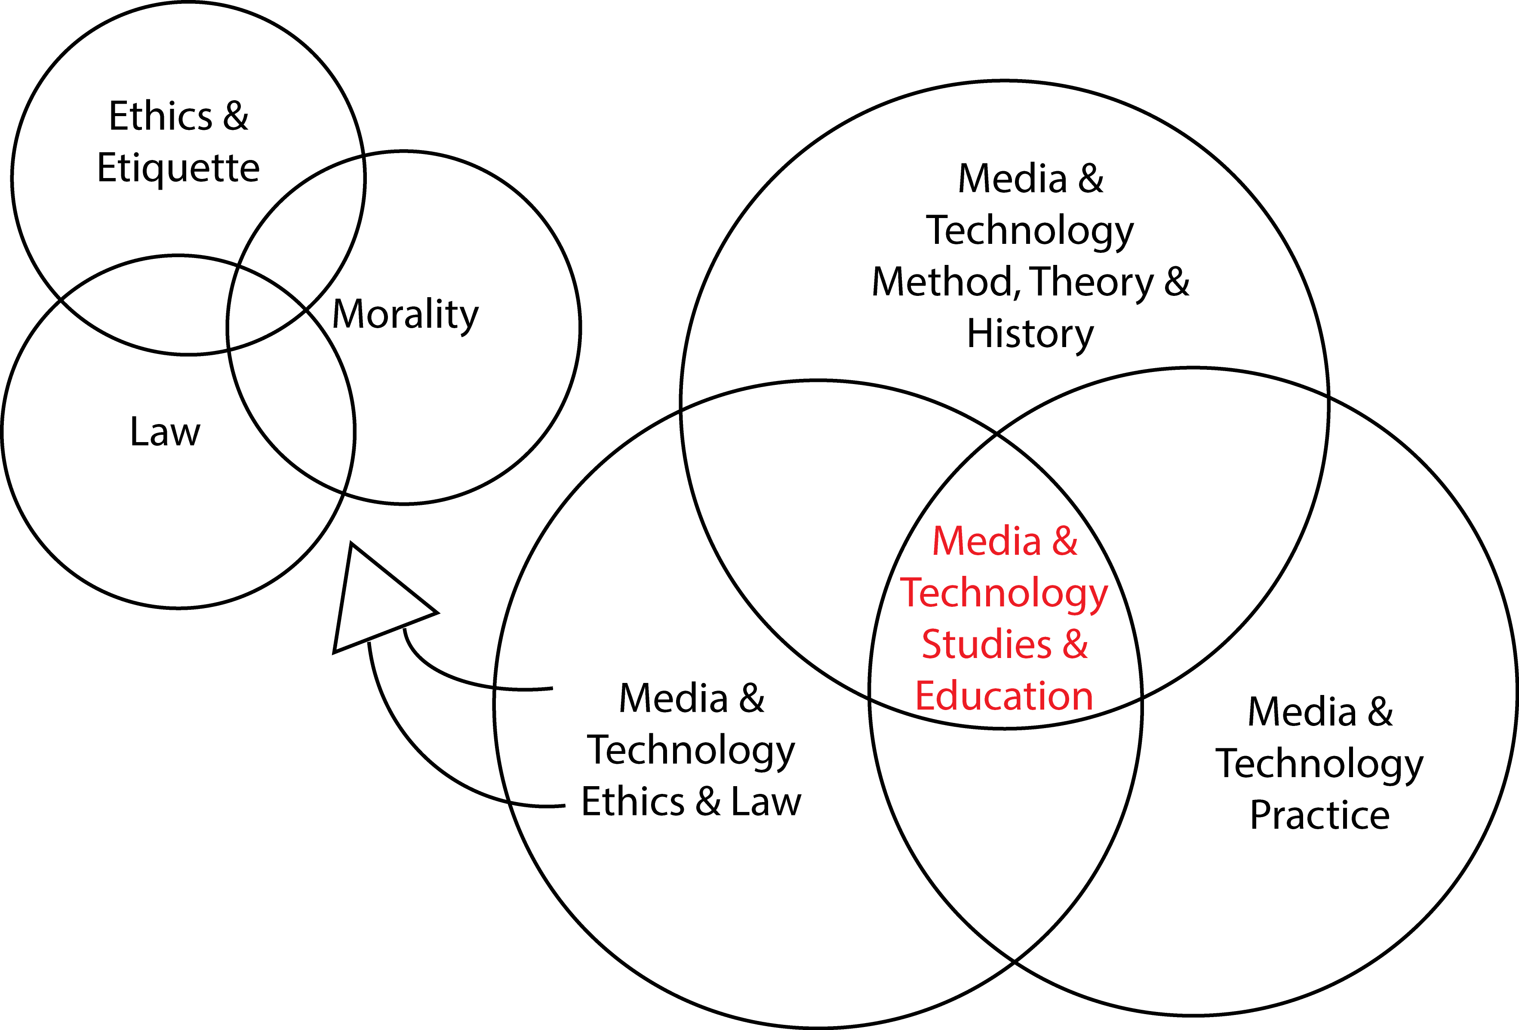

Week 1
Topic 1: Introduction

Reference:
MP example: What Makes Something Kafkaesque? https://ed.ted.com/lessons/what-makes-something-kafkaesque-noah-tavlin

Week 2
Topic 2: Children, Youth, and ICT Philosophy (Philosophy of Media & Technology)

Readings:
Plowman, L. & McPake, J. (2013). Seven myths about young children and technology. Childhood Education, 89(1), 27-33.
Petrina, S. (forthcoming). Philosophy of technology for children and youth. In D. Barlex & P. J. Williams (Eds.), An international perspective on pedagogy for technology education in secondary schools (pp. 1-11). Dordrecht, NL: Springer.

Secondary Readings
McClure, M. (2011). Child as totem: Redressing the myth of inherent creativity in early childhood. Studies in Art Education, 52(2), 127-141.
Petrina, S. (2003). 'Two cultures' of technical courses and discourses: The case of computer-aided design. International Journal of Technology and Design Education, 13(1), 47-73.

Week 3
Topic 3: Cyberethics, Technoethics, ICT Ethics

Readings:
Introna, L. D. (2002). The (im)possibility of ethics in the information age. Information and Organization 12, 71-84.
Luppicini, R. (2009). The emerging field of technoethics. In R. Luppicini & R. Adell (Eds.), Handbook of research on technoethics (pp. 1-19). Hershey, PA: Information Science Publishing.

Secondary Readings
Mahfood, S., Astuto, A., Olliges, R. & Suits, B. (2008). Cyberethics: Social ethics teaching in educational technology programs. Communication Research Trends, 24(4), 1-21.
Molnar, K. K., Kletke, M. G., & Chongwatpol, J. (2008). Ethics vs. IT ethics: Do undergraduate students perceive a difference? Journal of Business Ethics, 83(4), 657-671.
Fishman, B. & Dede, C. (2016). Teaching and technology: New tools for new times. In D. H. Gitomer & C. A. Bell (Eds.), Handbook of research on teaching (pp. 1269-1334). Washington, DC: AERA.

Week 4
Topic 4: Case Law: Cyberbullying and Sexting

Readings:
Murray, S. (2008). Safeguarding children and young people in the online environment. Journal of Nursing Research and Practice, 2(2), 26-29.
Shariff, S. (2015). From Lord of the Flies to Harry Potter: Freedom, choices, and guilt (pp. 141-160). In Sexting and cyberbullying: Defining the line for digitally empowered kids. New York, NY: Cambridge University Press.

Secondary Readings
Shariff, S. (2015). Canadian case law. In Sexting and cyberbullying: Defining the line for digitally empowered kids (pp. 87-93). New York, NY: Cambridge University Press.
Li, Q. (2010). Cyberbullying in high schools: A study of students' Behaviors and beliefs about this new phenomenon. Journal of Aggression, Maltreatment & Trauma, 19, 372–392.
Fine, B. & Fine, R. (2015). Teens react to bullying (Amanda Todd) (video file). Retrieved from: https://www.youtube.com/watch?v=VF6cmddWOgU
A.B. v. Bragg Communications Inc. Supreme Court of Canada. (2012). Retrieved from the Supreme Court of Canada http://scc-csc.lexum.com/decisia-scc-csc/scc-csc/scc-csc/en/10007/1/document.do
A.B. v. Bragg Communications Inc. Supreme Court of Canada. (2012). Appellant’s Factum. Retrieved from the Supreme Court of Canada http://www.scc-csc.gc.ca/factums-memoires/34240/FM010_Appellant_A-B-by-her-litigation-guardian-C-D_Redacted.pdf

Week 5
Thanksgiving (Holiday)

Week 6
Topic 5: Epistemology and Ontology of 21C Learning

Readings:
Knorr, C. (2012). What teens really think about their social media lives. Common Sense Media. Retrieved September 11, 2018 from https://www.commonsensemedia.org/blog/what-teens-really-think-about-their-social-media-lives
Andrew-Gee, E. (2018, January 6). Your smartphone is making you stupid, antisocial and unhealthy. So why can't you put it down⁉ Globe and Mail. Retrieved from https://www.theglobeandmail.com/technology/your-smartphone-is-making-you-stupid/article37511900/
Anderson, M. & Jiang, J. (2018, May 31). Teens, social media & technology 2018. Pew research Center, Retrieved http://www.pewinternet.org/2018/05/31/teens-social-media-technology-2018/

Secondary Readings
Hoffman, J. (2010). What we can learn from the first digital generation. Education 3-13, 38(1), 47-54.
Kereluik, K., Mishra, P., Fahnoe, C., & Terry, L. (2013). What knowledge is of most worth: Teacher knowledge for 21st century learning. Journal of Digital Learning in Teacher Education, 29(4), 127-140.
McWilliam, E. & Haukka, S. (2008). Educating the creative workforce: New directions for twenty-first century schooling. British Educational Research Journal, 34(5), 651–666.

Week 7
Rough Cuts: Student Video Projects

Week 8
Topic 8: Epistemology and Ontology of Simulation, VR, and ICT

Readings:
Aboriginal Territories in Cyberspace [AbTeC]. (2018). Home http://abtec.org/iif/
CBC Radio. (2018). Indigenous virtual reality: An experiment in 'Indigenization of cyberspace'. Retrieved https://www.cbc.ca/radio/unreserved/from-soapstone-carving-to-second-life

Secondary Readings
Banner, O. & Ostherr, K. (2015). Design in motion: Introducing science/animation. Discourse, 37(3), 175-192.
Huereca, R. M. (2010). The age of "The Diamond Age": Cognitive simulations, hive wetwares and socialized cyberspaces as the gist of postcyberpunk. Atlantis, 32(1), 141-154.
Leeker, M. (2017). Performing (the) digital: Positions of critique in digital cultures. In M. Leeker, I. Schipper, & T. Beyes (Eds.), Performing the digital. New York, NY: Transcript Verlag.

Week 9
Topic 9: Epistemology of Code

Readings:
Brennan, K. (2012). ScratchEd. In E. Reilley & I. Literat (Eds.), Designing with teachers (pp. 67-77). Los Angeles, CA: Annenberg School. https://web.media.mit.edu/~kbrennan/files/Brennan_ScratchEd_Meetups.pdf
Brennan, K. et al. (2015). Computational thinking with Scratch. http://scratched.gse.harvard.edu/ct/defining.html
McCosker, A. & Milne, E. (2014). Coding labour. Cultural Studies Review, 20(1), 4–29.

Secondary Readings
Resnick, M. (2012). Let’s teach kids to code. Retrieved from http://www.ted.com/talks/mitch_resnick_let_s_teach_kids_to_code?language=en
Resnick, M. (2013). Learn to code, code to learn. Retrieved from https://www.edsurge.com/n/2013-05-08-learn-to-code-code-to-learn

Week 10
Remembrance Day (Holiday)

Week 11
Topic 11: TBA (What do we want to do here?)

Readings:
TBA

Secondary Readings
TBA

Week 12
Fine Cuts: Student Projects

Participation (15%)
We refer to scholarly levels of participation as academic conversation, academic dialogue, or often performance, which entail a variety of things including articulation and presentation. Throughout, the challenge is to develop a facility for both description and depiction. Description and depiction are key practices across all the disciplines and interdisciplines. Commentary and criticism seem to presuppose a close reading of a text or work, immersion, and a transgressive reading, subversion, although this is neither always possible nor the case. If commentary presupposes solemn reverence for a discipline, text or work, then criticism presupposes gentle mocking or subversive irreverence for that same discipline, text and work. Indeed, interdisciplinarity (cross, meta, multi, trans, etc.) demands and presupposes immersion and subversion. All of this necessitates a certain vulnerability. Avoid defensive readings; read for understanding.

Participation is variant whereas modes have proliferated. Participation is interdependent with preparation for each class, which involves reading (highlighting, pagination margin notes, comments & questions, etc.), writing (note-taking, outlining, questioning, defining, mapping, framing, summarizing, journaling, blogging, tweeting podcasting, exposition, etc.), organizing (documenting, labeling, ordering, archiving, filing, sequencing events, chronicling, etc.), reflecting (rethinking, reincorporating, remapping, analyzing, synthesizing, etc.), and speaking (discussing, corresponding with peers, social media, etc.). While a variety of apps and media are readily available for organizing notes, consider Evernote for starters.

Assignments

- Seminar Leadership @ Pecha Kucha (20 x 20 @ 400) (Groups of 2-3) (35%)— Choose one week on the schedule and frame the seminar through a Pecha Kucha. Create a Pecha Kucha (20 images x 20 seconds) and present it to frame one of the seminars (see http://pechakucha.org/faq). The rules: create 20 slides that automatically advance every 20 seconds, as you speak along with the slides. We will collaborate together in class to determine helpful format suggestions and stylistic specifications. Your goal is to deliver a compelling performance to your peers, so please practice or rehearse. Afterwards, you will lead the discussion and relevant activities (1 hour total).

- Thematic Media Production @ Explainer Video / Tutorial: Ethical or Legal Case, Concept, or Problem (50%)— Media productions are the hallmark of cyberspace— Virtual communication and participation are blends or convergences of image, text and sound. Certainly, students of new media technologies ought to be conversant in all of these modalities. This assignment challenges you to creatively express yourself as well as apply your technical skills to explain an ICT / M&T ethical or legal case, concept, or problem; (e.g., cyberactivism, cyberbullying, copyright, right to be forgotten, etc.). Design and produce a video that explains the case, concept, or problem. The video should reflect your thoughtful engagement with the case, concept, or problem. The media production or video should be thorough and designed to inspire dialogue and pedagogical to address a student or audience. The challenge for you is to render the case, concept, or problem pedagogical.

A number of options are available for producing your thematic media productions. For instance, you could produce an explainer video or a tutorial. Another approach for segments might be to script an interview of yourself in front of a camera or animate with Videoscribe. The media production should be uploaded to YouTube and be about 5-7 minutes in length (Examples are provided). Please see me, if you are interesting in interviewing a peer or participant (UBC Research Ethics Board implications).

