EDCP 570: Seminar in Teaching ICT
Lecture Notes
S. Petrina (5 November 2018)
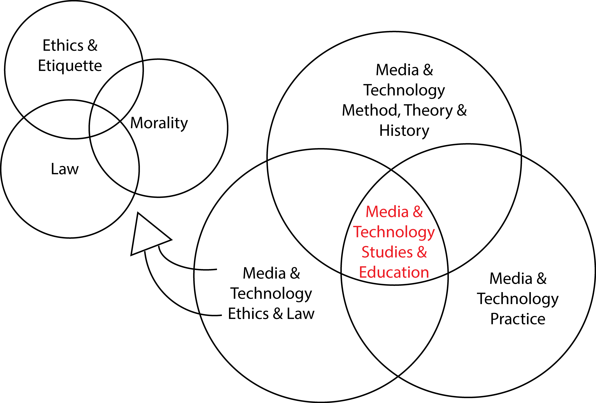

I. Philosophy of Media & Technology

- Philosophy
  - Philosophers
    - Elliston (1985, p. 333): The modern social version [the Socratic gadfly] is the agent provocateur. As such, the philosopher's task is to prick the conscience of the community, to provoke people into thinking about their actions and beliefs. The modern form for corporations is the philosopher in residence who acts as a corporate conscience. He [she or they] serves to remind executives of their duties to both other members of the corporation and the public at large.... A more radical version of this role was envisaged by Marx— the philosopher as the revolutionary.... The religious version of this proactive role is the missionary who stands in contrast to the neutral observer of the social sciences.... Another role that the philosopher can play, and one that Dr. Kipnis found assigned to him, is that of the confidante. Though not quite a confessor, the philosopher may— if he has the trust and confidence of others— become one in whom others can confide about incidents, issues and actions that trouble them. Each role places different demands on the philosopher. To be a gadfly one must identify problems precisely and attack them pointedly. To be a revolutionary one must be willing to assume responsibility— not only for one's own actions but the actions and fates of others. To be a confidante, one must be absolutely trustworthy, and guard that trust assiduously by never divulging secrets.
  - Definitions
    - James (1876, p. 178): If the best use of our colleges is to give young men [and women] a wider openness of mind and a more flexible way of thinking than special technical training can generate, then we hold that philosophy... is the most important of all college studies. However sceptical one may be of the attainment of universal truths... one can never deny that philosophic study means the habit of always seeing an alternative, of not taking the usual for granted, of making conventionalities fluid again, of imagining foreign states of mind. In a word, it means the possession of mental perspective.
    - Dewey, Democracy and Education (1916, pp. 383, p. 386): In fact, education offers a vantage ground from which to penetrate to the human, as distinct from the technical, significance of philosophic discussions…. “Philosophy of education” is not an external application of ready-made ideas to a system of practice having a radically different origin and purpose: it is only an explicit formulation of the problems of the formation of right mental and moral habitudes in respect to the difficulties of contemporary social life. The most penetrating definition of philosophy which can be given is, then, that it is the theory of education in its most general phases.
    - Criticism and Critique
      - Dewey, Experience and Nature (1929, p. ix): Philosophy, then, is a generalized theory of criticism. Its ultimate value for life-experience is that it continuously provides instruments for the criticism of those values whether of beliefs, institutions, actions or products that are found in all aspects of experience. The chief obstacle to a more effective criticism of current values lies in the traditional separation of nature and experience.
      - (1925/1929, p. 398): philosophy is inherently criticism, having its distinctive position among various modes of criticism in its generality; a criticism of criticisms, as it were. Criticism is discriminating judgment, careful appraisal, and judgment is appropriately termed criticism wherever the subject-matter of discrimination concerns goods or values.
      - Dewey, "Context and Thought" (1931/1985, p. 19): Philosophy is criticism; criticism of the influential beliefs that underlie culture; a criticism which traces the beliefs to their generating conditions as far as may be, which tracks them to their results, which considers the mutual compatibility of the elements of the total structure of beliefs.
    - Love of Wisdom
      - Dewey (1949, p. 713): philosophy is love of wisdom; wisdom being not knowledge but knowledge-plus; knowledge turned to account in the instruction and guidance it may convey in piloting life through the storms and the shoals that beset Life-experience as well as into such havens of consummatory experience as enrich our human life from time to time.
    - Consideration of obscure collateral consequences
      - Dewey (1929, p. 57): What is termed philosophy is only a more systematic and persistent performance of [or the extension of] the range, the scope, of thought, to consider obscure collateral consequences that show themselves in a more extensive time-span, or in reference to an enduring development.
    - Logical Analysis
      - Analytic Philosophy
        - Wittgenstein, Tractatus, 4 (p. 112): The object of philosophy is the logical clarification of thoughts. Philosophy is not a doctrine, but an activity. A philosophical work consists essentially of elucidations. The result of philosophy is not a number of "philosophical propositions", but to make propositions clear.
        - Russell (1924/1972, p. 147): The business of philosophy, as I conceive it, is essentially that of logical analysis, followed by logical synthesis.
        - Dummett (1975/1978, p. 458): Only with Frege [and his work on symbolic logic in the 1870s and 1880s] was the proper object of philosophy finally established: first, that the goal of philosophy is the analysis of the structure of thought; secondly, that the study of thought is to be sharply distinguished from the study of the psychological process of thinking; and, finally, that the only proper method for analysing thought consists in the analysis of language.
  - Conventional Taxonomy or Branches of Philosophy (provisional as branches proliferated and continue apace)
    - Aesthetics—(deals with judgment, preferences, and taste)
    - Axiology—(deals with ends and normative values)
    - Epistemology—(deals with origin, nature, construction, and circulation of knowledge)
    - Ethics—(or moral philosophy, deals with human conduct and morality)
    - Logic—(deals with rules and techniques of reasoning)
    - Metaphysics— (deals with ultimate origins and causes)
    - Ontology—(deals with being)
  - On Thinking Philosophically (v thinking about philosophy)
    - οϋ φιλοσοφία άλλά φιλοσοφείνν
      - Ferm (1936, p. vii): My bias (every one has a bias) in this matter of conducting first tours in this field— and there have been a good many repetitions with a good many beginners— is to keep the adventurous spirit uppermost and foremost throughout. After all, it is not philosophy as such that is the big thing but the joy, the sport, the thrill of philosophizing. οϋ φιλοσοφία άλλά φιλοσοφείνν [Not Philosophy, but philosophizing]. Nothing shall stand in the way of the student's responsibility to think and to judge for [herself, theirself, or] himself, at every turn. Not what he [or she, etc.] thinks makes the philosopher, but how he [or she, etc.] thinks what he [or she, etc.] thinks.
    - Khashaba (2004/2013, p. 262): Yes, except that I prefer to speak of philosophizing or thinking philosophically rather than of studying philosophy. Studying philosophy is worse than having nothing to do with philosophy if it is not active, creative engagement in philosophical thinking. Thinking philosophically means simply questioning everything, refusing to exclude anything from subjection to the jurisdiction of reason. A good philosopher is not one who leads readers to accept or adopt her/ his views but one who incites them to puzzle for themselves over the questions that originally gave rise to those views. That was the great secret of the Socratic elenchus. It led Socrates' interlocutors to look within and examine themselves. Plato is the best of philosophers because he continues the work of Socrates. He does not pretend to give us any truths or ready-made conclusions but gives us burning questions that must be kept burning.
  - Philosophical Method
    - Conceptual Analysis
      - Conceptual analysis is often used interchangeably with philosophical analysis or philosophical method. The sources of this sense of philosophical method are Descartes’ Discourse on Method and Kant’s Critique of Pure Reason, and their subsequent descriptions of the methods therein. For Descartes, analysis is for purposes of discovery and explication, encompassing divisive or reductive operations as well as combinatory operations or those normally associated with synthesis. Conceptual analysis is not analytic philosophy, diagrammatic ontology, formal analysis, content analysis, cultural analysis, discourse analysis, linguistic analysis (e.g., structure of linguistic meaning), or text analysis, although it may draw from methodological practices within each of these. Conceptual analysis is a means of clarifying or explicating and giving definition, dimension, and meaning to ordinary and obscure expressions (i.e., cultural, natural, or spiritual things, image, text, sound, etc.).
    - Logical Analysis
      - Russell (1924/1972, p. 147): The business of philosophy, as I conceive it, is essentially that of logical analysis, followed by logical synthesis.
      - Logic is more concerned with “thought as a product rather than with thinking as a process” (Ward, 1919, p. 258). What is thought a product of? If “logic safeguards the pursuit of truth and provides a measure of protection against specious forms of reasoning” (Elliston, 1985, p. 333) then logical analysis identifies patterns or structures of language [“set of symbols”] that produce or underlie the reasoning (Black, 1932, p. 238). For instance, technical language reduces variation of interpretation. How and why does it do this? Through what patterns are technical language and actions produced? Is nontechnical language, the “lexicon of lived experience,” comparatively more communicable (Witkin, 1997, p. 207)?

    - Metaphysical Analysis
    - Existential Analysis

- Philosophy of Media & Technology for Children & Youth
  - See Petrina (in press)
    - This chapter addresses the entangling alliance of pedagogy and philosophy in design, engineering, and technology education (DE&T) and focuses on the philosophy of technology (PT) for children and youth (PT4CY). Philosophy for children (P4C) generated a range of curricula and pedagogical techniques since the 1970s but has yet to attend to DE&T. Although acknowledging for over a century that children are natural makers and philosophers of technology, teachers and theorists of DE&T have not formed an alliance with P4C or developed curricula and methods for PT4CY. One gets an uneasy, false sense of security in scenarios wherein PT4CY is otherwise left to the children and youth alliance with commercial enterprise. The first two sections provide brief histories of philosophy in the schools and P4C. The third section gives and overview of PT4CY, focusing on the void of PT in P4C over the past forty years on one hand and the void of P4C in DE&T on the other (Lipman, 2001; Naji & Hashim, 2017). This section builds on the review of research and provides a variety of leads into PT4CY for advanced development of curriculum and pedagogy (C&P) or instruction (C&I). The chapter concludes by considering Barlex’s (2017) challenge to account for disruptive technologies in DE&T practices by asking if this necessitates a counterbalance of slow, soothing pedagogies and philosophies? But for all we hear about natural tendencies toward distraction and “twitch speed,” one might just as well propose disruptive, spontaneous, turbulent pedagogies and philosophies. If children are naturally gifted and suited to philosophy in various ways but ultimately unable to preserve wisdom or transfer this to sustainable DE&T as they age, then perhaps it is time to abandon the occupations of pedagogy and philosophy for the panacea of perpetual youth. Self-fulfillment
  - tba

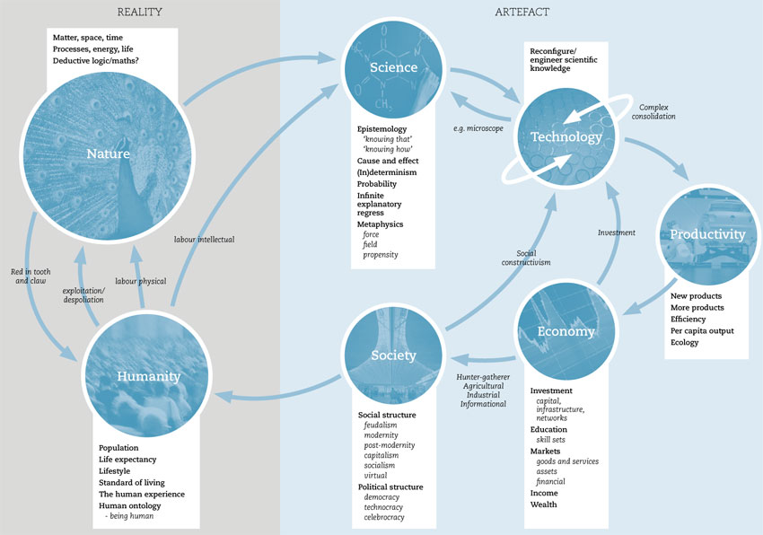
Figure 1. Crocker, G. (2014). A multivariate systems model of technology. http://www.philosophyoftechnology.com

