EDCP 570: Seminar in Teaching ICT
Lecture Notes
S. Petrina (19 November 2018)
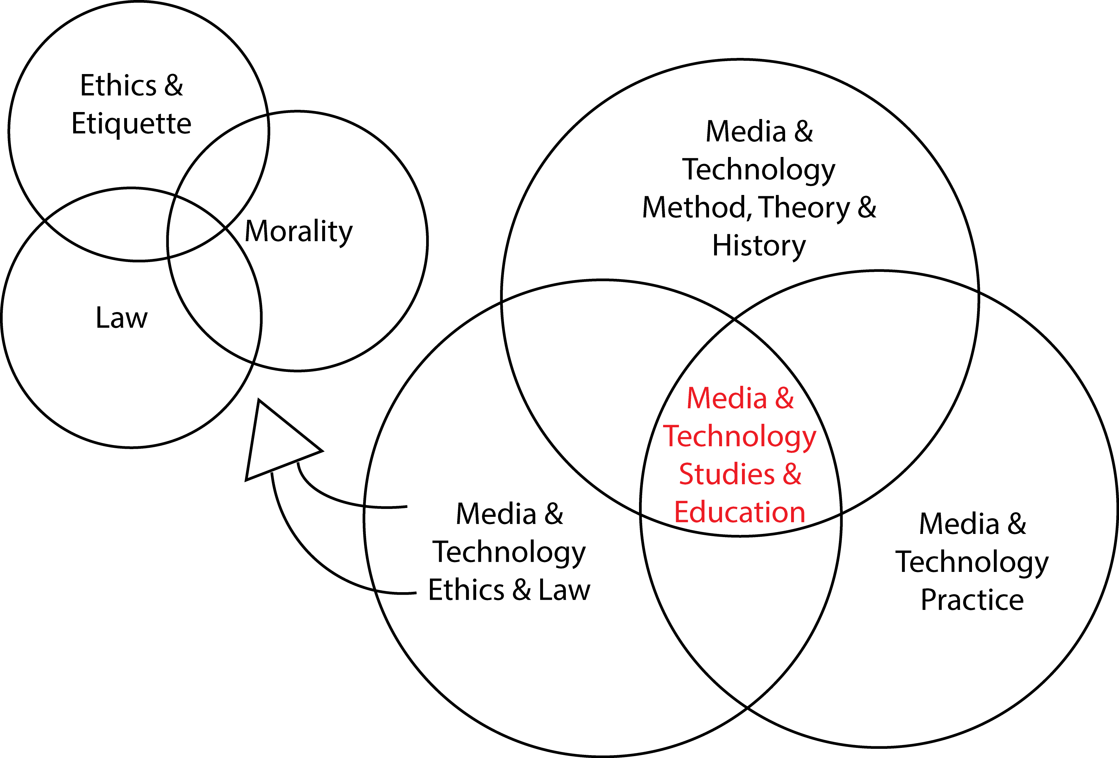

Big Ideas in ICT
(see also Big Ideas in D&T)

- Big Ideas or Core Ideas or Benchmarks or Generalizations or Key Concepts or Cross-Cutting Concepts
  - Big Ideas
    - Hudson (1997, p. 26): "Big ideas" are defined as large concepts or principles that facilitate integration of smaller facts and concepts and the relationship between them.
    - BC MoE, Glossary of Curriculum Terms (2016): Big Ideas are statements that are central to one’s understanding in an area of learning. A Big Idea is broad and abstract. It contains key concepts that generally are timeless and transferable to other situations. Big Ideas are the key concepts, principles, and theories that are used to organize knowledge within an area of learning. A Big Idea is a statement of an idea that is central to an area of learning or across disciplines and that links numerous understandings into a coherent whole.
    - BC MoE Curriculum Overview (2017): The Big Ideas consist of generalizations and principles and the key concepts important in an area of learning. They reflect the “Understand” component of the Know-Do-Understand model of learning. The big ideas represent what students will understand at the completion of the curriculum for their grade. They are intended to endure beyond a single grade and contribute to future understanding.
  - Generalizations
    - Schur (1970, p. 80): a statement which asserts a relationship between two or more concepts and is used in a similar manner as "principle" or "theory."
    - Tirrell (1994, p. 15): A concept is a general idea or abstraction that represents a class or category of things, actions, or ideas that have certain common characteristics.... A generalization is a universally applicable statement at the highest level of abstraction.
  - From “smaller facts and concepts” or concrete things to big ideas or generalizations and vice versa.
    - A big idea or generalization is an abstraction but there should be a way to link or trace back to the concrete (e.e., the Swiss army knife):

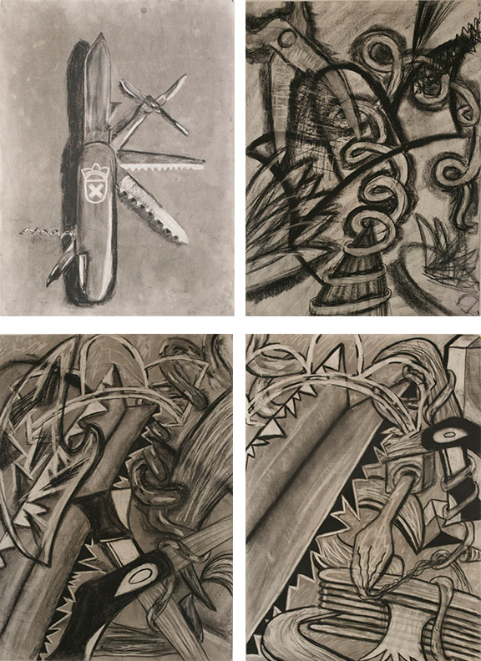
Figure 1. Abstracted Swiss Army Knife (Kelsey Fritsch, https://kelsey4142.wordpress.com/drawing-i/)

  - Concepts (e.g., Core Concepts, Key Concepts, etc.)
    - Barr, Graham, Hunter, Keown, and McGee (1997, p. 10): A concept is an abstraction, which pulls together a number of facts. Concepts group certain facts together and help organise them and make sense of them by revealing patterns of similarity and difference. To be understood, concepts need to be constructed by the learner under the guidance of the teacher.
    - Barr, Graham, Hunter, Keown, and McGee (1997, p. 10): A concept is an abstraction, which pulls together a number of facts. Concepts group certain facts together and help organise them and make sense of them by revealing patterns of similarity and difference. To be understood, concepts need to be constructed by the learner under the guidance of the teacher.
    - New Zealand Ministry of Education (2011): Key concepts are the ideas and understandings that we hope will remain with our students long after they have left school and have forgotten much of the detail. Key concepts sit above context but find their way into every context. Students need time and opportunity to explore these concepts, to appreciate the breadth, depth, and subtlety of meaning that attaches to them, to learn that different people view them from different perspectives, and to understand that meaning is not static. By approaching these concepts in different ways and by revisiting them in different contexts within a relatively short time span, students come to refine and embed understandings. https://seniorsecondary.tki.org.nz/English/Key-concepts/What-are-key-concepts

- Big Ideas in BC MoE’s ICT Curriculum
  - Grades K-3
    - Designs grow out of natural curiosity.
    - Skills can be developed through play.
    - Technologies are tools that extend human capabilities.
  - Grades 4-5
    - Designs can be improved with prototyping and testing.
    - Skills are developed through practice, effort, and action.
    - The choice of technology and tools depends on the task.
  - Grades 6-8
    - Design can be responsive to identified needs.
    - Complex tasks require the acquisition of additional skills.
    - Complex tasks may require multiple tools and technologies.
  - Grade 9
    - Social, ethical, and sustainability considerations impact design.
    - Complex tasks require the sequencing of skills.
    - Complex tasks require different technologies and tools at different stages.
  - Grades 10
    - User needs and interests drive the design process.
    - Social, ethical, and sustainability considerations impact design.
    - Complex tasks require different technologies and tools at different stages.
    - Multi-stage design projects benefit from collaborative work environments.
  - Grades 11-12
    - Design for the life cycle includes consideration of social and environmental impacts
    - Personal design interests require the evaluation and refinement of skills.
    - Tools and technologies can be adapted for specific purposes.
- Databases of big ideas for ICT
  - The challenge for teachers is to add to the resource pool of big ideas rather than subtract from the pool or database. Big ideas are living ideas, meaning that they require attention and revision over time.
- Benchmarks or Big Ideas in the international Standards for Technological Literacy (see also Appendix B in Tech Tally: Approaches to Assessing Technological Literacy)
  - Standard 17: Information and Communication Technologies
    - Benchmarks for Grades K–2
      - Information is data that has been organized.
      - Technology enables people to communicate by sending and receiving information over a distance.
      - People use symbols when they communicate by technology.
    - Benchmarks for Grades 3–5
      - The processing of information through the use of technology can be used to help humans make decisions and solve problems.
      - Information can be acquired and sent through a variety of technological sources, including print and electronic media.
      - Communication technology is the transfer of messages among people and/or machines over distances through the use of technology.
      - Letters, characters, icons, and signs are symbols that represent ideas, quantities, elements, and operations.
    - Benchmarks for Grades 6–8
      - Information and communication systems allow information to be transferred from human to human, human to machine, and machine to human.
      - Communication systems are made up of a source, encoder, transmitter, receiver, decoder, and destination.
      - The design of a message is influenced by such factors as intended audience, medium, purpose, and the nature of the message.
      - The use of symbols, measurements, and drawings promotes a clear communication by providing a common language to express ideas.
    - Benchmarks for Grades 9–12
      - Information and communication technologies include the inputs, processes, and outputs associated with sending and receiving information.
      - Information and communication systems allow information to be transferred from human to human, human to machine, machine to human, and machine to machine.
      - Information and communication systems can be used to inform, persuade, entertain, control, manage, and educate.
      - Communication systems are made up of source, encoder, transmitter, receiver, decoder, storage, retrieval, and destination.
      - There are many ways to communicate information, such as graphic and electronic means.
      - Technological knowledge and processes are communicated using symbols, measurement, conventions, icons, graphic images, and languages that incorporate a variety of visual, auditory, and tactile stimuli.
- Additional Sources of Big Ideas in ICT
  - Moursund (2005, pp. 14-18):
    - A new technology such as ICT is developed as an aid to helping to solve certain types of problems that people deem to be important. Education was not the driving problem that led to the development of ICT. However, ICT has proven to be a powerful aid in addressing a wide range of problems in education and in many other fields.
    - A new technology creates problems. First, there are the problems of change, as old ways of addressing certain problems give way to new ways to address the same problems. Second, the new technology facilitates the identification of old and new problems that can make effective use of the technology. Many of these are problems that could not and cannot be effectively addressed by older technologies.
    - The invention or development of a new physical body or mental tool creates both opportunities and challenges. In brief summary, a new tool:
      - Helps us to “better” solve some problems and accomplish some existing tasks that we are currently addressing without the new tool. Here, the term “better” may have meanings such as: in a more cost effective manner; faster; more precisely; with less danger; and so on.
      - Helps us to solve some problems and accomplish some tasks that cannot be solved without the tool, and helps us to identify new problems and tasks that require use of the new tools.
      - Creates new problems.
    - Computers are very good at carrying out tasks in a mechanical, “non-thinking” manner. They are millions of times as fast as humans in tasks such as doing arithmetic calculations or searching through millions of pages of text to find occurrences of a certain set of words. Moreover, they can do such tasks without making any errors.
    - Human brains are very good at doing the thinking and orchestrating the processes required in many different very complex tasks such as carrying on a conversation with a person, reading for understanding, posing problems, and solving complex problems. Humans have minds and consciousness. A human’s brain/mind capability for “meaningful understanding” is far beyond the capabilities of the most advanced computers we currently have.
    - There are many things that computers can do much better than human brains, and there are many things that human brains can do much better than computers.
    - Computers add a new dimension to the storage and retrieval of data and information. Computers can process (carry out operations on) data and information. Thus, one can think of a computer as a more powerful augmentation to brain/mind than is provided by static storage on paper or other hardcopy medium.
    - ICT provides a type of augmentation to one’s brain/mind. The power, capability, and value of this type of augmentation continue to grow rapidly. Certainly this is one of the most important ideas in education at the current time

