Spoken Language 10 - Identity Unit 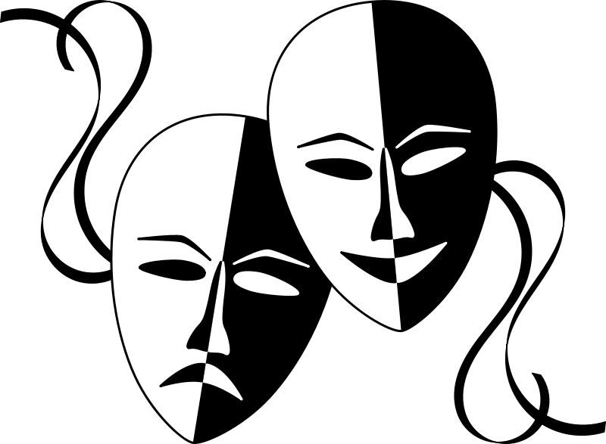

Ms.Mutama

Name:

Date:

Block:

***Identity* - A short film by Kalhil Adames**

What is identity? Is it readily definable? Is there one fixed definition or are there many parts?

How do you define yourself? Can you define yourself?

Who do others say you are? Should we care how we are depicted by others? Let’s explore some ideas regarding identity by viewing Kalhil Adames’ short film *Identity*.

*Reflection Questions*

1. We are all so unique in what captures our attention. What stood out to you most from the film and why?
2. What do the masks symbolize? Is this a good or bad thing?
3. Why do you think certain groups of people are wearing the same coloured masks? What do the different colours represent?
4. What do you think it means when one individual took off a mask and put on another?

3) What conflict is the girl facing and what happens by the end of the film? Name similar conflicts either you or your peers may have faced.

4) What is the significance of the allusion made to Plato’s *Allegory of the Cave?*

5) What connections can you make from the film to your own life? What does the film reveal about the complex nature of identity?