**Assignment 1:3 Three Definitions**

The purpose of this assignment is to practise the communication of a technical concept to a non-technical audience. There are three ways to explain a technical term to an audience outside of the field: parenthetical, sentence, and expanded definitions. Each type of definition varies in length and detail, and are tailored to different types of audiences. For this assignment, I have produced three definitions for an ‘integrated development environment’, a software tool commonly used in the computer science discipline.

Parenthetical definition

Computer programmers often use an integrated development environment (a software that checks and runs the programming code inputs) to create programs.

Sentence Definition

An integrated development environment (IDE) is a computer software tool in which programmers write the code needed to create a program. The IDE helps programmers to edit, fix, and run their code.

Expanded Definition

What is the history of IDEs?

Before computers came with display screens, program codes were physically punched onto punch cards. The punch cards were then fed into a computer-like machine that read the cards, stored their data, and executed the programs (“Integrated Development Environment,” n. d.). The earliest IDEs were created after computers came with a monitor screen and keyboard, allowing programmers to type inputs directly onto the computer. The world’s first IDE is the Maestro I, which was created by Softlab Munich in 1975 (“Integrated Development Environment,” n. d.). Since then, IDEs became an important tool in a programmer’s creative process.

What does it resemble?

An integrated development environment (IDE) provides a space for programmers to write their codes (Reges & Stepp, 2014). The IDE resembles WordPad and Microsoft Word in that it edits, offers suggestions, fixes any input errors, and formats the content, as shown in Figure 1. As a final step, software like WordPad and Microsoft Word export the document as a file or as a physical printout. IDEs, however, execute the inputted code as a computer program.

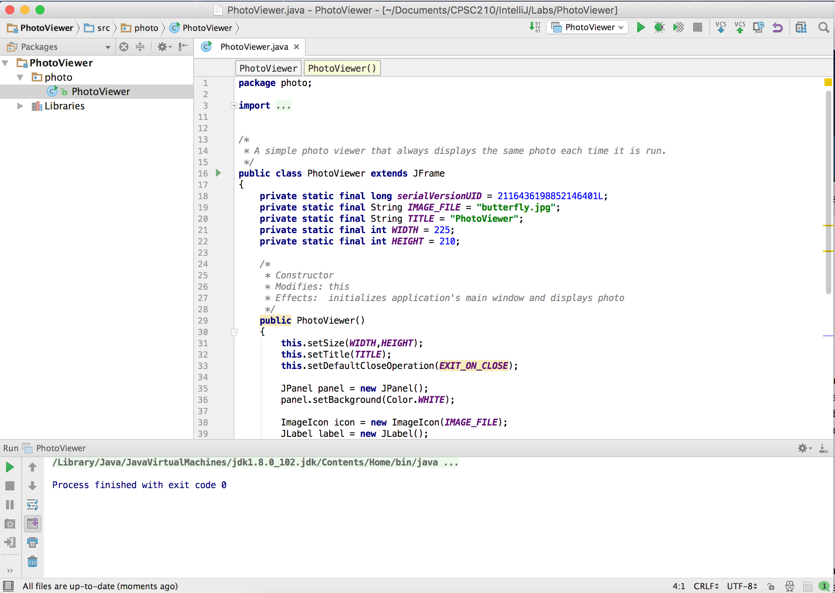

**Figure 1**. An example of an Integrated Development Environment (IDE).

What is needed to use it?

There are many different IDEs available, each used for different programming languages. When using a specific IDE, the programmer must use the specific language that the IDE supports; otherwise, the IDE will not understand the language nor run the code. Some IDEs support multiple programming languages (“Integrated Development Environment,” n. d). If users want to use additional languages that are not supported by a specific IDE, plugins can be installed to the IDE to expand its language support.

What are some examples of IDE?

IDEs are widely used to create computer software that many people are familiar with. Xcode is an IDE developed by Apple Inc. that is used for writing software for Apple computers (Macs), iPhones, iPad and other Apple products (“Xcode,” n. d.). Many games and applications available on Apple devices are created using Xcode. Microsoft’s Visual Studio is another IDE used to develop Microsoft Windows programs (“Microsoft Visual Studio,” n. d.).

**Reference List**

Apple. (n.d.) *Xcode IDE.* Retrieved from https://developer.apple.com/xcode/ide/

Integrated Development Environment. (n. d.). Retrieved September 24, 2016 from Wikipedia: https://en.wikipedia.org/wiki/Integrated_development_environment

Microsoft Visual Studio. (n. d.). Retrieved September 24, 2016 from Wikipedia: Retrieved from https://en.wikipedia.org/wiki/Microsoft_Visual_Studio

Reges, S., & Stepp, M. (2014). Building Java Programs: A Back to Basics Approach (3rd Ed.). Upper Saddle River, NJ: Pearson Education, Inc.