Nicole Ho Kiu Lee-Kauer
GEOG 121
Rebekah Kartal
7th October, 2016
Showcasing Western dominance through imagining Occupy Central
On the 30th September 2014, it was the peak of the Occupy Central movement. Out of excitement, I joined in the protest without fully understanding the purpose. What I experienced was a mix between outcry against violence, opposition of the government, and a defining movement for cultural identity. However, Time’s article glorifies the movement by depicting its sole purpose as democracy. I argue that Time’s article familiarize and victimize Hong Kong people in order to evoke empathy and show dominance of the West. Hence, in this essay, I will deconstruct how imaginaries in Time’s article was created through analyzing the real driving force of the Occupy Central movement, the media used to support the article, and their depiction of the Chinese government.
Time’s article was written to summarize the Occupy Central movement with a set of six questions. They depicted the movement as a noble protest with a direct purpose; “the main demand is full democracy” with universal suffrage in Hong Kong (Iyengar). While this was the initial purpose of the movement, , many people who participated the movement had different objectives by the time the article was written. For instance, when I was in the protest myself, people were chanting “CY Leung step down” who is our chief executive. This was only briefly mentioned in the middle of the article, while the two words “democracy and “freedom” were mentioned ten times and six times respectively (Iyengar). Moreover, the article began with “Hong Kong students are currently protesting for more political freedom” (Iyengar). Clearly, the writer is focusing on the initial purpose of democracy but not what the movement has evolved into. Moreover, many people took it to the streets when the police used rubber bullets and tear gas against unarmed students. Yet, the article failed to show the huge increase of protesters after the use of violence. Hence, it is clear to see the writer is specifically focusing on the democracy side of the movement in order to show political similarities between Hong Kong people and the West.
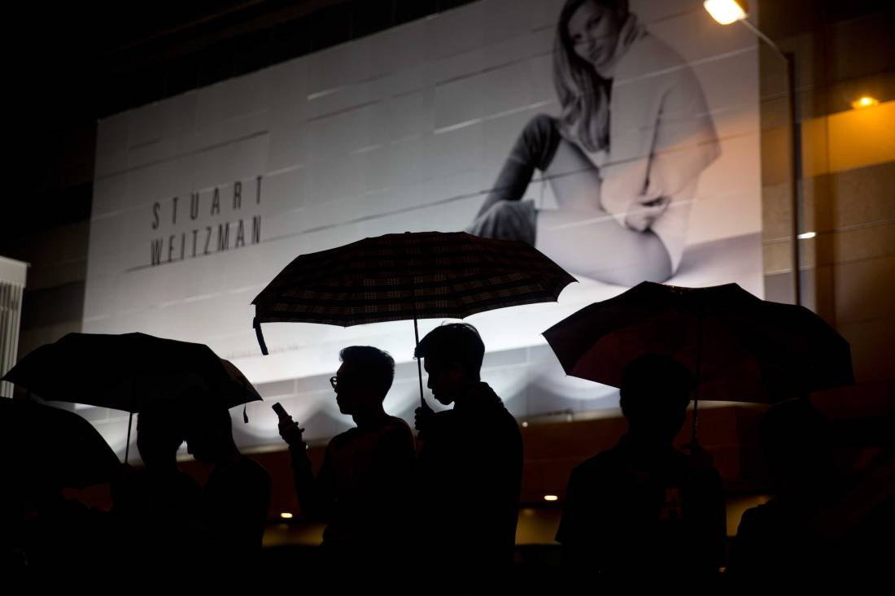
Figure 1
Aside from depicting the movement with a singular objective for democracy, this article tries to associate Hong Kong people with Western cultural identity using media. The photo used for the article shows an advertisement with a Caucasian woman on a huge billboard, which is looming over protesters who are holding umbrellas. This photo suggests Hong Kong is a place that is greatly influenced by Western fashion, which would allow the readers to imagine Hong Kong people sharing the same cultural values as themselves. By showing similarities in political and cultural values, I argue that the writer attempts to evoke empathy in the readers.
Moreover, the writer uses a casual and informal language such as “So what do Hong Kong’s pro-democracy protesters want?” alongside with a question and response structure which familiarize Hong Kong people because it seems like they readers are talking to the protesters directly. The use of victimization forms an appealing narrative where Hong Kong people are the victim and the West is the hero.
In addition, the article depicts the Chinese and Hong Kong government as an evil superpower when in reality; many politicians supported the movement. However, the article only showed the footage of Regina Yip’s speech that “(Hong Kong) We’re a part of China” and “China cannot afford to have someone elected as chief executive, who would go to Washington or London for help…” as well as other politicians who are against the movement. Meanwhile, the pan-democratic camp including the Democratic Party, Civic Party, and Labour Party had 18 members who joined the protest.
Hence, Time’s article depicted a strong narrative where Hong Kong people are victimized and familiarized in order to evoke sympathy in its readers. The story portrays Hong Kong people as victims, Chinese and Hong Kong government as the evil superpower, and Western society as the good guys. Therefore, I argue this article intended to demonstrate Western dominance and influence over countries that were once colonized.

Work Cited
Iyengar, Rishi. "Occupy Central: An Explainer." Time. Time, n.d. Web. 08 Oct. 2016.

