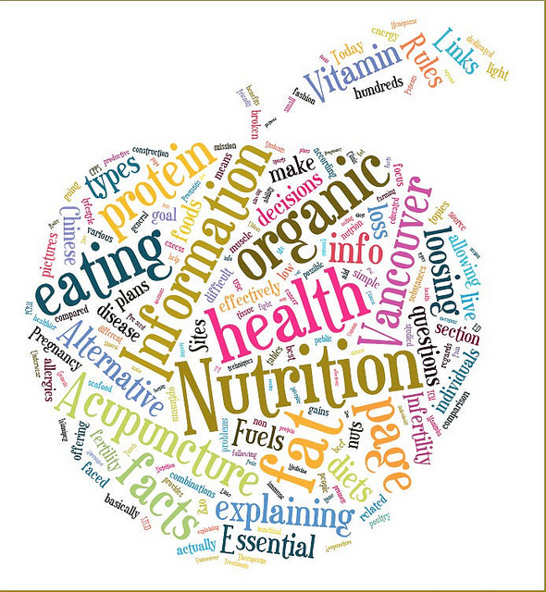

**1) March 15th:** come celebrate St. Patty’s with chocolate-mint fondue and green tea!

**2) March 22, 10 a.m MCML 154:** *Dietitian* Desiree Nielsen will be coming in to speak to us. Look forward to a fresh perspective on nutrition!

**3) April 5, 10 a.m MCML 154:** LDOC breakfast!  What better way to celebrate the term coming to an end then with delicious waffles!

Everyone is welcome to attend all events!

* Members: Free
* Non-members: $2

# Come check out NutriSocial! We have some great events coming up that you won’t want to miss!

http://www.flickr.com/photos/vvonstruen/6786472758/in/gallery-75728900@N06-72157632584361400/

Interested in Nutrition?