DEFINITIONS OF “PICC LINE”

Parenthetical Definition

A PICC line (peripherally-inserted central catheter)

Sentence Definition

A PICC line (peripherally-inserted central catheter) is a long, flexible tube inserted into a patient for a medium to long time period, either to introduce fluids directly into the circulatory system or remove fluids from it.

Extended Definition

A PICC line (peripherally-inserted central catheter) is a long, flexible tube inserted into a patient for a medium to long time period, either to introduce fluids directly into the circulatory system or remove fluids from it. The circulatory system is most frequently accessed from a vein in the front of the top of the elbow, running to the point in the chest where blood enters the heart; however, a PICC line can be used to access the circulatory system through veins in the lower leg as well.

*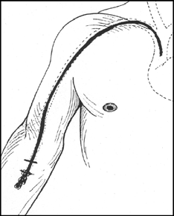*

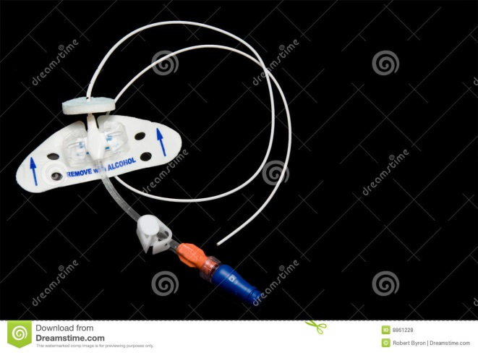

*Figure 1: A representation of how a PICC line sits in the body. Figure 2: A PICC line.*

*Components of a PICC Line*

A PICC line consists of the following parts: the Luer lock, the lumen, the clamp, the hub, the body, and the tip. The Luer lock is a standardized point of attachment between the tube and either the container holding the medication to be infused or the syringe for blood collection that is specifically designed to minimize fluid leakage. The lumen is a one-way valve that prevents fluid from backing up and encourages flow in the right direction. Some PICC lines only have one lumen, but more often multiple-lumen catheters are inserted to provide alternate routes of use if one route is unusable. The clamp provides a manual physical barrier between the Luer lock (and the environment outside the body) and the inside of the body. The hub is where the lumens converge into one common tube to enter the body. It helps to stabilize the catheter, preventing any movement of the apparatus in or out of the patient. The catheter body is the actual conduit that allows the fluid to transfer into the patient, and the tip is the interface between the catheter and the circulatory system inside the patient.

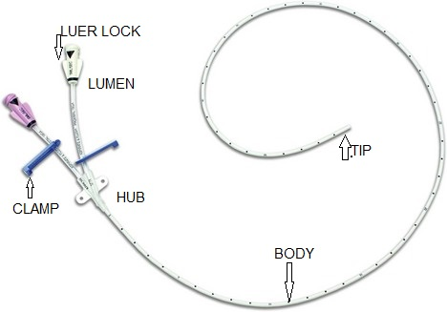*Figure 3: Parts of a PICC line.*

*Uses and Indications for PICC Lines*

The most common uses for PICC lines are:

* delivering medications, such as antibiotics and anti-cancer agents, directly into the bloodstream on a regular basis over weeks to months.
* feeding patients in situations where the traditional ways of introducing nutrients into the body are either inadequate for meeting the patient’s nutritional needs or impossible to use.
* drawing blood samples from patients whose veins make obtaining samples through other methods difficult.
* measuring and monitoring the pressure within the veins.

PICC lines are particularly useful for patients who do not have many viable veins in which to insert peripheral intravenous lines, and for patients who require medications that may be harmful to the veins in higher concentrations. They are also suitable for patients who do not need a permanent interface between the circulatory system and the environment outside the body, but who need secure, consistent, and hygienic access to the bloodstream for more than a few days.

When inserted correctly and with proper technique, and when well looked after, PICC lines are more cost effective and have fewer negative side effects for patients in terms of subsequent infection. PICC lines can be inserted at the bedside with minimal manpower and equipment when compared to the requirements of inserting central lines and ports, saving operating room costs as well as the cost of specialised surgical teams and equipment. Introducing the catheter away from vital organs gives the vital organs a buffer from invading bacteria and viruses. Medications can be given more safely through a PICC line than through other methods of intravenous administration. Because the blood flow is faster and the blood pressure is higher by the heart than in the peripheral veins, the fluid coming into the body is diluted more quickly as it enters the blood. As a result, fewer side effects associated with higher concentrations of medications have been noted when using a PICC line as opposed to a more traditional peripheral intravenous infusion.

*Contraindications for PICC Lines*

A PICC line is not suitable for every patient, and a PICC line insertion, like any other invasive medical procedure, carries with it some risk. Examples of these risks include a chance of blood clots, air bubbles, or pieces of the catheter being dislodged during insertion, and a chance of bacteria being introduced into the body as a result of the procedure. Other issues that may arise from the use of a PICC line include the skin around the entry point becoming damaged or the vein itself rupturing if the tube has pressure put on it or moves in any direction once the insertion is complete. Improper or inadequate care and maintenance of the PICC dressing may result in the insertion site getting infected and infection spreading rapidly throughout the body. Another set of problems may occur as a result of the catheter becoming blocked. If the catheter is blocked by things like naturally occurring glues, such as fibrin, or medications that have crystallized out of solution, the contents will not enter the body as quickly as expected (and be of less therapeutic value) and the catheter itself may rupture if the internal pressure becomes high enough.

Pre-existing conditions also play a role in whether a PICC line is inserted. For example, patients with chronic kidney disease often are not considered for PICC lines because in the event that they need to use a machine rather than a kidney to clean their blood, their choices for sites to attach to the machine may be limited if they have had PICC lines inserted in the past. Similarly, patients with abnormalities in their ECG (heart rhythm tracing) may not get a PICC line because PICC lines may cause abnormal rhythms to worsen.

For most otherwise-healthy people, a PICC line is a relatively safe and effective vehicle to move fluid in or out of the body. It saves veins, it delivers medications and food safely, it allows removal of blood samples for testing, and it does so in a cost-effective manner – a real boon to medicine and health care.

Works Cited

Argane J. “IV Essentials: Picking Up on PICC Lines”. *Nursing Made Incredibly Easy* 12 (1): 2014. Web: Accessed 30 May 2017.

Bowe-Geddes LA, Nichols HA. “An Overview of Peripherally Inserted Catheters.” *Topics in Advanced Practice Nursing eJournal*. 5(3): WebMD, LLC, 2005. Web: Accessed 30 May 2017

Earhart A. “Central lines: Recognizing, preventing, and troubleshooting complications.” *American Nurse Today* 8(13): 2013. Web: Accessed 30 May 2017.