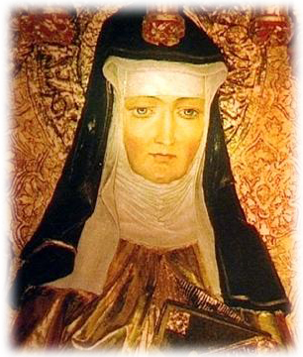
Hildegarde von Bingen

Hildegarde von Bingen
A mother of science, composer, scholar, medieval feminist, and visionary, Hildegard von Bingen is one of the few women of the 11th century to speak of literature with men without being burned at the stake.
A sickly 10th child, she was given as a 'tithe to God" by her family to the Benedictine order, where she took advantage of the literary culture and read widely.
When she became Abyss, she laid down like a rock until the Abbott allowed her to move the convent to a separate building to assert independence of her station.
She also wrote an encyclopedia of the uses of over 300 other plants. Yet despite these accomplishments, the Pope would not recognize her 'white-outs' as a message from God. We know her symptoms today match the blindness and euphoria of chronic migrane sufferers, and she also expressed a melancholy self-doubt many of us relate to today:
"But although I heard and saw these things, because of doubt and low opinion of myself and because of diverse sayings of men, I refused for a long time a call to write, not out of stubbornness but out of humility, until weighed down by a scourge of god, I fell onto a bed of sickness."
Later, another Pope encouraged her to finish her writings, which she did. She outlived most of her contemporaries and died age 82.

Unfortunately, her works were almost entirely ignored by Bacon, Aquinas and other male thinkers of the period who are often credited as opening the door for modern science and medicine.
Monastic life: Way better than it sounds.
http: //www.fordham.edu/halsall/med/hildegarde.asp

