Phaidra Ruck | 92513126
EDCP 305 – Digital Media in Arts Education
D. Bakan
October 16th, 2013

Revolution Road kills

Collins and Halverson have re-branded and marketed a dog’s breakfast in their common critique of the purpose and aims of School and Education, with a new sticker pointing out the nutritional benefits of technology. Perhaps the most significant feature of this article’s worth is the illusion of revolution which steadily erodes with a second and third reading. Like a sales pitch, which sounds really good at first, it wears off. There really is no revolution, just as there is no easy panacea in either technology or doing away with schools in the ongoing improvement forum on education.
At first glance, it is compelling and comfortable to accept such usual cynicism around the conversation of Education, where one can easily nod a head in agreement that technology just might be the tipping point in making Schools appear so utterly worthless to modernity, that they will be their own undoing.
But there is nothing revolutionary in this, in the usual definition of revolution as violent, sudden change or upheaval. The entrenchment of the Institution of schools means a slow death if at all. Collins and Halverson seem build a case against schools to call for society to collectively do ourselves a favour and euthanize the system with technology as if there is already a sweet hereafter waiting. We could just as well assume that a dog could die by getting hit by a car, so let’s get in a car and hit the dog. Hasn’t it already been hit?
No, it hasn’t been hit. Despite being large societal Institutions, Schools are not as slow to react as we think, appearing almost to rely on pure survival instinct as a dog would dodge a car. We may conjure up an old cliché to the end of the scenario, where the dog then chases and barks at the car, if only for the illusion to scare the mechanical monster of death away.
.Most dogs in 21st Canada are leashed, or docile, and under control of their Masters and do not bark in public unless threatened. Our school-dogs have trainers – the government—but still largely have a mind of their own, however length of leash is afforded. The other masters of private institutions are the breeders. They are really out to sell animals for profit as pets, and don’t really get as attached to their dogs.
Dogs are intelligent and can learn a new trick at any age, and Schools can, too. The myth that self-interested breeders like Collins and Halverson uphold is that you can’t learn to be a good master, or the dog is inherently stupid. So, admit the dog is dead, run it over, and buy a new breed. Get rid of schools and use technology instead. Road kill sounds so much more palatable when re-branded as Revolution.
The project of Schools was intended, and still is, a democratic project in a world filled with inequity. If Dog is Man’s Best Friend, Schools are Democracy’s best friend, for better or worse. Governments may be trainers, but ultimately the dog is all of ours and we will need to care for the dog, including picking up after it. That’s part of the deal as the supreme caretaker of another’s Life.
What we really need to do is take the lease off the dog and let it run around the park of technology a couple times. The dog will predictably come back after a while, maybe want to play a game of fetch until everyone is tired and ready to go home for the day, with a promise to return on the morrow.
Even a trick seems controlling and trivial, however novel to the Masters, compared to the intrinsic value of the shared experience of well-being in the park, caretaker and the cared-for.
That’s what a revolution is, rather than as some quick trick Marx showed us (that hid well cruelty to the animal). The free dictionary online points out that revolve is the origin word embedded in revolutions, not coup d’état. Revolution is an “orbital motion about a point”. Let’s try putting schools, and all of education, as the centrifical point in talks about pedagogy and technology. Let’s take the dog for a walk in the park and take the leash off for awhile.
Instead of revolutions in Education, perhaps Karma (and pet-care) is what we should be talking about in the conversations with technology--what goes around, comes around. What you give is what you get. Instead of merely picking on Dog-owners for choosing a Dog, or merely talking about going for a walk, why don’t we take an active role in training and taking care of our pets? They really can live a long, healthy life.
We might decide to take Collins and Halverson’s approach slightly differently and turn our back on the dog and leave it in a park. We think it likely not to survive, and then only in some devious way. It is heartbreaking to think of abandoning an animal this way, but this is why there are so many shelters out there for the Collins and Halverson’s of the world.
Collins and Halverson, if you’d like to apply to adopt at the shelter, I’ll be waiting for you.
We should remember that Education is not a single type pet, or the only pet you’ll ever have is the dog you grew up with. But we must also remember that School is our Dog, our best friend of Democracy, one we must take care of as Master. It’s up to us, not anyone else, to train the animal.

Appendix 1

http://www.northyorkshire.police.uk/2460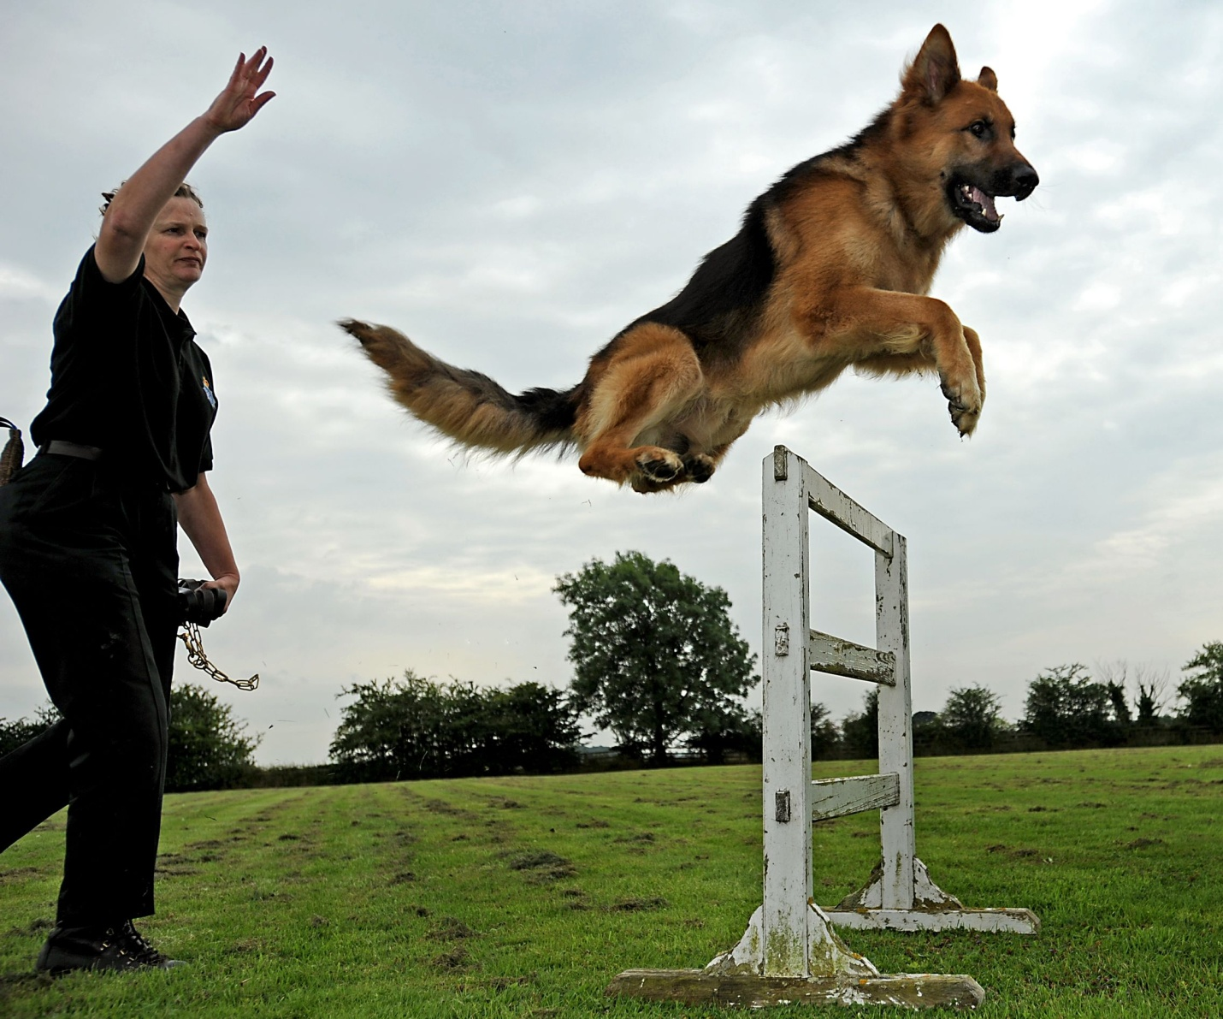

http://www.thefreedictionary.com/revolution. Long live Chicago.

