Teachnology

A Vision for E-learning
in Teacher’s Education at the University of British Columbia
June 23, 2013
Phaidra Ruck, BA

Prepared for Professor Mark Bullen
ETEC 520: Planning and Managing Technologies in Higher Education

Contents
Rationale 3
Context 4
External Factors 5
Internal Factors 9
Vision: Key Points 11
Implications: Key points 12
Details of Vision & Implications 13
Conclusion 20

Rationale
With an abundance of devices and opportunities in our lives for e-learning outside classrooms, it is no surprise that students are noticing the absence of these devices inside classrooms.
Imposing the notion of contemporary youth as ‘digital natives’ has been a way for institutions and stakeholders to abdicate (or postpone) responsibility for becoming informed e-learners (leaders?)within educational setting, and has falsely perpetuated a myth that youth are increasingly coming across ICT tools with apparently innate understanding and efficiency beyond the abilities of their teachers. Bullen and others have cried foul on the myth of the digital native, and called upon educational institutions to broaden as places of knowledge construction and evaluation, including in the digital realm.
There is an unmet need to address practical applications of E-learning pedagogy and instructional design in the UBC Teacher Education Program, to prepare candidates to teach professionally in a 21st-century public school system.
My current experience in the program this year lends me a unique look at the program as it stands, and makes recommendations for future teachers of teachers.

Context

Program 12-month Bachelor of Education program at UBC

Motto: Inquire, Imagine, Inspire

A post-baccalaureate degree approved by the Ministry of Education’s Teacher Regulation Branch, leading to recommendation to become certified to teach in BC.

BEd program strands:
- Inquiry and Dialogical Understanding
- Curriculum, Pedagogy and Assessment
- Social & Ecological Justice and Diversity
- Language, Literacies and Cultures
- Field Experience: School and Community

Although the vision of e-learning does not need to be restricted to any particular cohort, my vision may reflect my perception of utility and needs experienced in the secondary social studies cohort.

Place Neville Scarfe education building, UBC Vancouver

With the exception of the NITEP (Native Indian Teacher Education Program) courses housed in other campus sites such as the First Nations House of Learning

People Instructors

The Faculty of Education Directory currently lists 159 members. A very few instructors come from the local community of working teachers on a 2-year contract. Graduate students are often former teachers, predominately from the international community. Full-time Professors teaching pre-service teachers is a rare occurrence.

Staff & Services

The Teacher Education Office is staffed with program and practicum advisors, and a dedicated Associate Dean of Teacher’s Education. A career development specialist is absent, providing a gap in real-world needs, perhaps filled by the practicum placement itself. In addition there is a separate teacher education program for students for aboriginal ancestry, housed in the First Nations House of Learning. Two IT departments, one for IT service and one for rental, are also located in the Scarfe building.
Students

Note that both Tech-Based Certificates are considered a part of the Office of Graduate Studies and not available to pre-service teachers enrolled in the BEd program (elementary, middle years, secondary, and dual-degree).

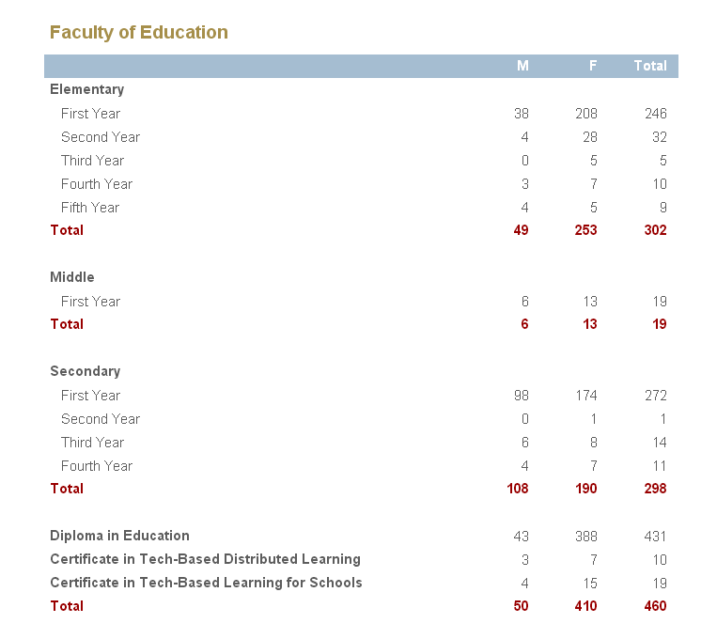
Enrolment as of November 1, 2012 (including Distance Education students).

External Factors
Key points
- Abundance of local access & tools (but not training)
- Grassroots pressures from students, parents, teacher’s professional development interests
- Top-down pressures from government, teacher’s union, workforce readiness
Details
Metro Vancouver benefits from an abundance of E-learning tools. Students along the continuum of traditional education institutions, from ECE through PhD, have ever-increasing opportunities to interact with E-learning over the course of their lives, as free Wi-Fi access and affordable tools become a ubiquitous part of the Canadian urban experience. Market competition and an electronic manufacturing race-to-the-bottom have driven prices of new devices down in recent years. At the same time, a wealth of used or freshly-obsolete devices end up in second-hand stores and free bins, creating unprecedented avenues for accessibility to both the internet and other E-learning tools. E-learning is also facilitated through computer terminals and scholarly subscriptions throughout the Metro Vancouver regional public library system, as well as within an increasing number of secondary school libraries.
This September will see the first class of students born in 21st Century enter secondary school grade 8, bringing with them a more pervasive sense of technology in the world than even Generation Y. While it is difficult to say whether a demand may come from the youth themselves to incorporate E-learning, it may also come from their parents—my generation— as we give birth to more Boomer Echo grandchildren around the world, and expect our kids to be prepared by our peers to fully excel in the digital world. With the last of their expendable income, Boomers may well pass on a sense of self-entitlement and appreciation of new toys to their progeny to show off the wealth and success of their family to friends—and teachers—in school. Teachers should be prepared to use this to their full advantage in lessons, rather than resisting a culture grounded in communications through regressive practices, such as locking away Smart phones and teaching technically-devoid lessons. Other teachers will reflect on their knowledge deficit with technology and put pressure on institutions of higher learning to provide a basis for professional development.
The increasing self-awareness of living in a ‘digital’ society with many ICT tools available for daily application has recently led the Government of British Columbia to engage with “BC Educational leaders [to begin] identifying digital literacy standards for our learners.” Further, the Ministry has decided to engage in a kind of E-learning platform for public consultations with online discussion forums on the BC Education Plan ebsite (though at the time of this writing they have been disabled; I was able to participate earlier this spring).
The glut of teacher candidate enrollment is another external pressure which may affect E-learning. The Government of Ontario has recently mandated that post-secondary institutions cut teacher candidate enrollment, and extend their programs to 2 year intakes to slow the graduation rate. E-learning is often used to address issues of large class population enrollments, so a reduction in the total student body may be misinterpreted as having less ‘need’ for e-learning as an ‘option’ of delivery, rather than an integral pedagogy.
The Government is also entering into a new round of bargaining with the BC Teacher’s Federation, creating an external pressure onto Teacher’s Education. The current BC Government would like to strike a decade-long deal with the teacher’s union to assuage interruptions to learning. An irony here is that if E-learning were more pervasive in the public school system at this time, a strike could be an excellent opportunity to experiment in temporary self-directed e-learning projects.
Another unpredictable external pressure involves public perception of international education and e-learning. What kind of demands will be placed on UBC to accept international students in an E-learning context for teacher education? There is already a large financial reward for institutions that increase international enrollment. Will teacher’s education succumb to this trend, and begin to offer E-learning branches of accredited education for off-shore ‘Canadian’ schools?
Demands from the global marketplace can also put increasing pressure on public school systems to address vocational readiness for youth, including at the point of post-secondary entrance.

Internal Factors
The Faculty of Education’s Digital Literacy Centre is located in a portable in the old Ponderosa building complex.
I went there about a month ago to find out more about teaching and learning with technology, but instead found a multi-purpose room, staffed by a lone doctoral student who told me apologetically the space was up for evaluation. Is there still an unknown champion of the Digital Literacy Centre? This might be an internal factor worth investigating, as the transition to the New Ponderosa Commons provides an opportunity to look at whether the goals and purpose of a centre like the DLC was met, and why it was allowed to lapse.
The Teacher Education Office may be a wildcard source of resistance or champion, as they do not use typical academic review committees apart of many other institutions. There is a sign of some demand to technology literacy in teacher’s education to begin; for example, a new elementary cohort has been created to launch this fall, called the Personalized Learning & Technology (PL-Tech) Cohort.
UBC Flexible Learning initiative’s is probably the biggest driver on campus for support of implementation for this kind of program, the follow through of which may largely be determined by the goals of the new UBC President.

Strategic goals of the Faculty of Education are in line with a vision of radical e-learning, and call upon members of the community to submit visions such as this for consideration. The stated goal to invest in high quality technology could move toward a culture of cutting-edge experimentation and evaluation of the uses of new technologies in education.
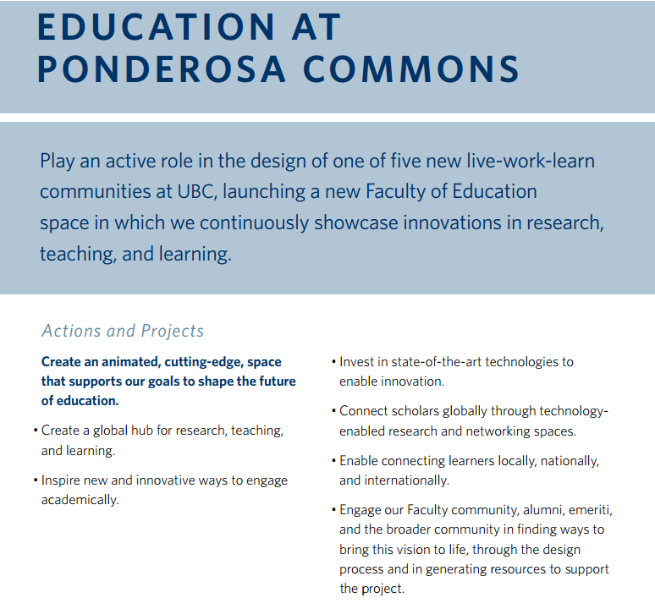
Faculty of Education Strategic Plan 2011-2016

..
Vision
Key points
- Environmental
  - School becomes a ‘learning commons,’ whether on or off campus, allowing for flexible learning environment modes. Classes become optional and more akin to workshops, as. Blended/hybrid model, with opportunities for place-based or experiential learning.

- Personal
  - Student-centred learning via online studies, personal development through virtual scenario tests and modules, subject inquiry and mastery over flexible timeline based on personal readiness, stage-based learning, project-based academic research and instructional design, classes ‘optional’ to promote individual responsibility, projects/portfolios mandatory for assessment.

- Social
  - Permanent peer teams collaborate in-program achievement (recommendation: 4 candidates + MKOs) throughout the duration of their training teams assigned to graduate student and Faculty member, specialized adjudicating committees, opportunity to attend Faculty research presentations and practice ‘class’ scenarios, online forum for curriculum exchange and discussion, virtual teaching environments and testing scenarios.
- Applicable
  - Application of theoretical study, projects, design to test in the classroom, with supervision, adjudication, and evaluation
  - Teachers are each equipped with working knowledge of a dynamic and common (compatible) technology toolbox

Implications
For students
- More time for research & showcasing specialization
- More chance for online collaboration with colleagues and peers, building international connections
- Classroom teaching optional for passionate experiential educators & lecturers
- Some students may miss ‘performance’ element of class or seminar participation
- Ability to upgrade technology training at own pace with specialized peer group (30 start-up specialists assigned to teams of 4 faculty members)
- Engagement as a leader with annual team of 4 and incumbent graduate students under supervision
- Engagement as a specialist BEd adjudicator on design days or committees
- Access to research analytics from BEd cohort
- Learning Commons bridges gap between faculty and student interactive spaces
For faculty
- More time for research & showcasing specialization on and off campus
- More chance for online collaboration with colleagues and peers, building international connections
- Classroom teaching optional for passionate experiential educators
- Ability to upgrade technology training at own pace with specialized peer group (30 start-up specialists assigned to teams of 4 faculty members)
- Engagement as a leader with annual team of 4 and incumbent graduate students under supervision
- Engagement as a specialist BEd adjudicator on design days or committees
- Access to research analytics from BEd cohort
- Learning Commons bridges gap between faculty and student interactive spaces
- Enhanced quality of knowledge creation and evaluation experience
For the public
- Potential for a higher quality caliber of teacher, more able to meet rapidly evolving technologically driven pedagogical demands.
Details of Vision & Implications
Students will need to complete a prescribed set of outcomes to meet the requirements for a BEd, but these requirements will not be delivered in a mandatory program of ‘participatory’ classes in the grind of 9-5pm.
The rationale for E-learning here is to allow students the maximum opportunity to complete program outcomes based on individual readiness and mastery, fostering a spirit of inquiry to study how best to design for one’s subject, to allow for more connections and mentoring across the Faculty, and to have time to participate in collective activities. As time and project management skills are essential to the modern educator, initial timelines and sets of candidates goals will be submitted (online) to their Faculty advisor for preliminary review, and revisited on a regular basis to ensure completion within a prescribed program timeframe, currently 12 months.
Adding ‘flexibility’ to any program creates a (un)certain amount of unknowns, such as how many components would be done individually as a team, and what would be the purpose of each activity, and what preferences would emerge for environments to conduct the activities (on campus, online, home, community field trips). This could be looked at on an annual review basis and kept relevant with then-current issues.
Some initial ideas that I would like to see would be a complete program module migration to Blackboard as a starting place for personal and team inquiry. Discussion topics of interest could be laid out as a foundation by the Faculty, such as social justice, critical media literacy, aboriginal education, outdoor education, e-learning, classroom management, and by cohort groups.

Virtual classroom modules and tests could provide a basis for teacher candidates to understand their own beliefs:
A student walks into class late. What do you do? Choose from one of the options below or choose Other. Why did you choose this option?
Analytical programs can provide powerful tools of insight to teacher candidates about their initial assumptions and beliefs, and give an opportunity for supervising Faculty to get to know their students in-depth. These could start as simple questionnaires as existing technology allows, and develop into full virtually-reality simulations with intelligent interactions, (moving forward AI).
Special experiential classes could be conducted by passionate education faculty members, using the entire cohort with interactive classes using 2.0 learning technology applications such as Learning Catalytics, or more traditional modes of presentations, team-teaching series, colloquiums, and special topics seminars. Teacher candidates can have a chance to teach a group of their peers by submitting proposals for Faculty approval, in order to call candidates to a Class. Another variant would see candidates have an opportunity to test their lesson designs in an online forum, or for experiential learning, on Design Days, where cohorts would take turns leading one another in experimental lessons. Instructional design can be adjudicated by the peer teams, or a ‘committee’ made of peers in a specialization (art, music, social studies) and appropriate experts on the subject (faculty, community members such as aboriginal elders, etc).
The ‘online’ learning commons could also provide collaboration tools and a place to showcase preliminary instructional design, or existing best instructional design to learn from or critique. To this end I created a Social Studies Cohort Skydrive account for cohort collaboration and sharing, which has shown some surprising results. I invite you to check out these First Class Applications on my BEd ‘research’ page, Once Upon an Inquiry.
Each candidate and team will receive a technology ‘toolbox’ of applications to master for use in an education setting and instructional design. Along with learning about psychological aspects of learning such as memory and learning modes, this will give all candidates a chance to understand how to apply proper matches of technology applications to learning outcomes. This will also allow candidates to conduct valuable research on whether or not a certain technology produces a more positive impact on learning than current practices. This can start a collective memory of best practices for Faculty members to evaluate further, especially for those interested in technology, experiential learning, and defining digital literacy or competencies.
Teams could be randomized across the cohort to mix up elementary, secondary and concentration areas to promote a wider perspective on pedagogy questions from each peer. They may also be sorted into concentrations, or have test groups against random groups, such as a group of all home-economics teachers.
Graduate students currently outnumber undergraduate students, and will likely continue to do so as the culture of life-long learning and professional development is well established in the teaching profession. Even if the current BEd intake of 550 students somehow sustains in the future, the multitude of graduate students would allow for a 1:4 graduate peer-team ratio, giving graduate students valuable leadership and teaching experience under the supervision of Faculty. Faculty members would also have a 1:4 Faculty to undergrad-team ratio. Currently there is surplus Faculty to teams with this ratio, to allow for parental, sabbatical, and research requests.
Faculty members benefit from a small team to lead, and are able to develop deeper understandings of education among all participants, while at the same time giving an opportunity to conduct online courses or in-person presentations in ‘education of scale.’
Extensive technology training for Faculty members is not necessary to implement e-learning immersion from the start of this program up to 5 years. To implement preliminary training for Faculty would require mass orientations and further training as I will describe now.
I recommend having the Education IT department work with the existing research and best practices in the Centre for Teaching and Learning at UBC to design the preliminary Blackboard cohort model with a new Standing Academic Committee. This committee will make adjustments on an ongoing basis.
A first cohort of 30 Faculty BEd technology specialists will be intensively trained. This will allow for a ratio of 1:4 specialists to Faculty teams to be assigned for ongoing training and liaisoning until all Faculty members achieve independence and are able to participate in Academic critique on the program on an equitable basis of knowledge. New Faculty members would need to attend their own pre-service orientation, following the recommendation made by Bates & Sangrà. The exact same process would happen for graduate students.
With more flexible learning schedules, students have time to evaluate their own work-life balance and adjust to hours of work in the public school system. In addition there is more opportunity for the Faculty to create community-wide social occasions (such as team sports days), host conferences, or research showcases.
Assessment would be conducted via the online learning modules (tests) and by a majority of portfolio or project-based assessment, such as full unit and lesson plans for the practicum. Peer adjudication with the committee of your group graduate peer and faculty member would be a part of the feedback process for individual work, in addition to any online discussions or team projects.
Rather than having all candidates exit a practicum at the same time, teams will submit readiness reports to the practicum coordinator with advanced notice such as 2 months, and individuals will be placed accordingly. This will allow for a Faculty advisor to have time to attend adjudication of all team members teaching in the classroom during the practicum timeframe.
E-learning immersion would allow for mandatory classes of 40 people to obsolesce or become optional and more akin to workshops. This allows time spent in a larger seminar to be appreciated and utilized far more than in the current ‘experiential’ reality, where the majority of Teacher Candidates bring a laptop to class and opt-out of participation until the period is up. Experiential classes would be run by interested faculty or peers on an ad-hoc basis. A good example of a workshop could be one which demonstrates how to use and operate Blackboard as an instructor, before moderating part of the online teacher candidate forum for a term.
Classrooms return to Homerooms. Teams may start the day in a homeroom to continue on individual or collective objectives, or meet on a pre-defined schedule with their Faculty advisor or each other. These homerooms would basically be lounges and workplaces with a few computer terminals and places for laptops.

A model learning-commons style homeroom. I designed this one to meet the needs of a secondary classroom, though it could be similarly integrated into existing rooms at UBC with little additional cost of furnishings, which may be largely open to students to propose and develop. The exercise itself is an example of an e-learning activity teacher candidates may undertake. Constructed using AutoDesk Homestyler.
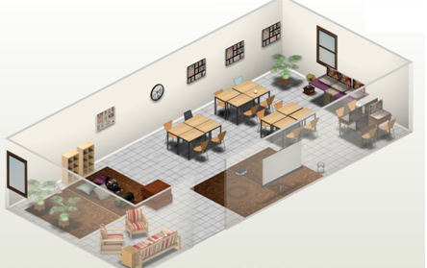

The library would become the place of research and learning which teacher candidates may spend the majority of time. The existing library may be expanded to include more of a learning-commons area, such as the IKB Learning Centre at UBC.

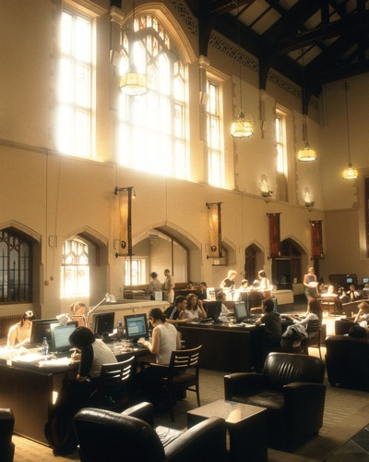
The Irving K. Barber Learning Commons:
A model for Learning Commons in Teacher Education

..

Conclusion
Popular and academic literature calls upon the importance to E-learning management and planning to be implemented in post-secondary institutions, but there are few blended learning models in teacher’s education to draw from. I have envisioned a program that would suit the needs and interests of UBC teacher candidates as a current 21st century teacher candidate myself, as I continue to looking for best practices in teaching and learning with technology.

Works Cited…
AutoDesk Homestyler
BC Digital Literacy Standards
BC Education Plan
Digital Literacy Centre
Faculty of Educaton Directory
Learning Catalytics
Location of Neville Scarfe Building (UBC Wayfinding)
Once Upon an Inquiry
“Ontario cuts teaching spaces, doubles program length”. Steve Mertl, Daily Brew. June 5th, 2013.
PL-Tech description
UBC BEd Program
UBC Flexible Learning Initiative
UBC Strategic Plan 2011-2016, p 20
UBC Vancouver Academic Calendar, 2013/14

Link to UBC BEd Program, strands, cohort, NITEP more.
Location of Neville Scarfe Building (UBC Wayfinding)
Faculty of Educaton Directory
Vancouver Academic Calendar, 2013/14, Screenshot June 23, 2013.
BC Digital Literacy Standards
BC Education Plan.
“Ontario cuts teaching spaces, doubles program length”. Steve Mertl, Daily Brew. June 5th, 2013.
Digital Literacy Centre.
PL-Tech description.
UBC Flexible Learning Initiative.
UBC Strategic Plan 2011-2016, p 20.
MKO: short form for ‘More Knowledgable Other’, a classic principle of education coined by Lev Vygotsky in the early 20th century.
Learning Catalytics.
You may also be interested in the section which reflects on early 1990s E-learning, A Net-Gen Retrospective: Collaboration in Gaming & “Game-Based Learning” on the eve of the Millenium.
AutoDesk Homestyler.

