Criteria & Objective:
The objective of this exercise is to define a relatively complex term in three ways: a parenthetical definition, a sentence definition, and an expanded definition. The definitions should vary in detail depending on the audience. This exercise is to practice explaining a complex term to an audience with little to no technical background on the subject.

Term: Polyploidy

Parenthetical definition:
Situation: A scientist explaining to a farmer.

Polyploidy (having more than 2 copies of each chromosome) can affect a how much of a crop is produced.

Sentence definition:
Situation: A biology student explaining to a friend who is not in sciences.

Polyploidy is a genetic condition in which one has more than two full sets of chromosomes.

Expanded definition for Non-technical Readers:
Situation: A biology student explaining to a high school student.

Polyploidy is a genetic condition in which an organism or a cell has more than two full sets of chromosomes. The term “polyploidy” is derived from the Greek root “poly” meaning “multiple” and the word “-ploid” or “-ploidy” meaning “having chromosome sets”. A full set of chromosomes refers to a full collection of unique chromosomes and not the number of individual chromosomes. For example, in figure 1, a full set of chromosomes would consist of one blue, one pink, and one yellow chromosome. Notice that in the triploid organism there are nine individual chromosomes, but only three sets of chromosomes. Furthermore, the number of unique chromosomes that make up a whole set varies among living things. For example, human cells have 23 unique chromosomes.
An organism’s ploidy refers to the number of full sets of chromosomes an organism or cell has. The addition of the corresponding number root in front of “- ploid” indicates the number of sets an organism has (Figure 1). For example, human cells have two copies of each chromosome and are referred to as diploid organisms, with “di-” meaning “two”. Human sperm and egg cells join together during fertilization to form one cell, therefore, individually they each have one set of chromosomes making them haploid cells, with “halpl-” meaning one. Organisms or cells that possess three or more copies of each chromosome are collectively referred to as polyploids.
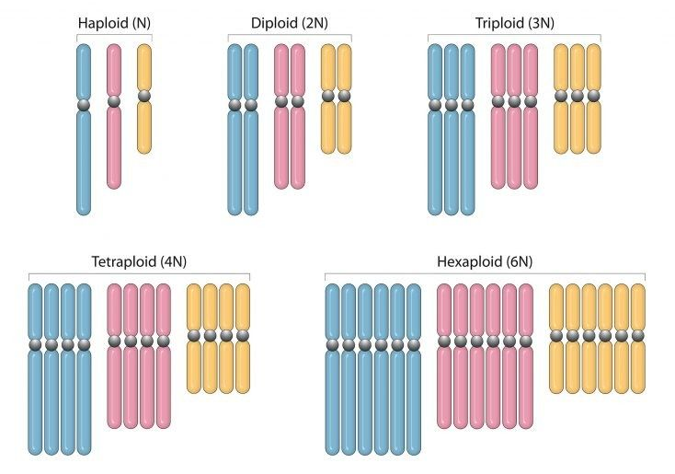
Figure 1 Schematic diagram representing different ploidy levels. Haploid cells possess one copy of each the blue, pink, and yellow chromosomes, while diploid cells have two copies, triploid cells have three copies, tetraploid cells have four copies, and hexaploid cells have six copies. Triploid, tetraploid, and hexaploid cells are polyploids. Photo adapted from biologyonline.com
Polyploidy is most frequently observed in plants (Soltis et al., 2015). In fact, most of the plants we eat are polyploids (Renny-Byfield & Wendel, 2014). Canola, cotton, wheat, peanut, coffee, and potato are all tetraploid plants meaning they have four sets of chromosomes. Bread wheat and oat is a hexaploid plant, with six sets of chromosomes, and strawberries are octoploids, with eight whole sets of chromosomes (Table 1). The highest ploidy level observed so far is twelve sets from certain species of persimmon and grass (Tamur & Sugiura, 1996). Having more sets of chromosomes can increase the crop yield and controls the amount of protein a plant produces (Blum 2013). For example, the hexaploid wheat species produces more gluten, than the tetraploid wheat species. Farmers grow different plants with different ploidy levels in order to select for certain traits that they want. On the other hand, polyploidy is rarely observed in animals (Muller 1925). There are some polyploid fish, amphibians, and insects, but extremely rare in mammals, and completely non-existent in birds (Otto & Whitton, 2000). Scientists theorize that the lack of polyploidy in all animals is due to the fact that animals have different sexes must combine their genetic material with a mate in order to reproduce, whereas plants are sexless and can reproduce on their own (Muller 1925).
Table 1 Polyploids of different ploidy levels and common examples from each level.
Ploidy Level | Sets of Chromosomes | Common Examples
Tetraploid | 4 | Canola, cotton, wheat, peanut, coffee, potato
Hexaploid | 6 | Bread wheat, oat
Octoploid | 8 | Strawberry
Dodecaploid | 12 | Persimmon

Works Cited
Blum, A. (2013). Heterosis, stress, and the environment: A possible road map towards the general improvement of crop yield. Journal of Experimental Botany, 64(16), 4829-4837. doi:10.1093/jxb/ert289
Muller, H. J. (1925). Why polyploidy is rarer in animals than in plants. The American Naturalist, 59(663), 346-353. doi:10.1086/280047
Otto, S. P., & Whitton, J. (2000). Polyploid incidence and evolution. Annual review of genetics, 34(1), 401-437.
Renny-Byfield, S., & Wendel, J. F. (2014). Doubling down on genomes: Polyploidy and crop plants. American Journal of Botany, 101(10), 1711-1725. doi:10.3732/ajb.1400119
Soltis, P. S., Marchant, D. B., Van de Peer, Y., & Soltis, D. E. (2015). Polyploidy and genome evolution in plants. Current Opinion in Genetics & Development, 35, 119-125. doi:10.1016/j.gde.2015.11.003
Tamura, M., Tao, R., & Sugiura, A. (1996). Production of dodecaploid plants of japanese persimmon (diospyros kaki L.) by colchicine treatment of protoplasts. Plant Cell Reports, 15(7), 470-473. doi:10.1007/BF00232976

