October 26 2011 3pm: Kristen Gorman
Talk Title:
"Climate-induced divergence in breeding population dynamics among Pygoscelis penguins, Western Antarctic Peninsula"
Tweet
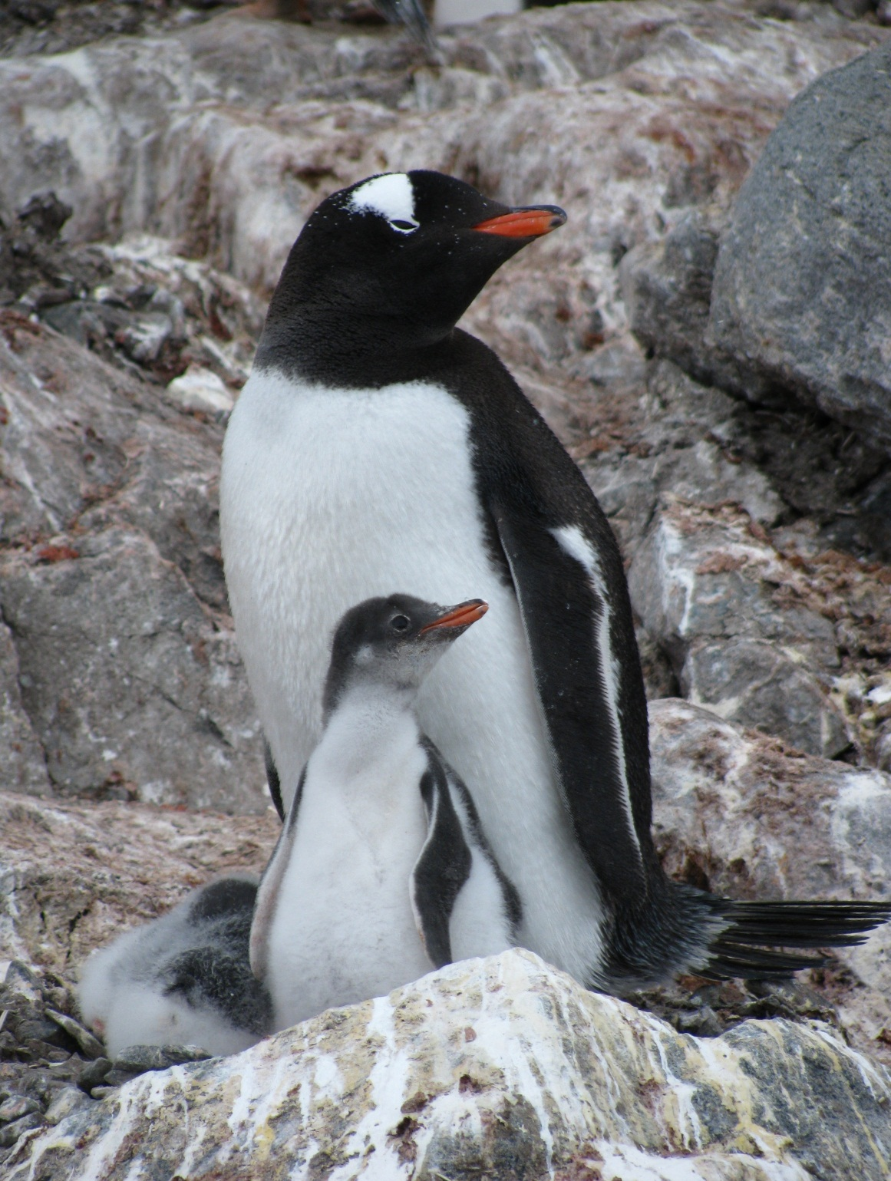
CANCELLED

