Critical thinking |  | Reflection
“…fosters the recognition of assumptions, beliefs, and values that underlie our thought processes as we solve problems, anticipate outcomes, and justify our actions” (Plack et al.) |  | “…is not simply stopping to think and problem solve or plan for future action based on what you already know; rather, it is critically questioning the content, process, and premise underlying the experience…” (Plack et al)
Critical Reflection is…

Janet Eyler et. al.,  1996 | - Is continuous  (ongoing)  - Is challenging  (pushing to develop new skills ,set new goals and take additional responsibility) | - Is connected  (to experiences and goals that frame or drive those experiences)  - Is contextualized  (in roles of self, in broader community setting/issues)
Robert Bringle & Julie Hatcher, 1999 | - Links experience to learning.  - Is guided and involves feedback to enhance the learning. | - Helps clarify values
E. Zlotski & P. Clayton, 2005 | - Is orientated to specific goals.  - Is integrative. | - Generates change in learners life
Fook, White & Gardener, 2006 | - a process (cognitive, emotional, experiential) of examining assumptions embedded in actions or experience.  - a reworking of concepts and practice based on this re-evaluation. | - re-evaluating these according to relevant criteria.  - connecting these assumptions with many different origins (personal,  emotional, social, cultural, historical, political).
adapted from Sarah Ash & Patti Clayton, 2009 and Fook et.al 2006.
Why critical reflection is important
Modern society is becoming more complex, information is becoming available and changing more rapidly prompting users to constantly rethink, switch directions, and change problem-solving strategies. Thus, it is increasingly important to prompt reflective thinking during learning to help learners develop strategies to apply new knowledge to the complex situations in their day-to-day activities. Reflective thinking helps learners develop higher-order thinking skills by prompting learners to a) relate new knowledge to prior understanding, b) think in both abstract and conceptual terms, c) apply specific strategies in novel tasks, and d) understand their own thinking and learning strategies.

Best Practices for developing a Community-Based Experiential Learning (CBEL) reflection strategy: The 4 C’s (Adapted from Eyler, Giles and Schmiedes’ 4 C’s of Reflection)
Continuous: An effective reflection strategy includes activities before, during and after the experience. Preparatory activities provide students with important information about the mandate and context of the community partner and the relationship between disciplinary content and community identified projects. This orientation prepares students to engage with commitment and confidence. Reflection during the experience can focus directly on the application of knowledge, methods and skills. After the experience, reflection activities focus on interpreting and analysing the experience, integrating new knowledge, making connections between local and global issues, and identifying personal changes in understanding, values and beliefs.
Pre-Reflection | Reflection During the experience | Post CBEL Reflection
Focused on Orientation:  Community partner, context of community partner, course outcomes, disciplinary perspectives, project or service parameters, self awareness, group work, community assets and challenges… | Focused on Action:  Applying/developing knowledge and skills, group dynamics, interpersonal relationships, community partner challenges, making connections between theory and practice…. | Focused on Understanding:  Making connections between course content and experience, revisiting learning outcomes, integrating new knowledge, identifying shifts in perspective changes in future practice
Connected: An effective reflection strategy makes an explicit connection between course content and CBEL activities. Reflection activities can support students in applying concepts/ theories to their project (application or evaluation based on theory). Reflection activities can be used to identify how their community partners are faced with or working with the theories articulated in the classroom thus supporting students understand core concepts at a deeper level (by identifying elements of models or theories in action). This is also a place where you can support students make personal connections to the course content or their experience (values, beliefs, passions, ethics etc.). Connected reflection results in more effective service and enhanced learning through the experience, integrating previous knowledge and new information, and formulating future courses of action. This is also a unique way to test, challenge or uphold theory and to give it meaningful personal context as students are supported in connecting experience to the “big picture” and looking at causes and solutions.
Challenging: Reflection should challenge students to articulate learning in new ways, raise critical questions and enable a deeper understanding of self, others and the world. Students benefit most when there is a balance between support and challenge. Reflection activities are an opportunity to challenge students’ cognitive, affective and psychomotor domains (head, heart and hands) as they grapple with new experiences, skills, thoughts and emotions. It is important to challenge students with written assignments, group tasks while also supporting them with formative feedback so they can critically engage with new ways of thinking, seeing and doing. This is the space to challenge comfort levels.
Contextualized: Reflection should be appropriate for the student level (year level and developmentally), context and setting of a particular CBEL experience. The volume and type of work should fit with the scale and scope of the CBEL experience, learning outcomes and supporting frame work in the course (time and grade value). The design and implementation of the reflection activity needs to be purposefully implemented. Example: An 8 page paper about a changing worldview might be unfair after a light touch engagement and may be better suited to an immersive or intensive experience.

Reflection Models
Borton, 1970

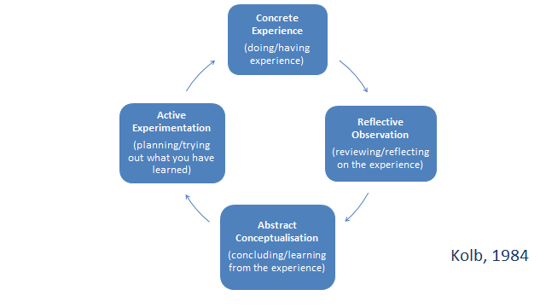

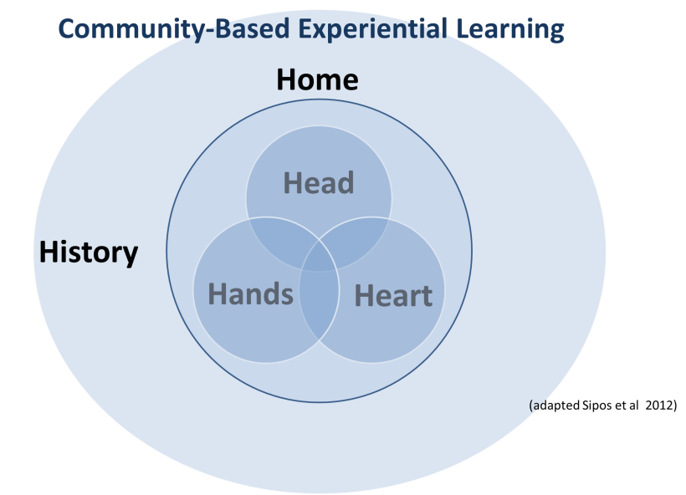
Sample Reflection Activities
Primarily adapted from Eyler J., Giles D. E., Schmiede. 1996. A Practitioner's Guide to Reflection in Service-learning: Student Voices and Reflections. A Technical Assistance Project funded by the Corporation for National Service. Nashville, TN: Vanderbilt University.
Eyler, Giles and Schmiede identify reflection activities that involve reading, writing, doing and telling as most effective for students. The following is a summary of a few sample activities from each of these types.
Reading | Directed Readings  Directed readings are additional readings outside of the traditional course textbooks that provide a broader or local context of social responsibility and civic literacy that can be used throughout the course. These readings are a means of enhancing a systemic understanding of societal concerns of students engaged in service. Faculty can use directed readings to challenge students to apply their knowledge within a discipline to current social needs and events. Directed readings take all literary forms (newspaper articles, short stories, novels, poetry, essay, etc.) and can become the basis for class discussions or directed writings. Faculty can also have students create their own list of directed readings through web searches for key words, such as citizenship, service learning, civic responsibility, individual rights and responsibilities, etc.  Reflection on these readings can involve:  - Comparing and contrasting personal experience with those in the reading.  - Discuss the challenges they are experiencing and how they might be reframed based on the experience of those in the reading.  - Create models that capture stages of their experience based on their own experiences and those in the reading.
Case Studies
Case Studies help students to make the connection between their course of study and their service learning experience.

Reflection on case studies can be used to:
- Prepare students for their experience in community by having them consider what to expect and questions they might ask in their placement.
- Provide points of comparison between the student’s experience in community and the case that is presented to enhance problem solving and deepen understanding of their placement.
Writing | Case Studies  Students write up a case study based on a dilemma they contended with at their site, including a description of the context, the individuals involved, and the controversy or event that created the dilemma. Students share the case studies in class and problems solve as a group how they would respond.
Quotes in Print
Quotes can be used as a means to initiate student reflection. Have students review a page of quotes and ask them to pick the one that best represents their experience with service learning. In group discussion or a brief individual writing assignment, have students articulate why they chose a particular quote. (Julie Reed and Christopher Koliba, Facilitating Reflection: A Manual for Educators and Leaders).
Reflective Essay
Reflective essays are a more formal example of journal entries, and are created via essay questions provided at
the beginning of the course. A reflective essay can be an opportunity to integrate new learning, challenge assumptions, assess personal growth, or articulate future action.
Experiential Research Paper
An experiential research paper asks students to identify a particular experience to analyze within a broader context in order to make recommendations for change. At mid-term, students are asked to identify and research an underlying social issue they have encountered in their placement. Based on their experience and library research, students make recommendations for future action. This form of reflection activity is particularly effective in interdisciplinary courses because it provides students with the flexibility to focus on their discipline while engaging with issues experienced at the service site. (Robert Bringle and Julie Hatcher, Reflection in Service Learning: Making Meaning of Experience, Indiana University-Purdue University at Indianapolis).
Journals
Journals can take many forms – structured, free form, critical incident logs. They can be individual or group based. While often challenging for students, they provide an important written records of their personal growth and changing perceptions. Structured journals can be used to direct student attention to important issues and questions that connect the service experience to course content. A structured journal provides prompts to guide the reflective process and supports the student to make connections. Students more experienced with reflection may find the free form journal more appropriate so they can structure them to suit their learning needs. Critical incident journals are a place for students to record a critical incident for each week of their experience. The critical incident refers to events in which a decision was made, a conflict occurred, a problem resolved and helps students to analyze their actions in relations to others and opportunities for growth. (Robert Bringle and Julie Hatcher, Reflection in Service Learning: Making Meaning of Experience, Indiana University-Purdue University at Indianapolis)
Online discussion groups
Through discussion forums, wikis or blogs students can create a dialogue with the instructor and peers involved in their service learning experience. This provides an important forum for students to connect with other students about issues at their site, help each other solve problems, identify patterns and make connections with course content. Students can rotate as a moderator of the discussion or the course instructor can post questions for consideration and topics for directed writings.

Doing | Mind Mapping  Write down a central idea and ask students to add related ideas that radiate out from the centre. Throughout the process students draw lines, dots, arrows to show the connections between the ideas generated. After the initial drawing certain concepts can be highlighted for further discussion, clarification or research. A mind map can be created individually or in small groups or over a class or a semester.
Learning Portfolios
Ask students to select and organize evidence related to accomplishments and specific learning outcomes in a portfolio. Portfolios can include drafts of documents, analysis of problems/ issues, project activities/plans, or annotated bibliographies. Ask students to organize evidence by learning objectives.

Photo Essay
This is an alternative approach to reflection, which allows students to use their figurative and literal “lenses” to view their service experience. Students use the photographs to reflect on their service experience in relation to course content. The photographs can be used as the basis to explore themes or concepts in the curriculum. These projects are also excellent ones to share with peers, the campus community, service sites, and year-end celebrations.

Telling | Dialogue in the Classroom and Community  Students are encouraged to participate in formal and informal discussions with staff and volunteers at service sites in order to learn different perspectives and to challenge assumptions. Small and large group dialogue in class based on specific questions and prompts encourages students to compare and contrast peer perspectives.
Presentations
Class presentations are an effective reflection activity for significant course milestones in the course. This is an opportunity for students to synthesize and summarize their learning and connect course content with their service experience. Inviting community partners as a final recognition of the students’ involvement and achievement is important for both partners and students.

Some Great Reflection Resources
- Campus Compact Reflection Resource http://www.compact.org/disciplines/reflection/
is a great starting point to get a practical understanding of using reflection to support service learning or experiential activities.
Specifically there are sections on:
  - FAQ
  - Student Learning Outcomes and Assessments
  - Structuring Strategies

- Generating, Deepening, and Documenting Learning: The Power of Critical Reflection in Applied Learning (Ash and Clayton 2009) http://webii.eckerd.edu/qep/faculty/files/Ash_Clayton_Generating_Deepening_and_Documenting_Learning.pdf
This is a fantastic article that provides a framework for defining learning objectives and reflection strategies that support student learning (that scaffolds) through Bloom's taxonomy.

- Reflection-Linking Service and Learning: Linking Students and Communities (Eyler 2002) http://www.stjohns.edu/sites/default/files/documents/adminoffices/asl-reflection.pdf
This article explores the outcomes that are possible through CBEL and how to support them with reflection. She gives specific examples of what to do and why.

- Critical Reflection: Review of Contemporary Literature (Fook, White and Gardner 2006) http://www.mcgraw-hill.co.uk/openup/chapters/0335218784.pdf
A literature review on reflection (specifically connected to Service-Learning or CBEL). The article is a great theoretical exploration and history of thought and practice (paradigms) in education.

