The target audience for the following definition is for people with minimal training in accounting and finance but would be required to understand the concept.

What is Deferred Revenue?

Parenthetical Definition: Deferred revenue (unearned revenue) is an accounting balance sheet item considered as liability since the action related to earning revenue has yet to take place.

Sentence Definition:
Deferred revenue is, unearned revenue, where payment is received in advance for goods and services not yet delivered. Therefore, deferred revenue is considered a liability, instead of asset, on balance sheet for reporting purpose.

Expanded Definition:
Deferred revenue is an accounting treatment for advance payment received where goods or service, yet delivered, is required under contractual terms. Essentially it is revenue not yet earned, therefore it could not be reported as part of income but instead classified as liability. The term would appears as a balance sheet item instead of income statement.
Under revenue recognition principle, deferred revenue is recognized when contractual terms are followed. For example, revenue from ticket sale, for concert in the next month, cannot be recognized at the time of sale as the joy of watching the concert has yet to happen until next month. Once the artist has performed and concert goer goes home happy & elated, then revenue from ticket sales could be recognized as revenue earned.
Deferred Journal entries for recording advance payment received and revenue recognition shown in figure 1-1 and 1-2. For example, figure 1-1 would be LiveNation's accounting record of Bastille's concert ticket sale of a $100 to an avid fan during presale period (anytime prior to date of the concert on Oct 8 2019). After Oct 8 2019, LiveNation would recognize the deferred revenue, shown in figure 1-2, as earned revenue - ticket revenue once Bastille has performed. In addition, figure 1-3 are examples of other types of deferred revenue that are commonly seen. In conclusion, figure1-4, deferred revenue as part of revenue recognition principle is all about timing of money received and service/goods delivered.

 | Debit | Credit
Cash | 100
Deferred revenue (liability) |  | 100
Figure 1-1
 | Debit | Credit
Deferred revenue (liability) | 100
Ticket Revenue (revenue) |  | 100
Figure 1-2
Types of Business | Deferred Revenue accounting title | Recognized Revenue accounting title
Magazine or Newspaper publisher | Unearned subscription revenue | Subscription revenue
Airline | Unearned flight ticket revenue | Flight ticket revenue
Hotel | Unearned rental revenue | Rental revenue
Figure 1-3
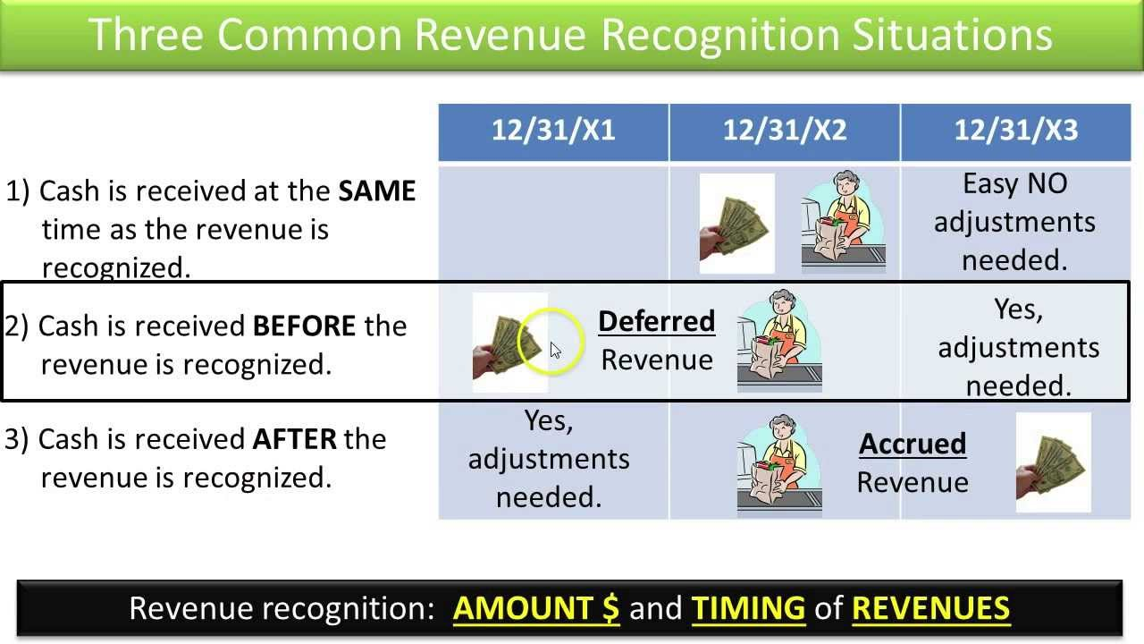
Figure 1-4

Work Cited:
Accounting Tools (2019). Deferred revenue. [online] https://www.accountingtools.com/articles/what-is-deferred-revenue.html (Accessed 24 Sept 2019)
Accounting Coach (2019). Deferred Revenue. [online] https://www.accountingcoach.com/blog/deferred-revenue (Accessed 24 Sept 2019)
Kimball, Kevin. "Deferred Revenues: Cash Is Received BEFORE Revenue Is Recognized - Slides 1-11." Youtube, 18 Oct 2013, https://images.app.goo.gl/vNEU7YtiB9Yqteeh6 (Accessed 30 Sept 2019)

