**Lutsel K’e Dene School**

**Community Education Planning Meeting**

**Friday, October 26, 2012 Community Hall**

**1:00 pm – 4:00 pm**

PARENTS & COMMUNITY -There will no school on Friday and everyone is welcome to come to the Community Hall for the afternoon! Some of the booths include:

* Storytelling
* Lutsel K’e Chipewyan Dictionary
* Parent Tool Kit – free books to read at home
* Using technology to support learning, cyberbullying
* Culture and Language, and Breakfast Program volunteers
* 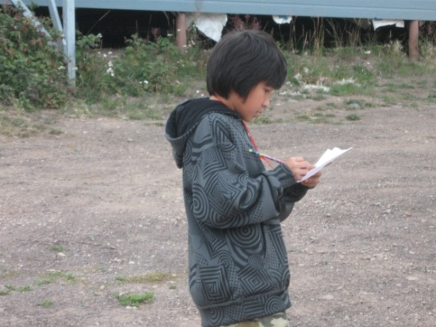DEA roles, Breakfast program

There will be videos to watch, caribou stew & bannock, snacks and drinks

DOOR PRIZES:

Return ticket to Yellowknife

KOBO e-reader $100 groceries Coop

Kids draw: iTunes music card, $25 Coop certificate Everyone welcome!