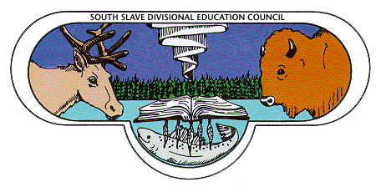 Fill out this passport for a chance to win one of the DOOR PRIZES:
- Return trip to Yellowknife
- KOBO e-reader
- $100.00 Coop certificate

Booth #1- Helping your child succeed in school- Parent Tool Kit_____
Booth #2- Storytelling_____
Booth# 3- Talking with your child____

Booth #4- Using technology to support learning____

Booth #5 – Lutsel K’e Dictionary ______

Booth #6 – Language and Culture _______

Booth #7- DEA Booth – Attendance, Breakfast Program, roles & responsibilities _____

Booth #8 – Aurora College ______

Would you be interested in learning more about how you can support your child at home and at school?
____Yes ____Not at this time
What are some suggested topics you might be interested in learning more about?
____helping my child with homework
____reading with my child
____moving between elementary-junior high-high school
____Understanding which courses to take for high school graduation
____preparing for Alberta Achievement tests
Other ideas:
______________________________________________________________________________
______________________________________________________________________________
______________________________________________________________________________
______________________________________________________________________________
Name:____________________________________________
Phone number:_____________________________________
Email address:______________________________________

