**Analyzing the Demand and Feasibility of Implementing More Bus Stops at UBC**

Prepared for

Kevin Desmond, Translink CEO

Prepared by

Pedraum Safarzadeh, ENGL 301 Student

March 20, 2018

**Table of Contents**

**Introduction …………………………………………………………………………………. 2**

**Background on Translink in the UBC neighbourhood ……………………… 2**

**Statement of Problem …………………………………………………………….. 2**

**Purpose of Study ………………………………………………………………….. 3**

**Methods of Research ……………………………………………………………... 3**

**Scope of Inquiry …………………………………………………………………… 4**

**Data Analysis ………………………………………………………………………………. 4**

**Reliance on Public Transit at UBC ……………………………………………... 4**

**Survey Results ……….……………………………………………………. 5**

**Demand for Adding Bus Stops from UBC Community …………………….. 6**

**Survey Results …………………………………………………………….. 6**

**Nighttime Safety on UBC Campus …………………………………………….. 7**

**Survey Results ……………………………………………………………. 7**

**Information from AMS Safewalk ……………………………………….. 7**

**Space for New Bus Stops on UBC Campus …………………………………. 7**

**Observations ………………………………………………………………. 7**

**Conclusion …………………………………………………………………………………. 8**

**Summary and overall interpretation of findings …………………………….. 8**

**Recommendations ………………………………………………………………… 9**

**INTRODUCTION**

**Background on Translink in the UBC neighbourhood**

The UBC campus is home to a large population containing mostly students who are either commuters or live in the neighborhood. Being one of the largest university campuses in Canada, bus routes to and from the campus is essential. Currently, most bus stops are localized in the northeast corner of the campus near Wesbrook Mall and University Boulevard.

**Statement of Problem**

The west side of the campus is underserved by the current bus routes. Buildings like West Mall Swing Space, CIRS, and the Mathematics building are at least a 15 minute walk to the nearest bus loop and students who have classes or study in these buildings are at a significant disadvantage and inconvenience. Nighttime commuters are at a relatively high risk from long walks as hazards such as cold/wet weather conditions, aggressive animals searching for food, car collisions from poor visibility, or the risk of assault can be of concern. Due to these safety concerns, nighttime commuters may resort to calling taxis or getting picked up by family or friends instead of purchasing monthly bus passes from Translink.

**Purpose of Study**

The purpose of this report is to investigate the demand for adding more bus stops in the UBC area, particularly on the west side of the campus, and to inform Translink of safety concerns for long walks to bus stops at night time. The report will also analyze potential spaces in the UBC neighbourhood for bus stops to be added and whether there is enough space on the streets, in order to determine the feasibility of the implementation.

With the population of UBC students on campus increasing each year, there is a much greater chance that students will move to buildings on the west side of the campus as the buildings near the current bus loops become more crowded. With the housing prices in the UBC area also increasing each year, many people will live off campus and getting rides home will be relied upon heavily. Translink has an excellent opportunity to increase revenue by implementing more bus stops on the west side of the campus because the safety concern for individuals will be eliminated and a lot more monthly bus passes will be purchased. Even with the cost of implementing more bus stops, Translink will certainly make a profit in the long term with the increase of customers purchasing bus passes per year.

**Methods of Research**

Thirty individuals in the UBC community were selected at random to complete an anonymous survey to give their opinions on how they feel about the convienvenice of current bus stops on campus and their safety on campus past dark. The surveys were conducted both during the day and at night and in a variety of buildings on campus. Individuals who were approached were first asked whether they live on campus or commute and only commuters were chosen to participate in order to provide more accurate results. The purpose of the survey was explained and after agreeing to participate, respondents were emailed a link to take the survey on surveymonkey.com to help better analyze and organize the results. Information regarding general safety on campus, primarily on the west side of campus where bus stops are lacking, was obtained from AMS Safewalk. AMS Safewalk is a program at UBC that allows anyone on campus to request an escort to their destination if they do not feel comfortable walking alone. Photographs were also taken on streets where new bus stops can potentially be added.

**Scope of Inquiry**

This report focuses on the following areas of inquiry: the proportion of the UBC community who commute to and from the UBC campus using public transit, the demand for adding bus stops on the west side of the campus, whether individuals who commute home from UBC at night feel safe walking alone to a bus stop and their biggest safety concerns, whether there is enough space space on the streets for bus stops to be added.

**DATA ANALYSIS**

**A: Reliance on Public Transit at UBC**

**Survey Results**

In order to measure the reliance on public transit at UBC, survey respondents were asked about their typical source of transportation when commuting to and from UBC and also the frequency in which they take public transit at UBC.

Figure 1 shows that approximately 86% of the respondents use public transit when commuting to and from UBC, an indication that a substantial proportion of the population at UBC rely on public transit. Figure 2 shows that a large majority of respondents, almost 75%, rely on public transit everyday when commuting to campus. Therefore, not only is public transit the main source of transportation for the UBC community but is also relied upon very often, even on weekends.

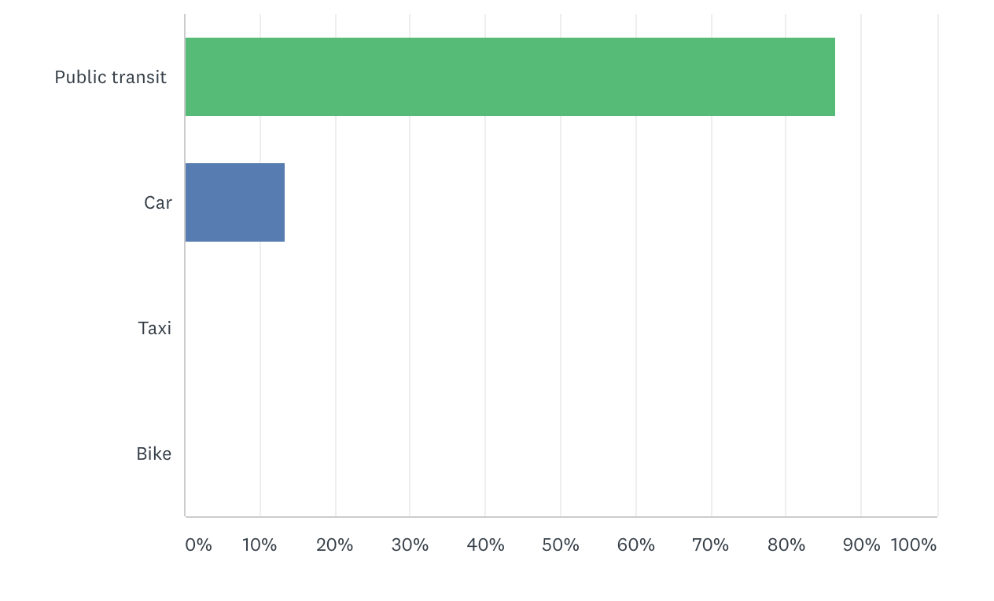

Figure 1: The sources of transportation of commuters in the UBC community

Figure 2: The measure of frequency where public transit is relied upon by commuters at UBC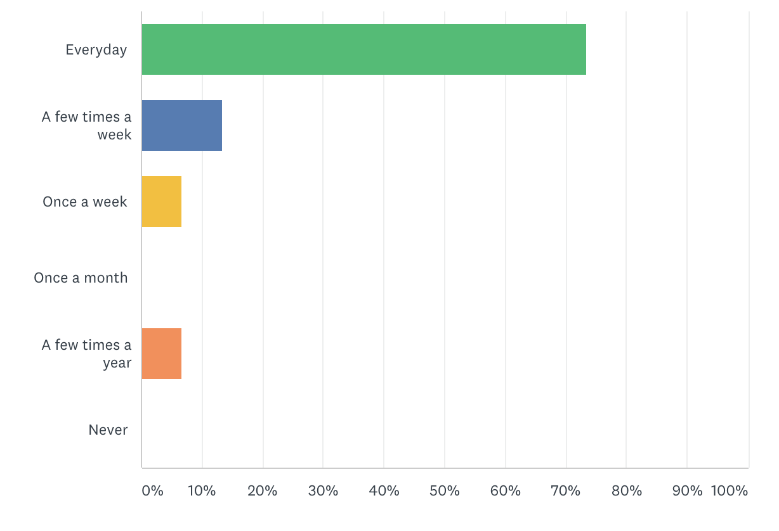

**B: Demand for Adding Bus Stops from UBC Community**

**Survey Results**

In order to determine the demand for adding more bus stops at UBC, survey respondents were asked about their opinion of the location of the current bus stops at the UBC campus, their familiarity with the C18 and C20 which are two bus routes that run along only the UBC neighborhood, whether they would like to see the more popular bus routes run along West Mall, and other areas in UBC where they feel like having a bus stop implemented will be beneficial.

<data still being collected>

<bar graphs and descriptions coming soon>

**C: Nighttime Safety on UBC Campus**

**Survey Results**

In order to assess the safety of commuters at UBC during nighttime, survey respondents were asked about whether they normally commute home from UBC past dark and their biggest safety concern, if they have any, when walking to a bus stop alone past dark at the UBC campus.

<data still being collected>

<bar graphs and descriptions coming soon>

**Information from AMS Safewalk**

<information still being collected>

**D: Space for New Bus Stops on UBC Campus**

**Observations**

<images and descriptions of streets where bus stops could be added to be posted here soon>

**CONCLUSION**

**Summary and Interpretation of Findings**

This investigation shows that implementing more bus stops at the UBC campus is a feasible option. According to survey results from the UBC population, public transit is relied upon very heavily, meaning the importance of customer satisfaction in the UBC area is key. Many respondents are not familiar with the C18 and C20 routes, which are already running in the West Mall area but a large demand for more popular bus routes like 49, 41, and 480 on the west side of campus is evident from the survey. The risk of assault is a main safety concern for nighttime commuters who need to take long walks to arrive to a bus stop which may be preventing them from using public transit and resorting to getting picked up by friends or family instead. Since there is a large amount of nighttime commuters at UBC, adding more bus stops in the West Mall area will also create a more crowded environment on the west side of the campus, greatly preventing the main safety concern for nightime commuters which is the risk of assault. Building an entire large bus loop on the west side of campus may be difficult, however, as space is limited in that area and some buildings may need to get demolished, as secondary sources show.

**Recommendations**

Following these recommendations will be very beneficial in progressing with the implementation of more bus stops at the UBC Campus:

* Due to space limitations for building an entire bus loop on the west side of the campus, the bus stops on Lower Mall for the C18 and C20 bus routes can also be used as stops for more popular bus routes like the 480, 49, 41, etc. The first stop will still be at one of the current three bus loops where space is a lot greater and the bus stops on Lower Mall will be either the second, third or fourth stop, depending on the bus route. The walk to a bus stop from the major and most populated buildings at UBC should then decrease to about 5 minutes or less, as both sides of the campus will have stops for all possible bus routes currently departing from UBC.
* Removing the C18 and C20 bus routes since they are of low popularity but having popular bus routes like the 480, 49, and 41 additionally cover the C18 and C20 routes for the small portion of the UBC population that still use them.
* Using the newly implemented bus stops on the west side of campus only after 7pm to prevent a major traffic increase on West Mall and Lower Mall.
* Advertising the C18 and C20 bus routes so that commuters on the west side of the campus who do not feel safe making a long walk to the main bus loop will be aware of these routes and can use them to get to the main bus loop.
* Increasing the frequency of C18 and C20 routes past dark since currently the area at which these routes run are relatively deserted leading to an increased risk of assault.