I always deem Vancouver as a perfect paradigm for a developed city with superb livability, sustainability, and social diversity. Compared with my crowded and smoggy home China, Vancouver has thriving linear commercial streets with great views, pleasant weather, fresh air, fast transit and a large number of suburban-style medium-density housing. After the field trip and numerous readings related to the history of Vancouver’s planning, I realized that this present booming city was not formed by the light of nature: numerous regulations and policies of city form and city design shaped it into its current shape.

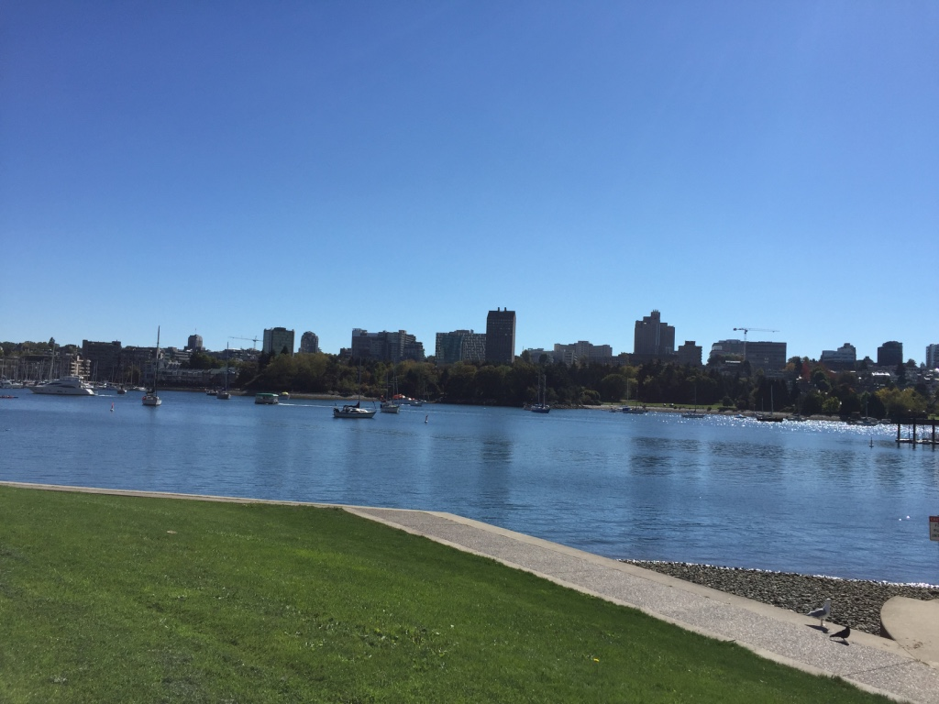
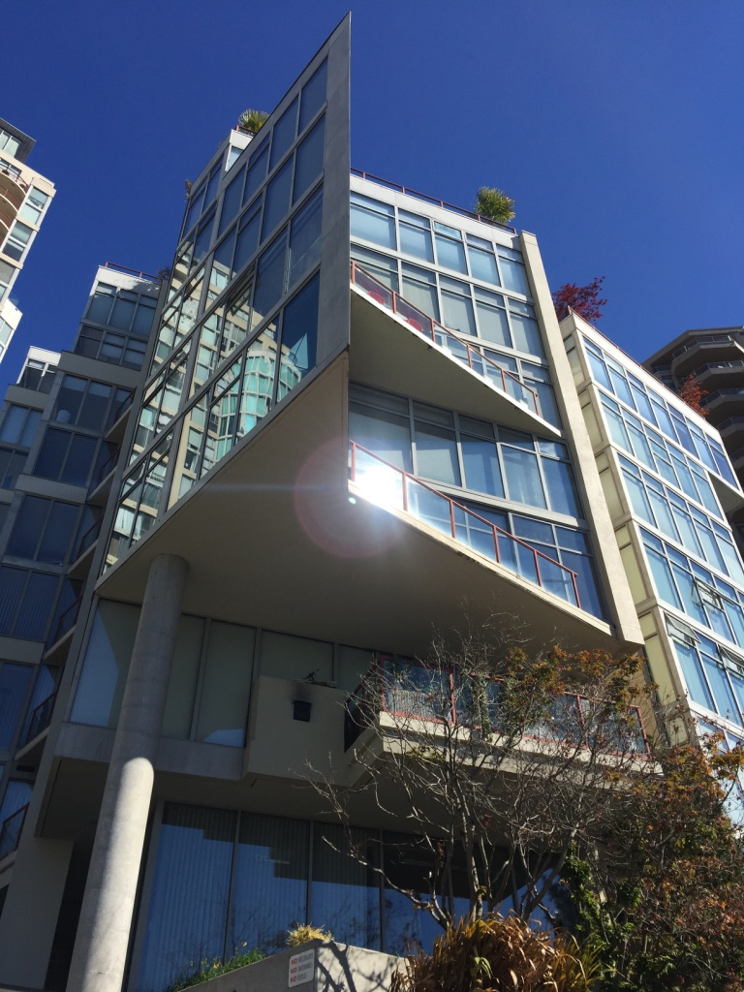
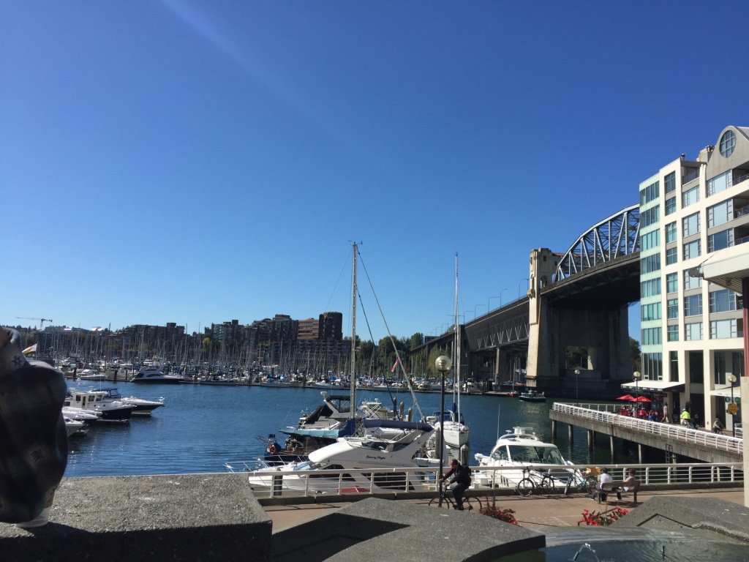
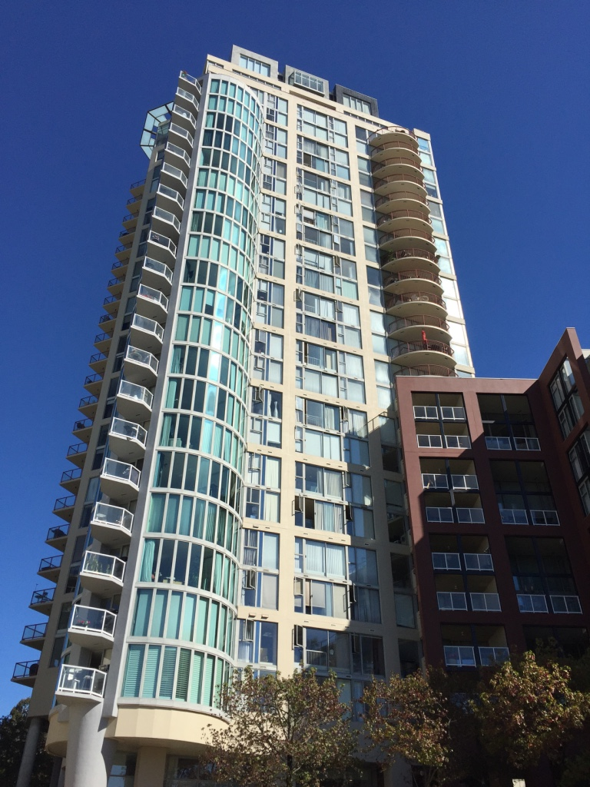
As we walked around the Downtown South, I noticed that Vancouverism’s iconic representation -- the podium towers -- associated with their neighborhood facilities, explained most of Vancouver’s aspiration for livability. (Pic 1) Since Burrard Street Bridge lies next to the 1000 beach, a row of mid-rise townhouses and several slender podium towers act as buffers to mitigate the negative influences of the bridge. Those podium towers near the 88 beach, rising from the developer’s negotiation with the city, finally become a successful example of high-density human-scale housing. The significant distance between the med-rise townhouses near the seawall and the inside particular-shaped diminutive-scale podium towers allowing enough sunshine to penetrate through, creates wonderful view corridors. (Pic 2+ Pic 3) Meanwhile, the several-story townhouses along sidewalks below the podium towers mitigate the high-density stress, and might preserve the sense of heritage and history of the post-industrial downtown.
[Pic 1]
[Pic 2]

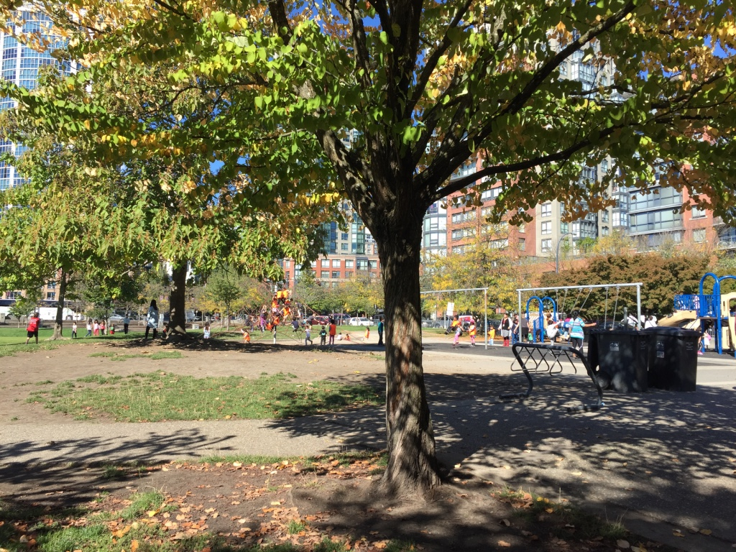
Instead of talking about podium towers alone, I find that the surrounding civic amenities, recreational opportunities and commercial functions also promote downtown Vancouver’s livability. The uninterrupted and irregular shaped Seawall (Pic 3 + Pic 4) was recently renewed, providing safe track and fantastic scenery not only for runners and cyclists but for strolling residents and tourists. I still remember a night, after dinner, promenading along the Seawall around the Marinaside Crescent, I was amazed by the tranquil sea and clusters of specks of light on the other side. Meanwhile, the Child Care Center, a primary school, and the Roundhouse Arts & Recreation Centre we passed by during the field trip reminded me again that the scalloped shorelines (Pic 3) create a series of focal points, providing enough space and opportunities for dynamic interaction between various of building types and communities. In terms of emphasizing the green space and landscape components, Downtown has successfully translated the suburban backyards into its urban forms. The laughing kids on the swings, slides, and lawns demonstrated this community’s success. (Pic 5)
[Pic 3]
[Pic 4]
[Pic 5]

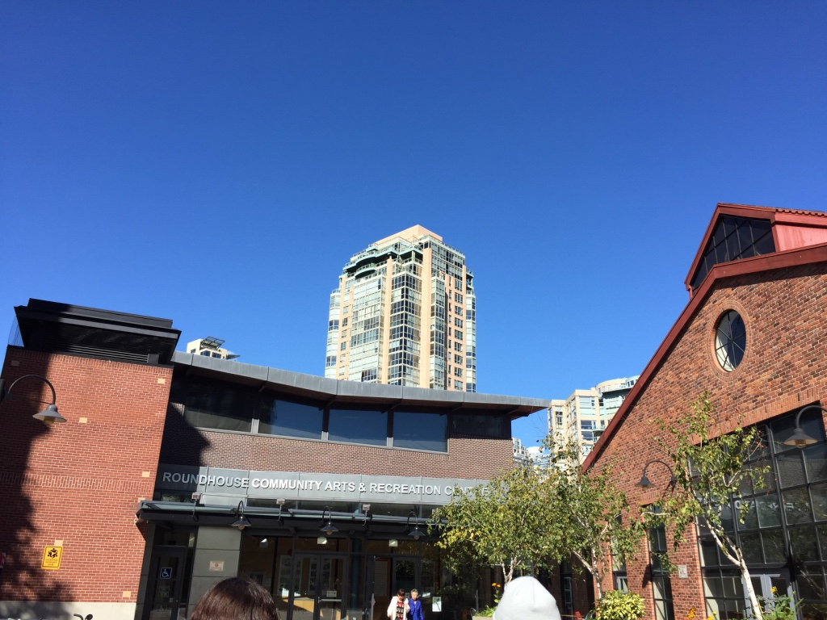
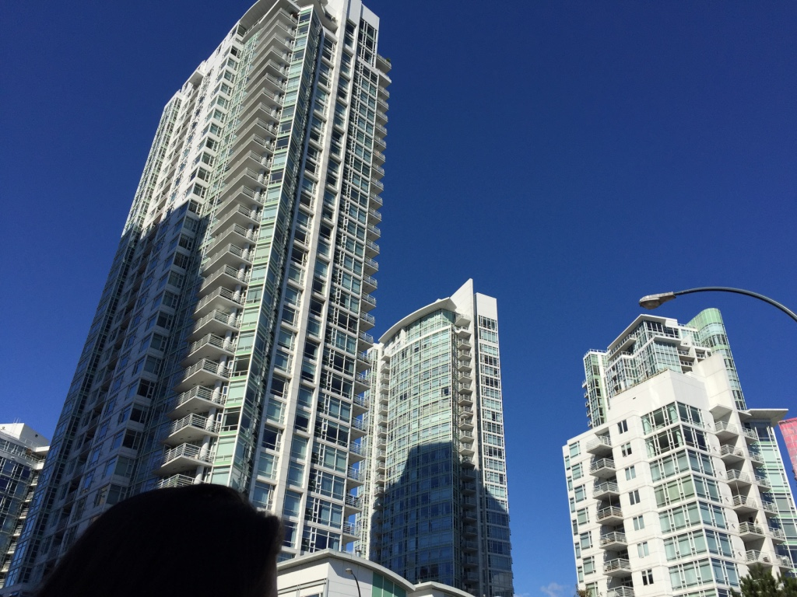
As I mentioned in the beginning, the current promising residential downtown is not formed automatically from nothing, but from reasonable zoning and planning. Except for a series of political policies and acts (such as the Strata Property Act and so on) changes, the construction of Concord Pacific is an indispensable event for the birth of Vancouverism. Concord Pacific not only introduced the podium tower to Vancouver, but brought huge investment, wealth, and immigrants. Those capital and demand for better planning and housing boosted the developer to cooperate with government planning agencies, generating an attractive community. Besides this enchanting exemplar for subsequent buildings in Vancouver and in the world, the Community Amenity Contributions (CACs) also brought an excellent solution to urban zoning density problems: through responding to the increasing of density by adding more public facilities, we could release the need for more facilities as the population grows. (Pic 6)
[Pic 6] Roundhouse Community Center

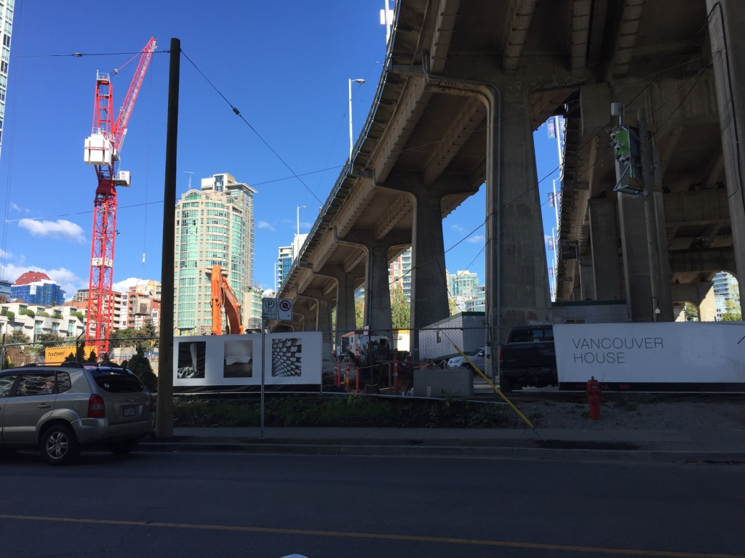
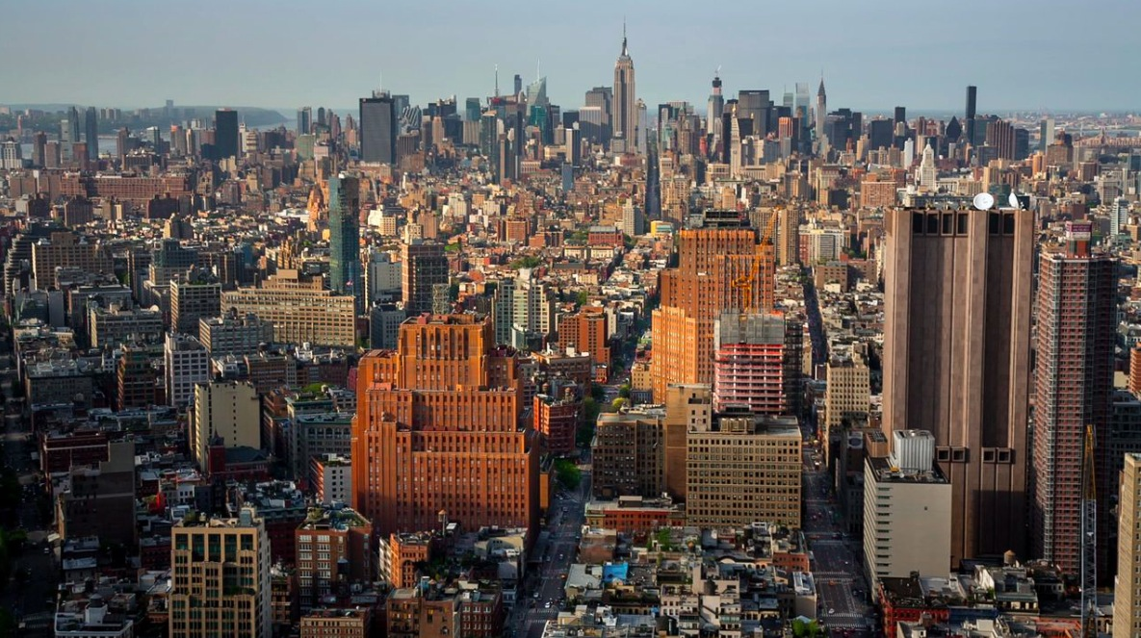
Although this city has demonstrated Vancouverism’s successful, showing sustainability, walkability, and livability, the abuse of podium towers has become a problem: the shiny homogeneous green and white glassy towers have dominated the city, without leaving space for buildings with different ideologies. (Pic 7,9) As a city with such vibrant collective cultures, Vancouver lacks the vitality aroused from the organically evolving society. Worrying about the consistent and predictable towers everywhere, I am glad to witness the construction of the Vancouver House by the Howe Street. (Pic 8) On behalf of Vancouver’s future development and a manifestation of art, Vancouver House boldly exploits the possibility of a more ambitious potential of city life. Vancouver House’s website introduces that it is more than a single twisted-shaped building: the grouping of buildings could bring visual splendor and living functionality. Is this the new and right form of urbanism? Is this a brave step of Vancouver to explore the antagonism of different ideologies like Manhattan? (Pic 9) Or it might just be another master-planned high-end podium tower of splendor which would squeeze more low-income individuals and households out of the market?
[Pic 7]
[Pic 8]

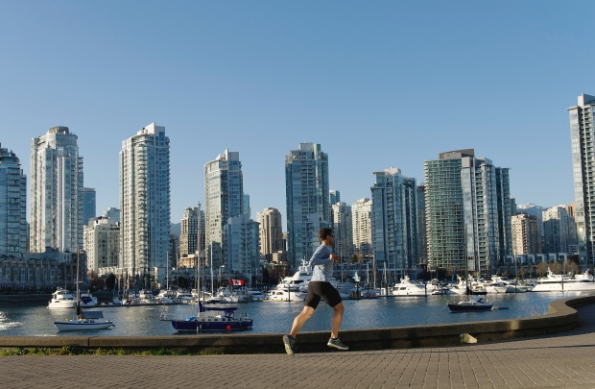
[Pic 9]

Up: Manhattan Skyline with diverse building types

Bottom: Vancouver Skyline with homogenous glassy towers

