UNIVERSITY OF BRITISH COLUMBIA

UBC School of Architecture and Landscape Architecture

Environmental Design Program

**ENDS 221: - Sustainability by Design. Making our Cities Healthy for Humans and Other Living Things.**

**Assignment 3: The building blocks of the city. 50 acres/20 hectares of sustainability.**

Date issued: Week six in tutorials. Date due: Week 10 in tutorial.

Overview:

This project will give you a chance to experiment as an urban designer at the Neighbourhood scale. You will get a chance to plan how an urban district might evolve over 40 years - towards increased sustainability. Your job is take a map/aerial photo of a 30 – 60 acre portion (provided) of the city and make changes that will:

1. Allow the existing population of the location to increase by up to double in some cases (you can find out the approximate population on the census site like you learned last assignment - however, sites do not exactly map to census districts, so knowing exact existing population is not required) - by adding 500 dwelling units.

2. Add 150 job sites.

3. Help people get around by walking, biking, and transit.

**Learning objectives:**

1. To demonstrate an ability to apply lessons learned in the first part of this course to a real site.
2. To understand that change to cities happens very slowly, but that it does happen.
3. To demonstrate a reasonable grasp of what is possible and what is not possible.
4. To demonstrate an understanding of the kinds of changes in the city that might be needed to address the multifold problems identified in this course.
5. To learn basic skills of design: scale, building type, circulation patterns, illustration techniques.

**Process:**

1. First select one of the ten sites provided on the map sheets provided. No more than two students in each tutorial can work on the same site. The sites are located in Vancouver, Burnaby, and Surrey. All but the East Clayton site are easily accessible, either close to UBC or accessible by Skytrain.

2. Next take a walking tour of your site. It is suggested that you team up with a partner for this. All areas are as safe as your own neighborhood, but working as a team will make you more comfortable and make residents more comfortable if they see you taking pictures. Look for housing types, job sites, and transportation features for walking biking, cars and transit. Look at streets, sidewalks, yards, house and building types, neighbourhood mix. All the things we have discussed in class.

3. Draw the changes you propose right onto your 8.5 x 11 plan. You may photocopy your chosen plan, or "cut and paste" it into a drawing program digitally. You can physically draw on the plan as shown in our examples, or do it with a simple illustration program like paint. Simplest is to draw with pencils. Digital drawing programs give a neater result. Here are the graphic symbols that represent buildings, transit lines, and green infrastructure. The rough scale of all maps is included on the maps/aerial photos. But the building sizes in the maps provide all the "scale" you need. You can easily see how big a single family house is, or an apartment block, or a townhouse by looking at the aerial maps. Then draw your own additions right on the map at the appropriate relative size.

*Graphic examples*: Here are the types of buildings that conform to your graphic symbols. Take note of them and look for these building types as you move around the city.

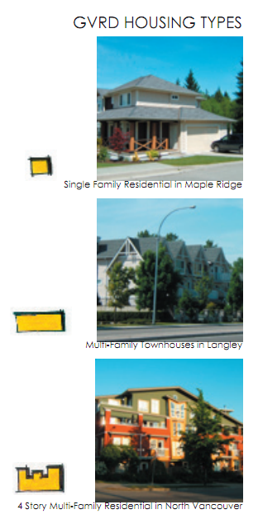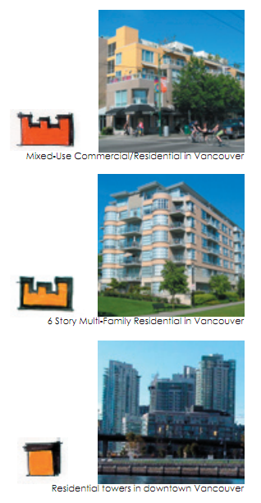

*Density associated with symbols*. This will tell you how many units and jobs you have provided. As you can see its easy to provide a lot of units in a tower. But neighbours might not like it and it might not be the most sustainable choice for other reasons as well.

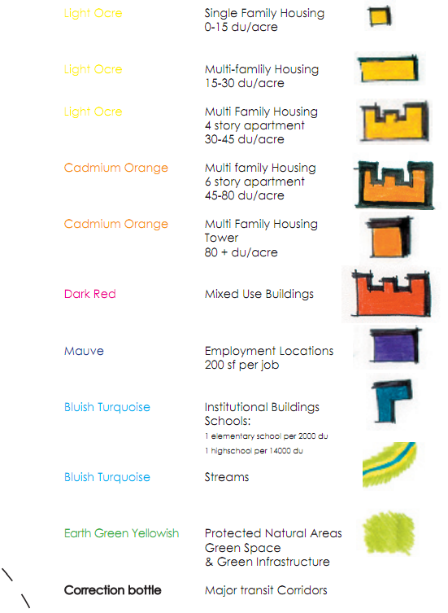

The graphic technique: outline the building you propose to place with a black marker pen. Copy the shapes of the symbols on the left. They represent symbols for different kinds of buildings (examples of finished products are on next page). Then indicate the proposed land use with a colored pencil of the colors indicated. The precise colour names indicate the names of Prismicolor brand pencils available at most art supply stores. But you can use your own or other colored pencils if the colors are very close. The colors shown are the standard colors used on all planning maps to indicated land use. Yellow is always low density residential, Orange is always used for medium and high density residential, red is always commercial, purple or mauve is for job sites, and blue always for public buildings like schools. Green spaces, as you would expect, are indicated in green. Use "white out" correction fluid to indicate major transit lines, either exiting or proposed, by tracing over roads.

**Project requirements.**

1. Find a way to add 500 housing units to your study area. Use the symbols discussed above to deploy this density.

2. Find a way to add at least 150 jobs in commercial, mixed use, or employment centers. Mixed use buildings are preferred but not always the most appropriate response. Figure 20 square meters of interior floor space per job. Green infrastructure changes are important but you will not yet be evaluated on these, having not yet been taught this material.

This project will give you a chance to experiment as an urban designer at the Neighbourhood scale. You will get a chance to plan how an urban district might evolve over 40 years - towards increased sustainability. Your job is take a map/aerial photo of a 30 – 60 acre portion (provided) of the city and make changes that will:

1. Allow the existing population of the location to increase by up to double in some cases (you can find out the approximate population on the census site like you learned last assignment - however, sites do not exactly map to census districts, so knowing exact existing population is not required) - by adding 500 dwelling units.

2. Add 150 job sites.

3. Help people get around by walking, biking, and transit.

**Learning objectives:**

1. To demonstrate an ability to apply lessons learned in the first part of this course to a real site.
2. To understand that change to cities happens very slowly, but that it does happen.
3. To demonstrate a reasonable grasp of what is possible and what is not possible.
4. To demonstrate an understanding of the kinds of changes in the city that might be needed to address the multifold problems identified in this course.
5. To learn basic skills of design: scale, building type, circulation patterns, illustration techniques.

3. Write a five-hundred-word description of your intervention telling us why you chose to "grow" this area as you have. Touch on your thoughts about how the changes you have made will enhance affordability, sustainable transportation, sustainable economic development (jobs), and the protection and expansion of green infrastructure. Tell us how you fit this added density in place in the least disruptive and most productive way, and why you chose to use the buildings you did.

My study area is located around the Arbutus Shopping Centre, below the intersection of the West King Edward Avenue and the Arbutus Street. While I was walking around this area, I surprisingly noticed that, this neighbourhood looks more like a suburban dendritic system with numerous cul-de-sacs, rather than adjacent neighbourhoods’ traditional gridiron interconnected patterns. However, from my own experience of roaming, unlike the entirely auto-oriented suburban streets, streets in Arbutus are actually super pedestrians and cyclists friendly.

The first reason for the occurrence of the cul-de-sacs is the low-density bungalows resides in Arbutus community. According to the *2006 census tract profile*, Arbutus has a density fewer than 5 dwellings unit per acre. Meanwhile, most of the dwellings are located at the peripheries of this block. Therefore, there would be no need for local residents to build automobile roadways across the centre green space. However, the Arbutus community is actually interconnected by numerous boulevards and greenways shaded by dense canopies of trees, allowing pedestrians and cyclists to flow through the system easily and pleasantly. Rapid and frequent bus stops along the W King Edward Avenue and the Arbutus Street also boost Arbutus residents’ frequency of using public transit system, reducing the importance of interconnected roadways.

Despite the expensive dominating detached bungalows, Arbutus neighbourhood is considered a low-income neighborhood by the *Statistics Canada*. One possible reason for the mismatch is that Arbutus residents may fail to report their global income and foreign property. Furthermore, numerous old residents’ low retirement salaries exacerbate this unconformity. Therefore, in order to provide affordable housing in this high-price neighbourhood, the intensification of housing is indispensable. I choose to replace most of the bungalows and two-story townhouses along the W King Edward Ave and the Arbutus St with multi-family housings, mixed-use buildings, 4-story apartments and 6-story apartments for their efficient cooling and heating systems. The frequent bus stops along these two arterial streets also provide easy access to the apartment residents, boosting the sustainable transportation modes of this area.

The flat and spacious Arbutus Shopping Centre and the Arbutus Club are quite attractive for redevelopment. While whole-sale alterations of existing single-family fabric might not be conceivable straightway, the gradual intensification of low-density commercial strips might be a good idea. The Arbutus Shopping Centre is approximately 2 acres, which is suitable for three residential point towers to be built at the top of the centre, adding at least 200 dwelling units to this area; I’d like to intensify one of the the Arbutus Club’s 2-story buildings by adding a 2-story commercial office point tower at the top of it, and construct two apartments to replace another one. I choose to build three multi-family townhouses to replace the original warehouse of the Arbutus Club, as a transition between the high-density job sites, apartments and low-density bungalows across the Maple Crescent. The central-located office building would be able to accommodate over 100 jobs per story while the other dwellings are enough for over 100 dwelling units.

I’d like to reserve original structure of the Arbutus Village Park. This wide green strip provides a relenting and unique public realm for the interaction of the community, promoting residents’ sense of place, liveability, as well as privacy. Meanwhile, trees shade dwellings, reducing convection losses and heat gains. Since two elementary schools and a high school locate only 800 meters away from the centre of the Arbutus community, new constructions for schools would be unnecessary.

Based on my observation, the area between the entrance to the Arbutus Shopping Centre and the bus station is predominantly occupied by shutting automobiles trying to find parking spaces. Meanwhile, the only way for pedestrians to step in the centre is to cross the parking lot. Therefore, taking into consideration of the future further thrusting density of the Arbutus Shopping Centre, I’d like to move the centre towards the Arbutus Street, and build a new 3-story parking near it, which would provide spaces for around 300 cars for the shoppers, residents and the people who go to work in the new Arbutus Club office building across the street. I also noticed the Amica at Arbutus Manor here, which provides retirement homes for the old. This current 2-story townhouse could be developed into a 4-story one, increasing both the dwelling units and the job demand.

All in all, from my own research of the Arbutus community, the intensification of the buildings along the main arterials around the district would be a good way to adapt to the high rising density of population in the next forty years.

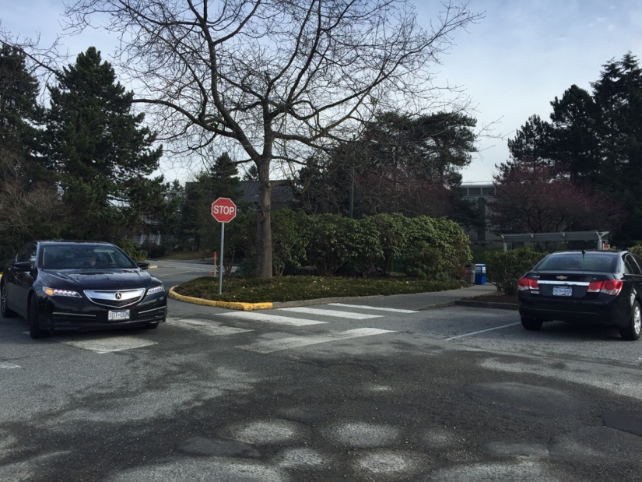

I was terrified by the shuttling cars when I was trying to cross the parking lot to get in the Safeway from the bus station near the street. The sustainable transportation mode of transits and walking would be discouraged if the Safeway were designed to serve drivers primarily.

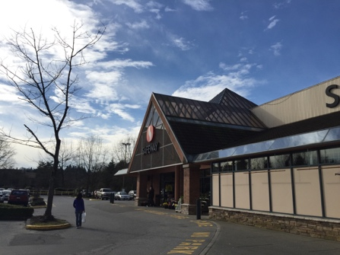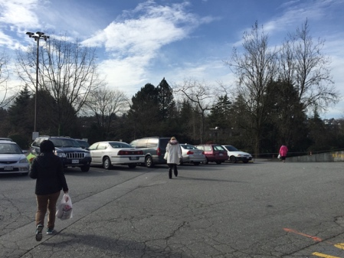

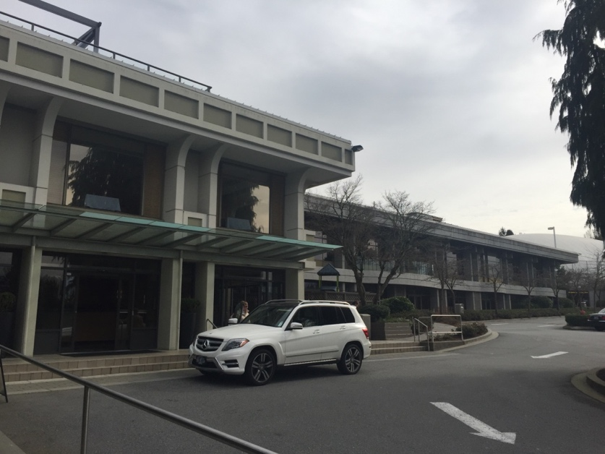

The Arbutus Club is occupying such a large land which could have more possibilities for higher density housing and jobs. Since the need for the rich’s leisure-time activities would not disappear, I’d like to reserve one of the club building and intensify it with more jobs while replacing others with apartments.

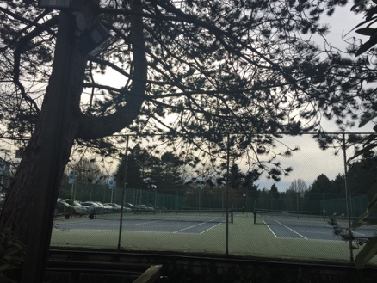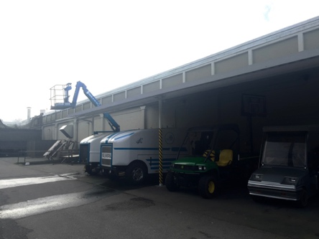

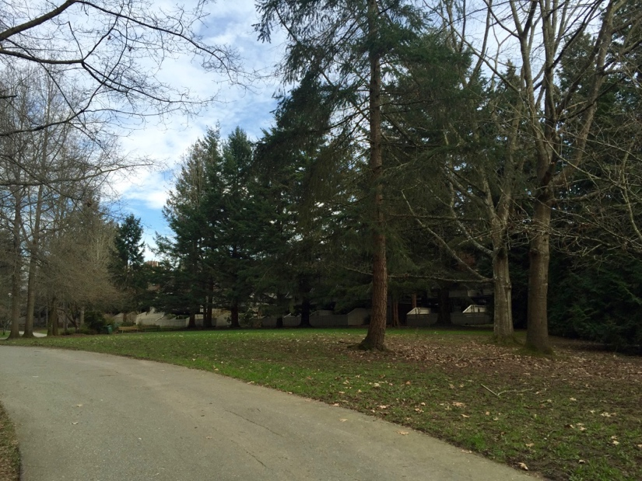

The central Arbutus Village Park is a perfect place for residents to enjoy the fresh air and great sight. Since the routes between trees are completely provided for pedestrians and cyclists, residents’ passion for sustainable mode of transportation would be encouraged. The green strip provide privacy for the apartments shaded by trees after intensification.

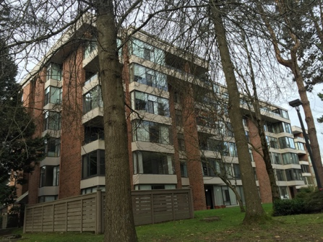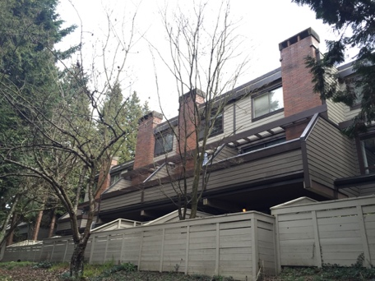

5. Format. 500-word text on one page. Plan on second page. Three photographs with 100 - 200 word captions on third page.

*Close up examples from other similar projects in other classes*: East Clayton and Langley area.

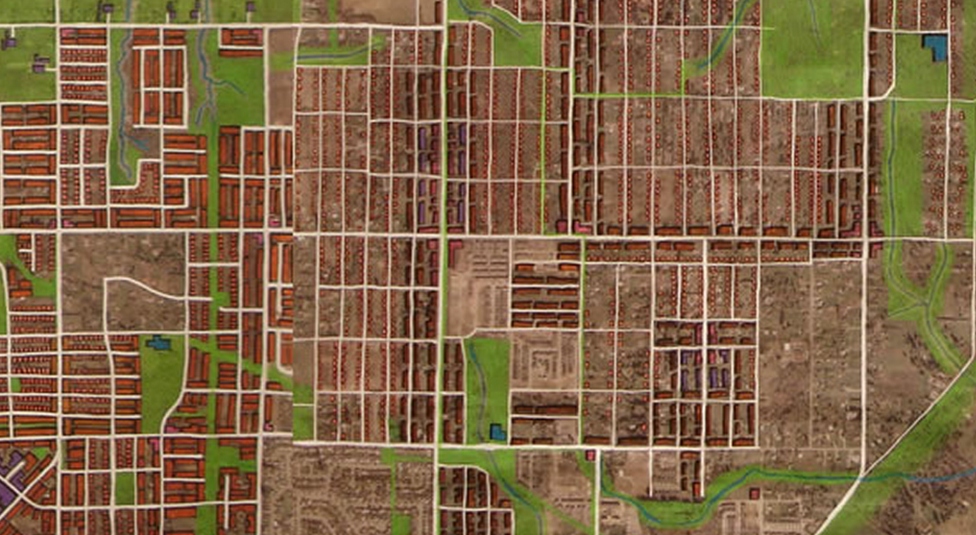

Below left, False creek south in Vancouver. Below Right Burnaby lake region Burnaby.

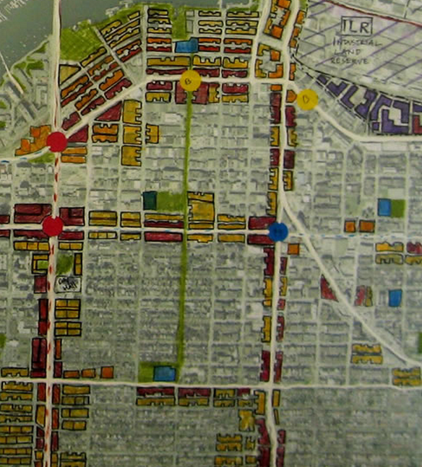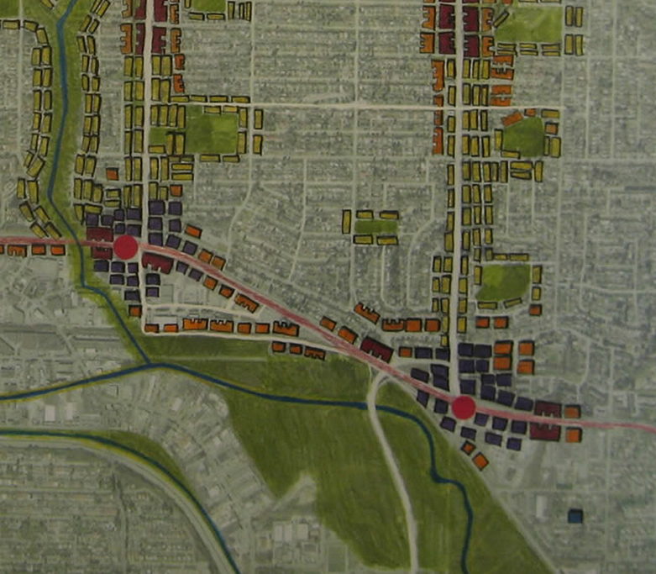

**Grading Criteria.**

1. Extent to which student applies lessons learned in first part of class: 10%
2. Demonstrates understanding of how cities can and can't change: 10%
3. Can evaluate and choose best strategies to enhance sustainability: 10%
4. Demonstrates a basic understanding of "scale" (how the size of things in plans relates to the size of things in the real world) 10%
5. Student demonstrates that they have met the program requirements for jobs and housing units. 20%
6. Presents a clear and cogent argument about how this area might grow over time towards increased sustainability (in the text). 20%
7. Map is graphically clear (graphic quality of map/plan/proposal). 10%
8. Entire submission is well form (graphic quality of entire submission) 10%

**Last Word.**

This project is designed to prove to you that you can design cities. You *can* have an impact. It takes a lifetime to change cities. But it can be done.