We invent and use images to communicate ideas.

But do we shape the world with these images or do they shape us?

Marshall Mcluhan said the medium is the message
we need to pay close attention to rapidly evolving medium and media

We need to ask: Do the images accurately reflect reality?

Who’s beliefs and values do they reflect?.
Who is included and who had they excluded?”

00:00:28 [times are approximate] Why eyebrows?
Eyebrows (and facial expressions) communicate emotions
Imagine a world of without eyebrows

Even emojis have eyebrows

David Bolter argues that electronic writing is constructed
With the writer building new elements from traditional ones

So . . . Let’s take a look back at images from the past in order to understand the power of the new technologies of today.

Marshall Muhlun notes the reciprocal relationship between human communication needs, practices, and Technologies.

World War II was no exception as the male workforce on the home front dwindled, allied governments’ communicated the need to for women to temporarily adopt, non-traditional roles.

Images were used to create a “reality to alter the perceptions of the world or part of the world” (Jonathon Rose) -
This is evident in war time print media. Where posters such as Rosie the Riveter did the necessary job. . . . of temporarily disrupting gender ideals,
00:00:59 [Image of Rosie the Riveter]:
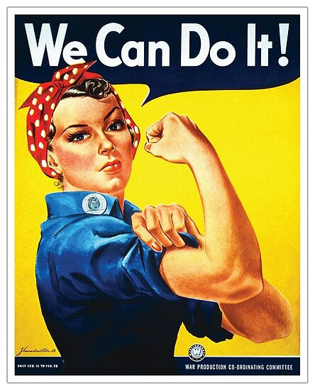
Rosie the Riveter shows a strong, powerful image of a woman with her direct somewhat challenging gaze. With her one eyebrow arched, she seems to say “Oh really, you don’t think I can? Just watch!”
A successful campaign as women took on non-traditional jobs; disrupting gender roles.
00:01:16 Temporarily. Once the war was over, she was sent back to the kitchen.
00:01:25 Fast forwarding in time and mediums, to the early beginning of text images- emoticons and emojis before we situate “Rosie” in today’ changing world of electronic writing and imagery.
Without facial expressions and gestures Emoticons were created to clarify text. Lacking gestures and facial expressions misunderstandings often occurred.
00:01:42 [Image of a test tube]
The first emoticon is said to have originated in 1982at Carnegie Mellon when a gag about a fake mercury spill was posted to an online message board.
It was taken seriously. The university was not impressed.
As a result, Dr. Scott Fahlman suggested that jokes and nonjokes be marked by two sets of characters we now recognize as standard emoticons: the smiley face :-) and the frowning face :-(.
00:02:02 Emoticons use punctuation marks, letters, and numbers to create pictorial icons to display an emotion or sentiment
Emojis - quickly followed as Emoticons were reiterated, inspired by Japanese kanji and manga art.
(๑•̀ㅂ•́)و (*•̀ᴗ•́*)و ̑̑

00:02:08
(Japanese Kanji are much more detailed and complex than the Western version. Note the arm raised in “triumph” and the eyebrows? Looks a bit like Rosie)
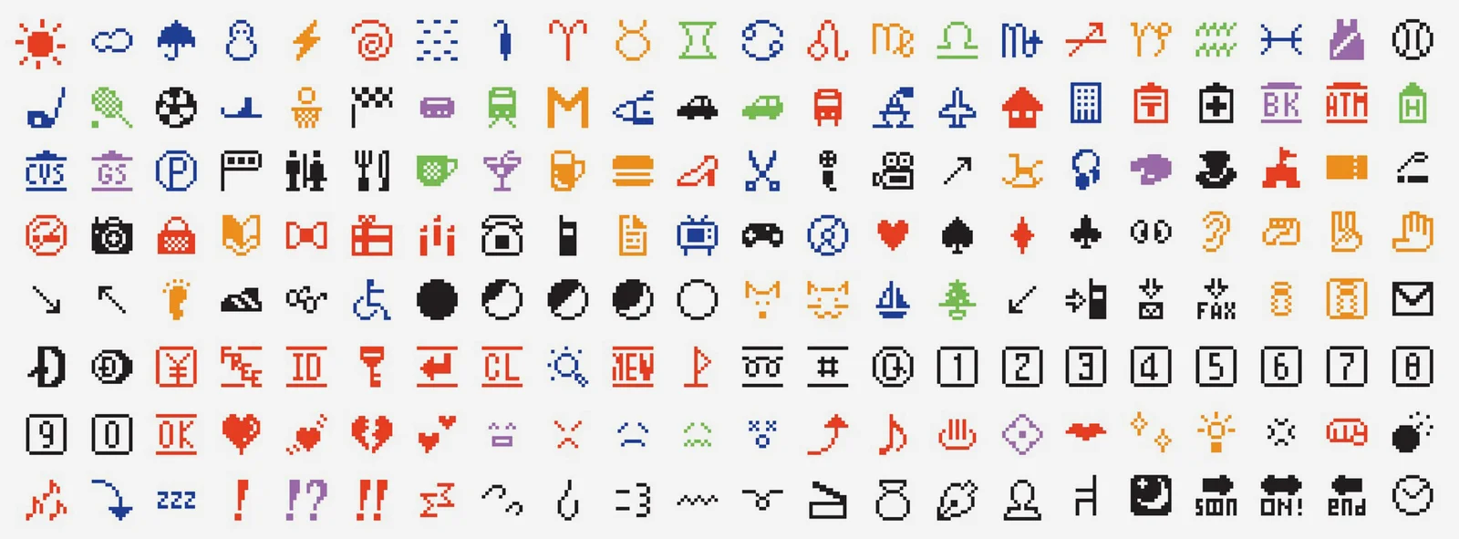

The first emoji were very simple (only 12 pixels by 12 pixels)
Weather. Time. traffic And technology

But they soon expanded. . . quickly permeated messaging worldwide
The smiley face was popular - looks kind of like the 70s Happy Face
Cute? Innocuous? Genderless? Perfect?
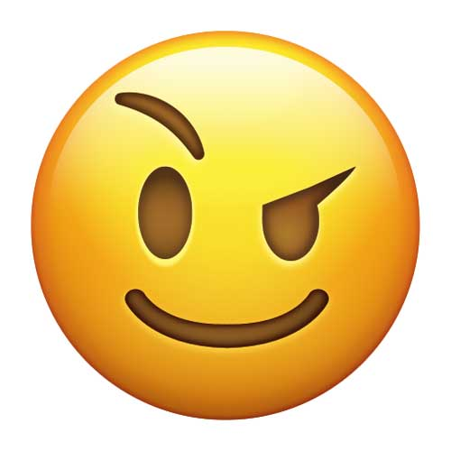
Maybe . . .

Bolter said the goal of alphabetic writing was to simplify by exclusion . . . emojis work by the exclusion of words depicting whole ideas or emotions. And . . . originally they worked by the exclusion of gender.

LInguist Vyvyan Evans notes that emojis “provide a visual form of communication that is both resonant and powerful.”

00:2:45: Unicode is an international character-encoding system designed to support the electronic interchange, processing, and display of the written texts. In 2010 emoji was standardized by Unicode so that it could be used across many platforms.

Even car manufacturers used emojis to advertise because “words could not describe their product” . .
Emoji was everywhere.
Sounds great!
But it is not without problems . . .

Who creates emojis and why has it taken so long to create emojis that are more representative of the diversity of people?

Apparently the Unicode Consortium solicits proposals
There is a website and forms to fill out.
But who knew that
I didn't need
We need to tell people
Proposals are put forward and accepted
As emojis were added - water guns replaced real guns . . .
. . . some changes have including:
2012 same sex couples added in 2012 .
2015 skin tones are added (although we are still waiting to see the baby in multiple skin tones.)
And of course, the 2017 the positioning of cheese on a hamburger was standardized
From the ridiculous to the serious. . . we have remediated emojis to be more representative and safer
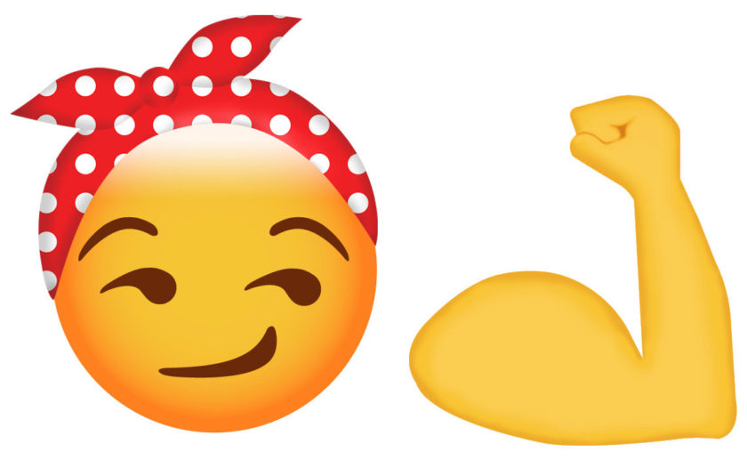
00:04:22 But wait . . . where are the women? (In 2014 The tech and design industry were (and still is) predominantly male)
(reiteration of Rosie image by Tamara Shopsin)
In “Emoji Feminism,” Amy Butcher retells her search for a strong, successful archetype or emoji to send to her newly tenured friend . . . who happens to be female. There were no female professors, lawyers, surgeons . . . but there were flamenco dancers; with “one arm in the air, does suggests an attitude of self-assurance, of cool-minded confidence” but it is not quite right . . .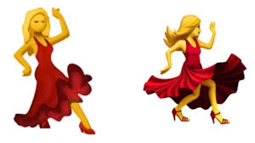
And there were ballet dancers dressed like bunnies in ears and leotards.
There was an underrepresentation of women in tech and digital industries as well as emojis
Women are still in the kitchen or shopping . . . welcome to 1950s and suburbia in emoji land.
The implication: girls are limited in what they were capable of doing.
Clearly, there was a need for better representation.
00:04:49 In 2016, Google submitted a proposal to the Unicode Consortium recommending the addition of 13 new female emoji that would give women better representation.
I challenge you to search for the female representation in emoji to see if the proposal had any effect.
00:05:15 " . . .language and language use have always been fluid and variable" (Dobson & Willinsky).

We now need to look ahead, to the future and to new reinterations of image, with a critical lens.
As educators and as parents we need to teach our youth to look at media images with a critical eye. And to take action.

00:05:32 The 2019 Emoji documentary ‘PICTURE CHARACTER” draws attention to the ways to solicit new emojis . . . ( for example the hijab and menstruation have been added as a result of proposals to the Unicode Consortium.)
00:05:55 WE ARE NOT POWERLESS, we can create your own emoji . . . as Katrina Parrot of iDiversicons suggests.
And there are also Apps such as Emoji-Me and Bitmoj that make creating one’s own cartoon-ified image in digital form by choose your physical traits such as hairstyle and colour, skin tone and facial features. They can then be used on multiple platforms
I'm not sure about occupations - further study need to be done - but we could always try petitioning for what we need.
00:6:20 There is one problem though.
What form constitutes the real, authentic or natural? Do we portray people as they exist? Or as they want to be seen?
Bolter argues “Remediation is always an attempt to redefine key cultural values’ (p. 43). We need to decide what those cultural values are and what is important.
What can we afford to include and exclude and what can we not afford to exclude in our “text?”

00:06:45 In The Emoji Code: The Linguistics Behind Smiley Faces and Scaredy Cats” Vyvyan ( Vie- vee - yen) Evans believes that “emoji is the next step in the evolution of human language. “Emoji adds more than a splash of color to our digital alphabet. It provides a visual form of communication that is both resonant and powerful.”

“ . . . do we know whether differences in language create differences in thought, or the other way around? [ Turns out . . . it’s both, language influences us and we influence it]... “
. (Boroditsky, p. 65)
The answer, it turns out, is both— . .the way we think influences the way we speak, but the influence also goes the other way” (Boroditsky).

This leads to more questions and challenges

07:25 "In creating Rosie [the Riveter],
advertisers create a reality to alter the perception
of the world or part of the world" - (Jonathon Rose argues, p. 62)

Now, we can create our own reality . . . through emojis. and avatars like Emoji-me, Bitmojis. Is this any different ?

For this reason we need to take care of with that representation
we need to think what is real whose world are we creating
Who is included and who is excluded and how can we change that?

07: 48:05 What sort of world do we want to live in?

The responsibility is all of our’s together.

References

Alonso, D. H. (2020). Emoji timeline. https://emojitimeline.com/

Bolter, J. (2001). Writing Space: Computers, hypertext, and the remediation of print (2nd ed). New York: Routledge, https://doi-org.ezproxy.library.ubc.ca/10.4324/9781410600110

Boroditsky, L. (2011). How language shapes thought Scientific American, 304(2).

Burge, J. .https://emojipedia.org/face-with-raised-eyebrow/

Butcher, A. (May 11, 2016). Emoji Feminism. The New York Times.
https://www.nytimes.com/2016/03/13/opinion/sunday/emoji-feminism.html?_r=0

Colt, J. (2018) Want Animoji, but not the iPhoneX? Try these Apps instead. WIRED. https://www.wired.com/story/app-pack-animoji-dupes/

Cult of Mac image: Racially diverse emojis [Image]. https://www.cultofmac.com/313191/apple-adds-300-racially-diverse-emojis-ios-8-3/

Dobson and Willinsky. (2009) Digital Literacy.Cambridge Handbook of Literacy
https://pkp.sfu.ca/files/Digital%20Literacy.pdf

Dyem J. (2016). Google wants better female representation in emoji. Android Authority. https://www.androidauthority.com/female-emoji-692031/

Evans, V. (2017). The Emoji Code: The linguistics behind smiley faces and scaredy cats.

Grannan, C. (2016). What is the difference between emojis and emoticons? Encyclopaedia Britannica. https://www.britannica.com/story/whats-the-difference-between-emoji-and-emoticons

Horne, M. (updated March 13, 2019.)These World War II Propaganda Posters Rallied the Home Front. HIstory.com. https://www.history.com/news/world-war-ii-propaganda-posters-photos-united-states-home-front
Kaifa,Y., Richard, G. & Tynes, B. (2016). The Need for Intersectional Perspectives and Inclusive Designs in Gaming Diversifying Barbie: Intersectional Perspectives and Inclusive Designs in Gaming. (pp. 1-19).
Krueger, A. (March 24, 2016). The Inside Story of Bitmojis: Why We Love Them, How They Make Money, Why They Are Here To Stay. Forbes. https://www.forbes.com/sites/alysonkrueger/2016/03/24/the-deeper-meaning-behind-bitmojis-why-we-all-love-them-so-much/#61251f94a435
Lacoma, T. & Beaton, P. (July 3, 2020). What is Bitmoji? Digital Trends. https://www.digitaltrends.com/mobile/what-is-bitmoji/
Le, V. (11.12.19). The smiley face. Ubiquitous icons: Peace, power and happiness .https://99percentinvisible.org/episode/ubiquitous-icons-peace-power-and-happiness/2/
McCarty, D. Stepford Wives [Photo] .Retrieved from https://unsplash.com/photos/CBDrkkViM-Q.
MIller, J.H. (1942). Rosie the Riveter. (Poster). In Horne, M. (03.13. 2019) These World War II Propaganda Posters Rallied the Home Front. History.com. Retrieved from https://www.history.com/news/world-war-ii-propaganda-posters-photos-united-states-home-front#&gid=ci0230e630c06326df&pid=poster-by-j-howard-miller-4
McLuhan, M. (1964). Understanding the media: an extension of man. qtd. in MOD 0.12 (Summer Session 2020). ETEC 540. McLuhan thesis: "the medium is the message"
National World War II Museum New Orleans. Women Welders [Image). Women of World War II. Retrieved from https://www.nationalww2museum.org/war/topics/women-world-war-ii
Nakamura, L. (2014).When internet shaming crosses the lines: Racial spectacle and memetic culture. [Video File] Retrieved from https://youtu.be/AWa8mzeAsQM.
NowThis. (April 30, 2019). Documentary 'Picture Character' demystifies creation process for more inclusive Emoji [Post]. Retrieved from https://www.facebook.com/watch/?v=312986642957289
NowThis. (4/30/2019) Documentary “Picture This.” NowThis. https://nowthisnews.com/videos/future/documentary-picture-character-and-the-creation-of-emojisPardes, A. (02.01.2018). The WIRED guide to emoji. WIRED. https://www.wired.com/story/guide-emoji/
Rose, J. (2000). Chapter 2: Making “pictures in our heads” The rise of government in advertising. Westport, Conn. p.62.
Scheinberg, E. (1994). The Tale of Tessie the Textile Worker: Female Textile Workers in Cornwall During World War II. Labour/Le Travail, 153-186.
Shane, M. & Cheney, S. Dir. (2019). Picture character movie trailer https://youtu.be/-q96wvdJTJ8
Shopsin, T. Rosie Reimagined [Emoji picture]. In Butcher, A. (May 11, 2016). Emoji Feminism.
Tomanszewski,. K. (2017). The life of an emoji. The Future of writing. http://www.futureofwriting.com/2017/12/19/the-life-of-an-emoji/
Unicode. About emoji. https://home.unicode.org/emoji/about-emoji/
Zaltman, H. (2019). New Rules The Allusionist (Episode 102) [Audio podcast episode]. http://theallusionist.org/new-rules

***********************************************************************************************
Bitmojis and Emojis-Me images created from personal iPhone apps

