ENG 1.3

Hello Josy,

Assignment 1.3 focuses definitions. Parenthetical, sentence, and expanded definitions are practiced. The learning objectives include: selecting the appropriate amount of detail for a given situation; differentiating between the levels of details in definitions; understanding the importance and role of definitions used in technical writing; and understanding definition requirements based on audience and purpose.

I have chosen to practice three different types of definitions for the term “periodontitis”. My intended audience includes laypeople who do not have any dental terminology knowledge. The definitions should be clear to any client within a dental practice who requires knowledge about the condition.

Please find my English assignment 1.3 below for your review. I look forward to your critical feedback and peer assessment.

Thank you,

Rebecca

**Parenthetical Definition**

Periodontitis (gum disease) can be either aggressive or chronic in nature.

**Sentence Definition**

Periodontitis is a serious disease of the mouth that damages the soft tissues, as well as, the surrounding bone structure and ligaments of the teeth. It can cause teeth to loosen; and lead to tooth loss without treatment.

**Expanded Definition – etymology, required conditions, visual, comparison**

The word periodontitis can be broken down to “peri” (around); “dontal” (tooth or teeth); and “itis” (inflammation of an organ or tissue). (Dictionary.com, 2017)

Periodontitis occurs due to: unremoved tartar and plaque biofilm around the teeth and gums; poor oral hygiene; nutrition deficits; smoking; and certain systemic diseases, such as diabetes. (Youssef, A., 2012) Periodontitis can be prevented by brushing, flossing, using mouth rinse, knowing and addressing your risk level (such as smoking), and seeing a dental professional regularly. (American Academy of Periodontology, 2017)

Is periodontitis the same as gingivitis?

Gingivitis often precedes periodontitis, however, gingivitis does not always progress into periodontitis. With gingivitis, there is swelling and inflammation of the gums surrounding the teeth, but there is no bone loss and the disease is still reversible. Contrarily, periodontitis often begins with untreated gingivitis. As it progresses, both bacteria and the body’s immune system damage the surrounding tissues of the tooth causing irreversible bone loss and soft tissue destruction. (WebMD, 2017)

**A comparison of healthy gums, gingivitis and periodontitis.**

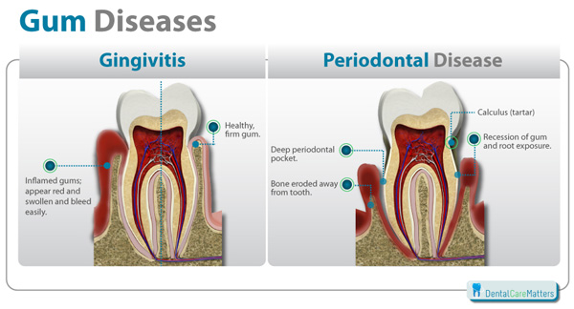

MedEq. (2016) Gingivitis and Periodontitis: Who it Effects and How. Retrieved May 31, 2017, from: <http://www.emedeq.org/oral-health-blog/2016/1/14/gingivitis-and-periodontitis-who-it-effects-and-how>

References

American Academy of Periodontology. (2017). Preventing periodontal disease. Retrieved May 31, 2017,

from: <https://www.perio.org/consumer/prevent-gum-disease>

Dictionary.com. (2017). Periodontitis, Retrieved May 31, 2017, from:

<http://www.dictionary.com/browse/periodontitis>

MedEq. (2016). Gingivitis and Periodontitis: Who it Effects and How. Retrieved May 31, 2017, from:

<http://www.emedeq.org/oral-health-blog/2016/1/14/gingivitis-and-periodontitis-who-it-effects-and-how>

WebMD. (2017). Gingivitis and Periodontal Disease (Gum Disease). Retrieved May 31, 2017, from:

<http://www.webmd.com/oral-health/guide/gingivitis-periodontal-disease#1>

Youssef, A. (2012). Periodontitis. Retrieved May 31, 2017, from:

<http://www.studiodentaire.com/en/conditions/periodontitis.php>