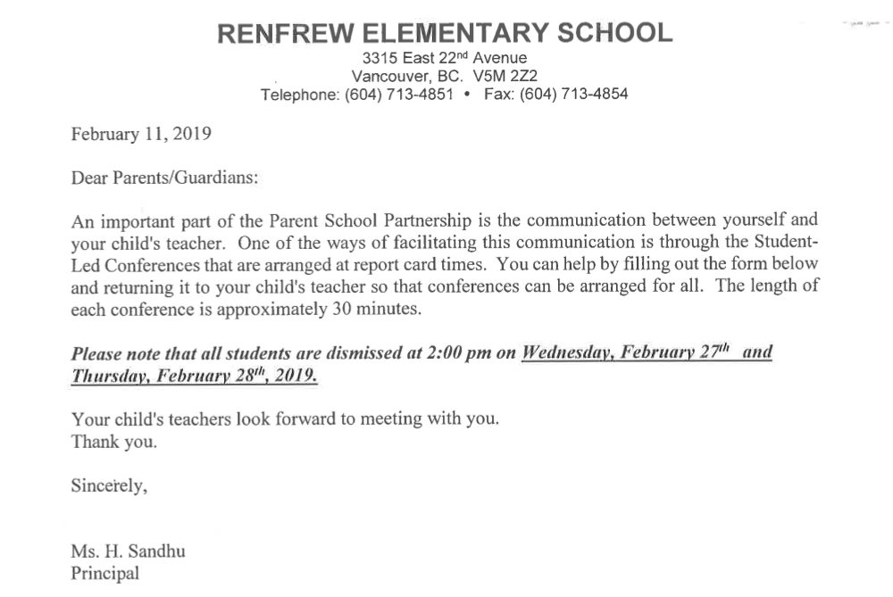

***\*\*\*If none of the times work for you below please let me know\*\*\****

If you could please try to choose the earliest time slot and avoid large time gaps that would be greatly appreciated

|  |  |  |  |  |  |
| --- | --- | --- | --- | --- | --- |
| Date and time: Wednesday, February 27th | Child’s Name | Sibling’s name and teacher | Date and time: Thursday, February 28th | Child’s Name | Sibling’s name and teacher |
| 2:15-2:45 | 2:15 Aidaan van Tijn | Jasper van Tijn, Lucia Bieldstein | 2:15-2:45 | Logan Raun |  |
| 2:15-2:45 | Sylvie Alscher |  | 2:15-2:45 |  |  |
| 2:15-2:45 |  |  | 2:15-2:45 |  |  |
| 2:45-3:15 |  |  | 2:45-3:15 | Liam |  |
| 2:45-3:15 |  |  | 2:45-3:15 |  |  |
| 2:45-3:15 |  |  | 2:45-3:15 |  |  |
| 3:15-3:45 |  |  | 3:15-3:45 | Jimmy Cullingworth |  |
| 3:15-3:45 |  |  | 3:15-3:45 | Tasha Chan | Brendan/Ms. Kudryk |
| 3:15-3:45 | Sloane |  | 3:15-3:45 |  |  |
| 3:45-4:15 |  |  |  |  |  |
| 3:45-4:15 |  |  |  |  |  |
| 3:45-4:15 | Chloe | Zoe/ Ms Smith |  |  |  |
| 4:15-4:45 | Zoe | Jacob/Ms Kudryk |  |  |  |
| 4:15-4:45 |  |  |  |  |  |
| 4:15-4:45 | Ameera | Ahmya/ Ms Cheung |  |  |  |
| 4:45-5:15 | Quinn | Griffn-Cora Wong |  |  |  |
| 4:45-5:15 | Carson Anthony |  |  |  |  |
| 4:45-5:15 | Murphy |  |  |  |  |
| 5:15-5:45 | Owen Lee | Olivia / Ms. C. Wong |  |  |  |
| 5:15-5:45 | Nygel | Noah/ Ms. C. Wong |  |  |  |
| 5:15-5:45 | Simran |  |  |  |  |
| 5:45-6:15 | Anne Wong  Vivek |  |  |  |  |
| 5:45-6:15 | Gavin Hong | Jeremy / Ms. Hoang |  |  |  |
| 5:45-6:15 | Ada Celikok | Su Celikok- Ms. Wong |  |  |  |