Question 1
The nearest neighbour index is the ratio of the observed neighbour distance to the mean random distance. An index value less than 1, as in Figure 1, shows clustering, where the crimes are more spatially aggregated than expected. In Figure 1, the index increases as order increases but the values are still under 1. Relative indices also change as order increases, as we see in Figure 1, the line for commercial break and enter crimes crosses over both robberies and stolen vehicles.
Over a city, land use may not be randomly distributed so spatial distribution of crimes may not be completely random. For example, commercial areas may be in clusters with other commercial areas in certain parts around the city. The User Input Area Z-Scores are -67.8104 (commercial break and enter crimes), -42.9953 (robberies), -65.3034 (stolen vehicles) and -77.4486 (residential break and enter crimes).
Question 2
A greater Moran’s I value means a stronger spatial autocorrelation, or cluster, which is the opposite of the nearest neighbour index (smaller index means spatial aggregation, or clustering). Both Figure 1 and 2 are similar in that there is stronger spatial aggregation with a smaller order and distance, respectively. In Figure 2, the values for different crimes are greater than the values for population. See the next section (Moran’s Results) for more details.
Figure 1: Nearest Neighbour Analysis

Moran’s Results
Looking at Figure 2, as distance increases, Moran’s I decreases. A greater Moran’s I value means a stronger spatial autocorrelation, or cluster. Figure 2 shows that there is stronger spatial aggregation with a smaller distance, and as distance increases, there is weaker spatial autocorrelation. Values for different crimes are greater than the values for population, the “default” or “null” values. This may be because crimes are not distributed based on population distribution and may be related to the land use distribution.
For stolen vehicles, the Moran’s I value is 0.026307, the normality significance is 25.149556 and the randomization significance is 25.242788. For commercial break and enter crimes, the Moran’s I value is 0.006146, the normality significance is 6.388181 and the randomization significance is 6.488141. For residential break and enter crimes, the Moran’s I value is 0.032431, the normality significance is 30.708423 and the randomization significance is 30.739723. For robberies, the Moran’s I value is 0.020769, the normality significance is 19.892049 and the randomization significance is 20.327476. For total population 15 years old and above in a dissemination area (DA), the Moran’s I value is -0.000030, the normality significance is 0.668983 and the randomization significance is 0.674652.
Figure 2: Moran Correlogram

Fuzzy Mode Clusters versus Nearest Neighbour Hierarchical Spatial Clustering
The fuzzy mode clusters show hot spots of residential break and enter crimes, which seem to be around the central north regions of the study area. It is a point location technique, but the measurements may not be precise, hence the name “fuzzy” mode. Nearest neighbour hierarchical (NNH) clustering shows hot spot areas. It shows spatially close incidents of residential break and enter crimes, which are seen around the central north regions of the study area. See Figure 3 for fuzzy mode clusters and NNH clusters.
Standard NNH Spatial Clustering versus Risk-Adjusted Results
The standard results showing hot spot areas (Figure 3) may be misleading, but using risk-adjusted results takes population into consideration. That way, one can see the relative risk for a person in an area. The first-order risk-adjusted results (Figure 4) are clustered again (Figure 5) and again (Figure 6).
Knox Index
The Knox Index compares the relationship between car thefts in regards to space (distance) and time. The Chi-Square value is 114.16713 (see Table 1 of Appendix), which does not lie within the range of values generated by the simulations. Since the Chi-Square value is much larger than the range, then there is spatial and temporal clustering.
Kernel Density Estimation
Kernel density estimation shows the likelihood that a residential break and enter crime will occur at a location (see Figure 7). The dual surface map (see Figure 8) shows a relative-risk surface by also taking population into account. Spatial distribution and hot spot analysis generate statistics for the data incidents themselves, while kernel density estimation interpolates data incidents to generalize over a whole region. One can see both the high density and low density areas.
Maps
Figure 3: NNH Clustering (First-Order Clusters) of Residential Break and Enter Crimes, Zoomed into Central North Ottawa-Nepean
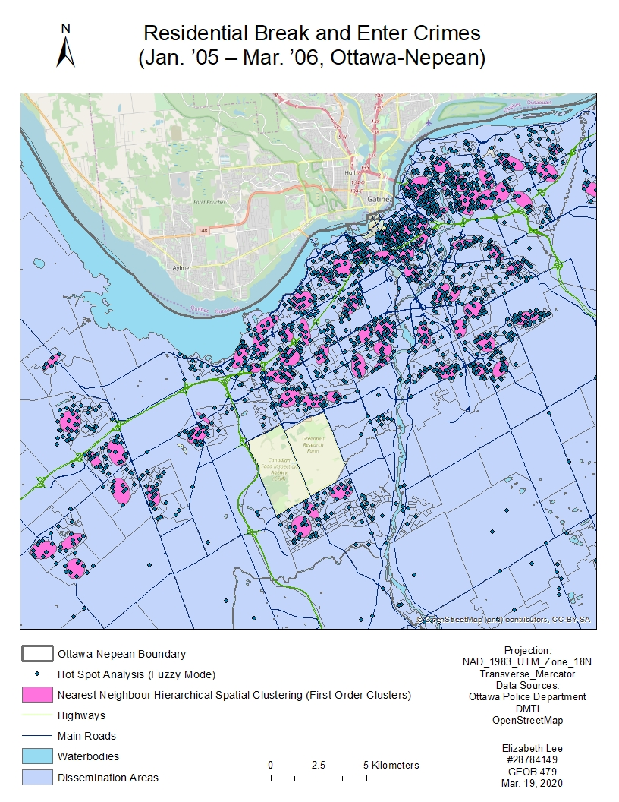
Figure 4: NNH Clustering (Risk-Adjusted, First-Order Clusters) of Residential Break and Enter Crimes, Zoomed into Central North Ottawa-Nepean 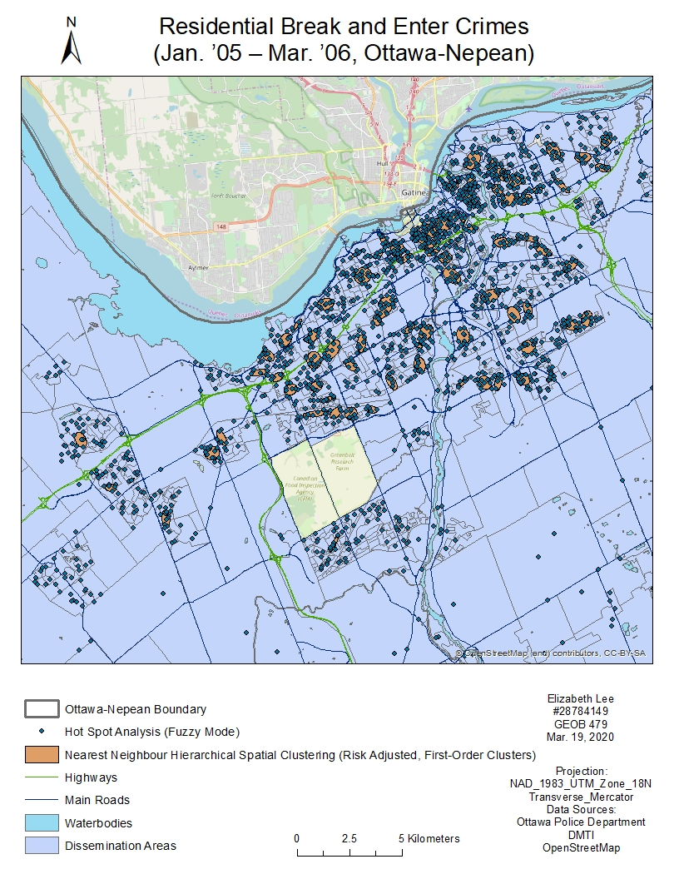
Figure 5: NNH Clustering (Risk-Adjusted, Second-Order Clusters) of Residential Break and Enter Crimes, Zoomed into Central North Ottawa-Nepean
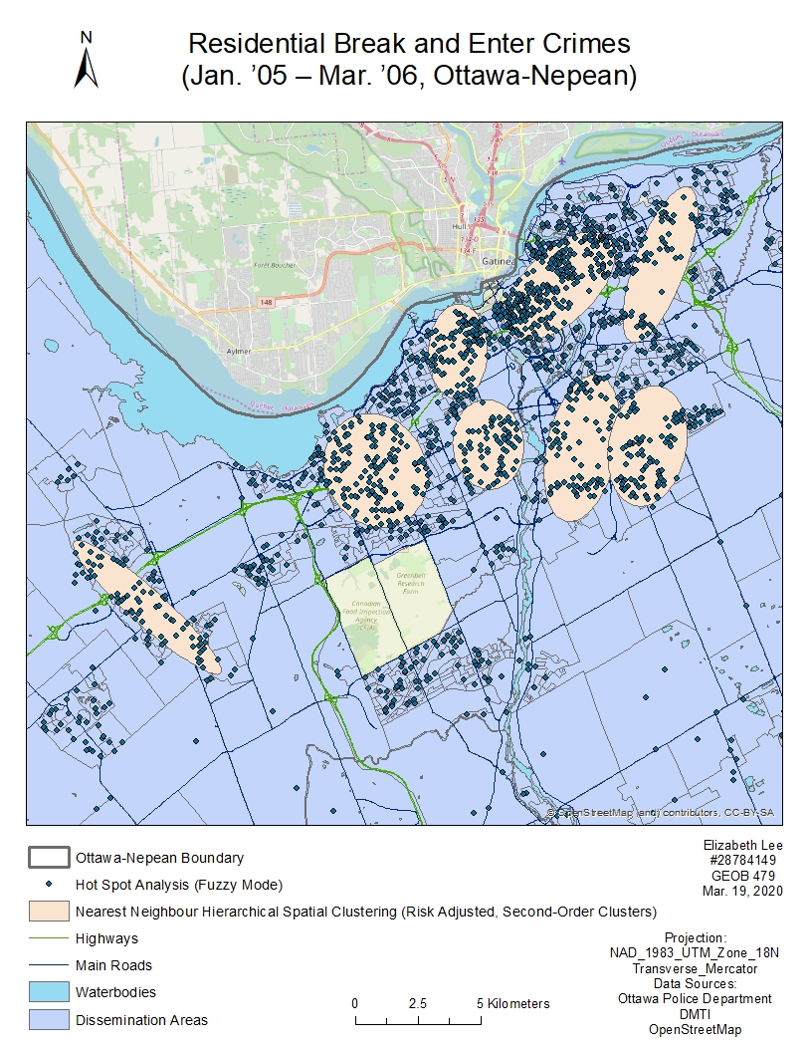
Figure 6: NNH Clustering (Risk-Adjusted, Third-Order Clusters) of Residential Break and Enter Crimes, Zoomed into Central North Ottawa-Nepean 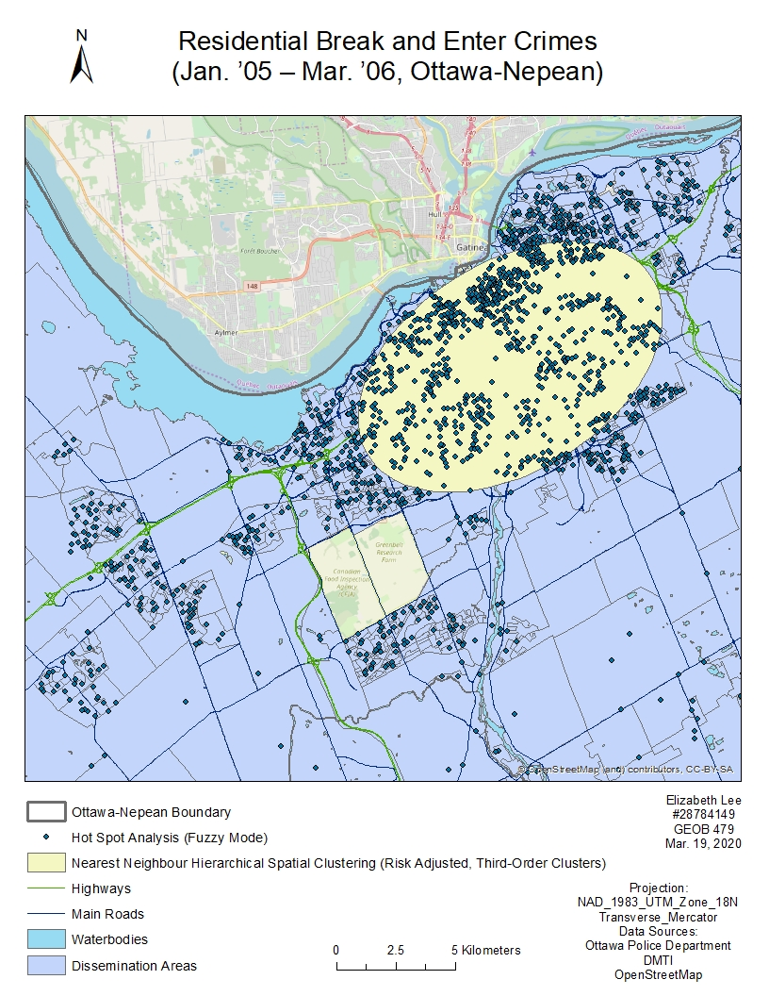
Figure 7: Kernel Density Estimation (Single Surface) of Residential Break and Enter Crimes, Zoomed into Central North Ottawa-Nepean
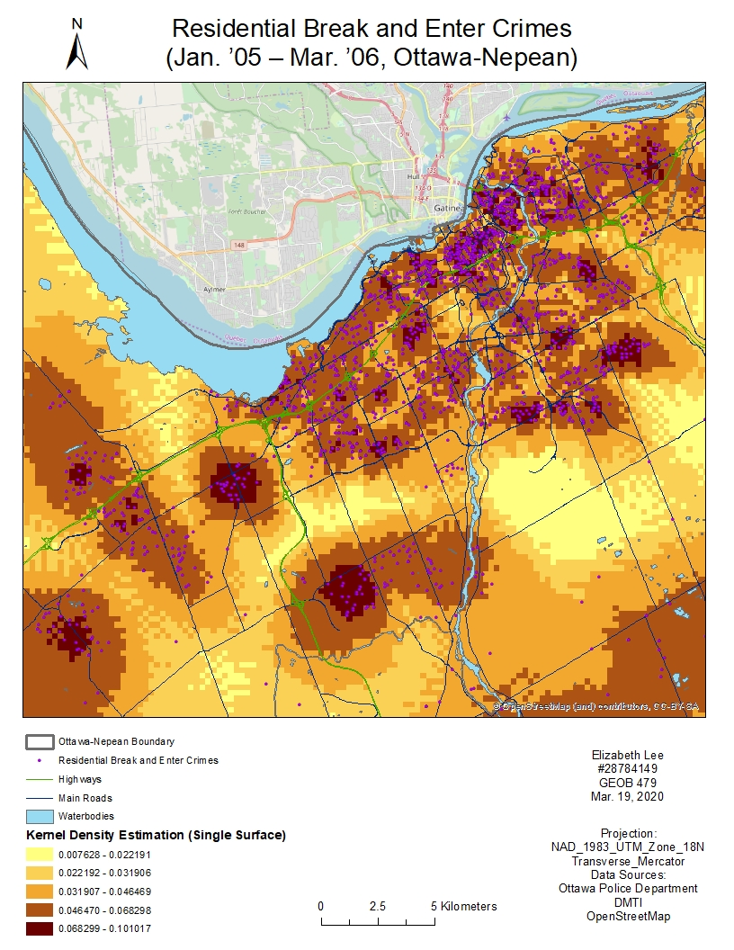
Figure 8: Kernel Density Estimation (Dual Surface) of Residential Break and Enter Crimes, Zoomed into Central North Ottawa-Nepean 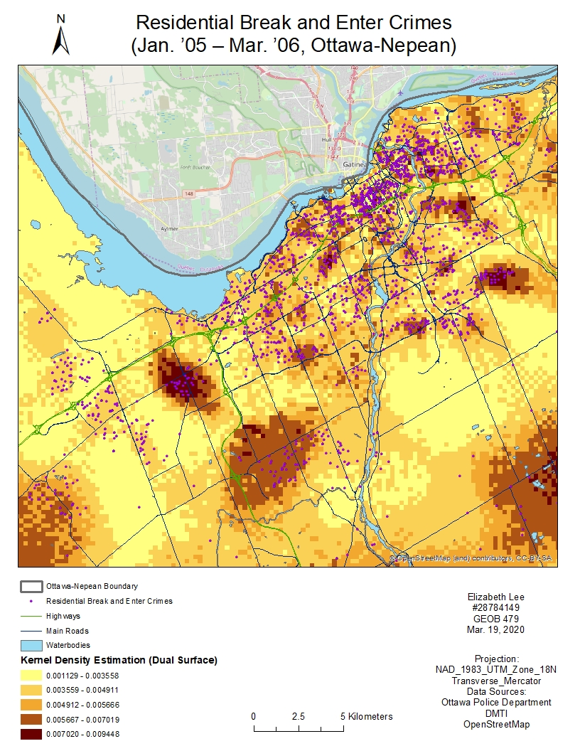
Appendix
Table 1: Knox Index: Interaction of Space and Time
-----------

Sample size ...........: 2152
Measurement type ......: Direct
Input units .... ......: Meters
Time units ............: Hours
Simulation runs .......: 99
Start time ............: 11:06:33 AM, 03/06/2020

"Close" time ........: 12.00000 hours
"Close" distance ....: 5000.00000 m

| Close in space(1) | Not close in space(0) |
--------------------------+-------------------------+-----------------------------+----------------
Close in time(1) | 502829 | 1535276 | 2038105
Not close in time(0) | 65608 | 210763 | 276371
--------------------------+-------------------------+-----------------------------+----------------
| 568437 | 1746039 | 2314476

Expected:
| Close in space(1) | Not close in space(0) |
--------------------------+------------------------+------------------------------+---------------------
Close in time(1) | 500560.08007 | 1537544.91993 | 2038105.00000
Not close in time(0) | 67876.91993 | 208494.08007 | 276371.00000
--------------------------+------------------------+------------------------------+---------------------
| 568437.00000 | 1746039.00000 | 2314476.00000

Chi-square ..........: 114.16713
P value of Chi-square: 0.00010

End time ..............: 11:06:33 AM, 03/06/2020

Distribution of simulated index (percentile):
Percentile Chi-square
---------- ---------------
min 0.00000
0.5 0.00000
1.0 0.00000
2.5 0.00182
5.0 0.00783
10.0 0.02554
90.0 2.99181
95.0 4.43272
97.5 5.10162
99.0 7.30587
99.5 7.30587
max 7.30587

Simulation ended ......: 11:06:49 AM, 03/06/2020
Figure 9: Screenshot of Nearest Neighbour Analysis for Commercial Break and Enter Crimes
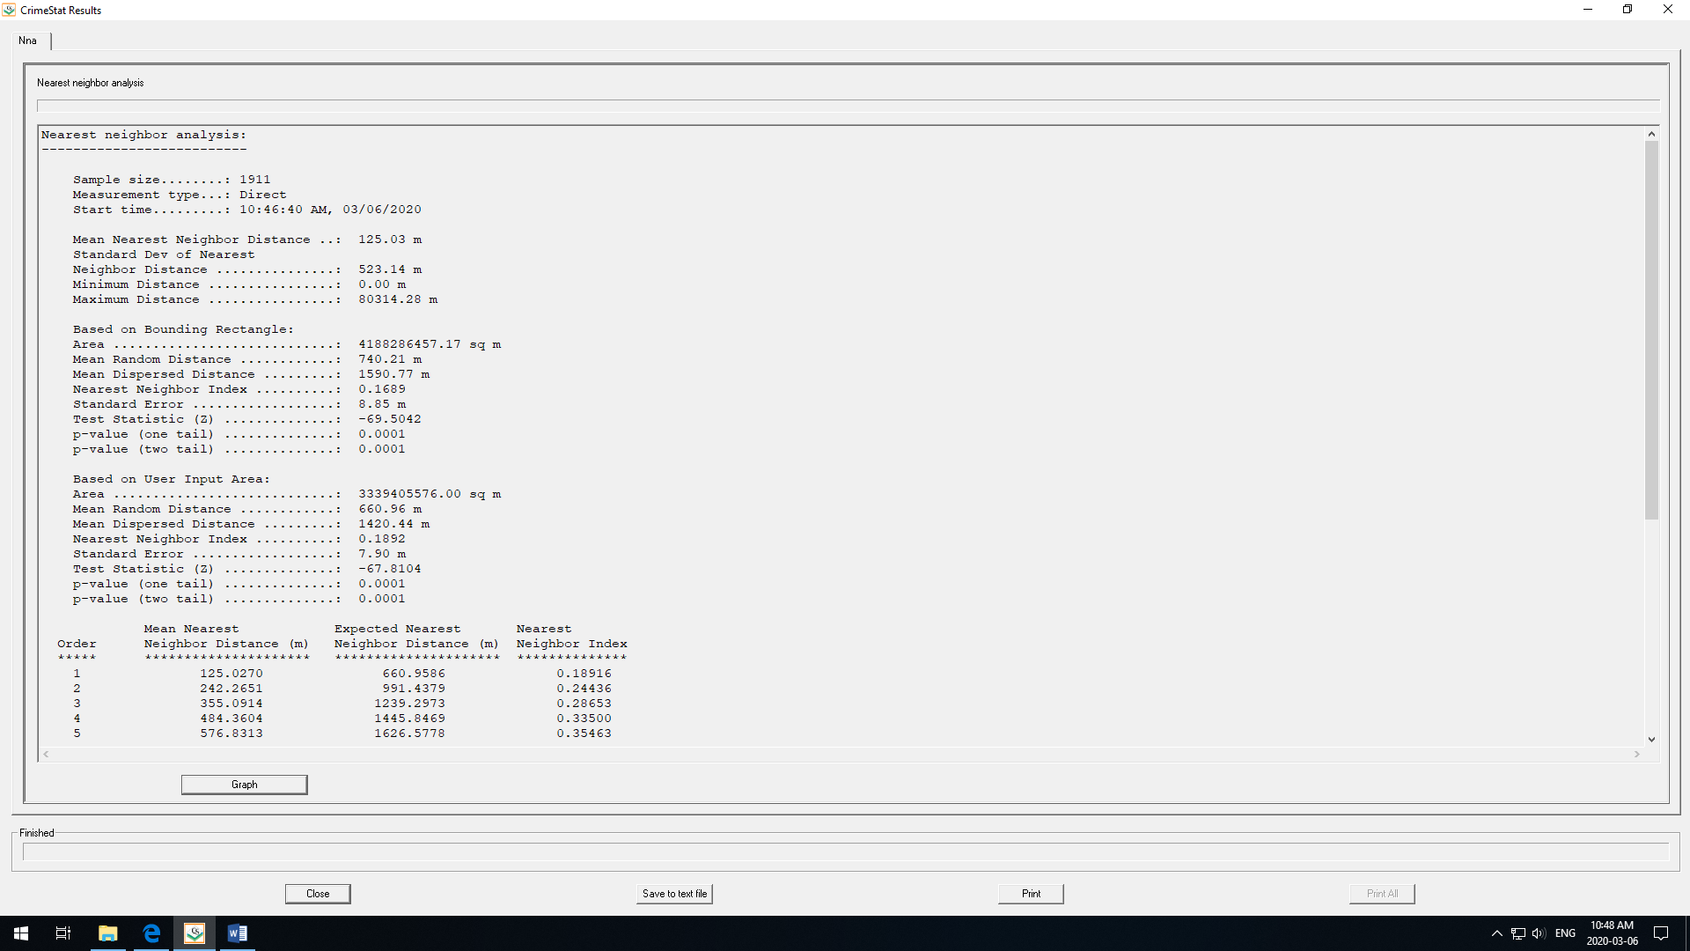
Figure 10: Screenshot of Nearest Neighbour Analysis for Robberies
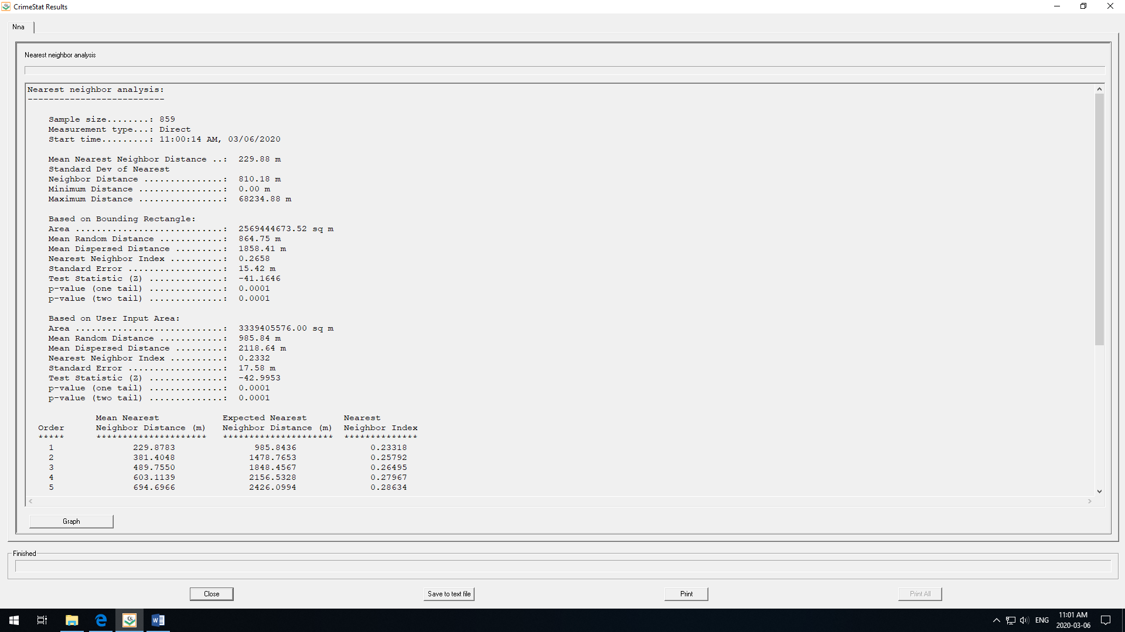
Figure 11: Screenshot of Nearest Neighbour Analysis for Stolen Vehicles
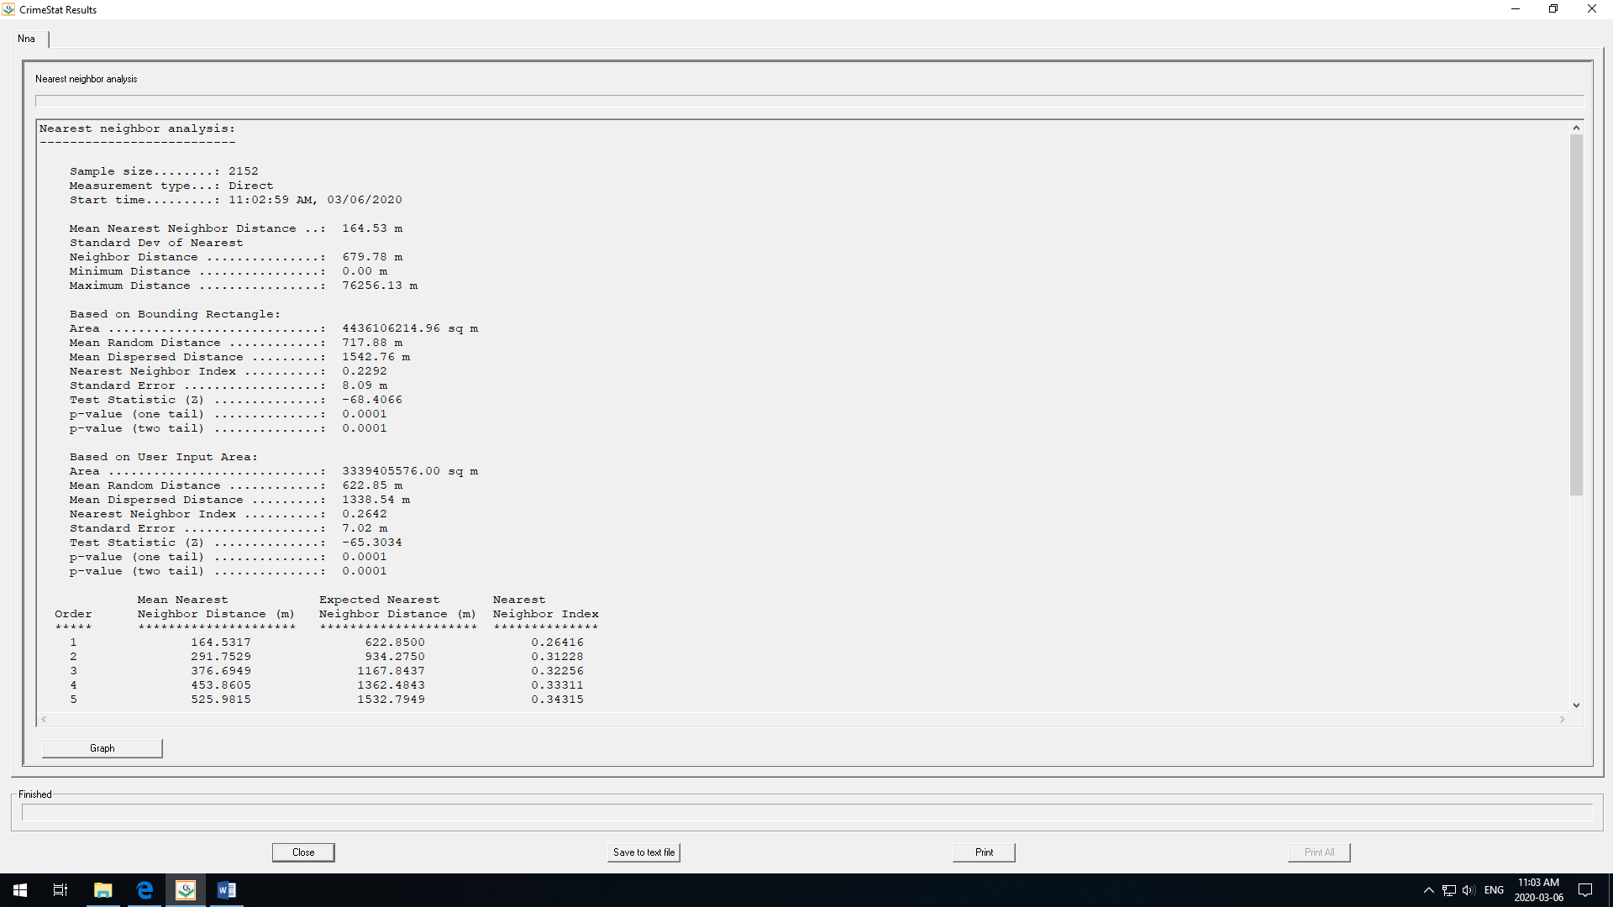
Figure 12: Screenshot of Nearest Neighbour Analysis for Residential Break and Enter Crimes
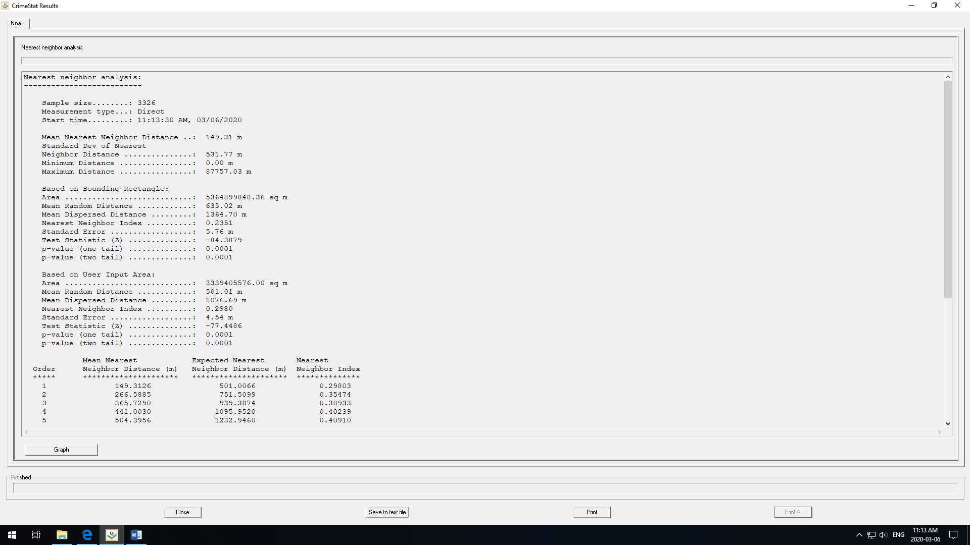
Figure 13: Screenshot of Moran’s I Results for Stolen Vehicles
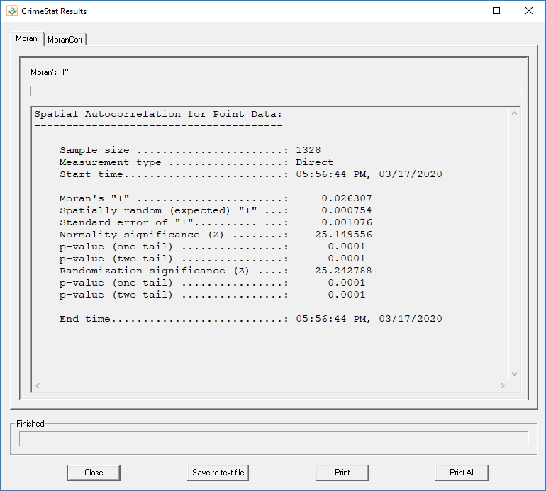
Figure 14: Screenshot of Moran’s I Results for Commercial Break and Enter Crimes
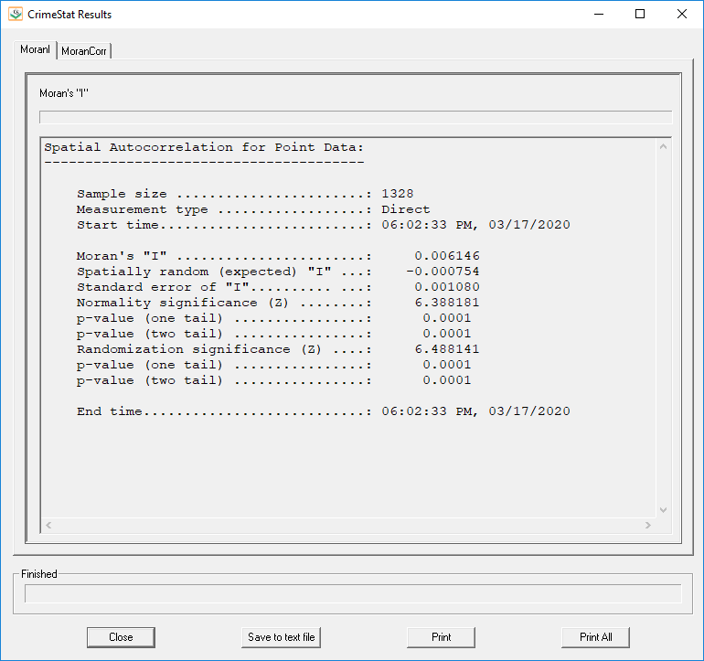
Figure 15: Screenshot of Moran’s I Results for Residential Break and Enter Crimes
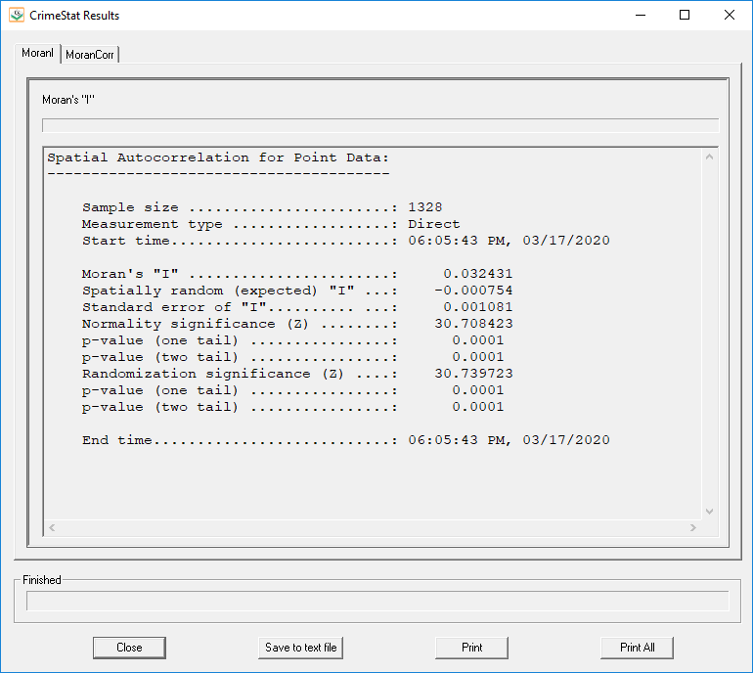
Figure 16: Screenshot of Moran’s I Results for Robberies
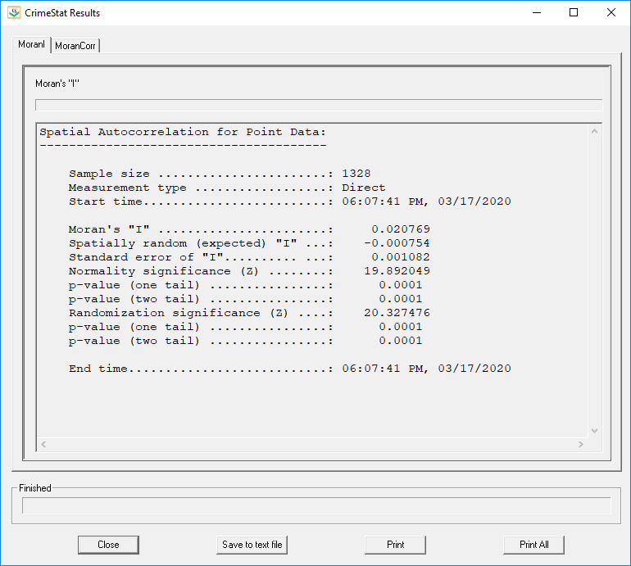
Figure 17: Screenshot of Moran’s I Results for Total Population 15 Years of Age and Above in a Dissemination Area (DA)
