Instructions:
- By default, all sections in this template are required, unless explicitly denoted as optional.
- All required information must be contained in this formal syllabus; don’t direct students to a course website or Canvas for required information.
- Grey shaded text denotes instructions and should be deleted before distributing.
- Square brackets [ ] denote hints and notes that should be replaced, modified, or deleted.
- Don’t forget to complete the footer. Remember to update the version date after each revision.
- This template should be used for courses offered through the Robert H. Lee Graduate School.
- Your Divisional Assistant should be able to assist with formatting issues.
COURSE INFORMATION
Course title: | [course title as shown in UBC Calendar (except pilot courses)]
Course code: | [e.g., BAFI 520] | Credits: | [1.5, 3, etc.]
Session and term: | [e.g., 2023W1, Period 1] | Class location: | [building code and room no.]
Section(s): | [section number(s)] | Class times: | [days of week and times]
Course duration: | [start and end dates] | Pre-requisites: | [course codes or n/a]
Division: | [Finance, etc.] | Co-requisites: | [course codes or n/a]
instructor information
Instructor: | [name, credentials]
Phone: | [phone number] | Office location: | [building code and room no.]
Email: | [email address] | Office hours: | [days of week and times]

[When applicable …]
Teaching assistant: | [name]
Office hours: | [days of week and times, and location]
Email: | [email address]
Course Description
[Provide a detailed but succinct description of the course. Ensure consistency between this course description and the brief course description in the UBC Calendar. Avoid repeating what will be in the learning objectives below.]
Course Format
[Additional information on course structure. Typical use of class time (lecture, discussion, cases, flipped classroom). Tutorials or labs if any. Is this a blended online + face-to-face course? Is this a flex course that meets less frequently than typical? Please note that all courses are expected to be delivered as majority in-person: e.g. videos and other digital media can be part of course delivery, but the instructor and students are expected to be in-person for the majority of instructional hours.]
Learning Objectives
By the end of this course, students will be able to:
- [Identify / explain / apply / analyze / integrate / evaluate / etc.] …
- …
…
[Use actions and outcomes that are observable and measurable. Avoid unobservable outcomes such as “understand,” which can be reworded as “describe” or “explain.” Refer to Bloom’s Taxonomy. Here is an explainer complete with examples (University of Arkansas)]

SUstainable development goals (SDGs)
We are including SDGs in course syllabi to show where they are addressed in coursework. This is a part of Sauder’s commitment to contributing meaningfully to global sustainability and resilience. For assistance or questions on SDG’s or their inclusion, please contact Kate White at katherine.white@sauder.ubc.ca

At UBC Sauder, we are committed to responsible business practices that can have transformative impacts on society. One of the ways we are reinforcing our commitment to responsible business is by showcasing relevant content in our courses via the lens of the United Nations Sustainable Development Goals. In this course, we will touch on topics that relate to the following goals:

Below is an example for a marketing course. Revise the example for your course. Please copy and paste between two to five SDG goals from the list following the example into the table for your own course. Then fill in your own description of where the goal is covered in your course.

Sustainable Development Goal | Description of how and when the goal is covered in the course.
GOAL 3: Good Health and Well-being | In week 1, we will have one full class dedicated to negative impacts of marketing on consumer health and well-being, as well as potential ways to mitigate these. These topics will be revisited in week 3 with a small-group discussion and in week 4 with an in-class exercise. In week 6, we will have a dedicated class activity on the impact of advertising on consumer self-esteem and body image, and ways to overcome this.
GOAL 12: Responsible Consumption and Production  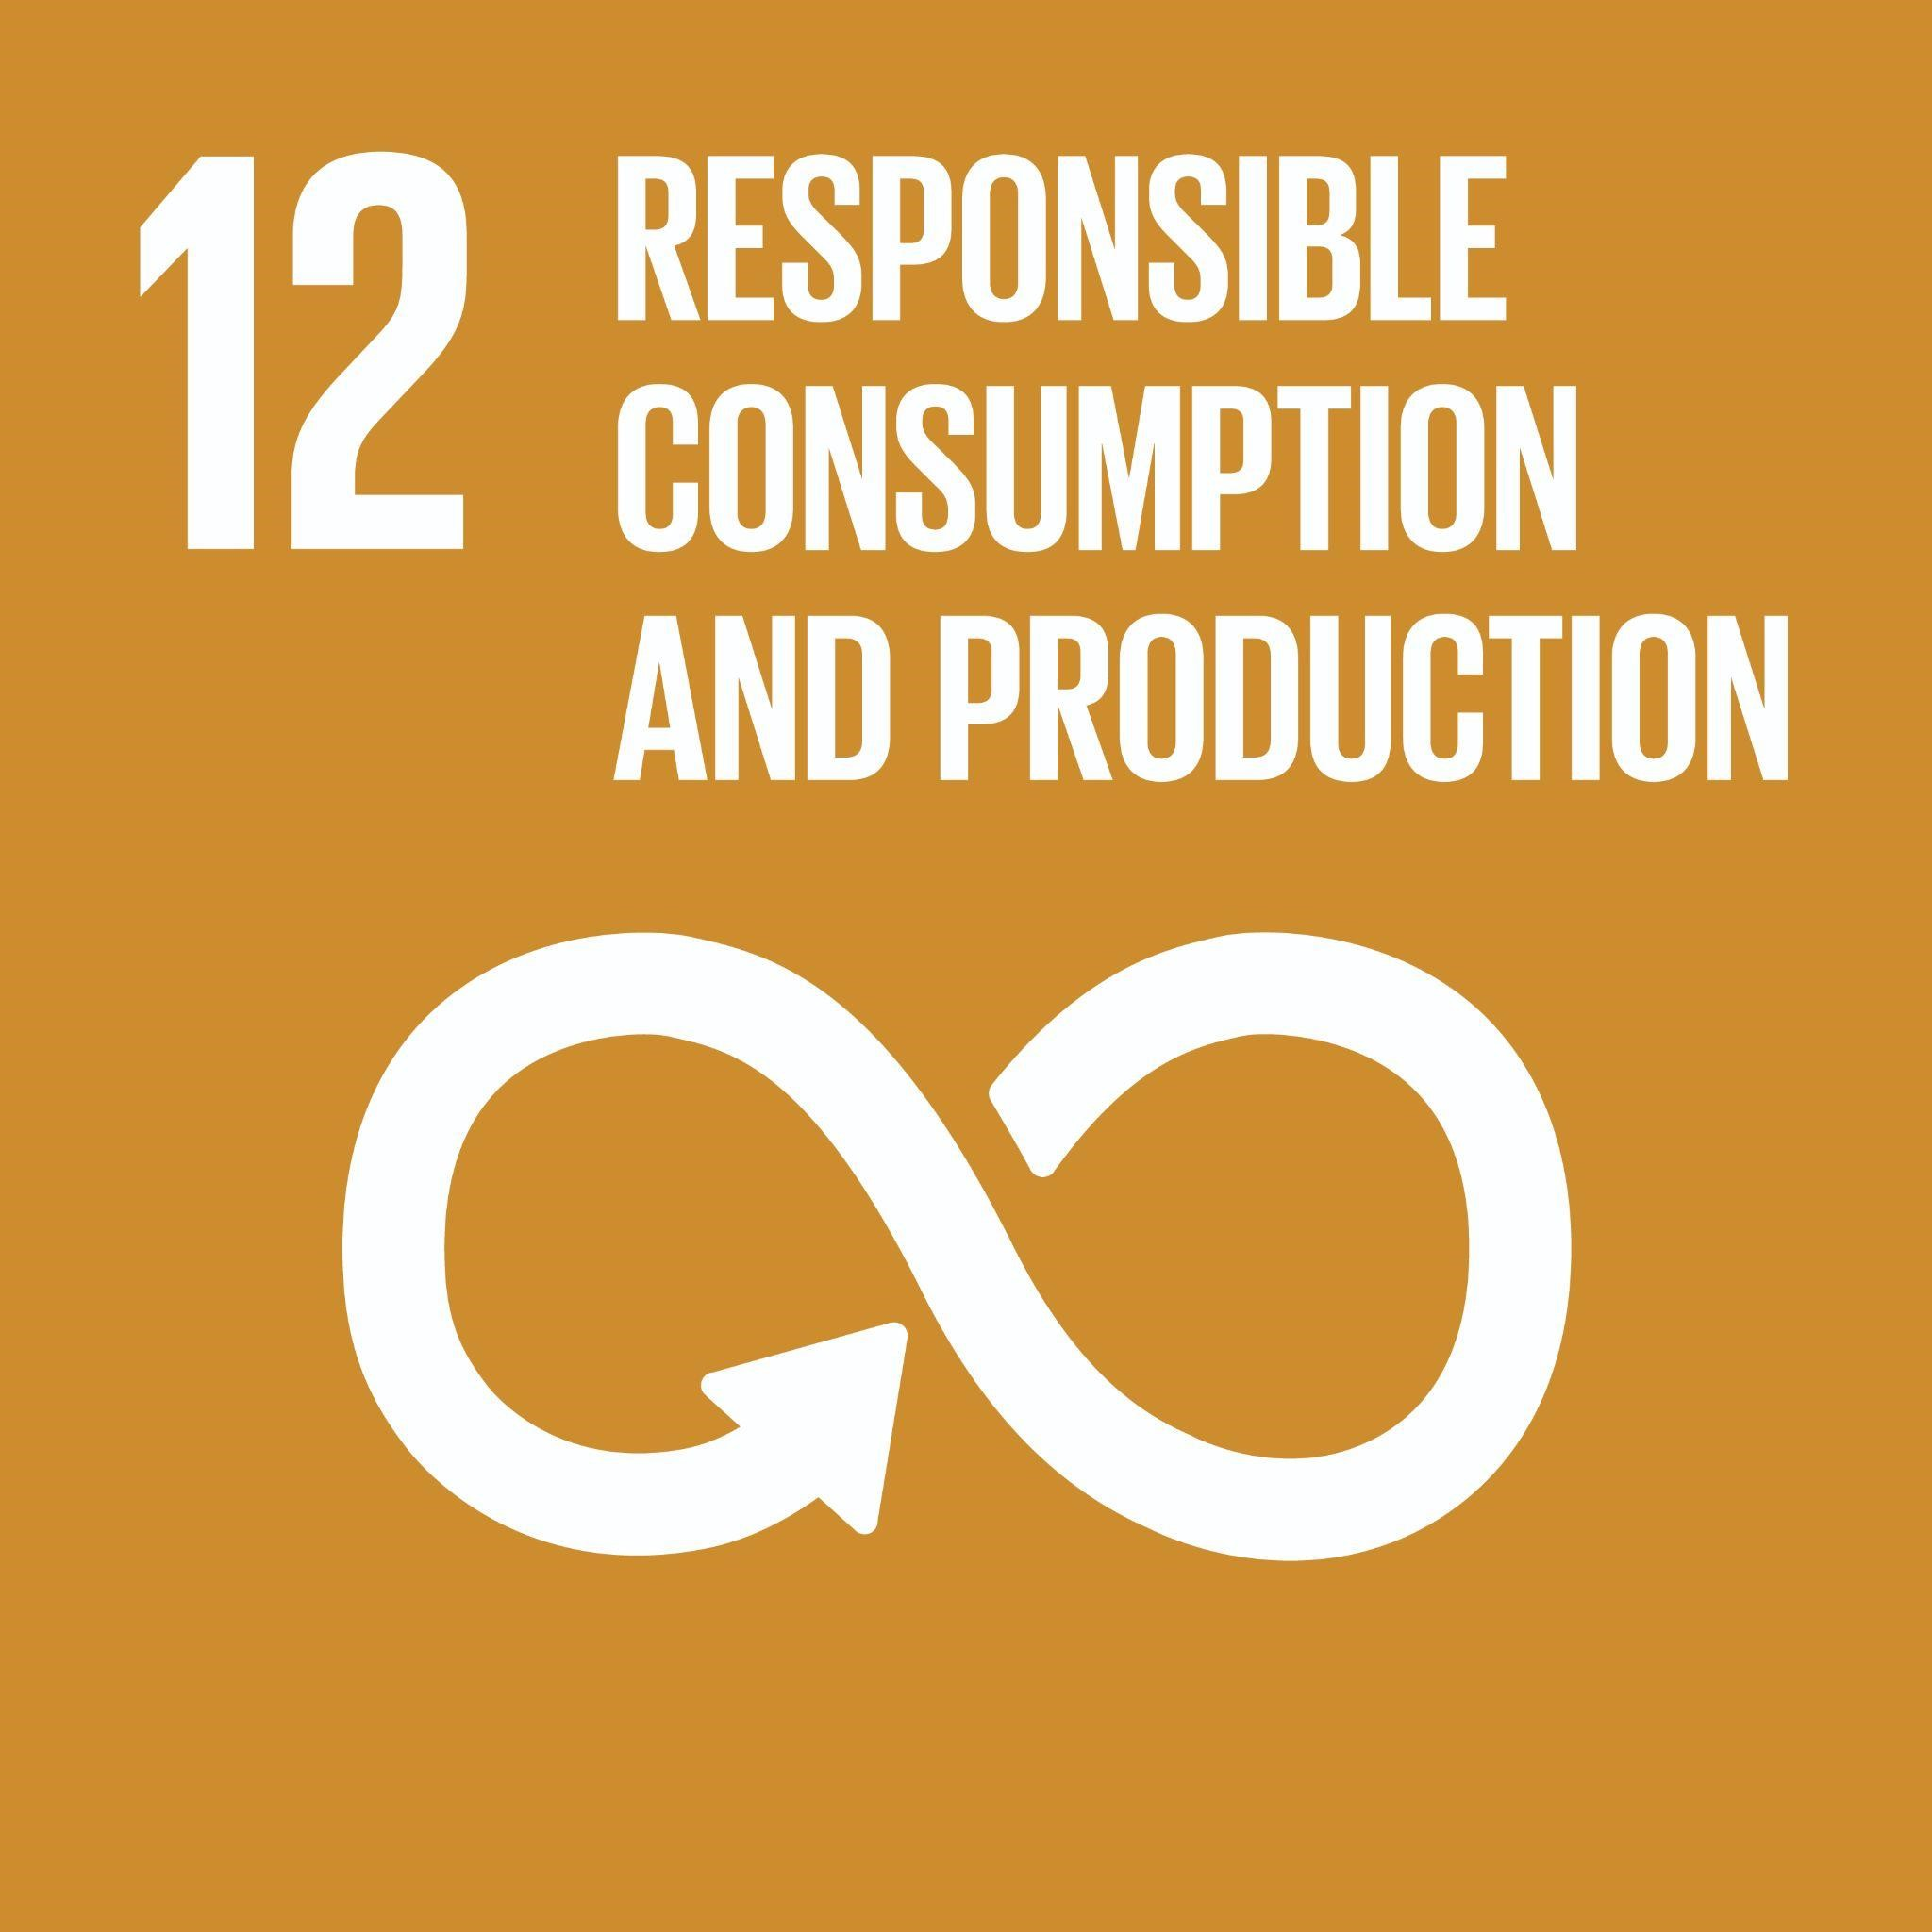 | In weeks 1 and 7, we will engage in experiential exercises that will allow us to think critically about the important role marketers have in terms of impacting responsible production and consumption. In week 12, we will consider the negative environmental impacts of consumption and a framework for encouraging more responsible consumer behaviours.
Goal 10: Reduced Inequality  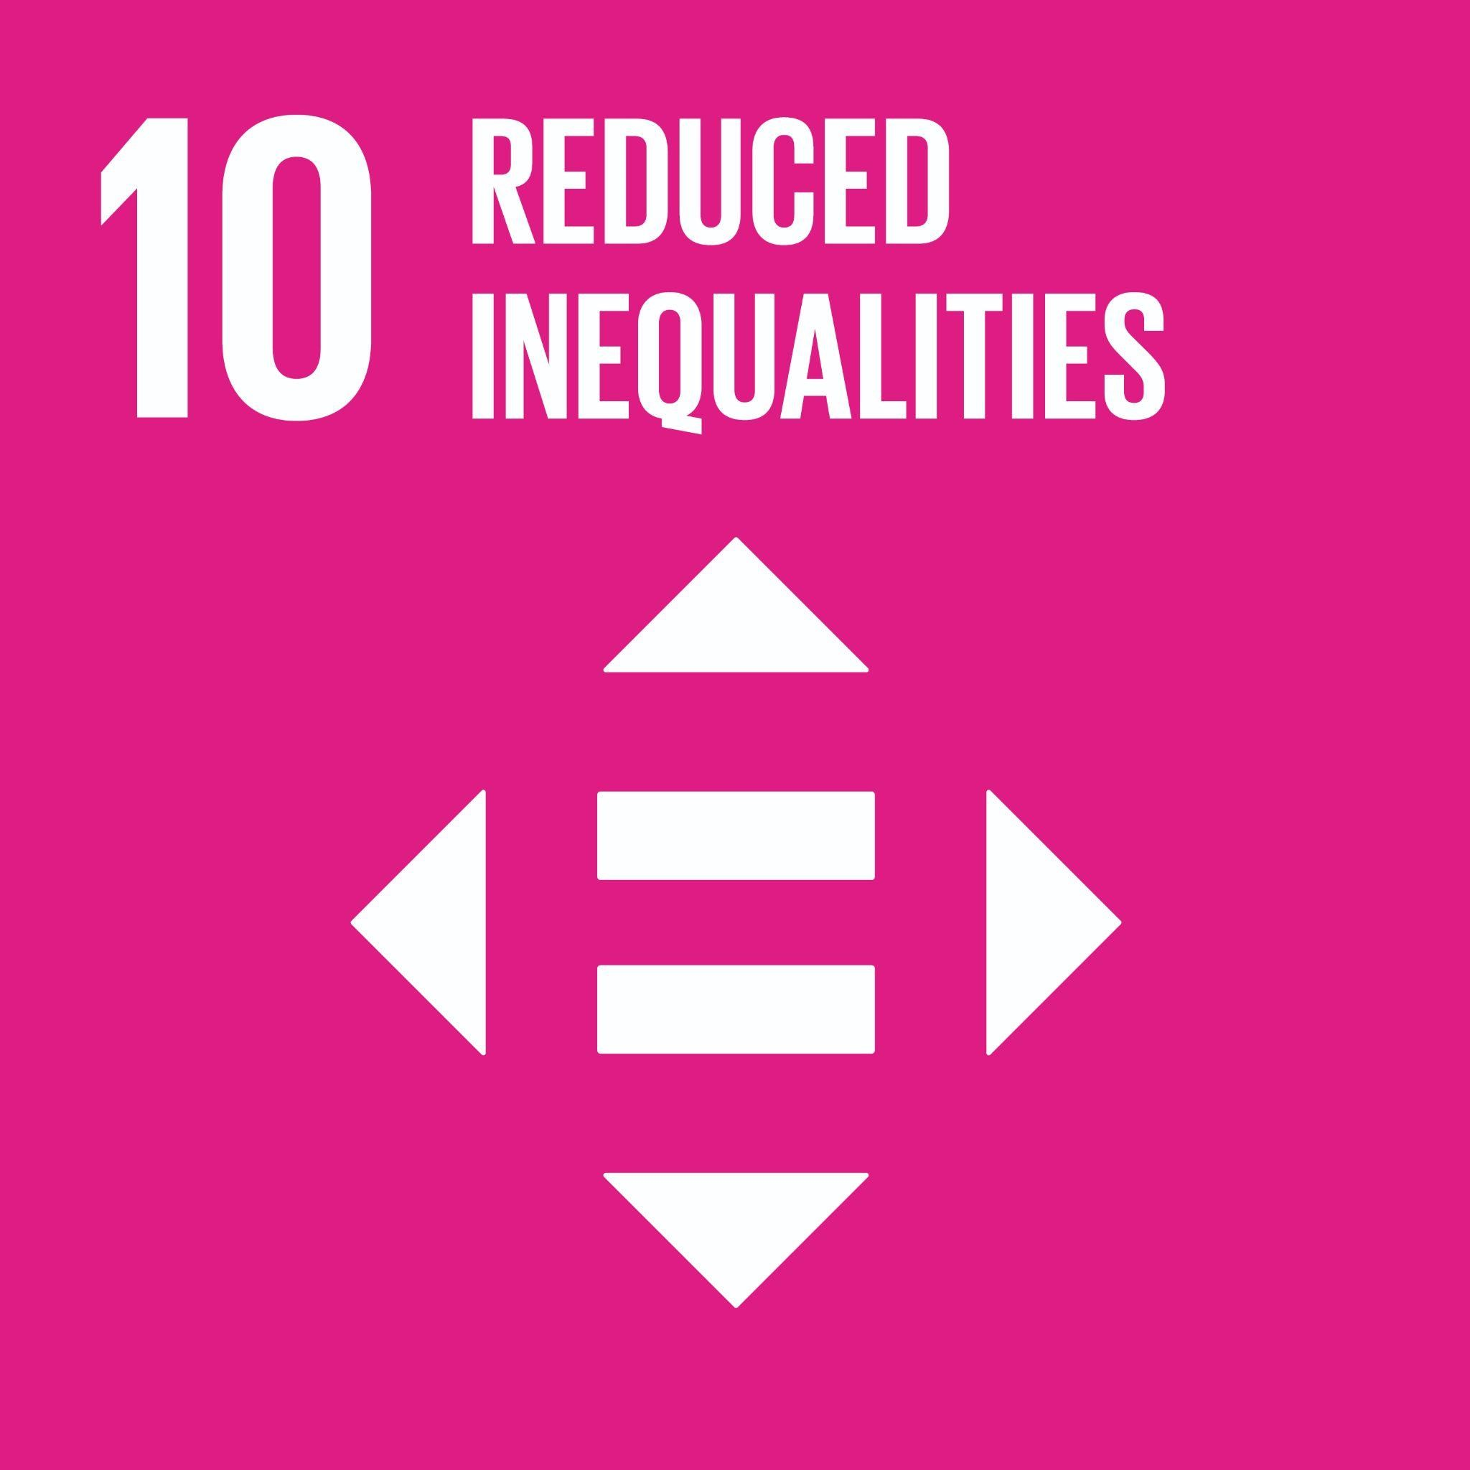 | In week 11, we will have reading, lecture content, and group discussions on how segmentation can treat consumers differentially based on various demographic differences, which can impact consumers’ access to different products and services.

Below is the complete SDG goal list to copy and paste from for the table above. Delete the below list once you have included your applicable goals in the table above.

Goal 1: No Poverty  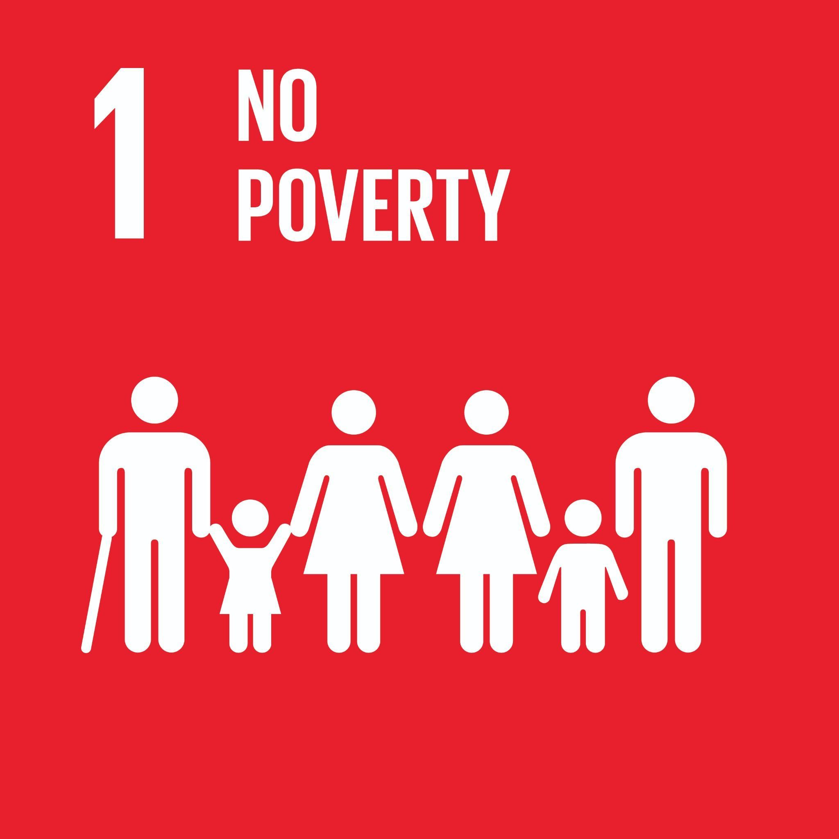 | End poverty in all its forms everywhere  Global Examples: access to basic goods and services, financial security, poverty elimination, income poverty, social services, poverty elimination, homelessness, thriving wage, skills training, income support, charitable donations
Goal 2: Zero Hunger:  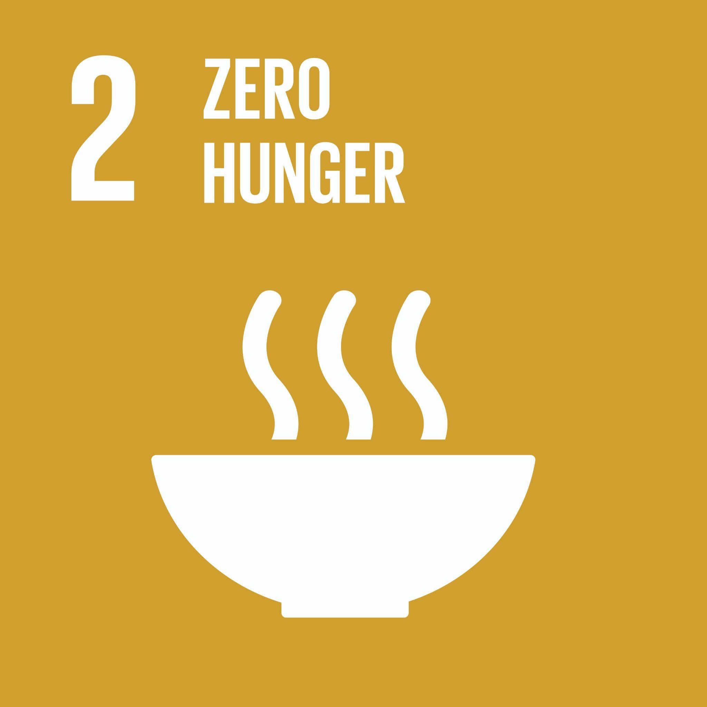 | End hunger, achieve food security and improved nutrition and promote sustainable agriculture  Global Examples: food security, malnutrition, equitable land access, healthy food, child obesity, regional food systems, farmer livelihoods, international food trade, urban agriculture, food waste, food byproducts use, food procurement, retail and distribution, food supply chains, circular food economy
Goal 3: Good Health and Well-being | Ensure healthy lives and promote well-being for all at all ages  Global Examples: disease prevention and response, addiction prevention and treatment, healthcare access, reproductive health, medication, mental health, aging, physical activity, quality of life, public health, workplace health and safety, health equity, pandemic response consumer, well-being, employee well-being, negative effects of advertising/consumption, health care optimization
Goal 4: Quality Education  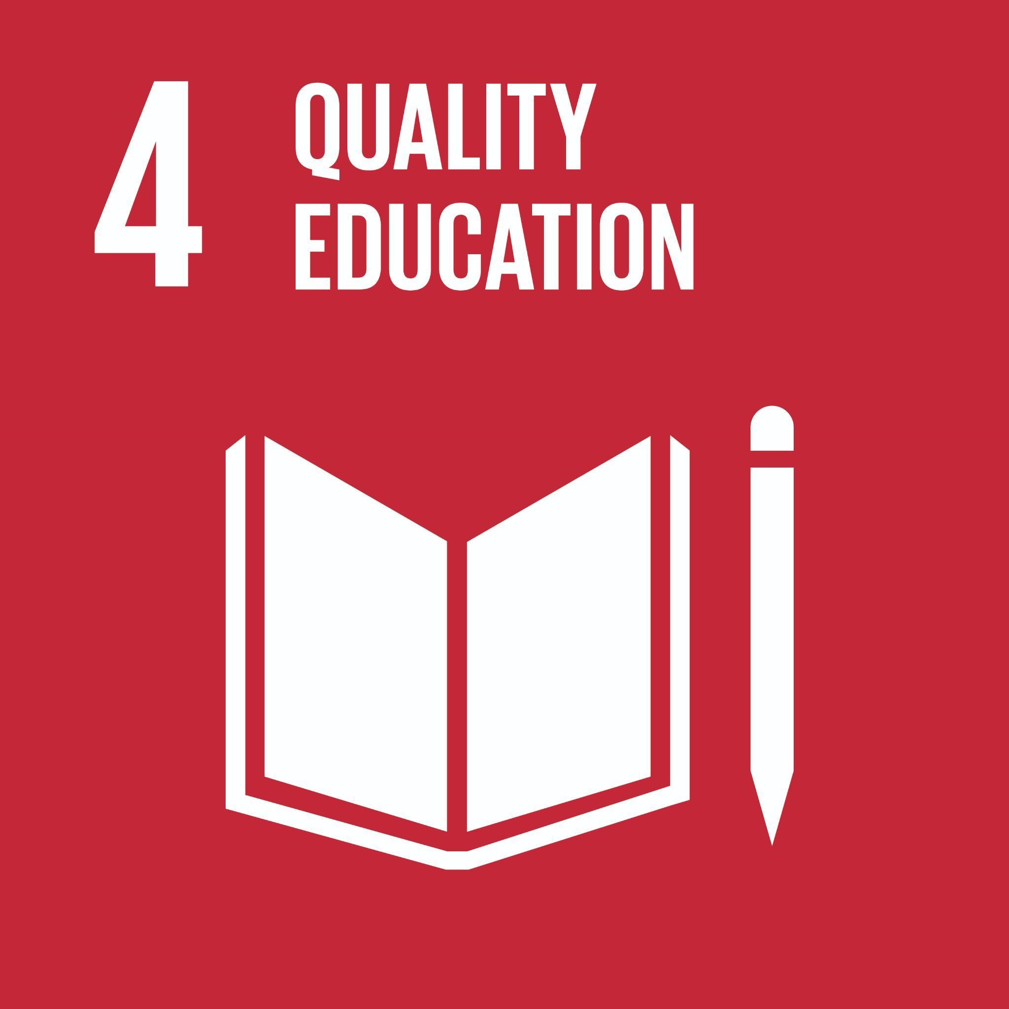 | Ensure inclusive and equitable quality education and promote lifelong learning opportunities for all  Global Examples: eliminating disparities in access to education, skill development, literacy and numeracy, equity in education, Indigenous education, responsible management topics, quality university education, safe, inclusive, and effective learning environments, financial literacy, climate literacy, life-long learning
Goal 5: Gender Equality  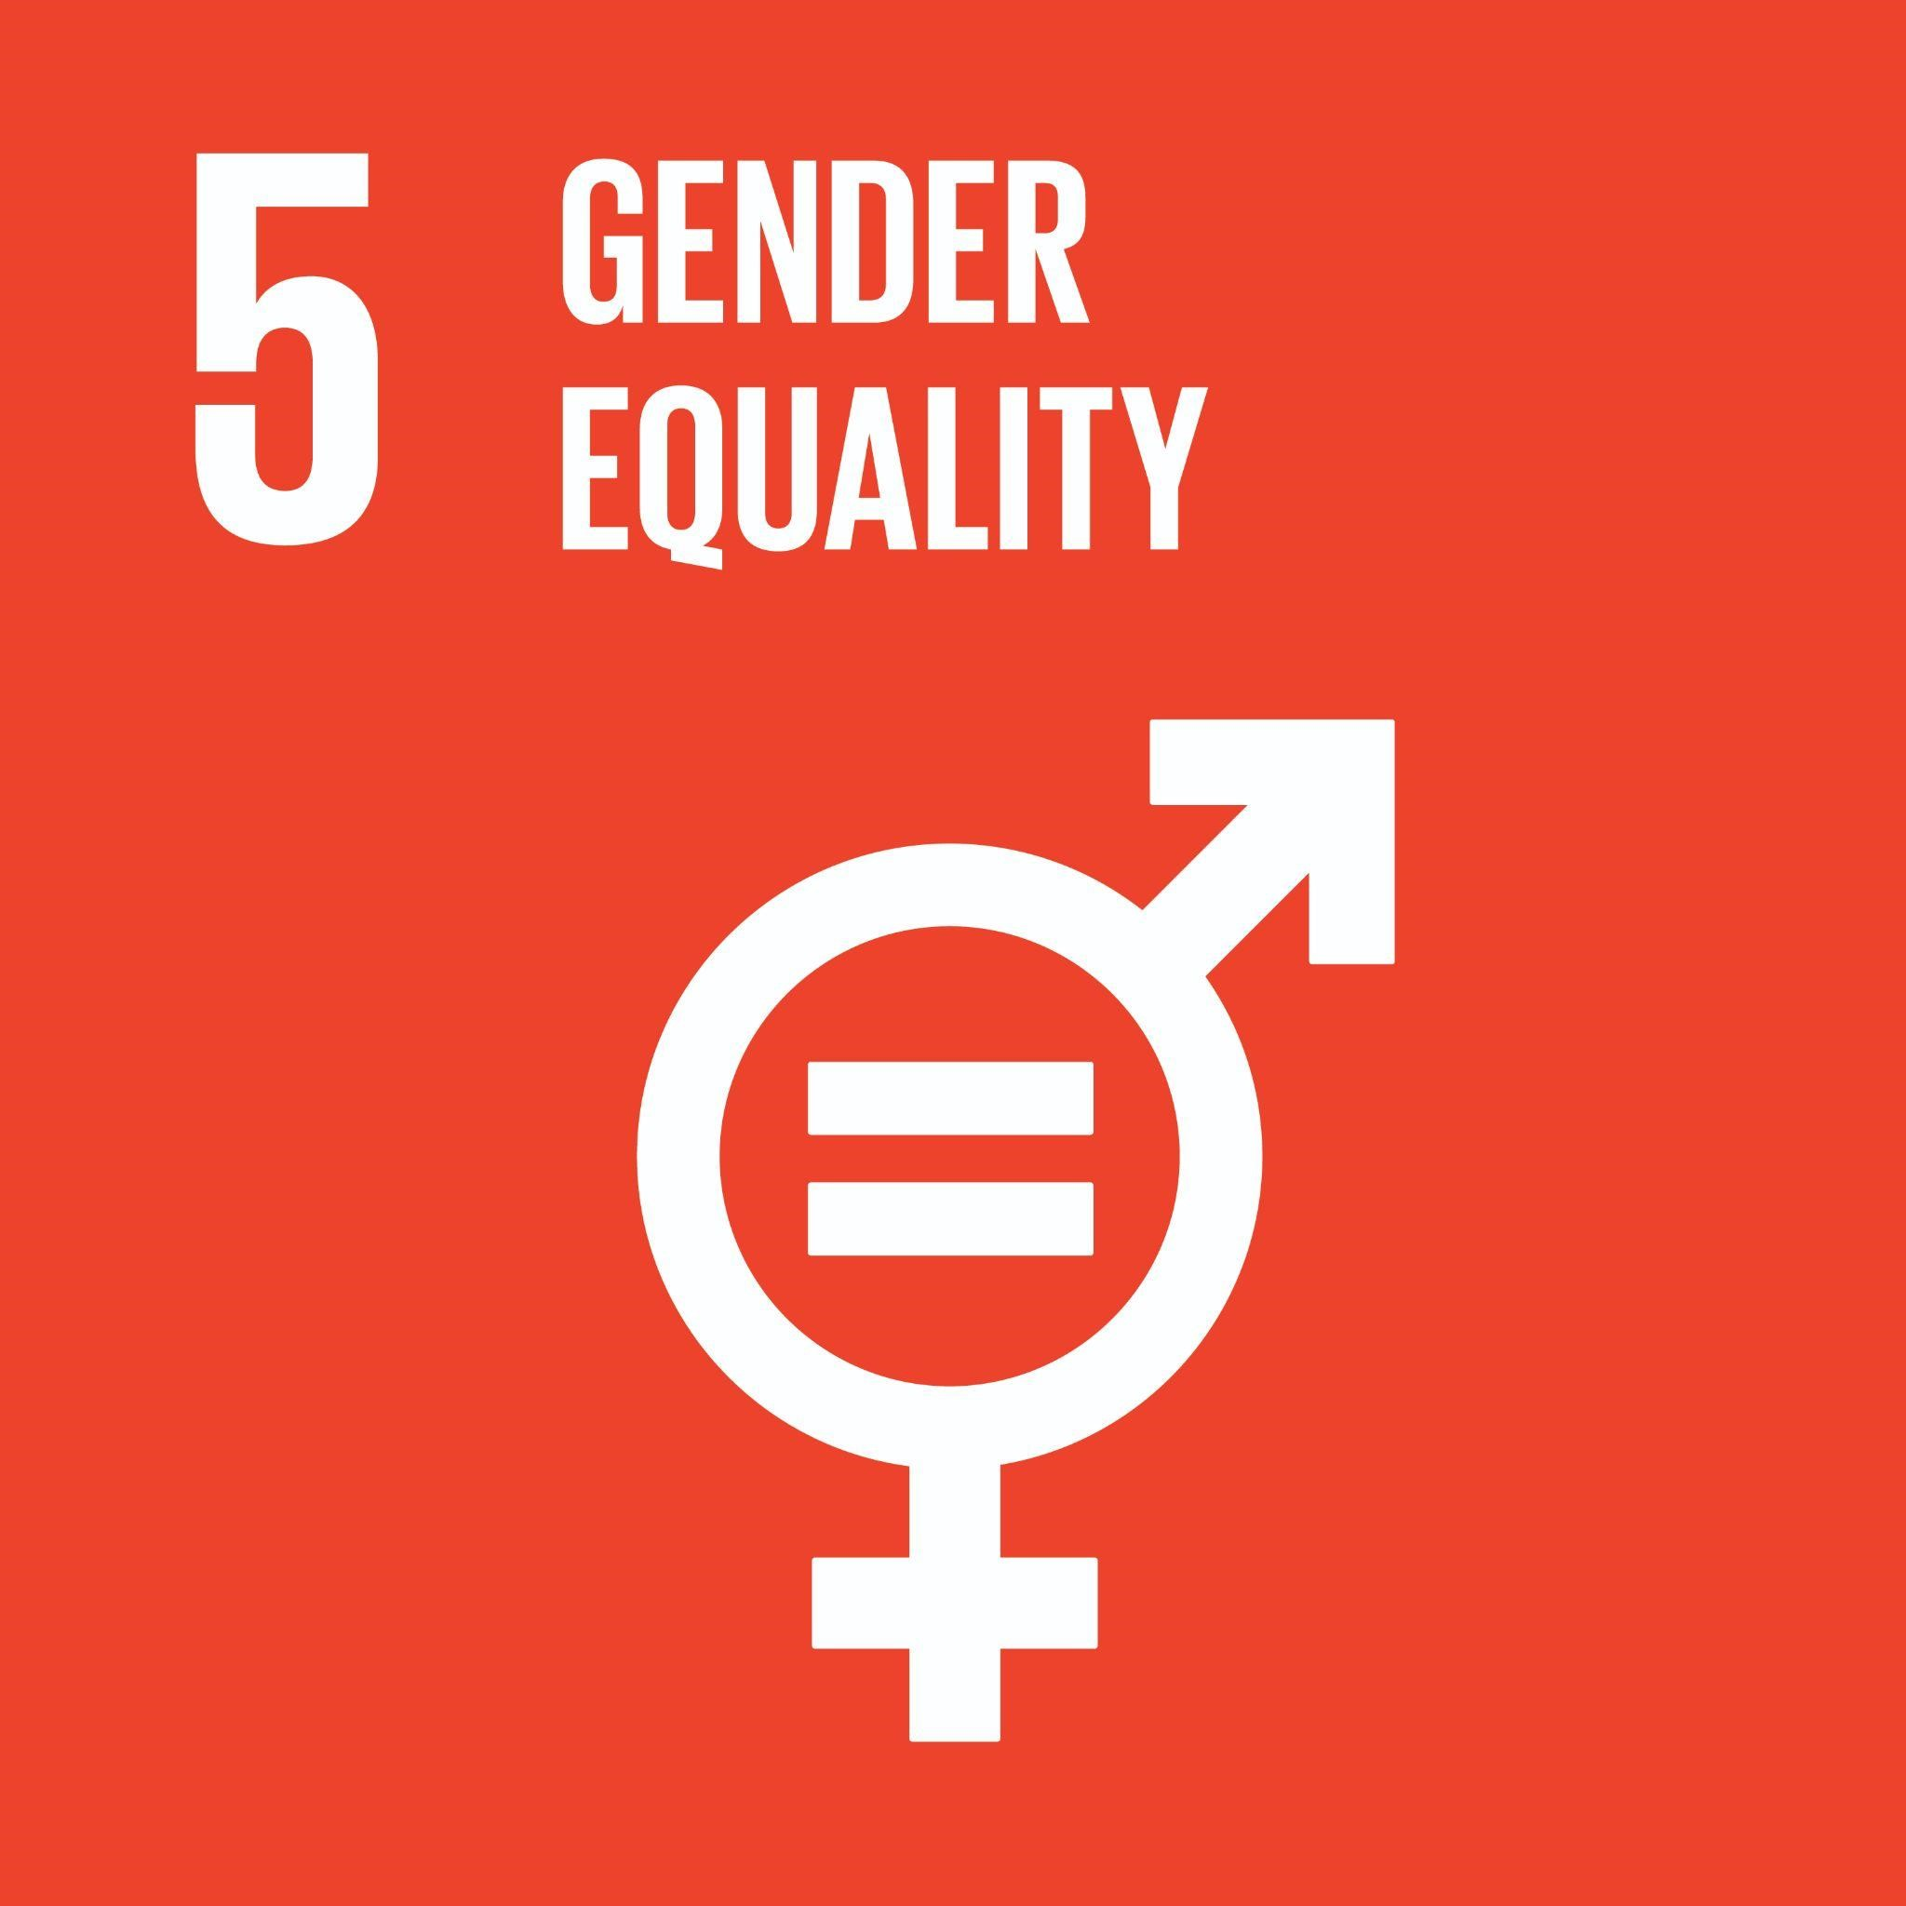 | Achieve gender equality and empower all women and girls  Global Examples: women’s rights and safety, violence against women, unpaid/domestic work recognition and support, women leadership and ownership, gender pay gap, non-binary gender rights, gender equity, women in entrepreneurship, LGBTQIA+ issues, employment and pay equity, diverse leadership, reproductive health, gender pay gap, gender disparities in promotions
Goal 6: Clean Water and Sanitation  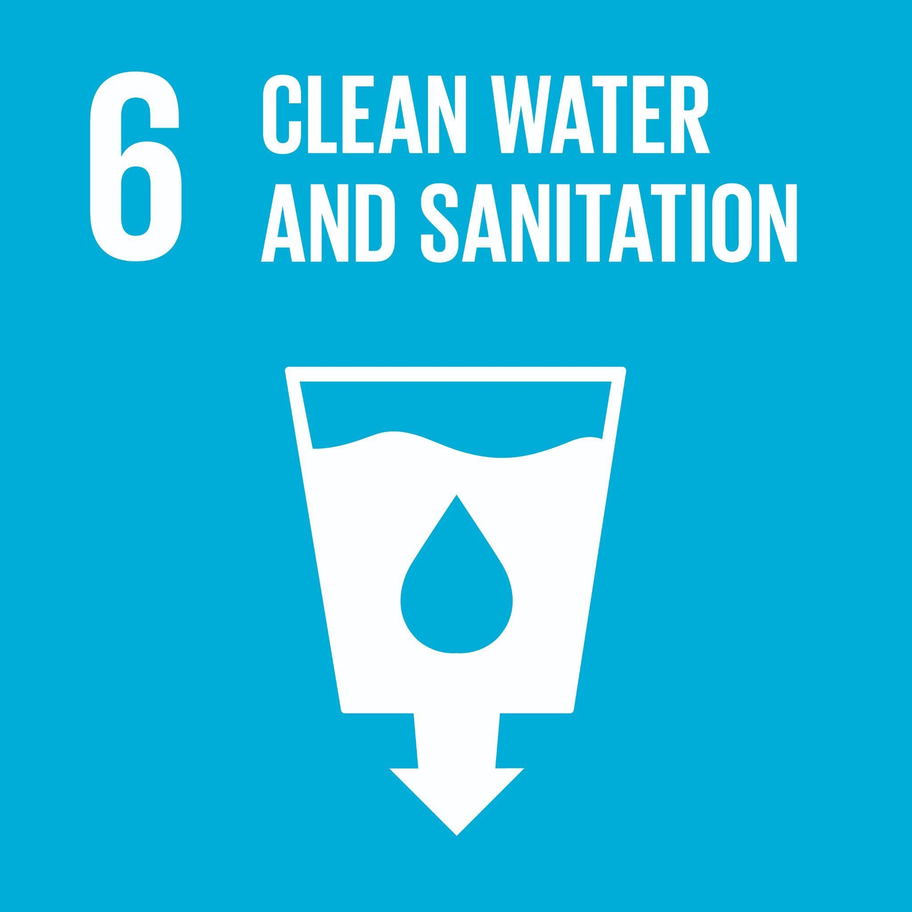 | Ensure availability and sustainable management of water and sanitation for all  Global Examples: access to clean drinking water, adequate waste water treatment, integrated water resources management, water reuse and recycling, watersheds, rivers, streams, ground water, water treatment, conservation
Goal 7: Affordable and Clean Energy  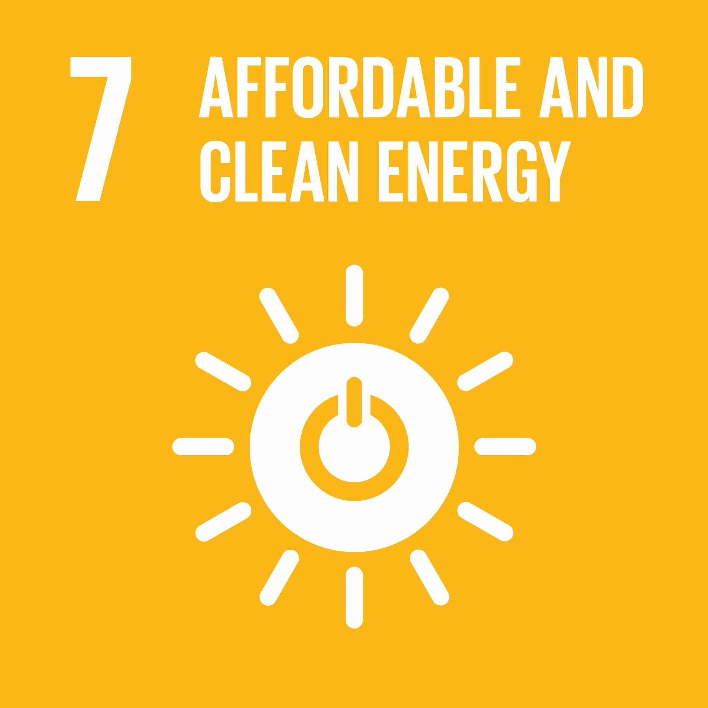 | Ensure access to affordable, reliable, sustainable and modern energy for all  Global Examples: access to clean energy, energy efficiency, energy policy, renewable energy, affordable clean energy, energy infrastructure upgrades, energy conservation, fossil fuel divestment, energy efficient buildings, renewable energy, community energy infrastructure
Goal 8: Decent Work and Economic Growth  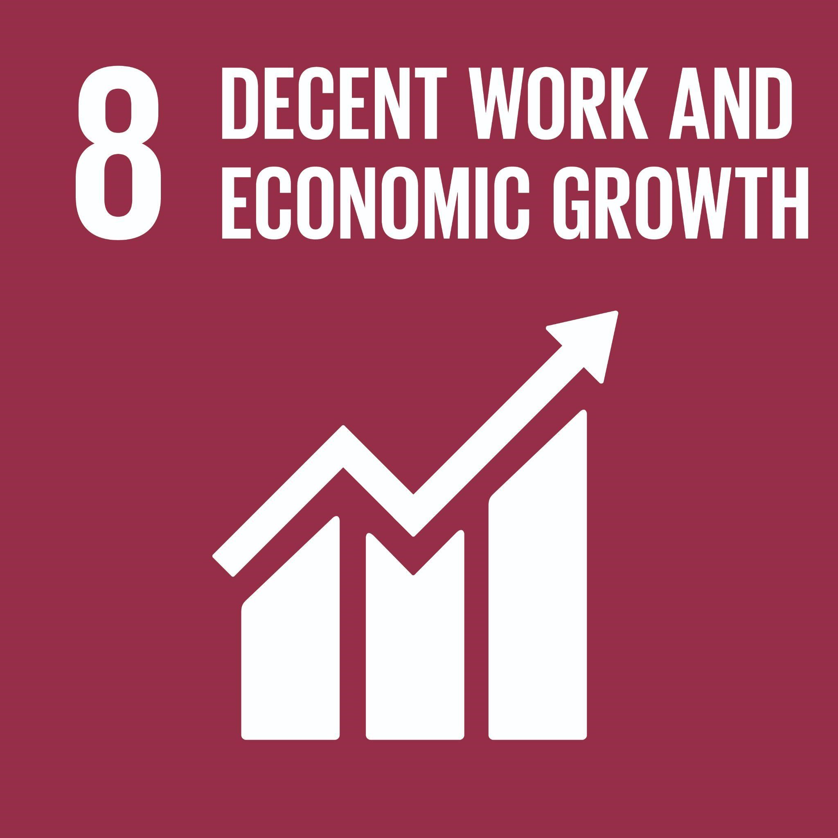 | Promote sustained, inclusive and sustainable economic growth, full and productive employment and decent work for all  Global Examples: economic diversification, small and medium businesses, fair trade, access to financial services, decent job creation, entrepreneurship, creativity and innovation, meaningful work, employment equity, income equity, labour rights, micro-finance, social finance, safe & inclusive workspace, alternatives to never-ending growth
Goal 9: Industry, Innovation and Infrastructure  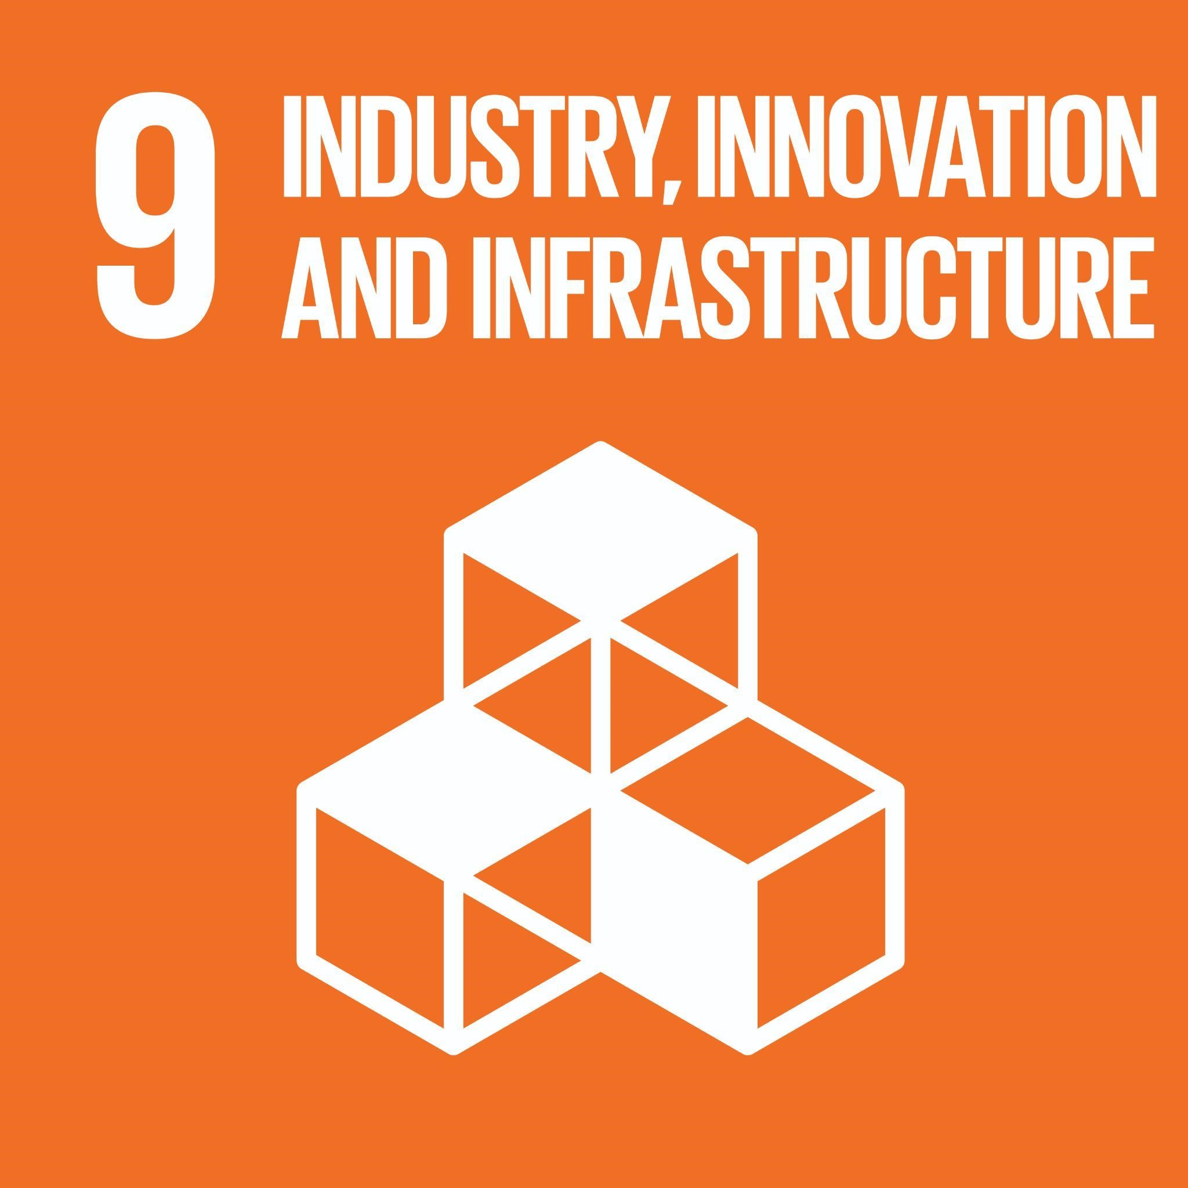 | Build resilient infrastructure, promote inclusive and sustainable industrialization and foster innovation  Global Examples: resilient infrastructure, inclusive and sustainable industrialization, innovation, access to transportation, micro-finance, access to credit, small-scale industry support, research and technology, entrepreneurship, access to technology, social enterprise
Goal 10: Reduce Inequality | Reduce inequality within and among countries  Global Examples: income equality, income support, inclusive employment policies, anti-racism, anti-discrimination, Indigenous reconciliation, disability, religion, race, equity, diversity and inclusion, wealth inequality, bias in AI, price discrimination, discrimination in segmentation, Indigenous inclusion, Indigenous participation
Goal 11: Sustainable Cities and Communities  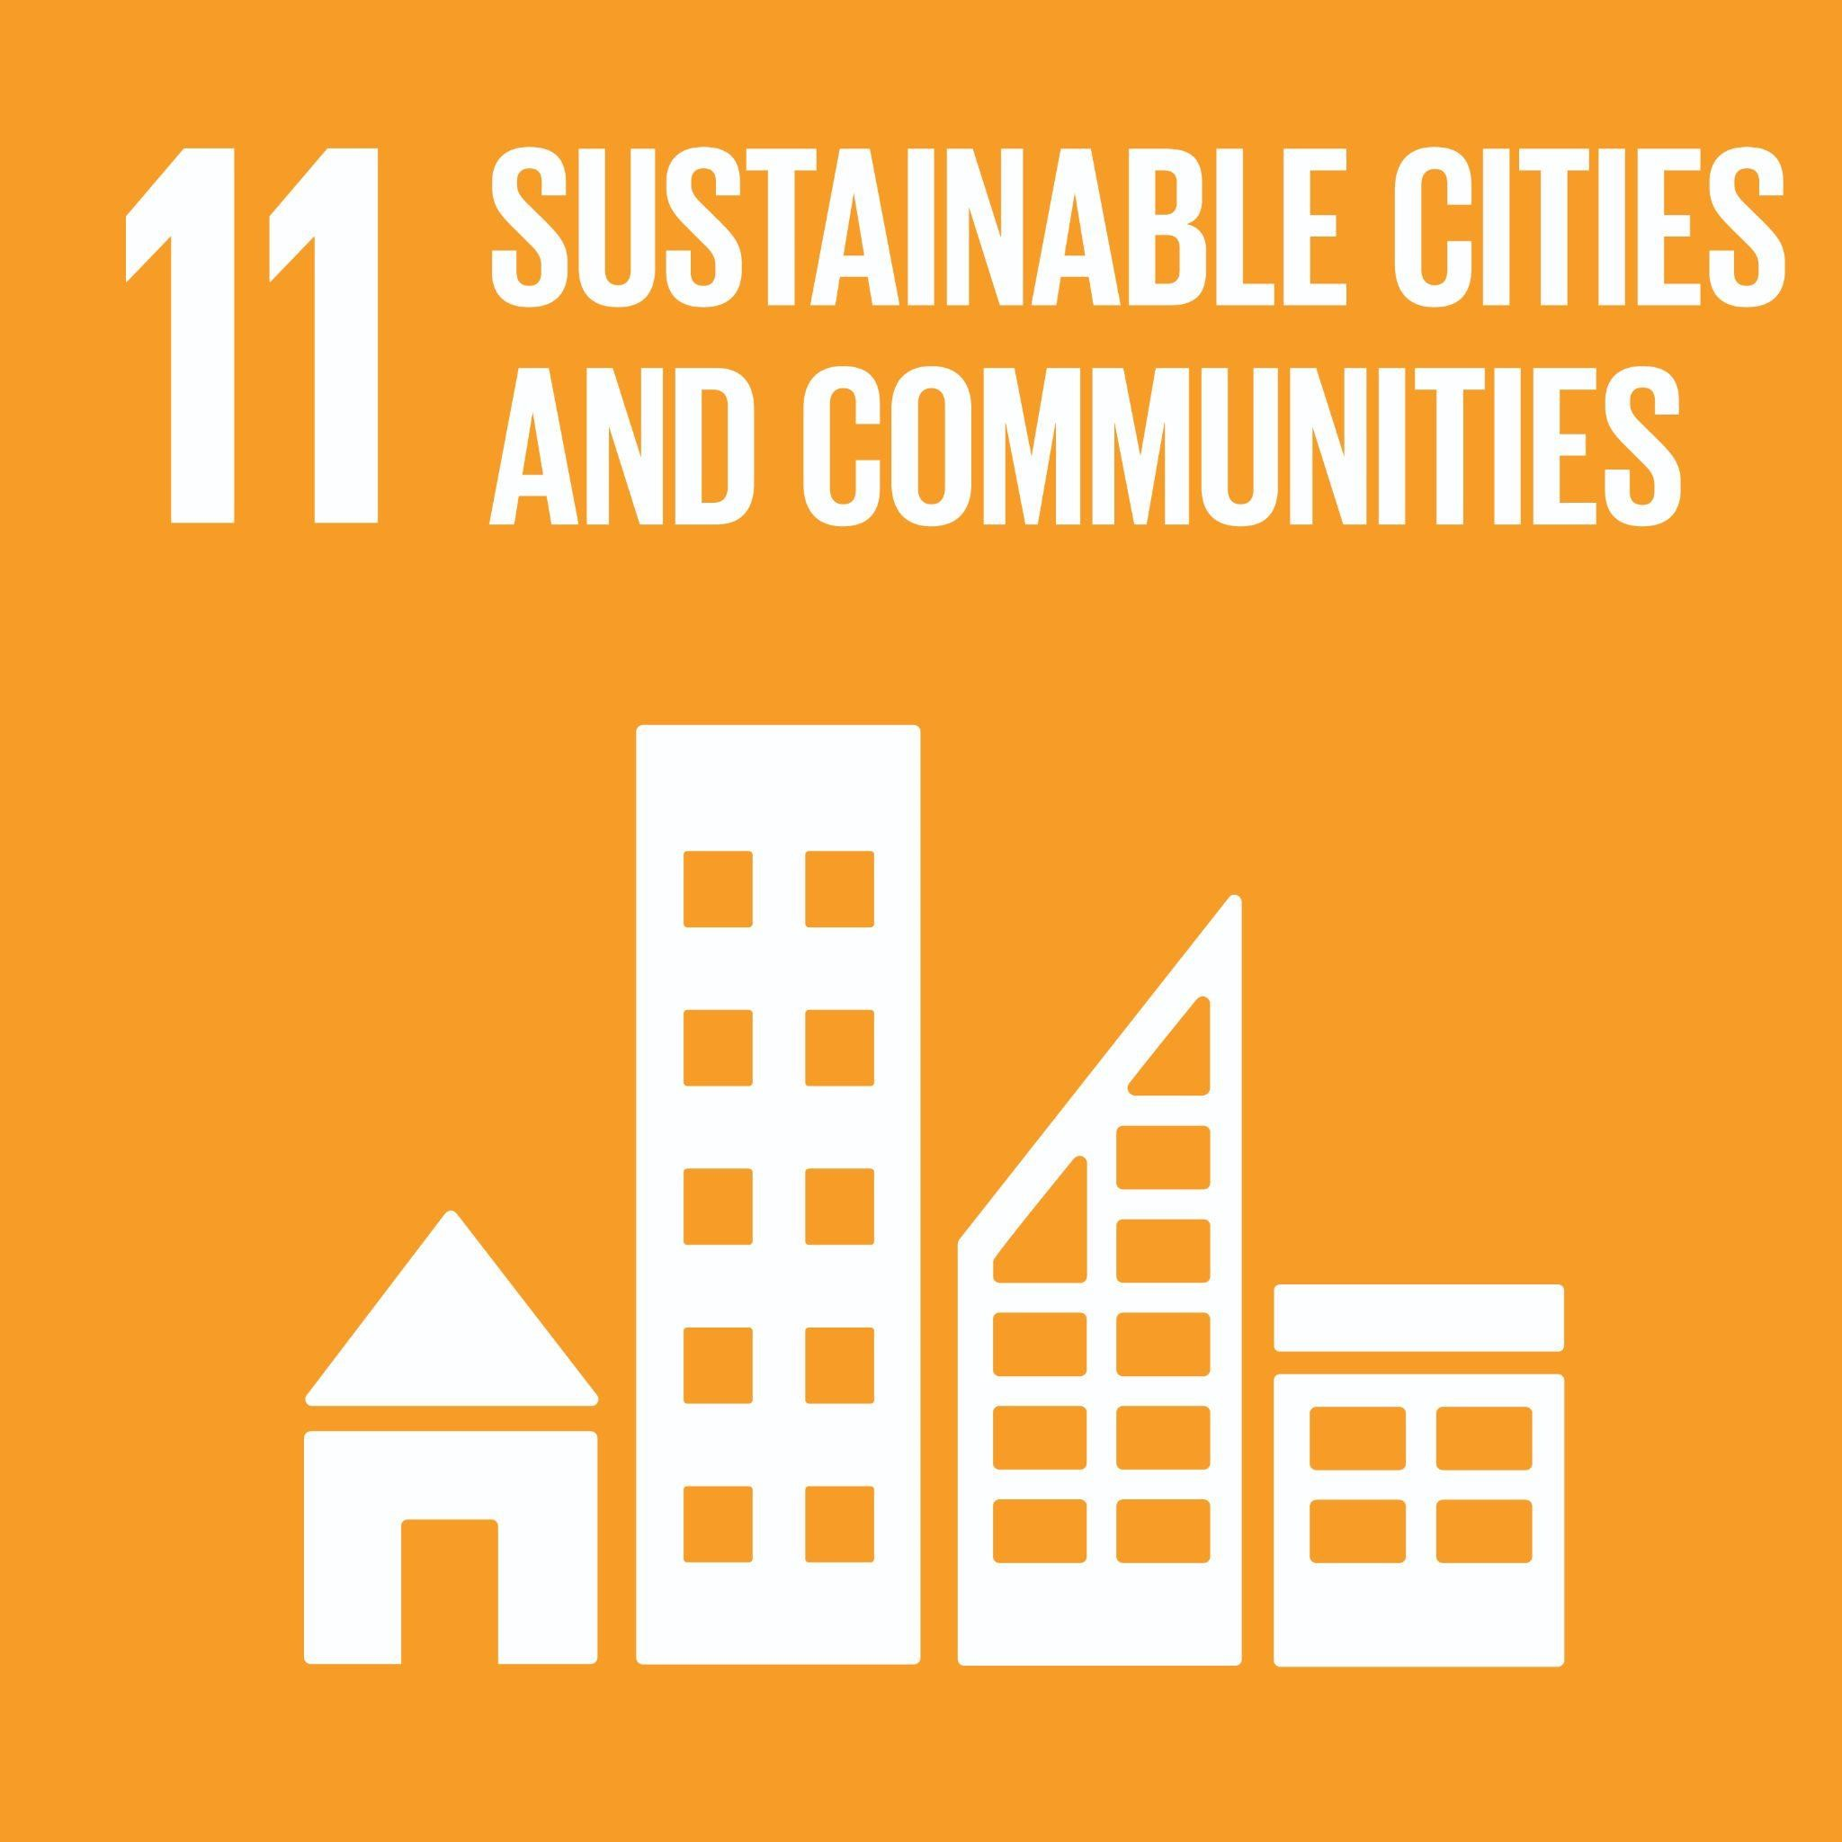 | Make cities and human settlements inclusive, safe, resilient and sustainable  Global Examples: transportation access, road safety, cultural/natural heritage, safe and affordable housing, urban planning, air quality, inclusive/safe/healthy public spaces, urban containment, urban governance, sustainable land use, effects of climate change on cities, valuing risk, sustainable transportation
Goal 12: Responsible Consumption and Production | Ensure sustainable consumption and production patterns  Global Examples: sustainable and equitable sourcing and production, sustainable procurement, sustainable distribution, food waste, life cycle analysis, recycling and reuse, ecological footprint, corporate social responsibility, fair trade, circular economy, consumer well-being, responsible sourcing, low emission supply chain design, responsible/ethical supply chain
Goal 13: Climate Action  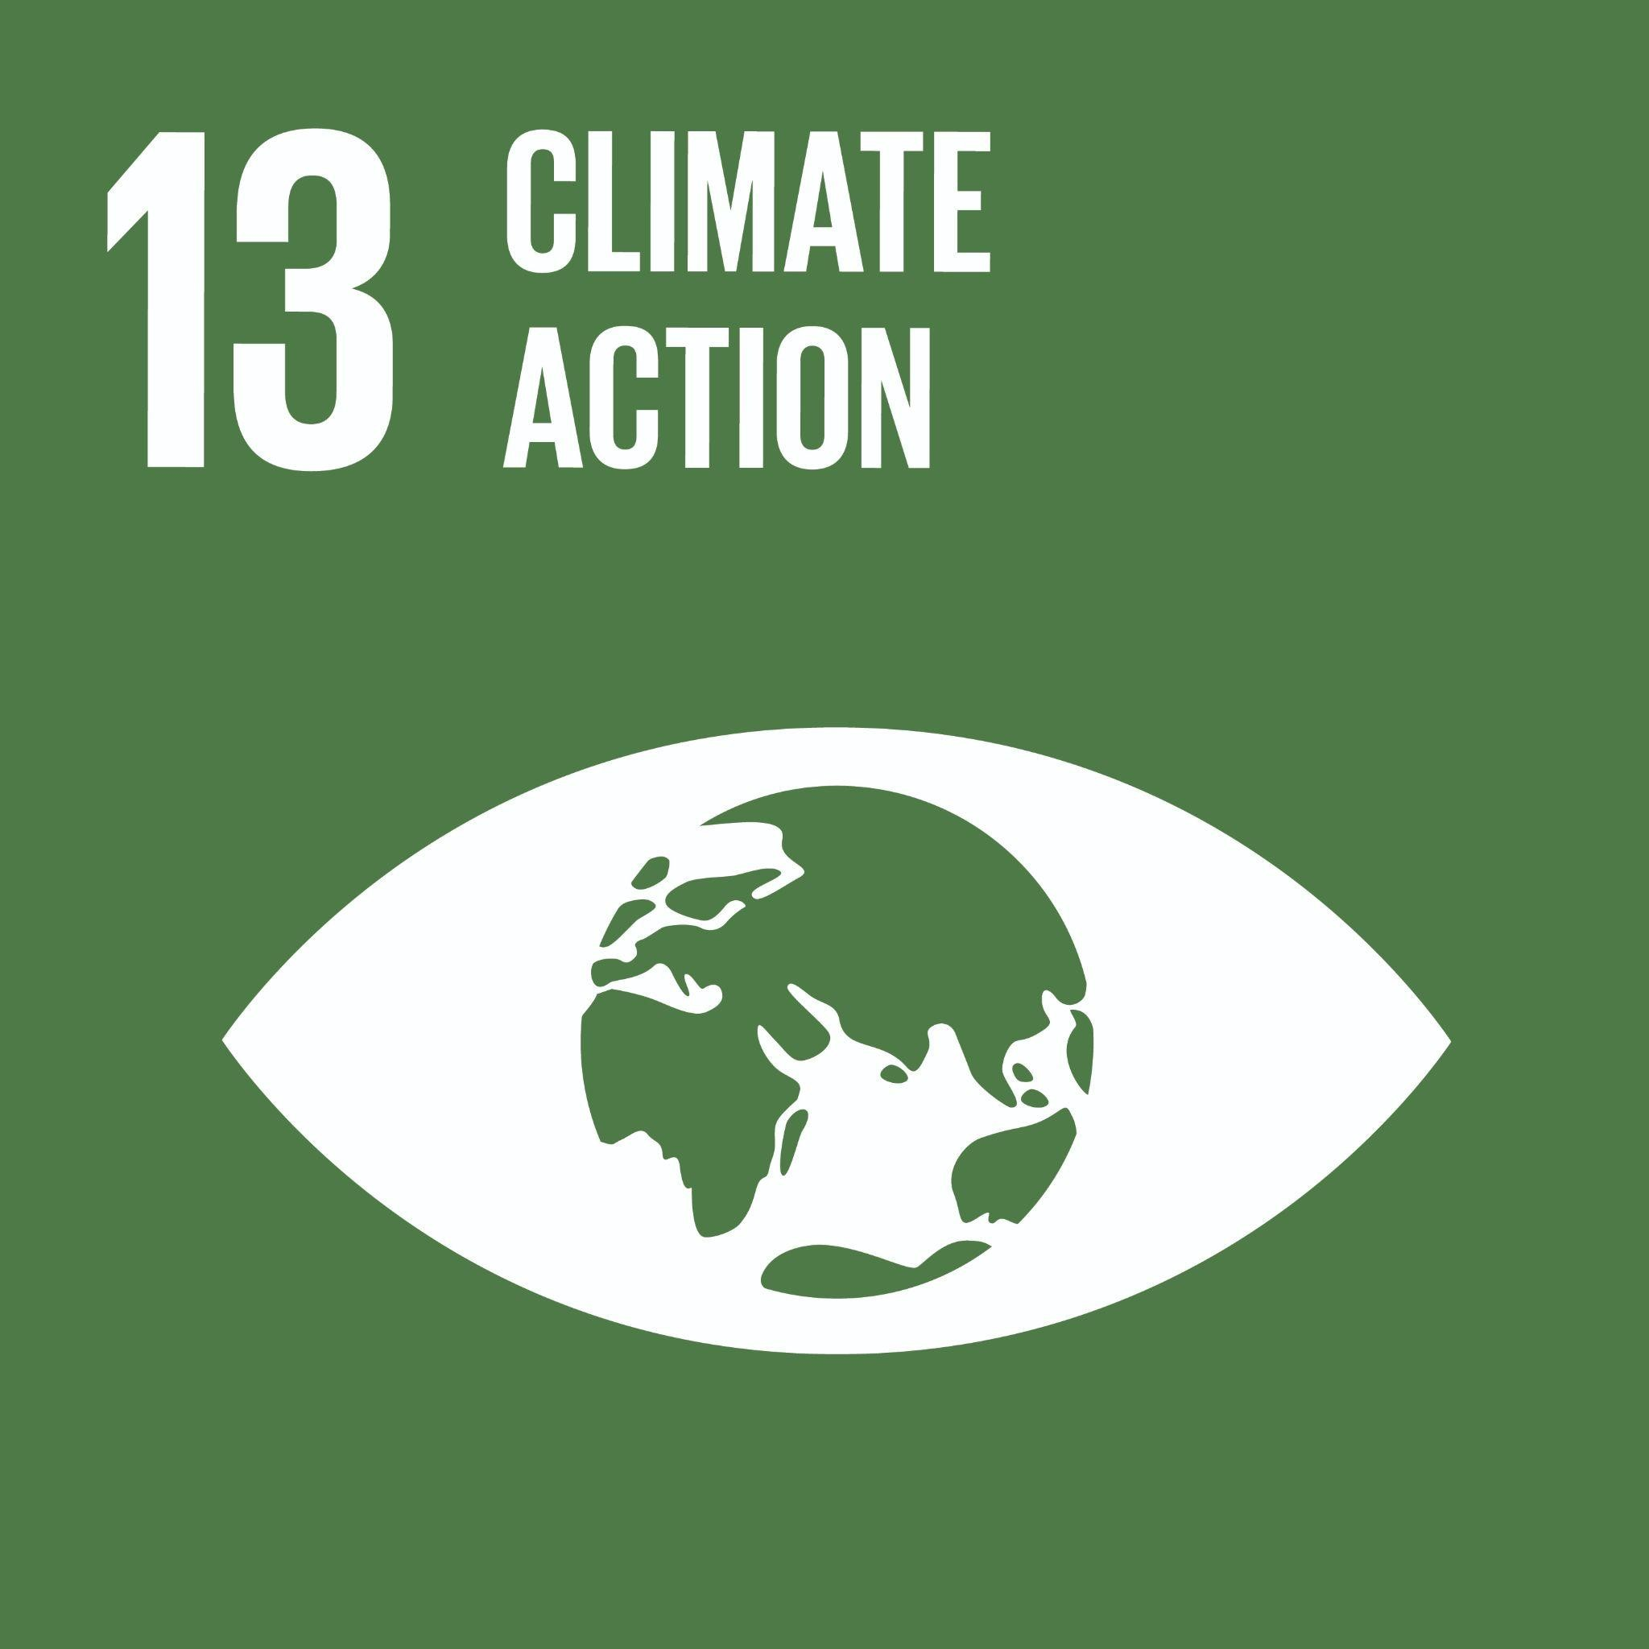 | Take urgent action to combat climate change and its impacts  Global Examples: natural disaster response, climate change mitigation, climate change adaptation, climate justice, climate policy, resilience, environmental externalities, low emission supply chain design, Environmental Disclosure, ESG accounting and reporting, Cap and Trade, Carbon Markets, Carbon Pricing;
Goal 14: Life Below Water  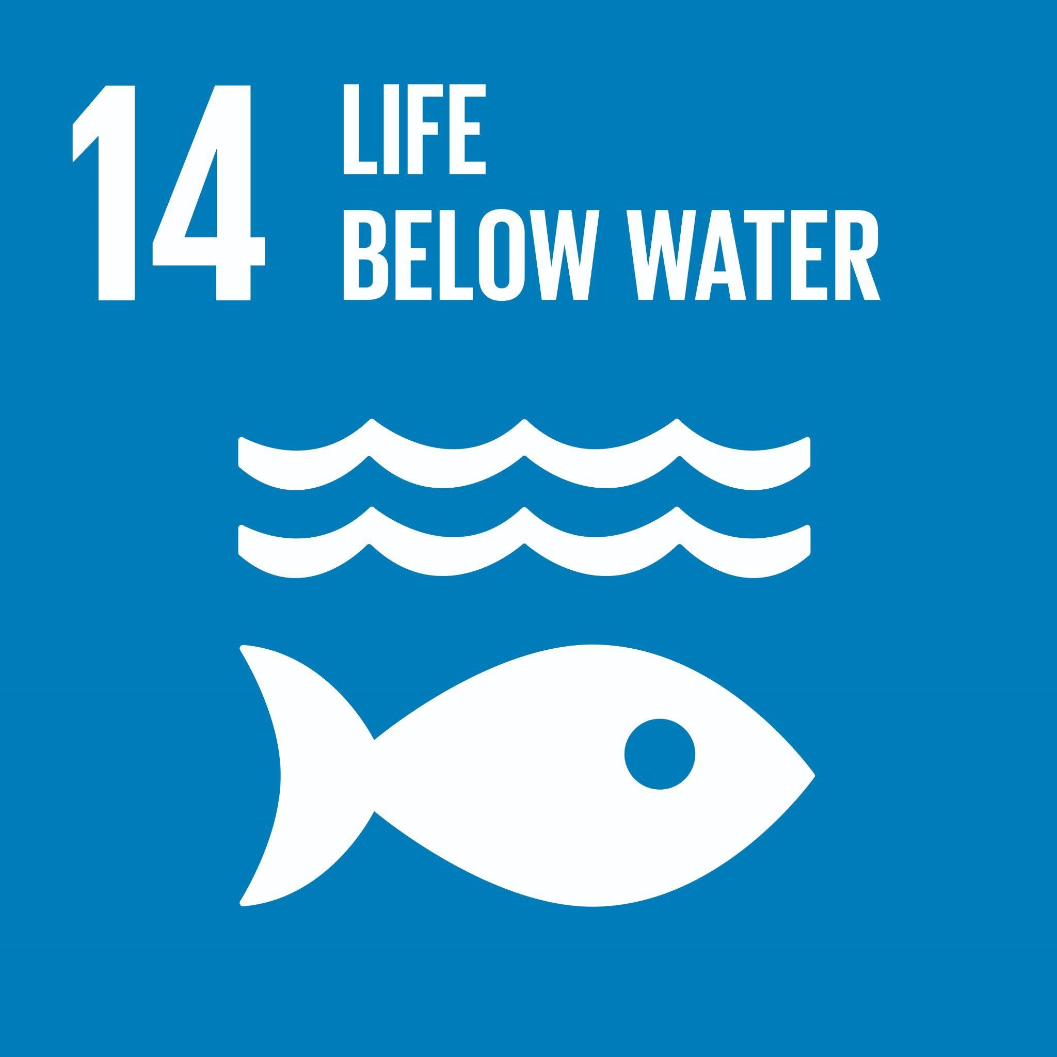 | Conserve and sustainably use the oceans, seas and marine resources for sustainable development  Global Examples: fishing and fisheries, ocean and freshwater pollution, coastal laws and water regulation, water conservation, aquatic ecosystem health
Goal 15: Life On Land  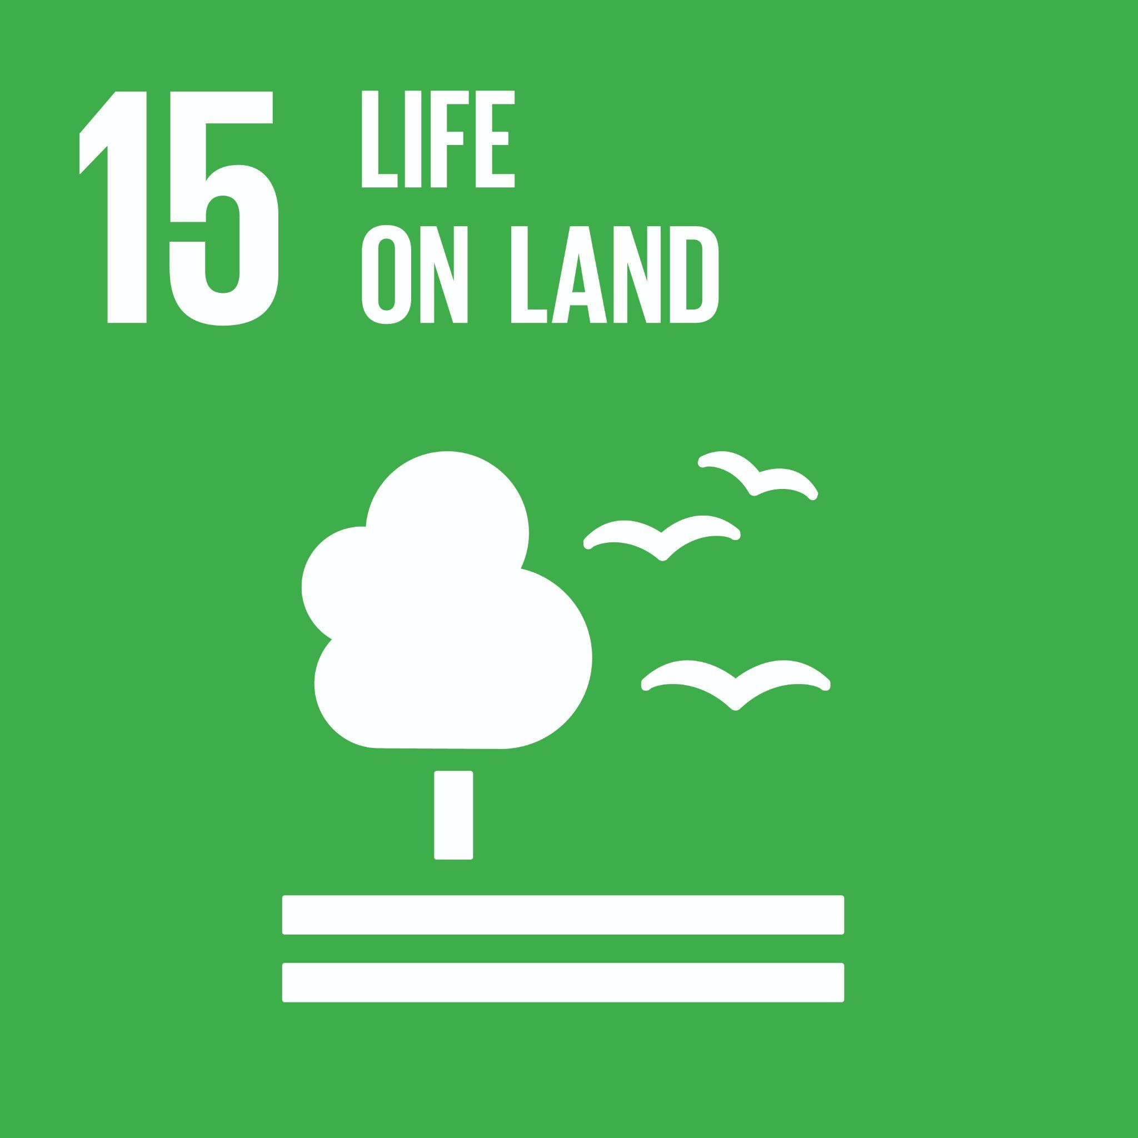 | Protect, restore and promote sustainable use of terrestrial ecosystems, sustainably manage forests, combat desertification, and halt and reverse land degradation and halt biodiversity loss  Global Examples: forests, wetlands, mountain and alpine ecosystems, sensitive ecosystems, biodiversity, soil health, endangered species, invasive species
Goal 16: Peace, Justice, and Strong Institutions | Promote peaceful and inclusive societies for sustainable development, provide access to justice for all and build effective, accountable and inclusive institutions at all levels  Global Examples: violence, corruption, government spending, public engagement, equity, advocacy, governance, leadership, laws and regulations, civic engagement, policy, accountable and transparent institutions, ethical institutions, responsive and inclusive decision making, ESG, data usage and transparency, transparency in financial reporting, environmental disclosure, codes of ethics
Goal 17: Partnerships for the goals  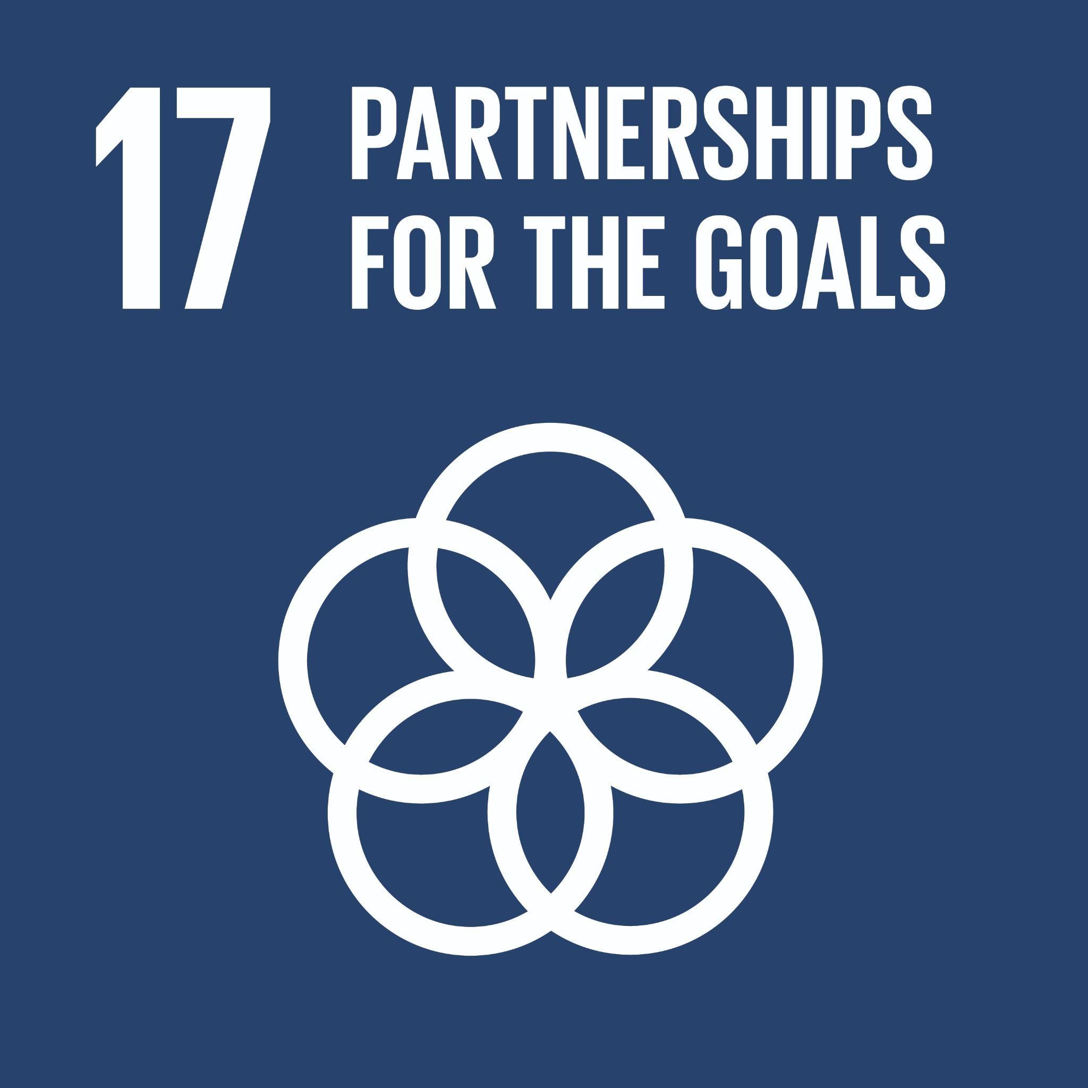 | Strengthen the means of implementation and revitalize the Global Partnership for Sustainable Development  Global Examples: international cooperation, trade, taxes, access to technology, data collection and sharing, cross-sector collaboration, cooperation, collaboration, partnerships, collective action, inter-disciplinary

AssessmentS

Summary
Component | Weight
Assignments | %
Group project | %
Midterm exam(s) | %
Final exam | %
Class participation | xx%
Total | 100%

Details of Assessments
[Explanation of each category in the Summary of Assessments above.

LEARNING MATERIALS
Required: [books, reading package, etc.]
Estimated cost of required materials: $xxx
Additional materials recommended but not required:

Course-specific Policies and resources

Missed or late assignments, and regrading of assessments
Late submissions will not be accepted and will receive a grade of zero. [This is standard for RHL courses.]
[Enumerate other policies on missed or late assignments, and regrading of assessments.]

Academic Concessions
If extenuating circumstances arise, please contact the RHL Graduate School program office as early as reasonably possible, and submit an Academic Concession Request & Declaration Form. If an academic concession is granted during the course, the student will be provided options by RHL, or by the instructor in consultation with RHL, per UBC’s policy on Academic Concession.

Other Course Policies and Resources
[Include the following policies and resources as appropriate.
- Policies on assessment due prior to students joining the course (i.e., during the add/drop period).

Code Plagiarism
Code plagiarism falls under the UBC policy for Academic Misconduct. Students must correctly cite any code that has been authored by someone else or by the student themselves for other assignments. Cases of "reuse" may include, but are not limited to:
  - the reproduction (copying and pasting) of code with none or minimal reformatting (e.g., changing the name of the variables)
  - the translation of an algorithm or a script from a language to another
  - the generation of code by automatic code-generations software
An “adequate acknowledgement” requires a detailed identification of the (parts of the) code reused and a full citation of the original source code that has been reused.
Students are responsible for ensuring that any work submitted does not constitute plagiarism. Students who are in any doubt as to what constitutes plagiarism should consult their instructor before handing in any assignments.

[Note that course policies must be reasonable and fair. For example, it is not reasonable to award zero to a student who missed an assignment due to registering into the class during the add/drop period. Policies cannot be punitive; only UBC’s President is authorized to impose discipline, and only after a finding of misconduct. For example, a grade deduction of 10% of the course grade for poor contribution to a group project when the student’s group members would have each earned 7% would be considered punitive. Unreasonable or punitive policies are appealable to the Dean’s Office and the Senate’s Committee on Appeals on Academic Standing.]

Policies applicable to Courses in the Robert H. Lee Graduate School [DO NOT MODIFY]

Attendance
Excepting extenuating circumstances, students are expected to attend 100% of their scheduled class hours. Absent students limit their own academic potential, and that of their classmates, and cause unnecessary disruption to the learning environment. Students missing more than 20% of the total scheduled class hours for a course (including classes held during the add/drop period) without having received an academic concession will be withdrawn from that course. Withdrawals, depending on timing, could result in a “W” or an “F” standing on the transcript.

Punctuality
Students are expected to arrive for classes and activities on time and fully prepared to engage. Late arrivals may be refused entry at the discretion of the instructor or activity lead. Students arriving later than halfway through a scheduled class will be treated as absent for that class.

Electronic Devices
In-Person Regulations
Devices such as laptops, tablets, and cell phones are not permitted to be used in class unless directed by the instructor for in-class activities. Students who do not follow the School’s policy in this regard may be required to leave the room for the remainder of the class, so that they do not distract others. Research shows that students’ use of laptops in class has negative implications for the learning environment, including reducing their own grades and the grades of those sitting around them.

Citation Style
Please use the American Psychological Association (APA) reference style to cite your sources.

Details of the above policies and other RHL Policies are available at: http://www.calendar.ubc.ca/vancouver/index.cfm?tree=12,199,506,1625

University Policies and resources [do not modify this paragraph]
UBC provides resources to support student learning and to maintain healthy lifestyles but recognizes that sometimes crises arise and so there are additional resources to access including those for survivors of sexual violence. UBC values respect for the person and ideas of all members of the academic community. Harassment and discrimination are not tolerated nor is suppression of academic freedom. UBC provides appropriate accommodation for students with disabilities and for religious observances. UBC values academic honesty and students are expected to acknowledge the ideas generated by others and to uphold the highest academic standards in all of their actions. Details of the policies and how to access support are available on the UBC Senate website at https://senate.ubc.ca/policies-resources-support-student-success.

Respect for Equity, Diversity, and Inclusion
The UBC Sauder School of Business strives to promote an intellectual community that is enhanced by diversity along various dimensions including status as a First Nation, Metis, Inuit, or Indigenous person, race, ethnicity, gender identity, sexual orientation, religion, political beliefs, social class, and/or disability. It is critical that students from diverse backgrounds and perspectives be valued in and well-served by their courses. Furthermore, the diversity that students bring to the classroom should be viewed as a resource, benefit, and source of strength for your learning experience. It is expected that all students and members of our community conduct themselves with empathy and respect for others.

Academic Integrity
The academic enterprise is founded on honesty, civility, and integrity. As members of this enterprise, all students are expected to know, understand, and follow the codes of conduct regarding academic integrity. At the most basic level, this means submitting only original work done by you and acknowledging all sources of information or ideas and attributing them to others as required. This also means you should not cheat, copy, or mislead others about what is your work. Violations of academic integrity (i.e., misconduct) lead to the breakdown of the academic enterprise, and therefore serious consequences arise and harsh sanctions are imposed. For example, incidences of plagiarism or cheating may result in a mark of zero on the assignment or exam and more serious consequences may apply if the matter is referred to the President’s Advisory Committee on Student Discipline. Careful records are kept in order to monitor and prevent recurrences.

Academic Freedom and Students Studying from Outside Canada[do not modify this paragraph]
During this pandemic, the shift to online learning has greatly altered teaching and studying at UBC, including changes to health and safety considerations. Keep in mind that some UBC courses might cover topics that are censored or considered illegal by non-Canadian governments. This may include, but is not limited to, human rights, representative government, defamation, obscenity, gender or sexuality, and historical or current geopolitical controversies. If you are a student living abroad, you will be subject to the laws of your local jurisdiction, and your local authorities might limit your access to course material or take punitive action against you. UBC is strongly committed to academic freedom, but has no control over foreign authorities (please visit http://www.calendar.ubc.ca/vancouver/index.cfm?tree=3,33,86,0 for an articulation of the values of the University conveyed in the Senate Statement on Academic Freedom). Thus, we recognize that students will have legitimate reason to exercise caution in studying certain subjects. If you have concerns regarding your personal situation, consider postponing taking a course with manifest risks, until you are back on campus or reach out to your academic advisor to find substitute courses. For further information and support, please visit: http://academic.ubc.ca/support-resources/freedom-expression

Use of Artificial Intelligence
[A statement on the use of generative AI must be included. Select the statement which describes your approach: whether you permit generative AI or if it is not permitted. If you choose to permit generative AI, there is basic language here on attribution as well as sample citation requirements to include in your assignment guidelines on the last page of this syllabus.]

Generative AI (Including ChatGPT) Not Permitted
Any work submitted must be your own original work, written without outside assistance or collaboration. Any use of generative artificial intelligence (AI), including ChatGPT, is not permitted and constitutes academic misconduct. Any student suspected of submitting work that includes AI generated content may be asked for preliminary work or other materials to evidence the student’s original and unaided authorship. The student may also be asked to separately explain or support their work. AI identification methods may also be employed by the instructor. After review, if it is determined by the instructor that submitted work likely contains AI generated content, the work may receive a zero and may be subject to further misconduct measures set out in the UBC Academic Calendar.

[OR]

Generative AI Permitted Where Specified With Attribution
For this course, students may use generative artificial intelligence (AI), including ChatGPT, for specific assessments or coursework, where it is expressly specified by the instructor. In these cases of permitted use, students must disclose any use of AI-generated material as per the assessment guidelines. [Optional inclusion: At a minimum, this will include proper attribution, including in-text citations, quotations and references. Please see your assessment guidelines for full details.]

COPYRIGHT [OPTIONAL]
All materials of this course (course handouts, lecture slides, assessments, course readings, etc.) are the intellectual property of the instructor or licensed to be used in this course by the copyright owner. Redistribution of these materials by any means without permission of the copyright holder(s) constitutes a breach of copyright and may lead to academic discipline and could be subject to legal action. Any lecture recordings are for the sole use of the instructor and students enrolled in the class. In no case may the lecture recording or part of the recording be used by students for any other purpose, either personal or commercial. Further, audio or video recording of classes are not permitted without the prior consent of the instructor. Students may not share class Zoom links or invite others who are not registered to view sessions.

acknowledgement [OPTIONAL]
UBC’s Point Grey Campus is located on the traditional, ancestral, and unceded territory of the x^{w}məθk^{w}əy̓əm (Musqueam) people, who for millennia have passed on their culture, history, and traditions from one generation to the next on this site.

Course Schedule
(Subject to change with class consultation)
Class | Synchronous  Or  Asynchronous | Date | Topic | Readings or Activities | Assessments due
1
2
3
…

