**Project 2**

Uplands Turner Tower

Rick Bryant

3404549

October 28th/ 2015

Page 1 of 5

**Executive Summary**

This report was implemented to assist the developer by providing a market analysis of the specific projects opportunities and constraints within the market. The market analysis carried out was directed at the specific developers’ ability in the target market. Key methods of analysis used in this report include; future use of the project is a residential condominium, highest and best use of the site is high density residential zoning, the location of the site has been pre-determined, and the absorption rate in the target market has been projected at 33350 square feet annually. All supporting graphs and tables may be found in the appendix at the end of the report. Results of market data analyzed illustrates the strength in local condominium starts, vacancy rates, and MLS sales data; and the weakness in the local employment rate and in the target market demand.

Although the project has little risk in terms of indirect economic influences, the risk associated with the phase in the business cycle and undesirable unemployment and migration rates is too high for the project to be financially feasible.

Recommendations for the developer can be summarized as;

* Postpone the Uplands Turner Tower project until market conditions improve.
* Reducing the capture rate could decrease the volatility of the project significantly in the future.

The market analysis in this report is not without limitations, such as relying on data from census reports which can be dated and revenue projects could be skewed later due to a sudden economic change or economic shock.

Page 2 of 5

**Introduction**

Uplands Turner Tower developers market analysis goal is to evaluate the conditions for the pre-selected site, in order to determine the appropriate end-result recommendation for the project. Inductive research was undertaken to draw conclusions based on economic, political, regional and local data. The relevant data used uncovered project feasibility, revenue forecasts, opportunities and constraints, and development scheduling. Surrounding conflicting or symbiotic neighborhood patterns were also politically and technically tested for to produce a better analysis. Prior to the market analysis, the developer and his/her team determined that high density residential condominium units and 4900 Uplands drive, are the highest and best use, future use, and best site for Uplands Turner Tower.

**Economic Overview**

The data gathered in this report suggests that the current Canadian economy is in the post boom risk phase, where market participants will start to pull out and leave too much funding for a small amount of projects. This is supported by the previous long term growth in construction starts and decreasing employment rates that will largely influence the opportunity of Uplands Turner Tower. Increasing migration rates and decreasing employment rates will create a less than desirable environment for the opportunity of Uplands Turner Tower because this will decrease the market slightly and therefore less buyers (Refer to figure 2.2 in the Appendix). In the near future the national, provincial, and especially the local economy will experience decreasing vacancy rates, steady increases in condominium starts, and slightly higher unemployment rates (Refer to figures 1.6, 1.7, 1.3, 2.3, and 2.4 in the Appendix). These trends will continue to affect Uplands Turner Tower until the start of the incoming recession. Historically, at this point in the business cycle, condo starts, construction inventory, and employment rates have all been higher. This indicates that this period of expansion was not as strong as in the past.

Page 3 of 5

**Indirect Economic Influences**

The Uplands Turner Tower project uses interactive planning strategies, such as gaining inputs prior to applying for approvals. This will help create a healthier approval process. There is little effort necessary to integrate the Uplands Turner project with the existing infrastructure since the site has had preliminary access to these services. A project of this size will have a large impact of government services in the area, such as gas, water and sewer, electricity, and garbage disposal. Environmental approvals have been met prior to market analysis and will not affect the project at this stage. The only aspect of public regulation that the project will need to address with political parties is access to government services. This is due to the sheer size of the project and will need ample planning to integrate into the system. In light of this indirect influences have a miniscule impact on the risk of the project.

**Direct Economic Influences**

The market price range for Uplands Turner Tower is between $150000 and $250000, for a bachelor’s suite and 2 bedroom unit respectively. These condominium units feature above average location and average quality. These features are competitive in the target area. All necessary amenities are presented in an immediate 1 km radius around the project and there are many secondary amenities that make the site more desirable than surrounding neighborhoods. Population is growing in the area at a consistent rate with surrounding neighborhoods and local migration is steadily increasing at 1.3%. This is consistent with the regional and national rates of 3.6% and 4.0%. The median income of the local target market is $27840, and increasing at a rate of 3.6% annually. The average household income for the target market is $74150 as of 2013. 90% of local income is distributed through the service sector and 60% of all income is attributed to salaries. Local vacancy rates affecting the target market have been steadily decreasing from 2.9% to 2.3$ for bachelors’ suites, 5.6% to 3.3% for 1 bedroom units, and 9.0% to 6.2% for 2 bedroom units. This trend is also evident in the regional market where vacancy rates have been steadily decreasing c. 2012 (Refer to figures 1.6, 1.7, 1.8, 2.2, and 2.3 in the appendix).

Page 4 of 5

Local condominium starts in the target market overall have been steadily increasing from 14(2013 Q1) to 38(2015 Q3). Current inventory is 140 units and is projected to steadily increase in the short term. MLS sales in the local target market have increased by 26% since 2014, 265 out of 495 have been sold, and listing volume has increased by 7% since 2014. The sale to list ratio has increased by 8% since 2014, and days on the market have decreased from 94 to 87, a decrease of 8% since 2014. The local market absorption rate has averaged 46 units annually which coincides with regional and national absorption levels increasing since 2011 and 2012 respectively. The projected local market share of the project is 34% with a projected capture rate of 11406 square feet annually. Competition in the area is moderate with 92 units in opposing projects. Other approved private sector condominium projects, such as Studio NA condominium development, Seawalk Condominium Tower, and the Longwood Residential development, pose a threat to Upland Turner Tower in the local market (Refer to figures 1.3, 1.4, 1.5, 1.9, and 2.1 in the appendix).

Common demand and supply analysis constraints affecting the target market are as follows. Inadequate parking and high traffic volume are physical constraints that are inherent of a location of a project like this one. This decreases its attractiveness of the property for families. Economic constraints such as a weak target market and a decreasing employment rate expose the project to a higher amount of risk than desired. Activist groups for the target market are a political constraint that could slow down the approval process and therefore extend the project time and leave room for more risk.

**Market Analysis Forecasts**

The developments completion will be at the end of 2016, the same 6 month span as most of the competing projects. Units will be absorbed into the market over the next 3 years, where they will meet a similar market demand as at completion. The market absorption rate for the project is 33350 square feet annually. The expected months on the market for Uplands Turner Tower is 35 months. This result exemplifies weak market strength, where below 24 months would be considered average. The market share of Uplands Turner Tower is 34%, resulting in a

Page 5 of 5

capture rate of 11406 square feet annually. Projected prices for each unit type are; $650 for bachelor’s suite, $750 for a 1 bedroom, and $850 for a 2 bedroom. Project revenues, less operating costs, are projected at $294800 annually. Proposed site holding capacity is 10 bachelor’s suites, 24 1 bedroom units, and 14 2 bedroom units. Total population holding capacity is between 52 and 110 persons.

**Conclusions & Recommendations**

It is recommended that the developer of Uplands Turner Tower postpone the project for better market conditions, specifically postpone until the credit induced expansion stage after the incoming recession. This conclusion is a result of the less than desirable migration, unemployment rates, and ultimately timing of the project in the current volatile market. It has been decided that these risks far outweigh the potential of the project, such as; small indirect economic influences e.g. integration, lower direct economic influences e.g. decreasing vacancy rates, and a healthy construction inventory with increasing MLS sales in the local target market.

Page 1 of 1

**Bibliography**

**Canadian Mortgage and Housing Corporation**

https://www03.cmhc-schl.gc.ca/hmip-pimh/en/TableMapChart/Table?TableId=1.9.2.3&GeographyId=4460&GeographyTypeId=3&DisplayAs=Table&GeograghyName=Nanaimo#Publication/1/1/Canada

**Statistics Canada**

http://www.statcan.gc.ca/tables-tableaux/sum-som/l01/met01/met131-eng.htm

**Municipal Services**

http://www.investnanaimo.com/cms.asp?wpID=121

http://www.investnanaimo.com/cms.asp?wpID=14

http://www.investnanaimo.com/cms/wpattachments/wpID109atID110.pdf

http://www.nanaimo.ca/assets/Departments/Economic~Development/Why~Nanaimo/CommunityProfile.pdf

**MLS Listings**

http://www.realtor.ca/map.aspx#CultureId=1&ApplicationId=1&RecordsPerPage=9&MaximumResults=9&PropertyTypeId=300&PriceMin=150000&PriceMax=275000&TransactionTypeId=2&StoreyRange=0-0&BuildingTypeId=17&BedRange=0-0&BathRange=0-0&NumberofDays=365&OwnershipTypeGroupId=2&LongitudeMin=-124.08676838809825&LongitudeMax=-123.95089840823985&LatitudeMin=49.194255966981984&LatitudeMax=49.237762700749926&SortOrder=A&SortBy=1&viewState=m&CurrentPage=1

**VIREB**

http://www.vireb.com/index.php?page=20

Page 1 of 10

**Appendix**

**Figure 1.1 & 1.2 -** Site Photos

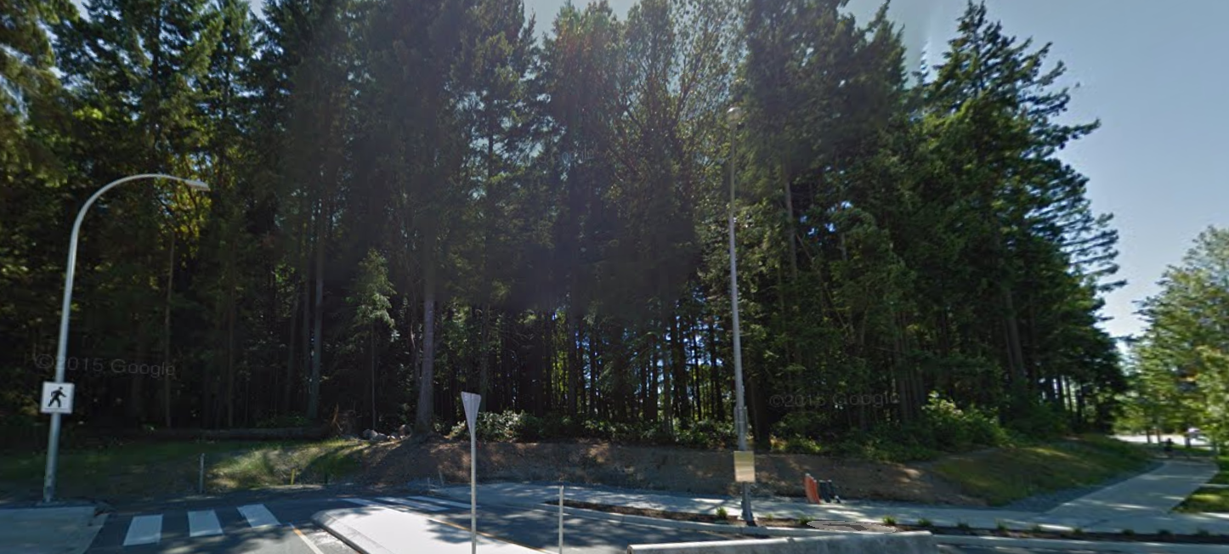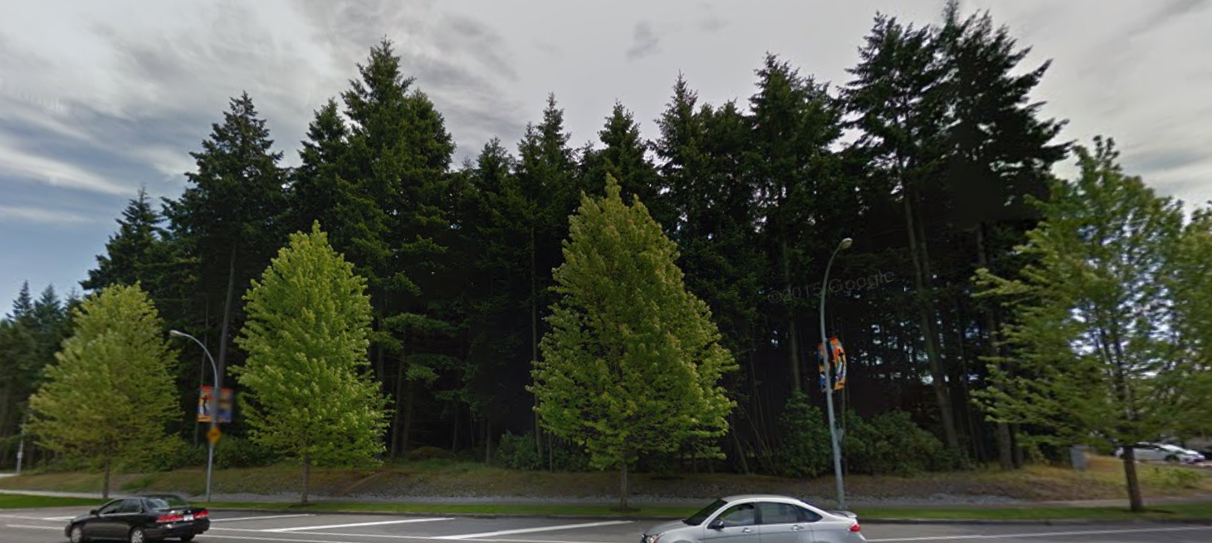

Page 2 of 10

**Figure 1.3 -** Local, Regional, and National Condominium Starts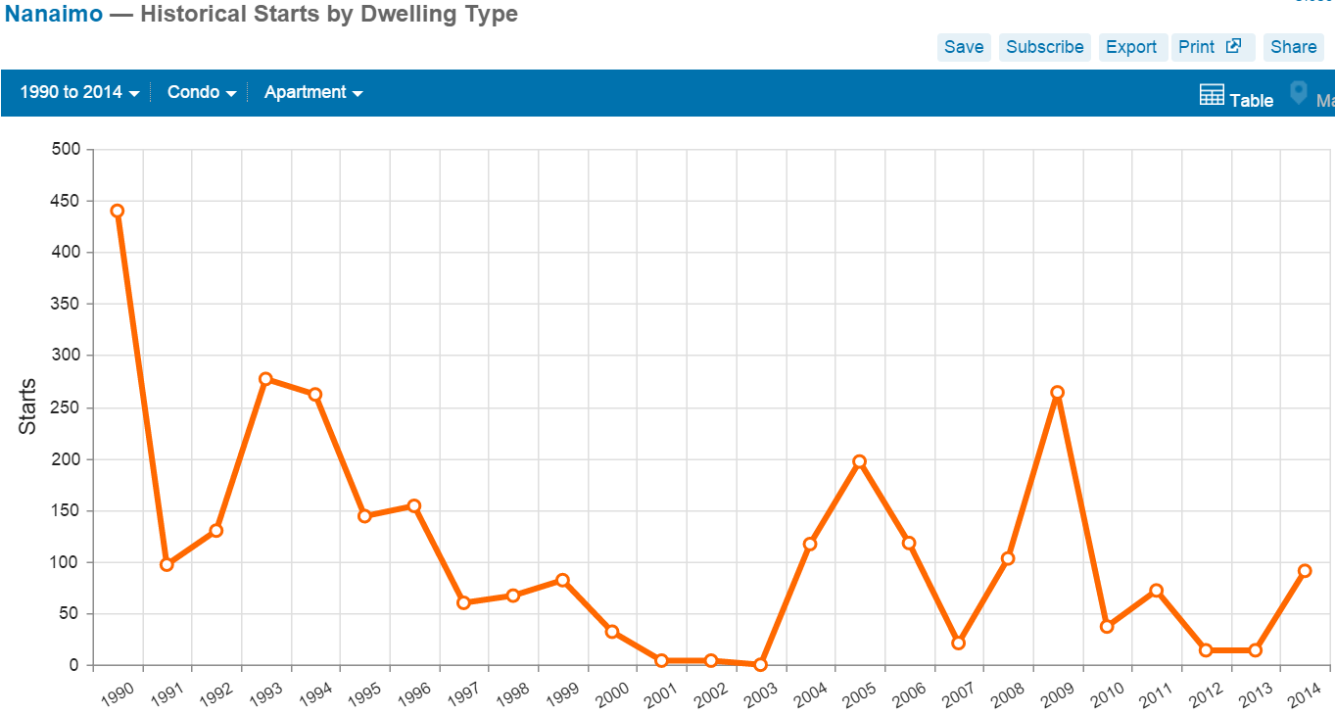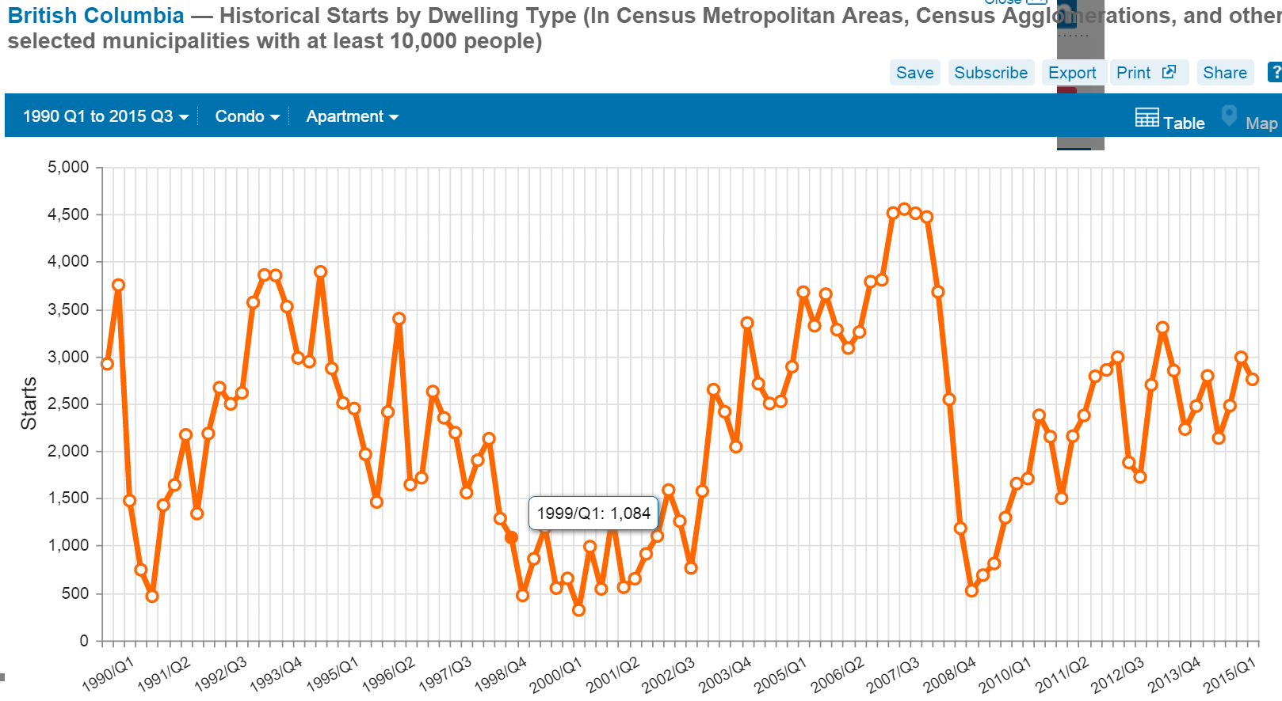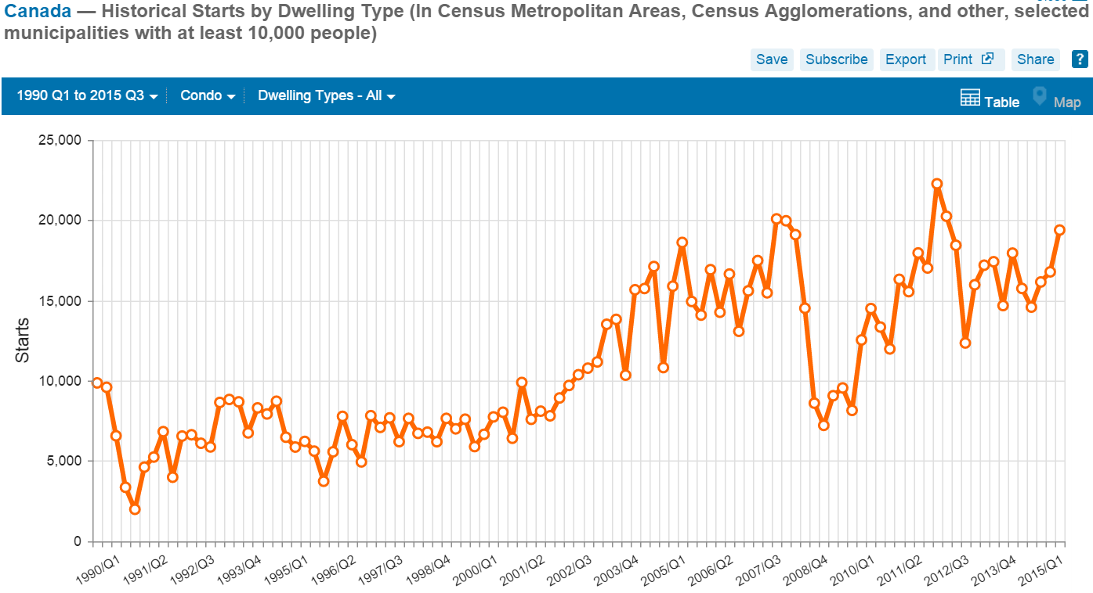

Page 3 of 10

**Figure 1.4** - Local, Regional, and National Condominium Absorption Rates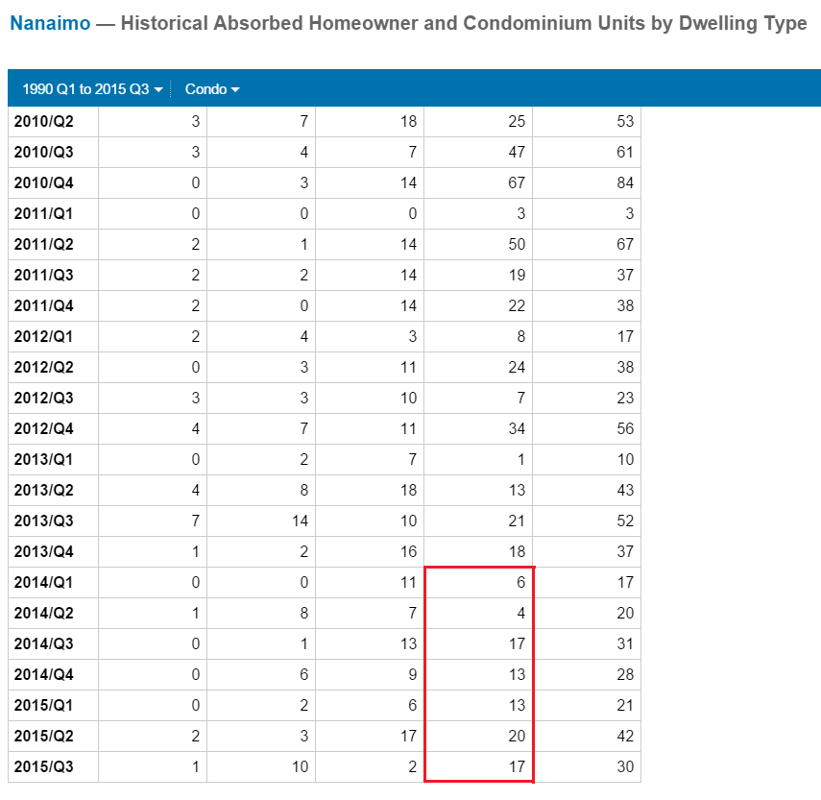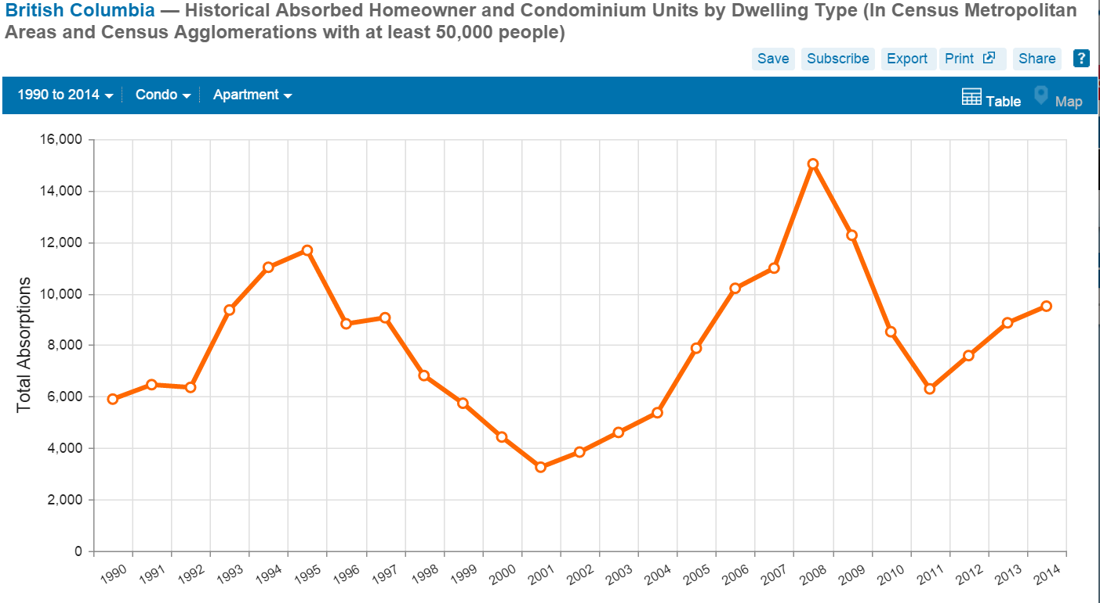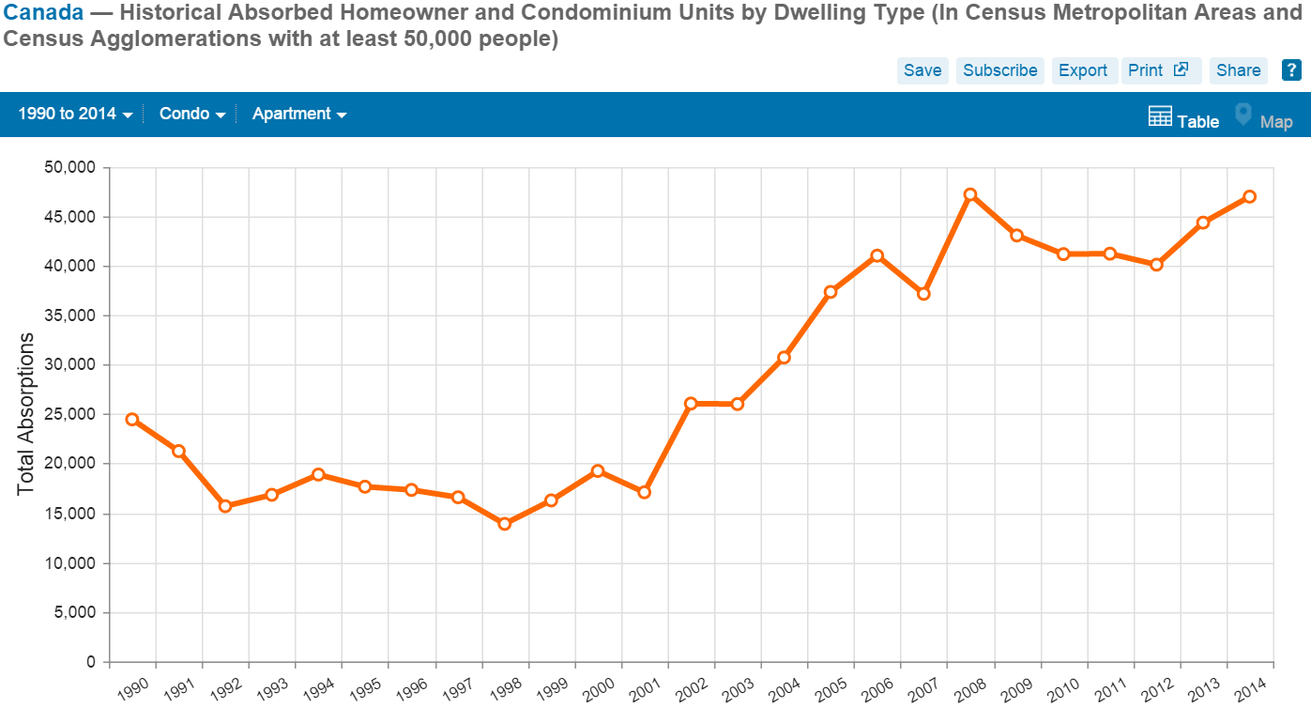

Page 4 of 10

**Figure 1.5** - Local, Regional, and National Condominium Construction Inventory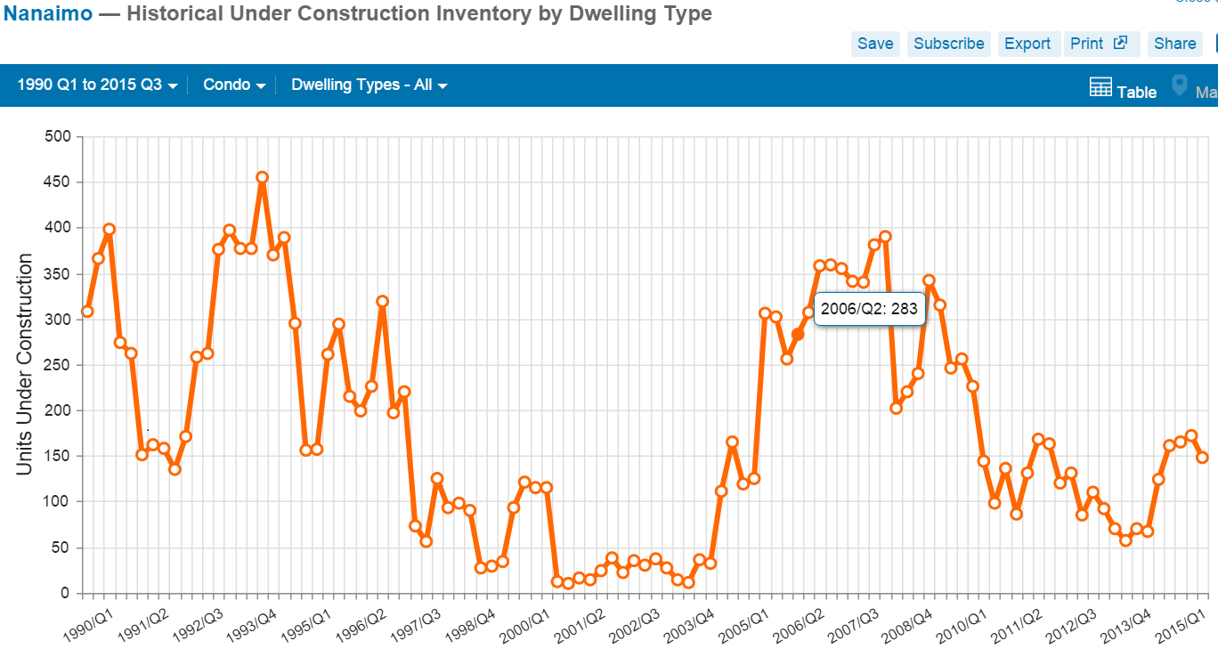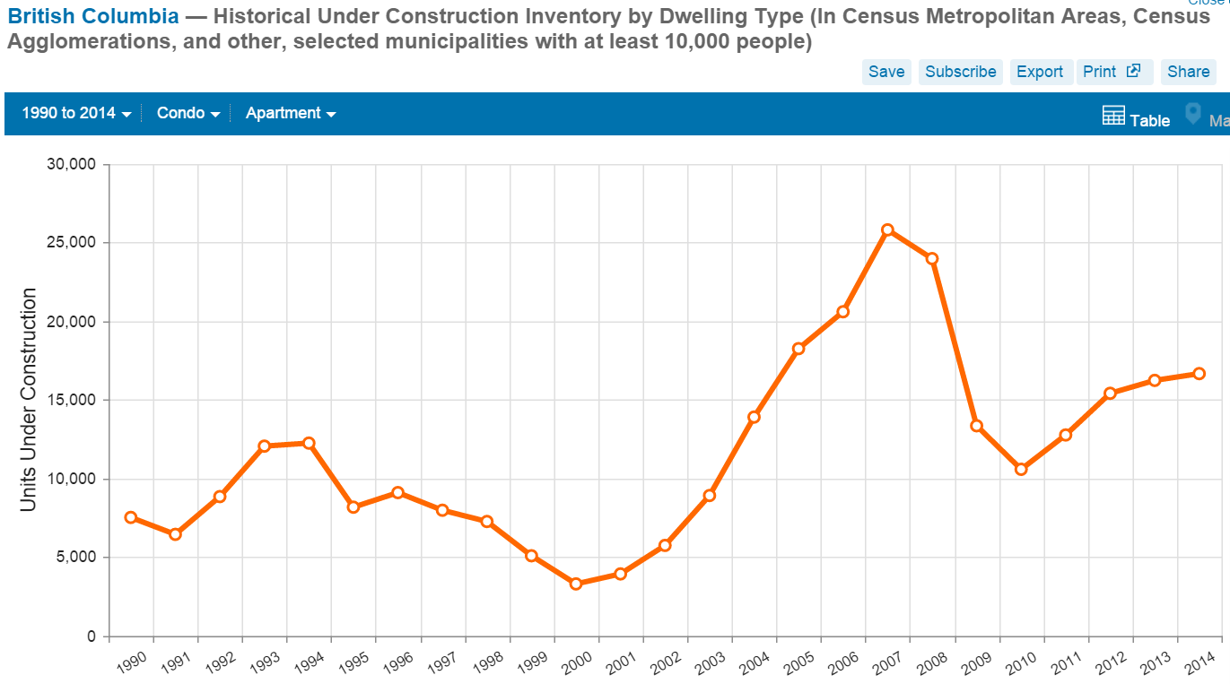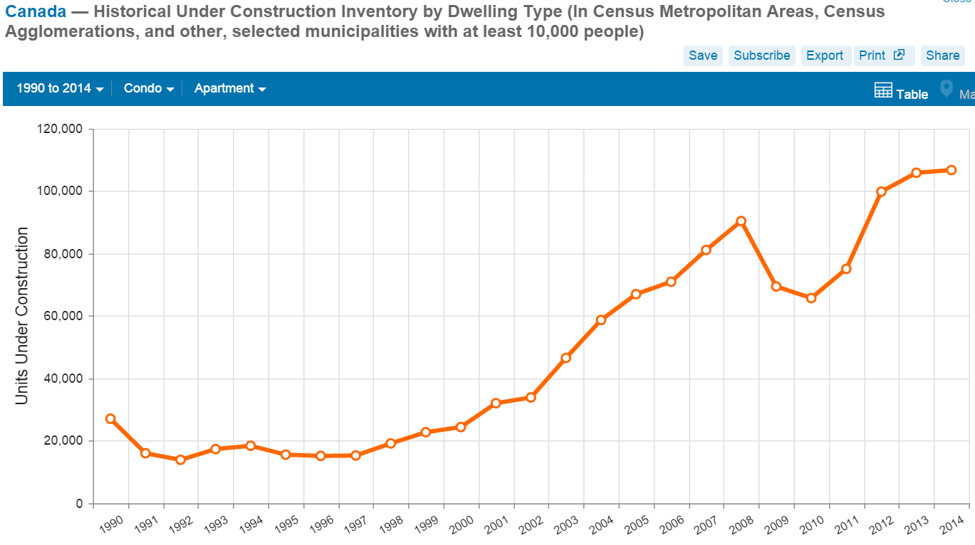

Page 5 of 10

**Figure 1.6** - Local Vacancy By Unit Type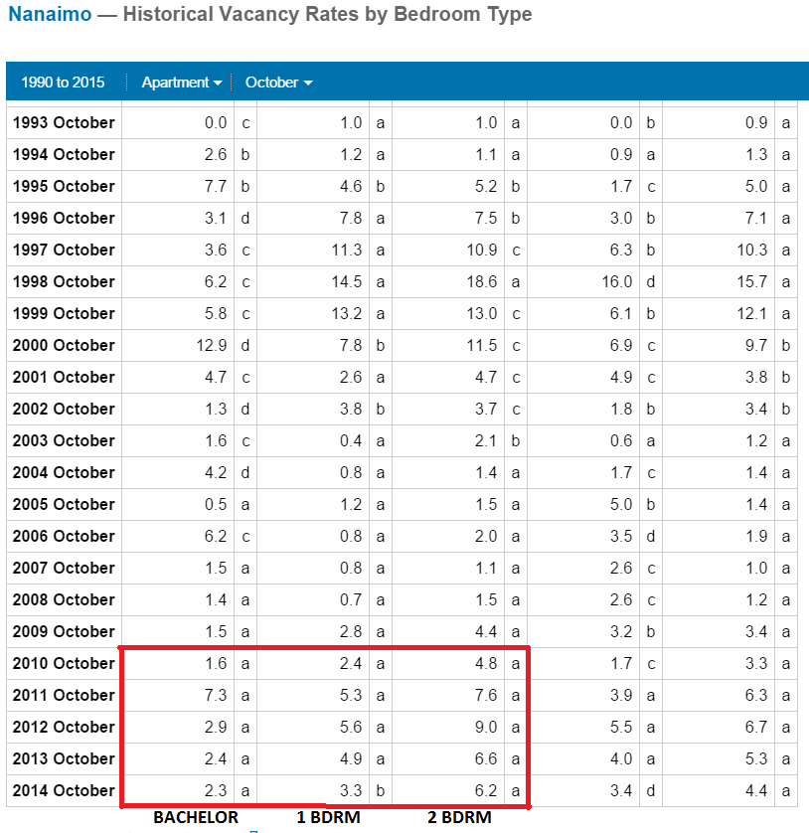

Page 6 of 10

**Figure 1.7** - Regional and National Total Vacancy Rates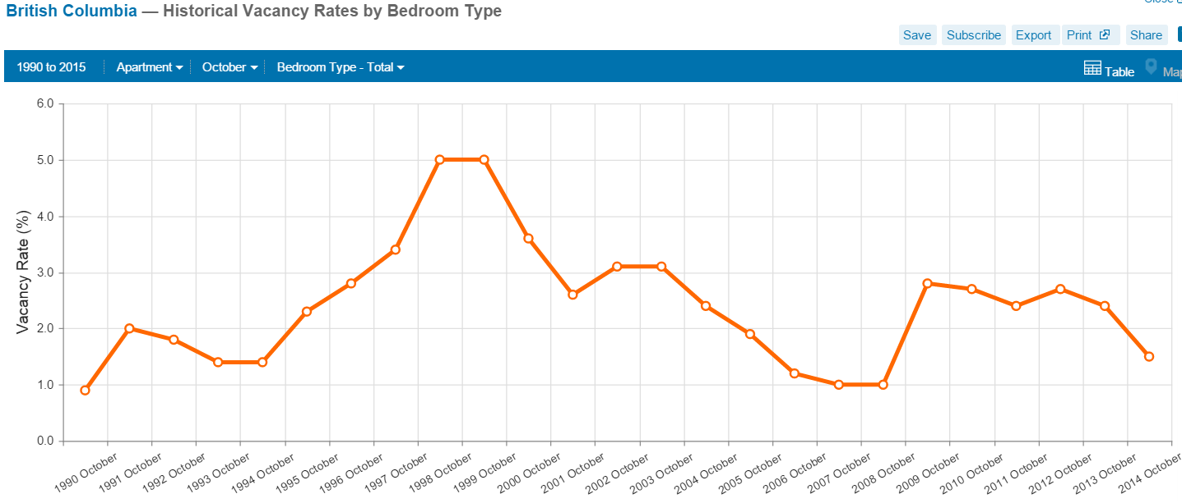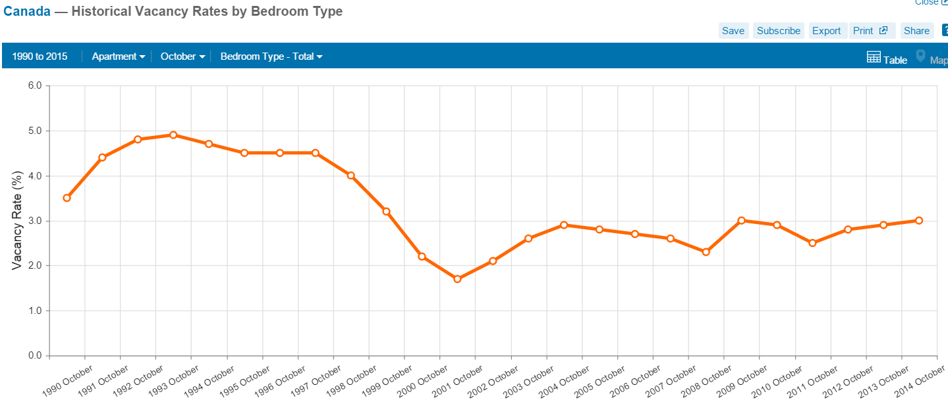

Page 7 of 10

**Figure 1.8** - Local Income Distribution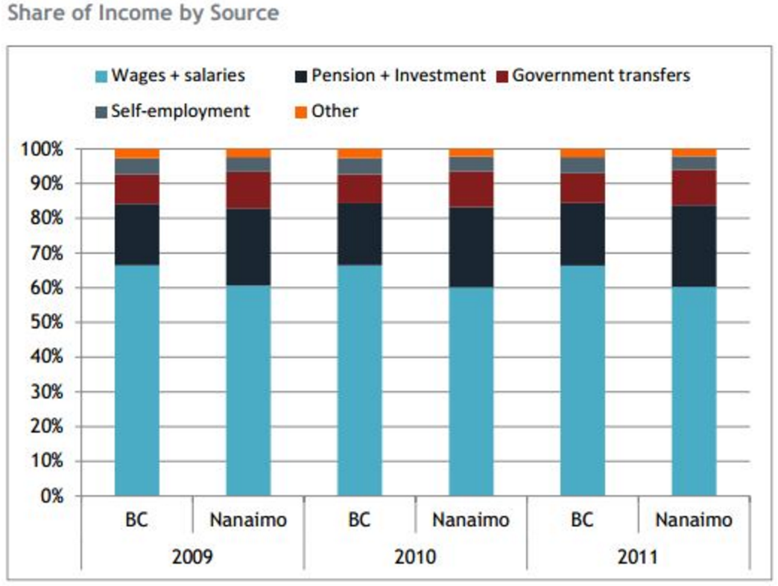

**Figure 1.9** - Local Market Project Competition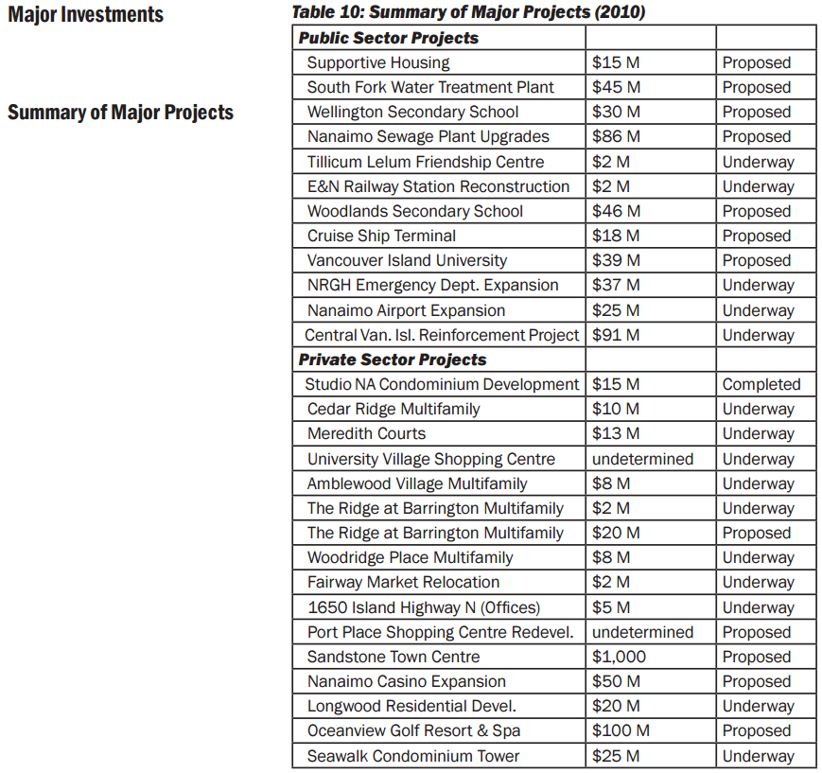

Page 8 of 10

**Figure 2.1** - Local Condominium Listing to Sales Ratios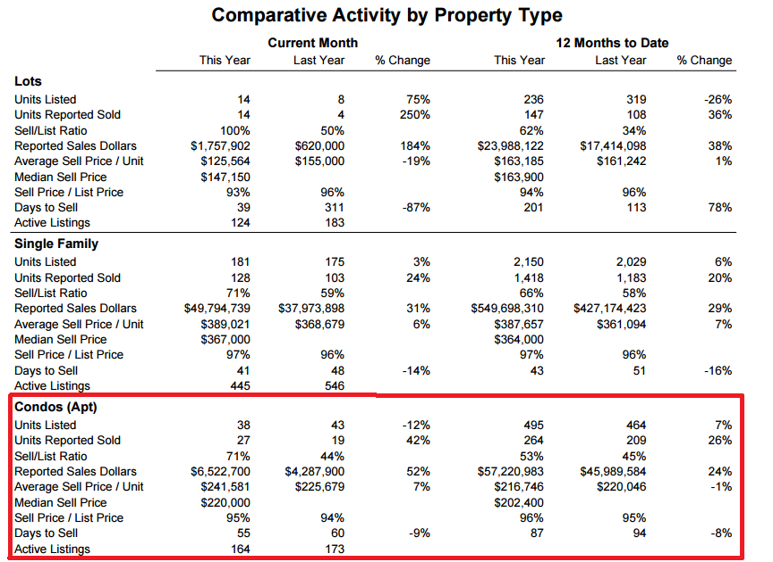

**Figure 2.2** - Regional Migration/ Population & Demographic Growth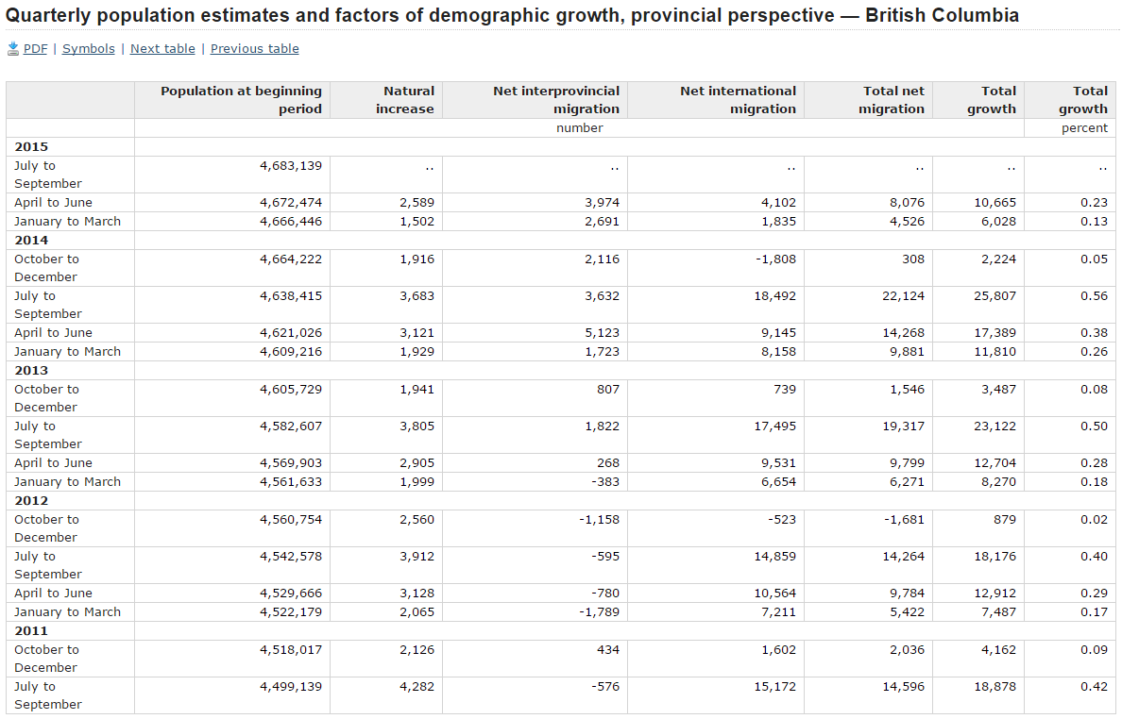

Page 9 of 10

**Figure 2.3** - Local Employment Growth & Distribution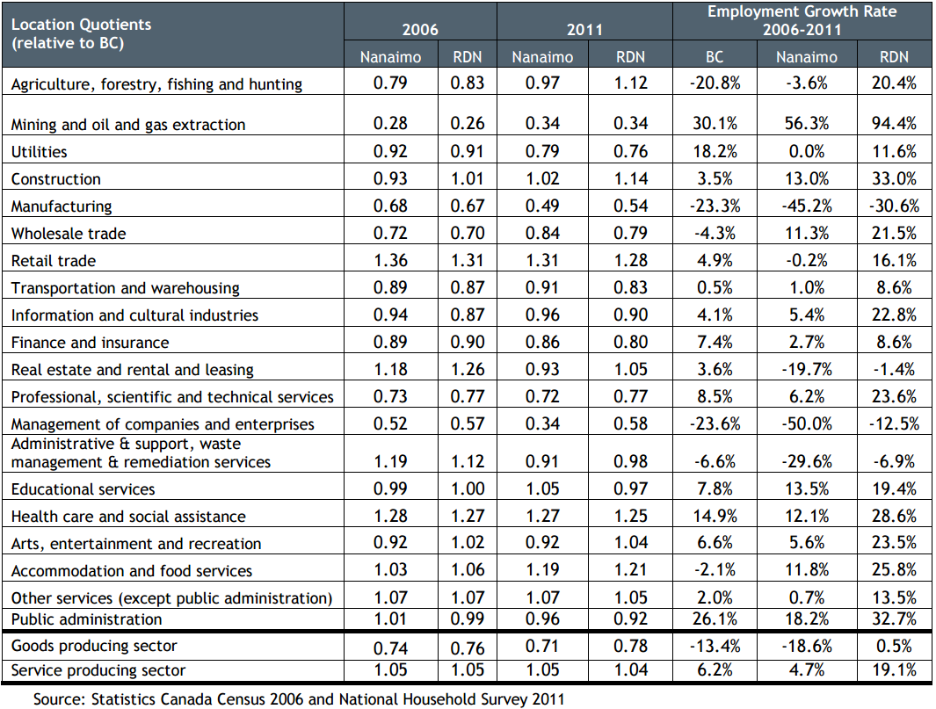

Page 10 of 10

**Figure 2.4** - Regional and National Employment Growth