To: Travis Gritter, Eric Hsu, Josh Macdonald

From: Richard Bryant

Date: Feb 26th 2017

Subject: Improving a dismal customer experience, or net promotor score (measure for customer experience), at Best Buy Canada, Nanaimo.

Introduction

Net promoter score is a measure created to observe and improve upon the feeling that customers have when they are leaving our stores. This feeling that we track gives us data, that we can then gauge the degree to which our customers share our core belief system. Nps is extremely significant to todays customer service market because nps acts as a new decision making paradigm of which to challenge the status quo and change employee behaviors for the better. We have had a history of unsatisfactory nps ratings over the course of last quarter. This has lead to a growing population of customers whose residual feeling and experience have been inadequate to promote future business.

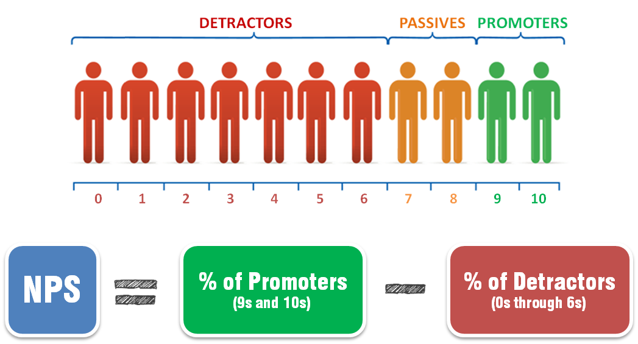

Purpose

This reports purpose is to inform and educate the primary and secondary audiences of the significant positive impact on future business that nps will drive; as well as to challenge behavioral barriers that the business faces and improve upon the feeling that is imposed upon all customers. This document will also aid other sales persons in understanding how the customer experience is changing and how they may adapt to and promote future business themselves. Readers will use this knowledge to exceed their business’ performance goals and use this new perspective to action an improved customer experience.

Research methods

We will create a research plan that will include each major task, the steps involved to compete each task, and all significant problems that we may face for each task.

Primary data sources: Survey questionnaire results, walk out interviews, in store discussions with managers at time of sale.

Secondary data sources: General and specific “print” sources

Limitations or omissions

Only a percentage of all data is realized through the voluntary data capturing vehicles that we provide. We must consider that surveys will be bias toward few individual employees because these employees are the most effective at promoting the survey. The walk out interviews conducted will give customers an option to give feedback at the time of the experience, altering answers considerably. The secondary resources that we intend to use will be based on the most relevant, accurate, and complete data; this may positively or negatively affect our research depending on the outcome. Lastly, the customer service experience is ever-changing and the data that we collect gives a snapshot of that specific moment in time; these snapshots must be looked at collectively and considered with equal weight. It is not inherent of net promoter to omit any data. This is a metric used to measure profitability and therefore omitting data would be considered a fraud.

Definitions

Nps is a measure created to observe and improve upon the feeling that customers have when they are leaving our stores. The nps data we collect on the way customers view us allows us to gauge the degree to which our customers share our core belief system. Nps acts as a new decision making paradigm of which to challenge employee behavioral barriers.

Research Topic List

The following is a list of each topic research and considered to help inform the readers of the significant positive impact nps will have on future business, and to challenge behavioral barriers improving the resulting feeling customers are left with. Topics: What is nps? What are the main sources of a dismal net promoter score? What are the major consequences of a dismal net promoter score? What is under our control that we have the ability to change?

Conclusion Preview

The findings of our report will illustrate complete, reliable, and accurate data used to solve behavioral and performance target barriers. We will provide an overall judgement for what the residual customer feelings mean, as well as recommendations for a feasible and realistic course of action.

Audience and use profile

Our primary audience readers are best buy employees, male and female, ranging from seventeen to forty-four years old. Secondary audience consists of outside customer service or sales persons who want to learn about forward thinking business tactics. Our relationship with audience is as a fellow employee of the same rank and a professional who cares about my business’ well being and effectiveness in the market. The purpose of the document is to teach the underlying forces that drive an industry leading business and to address and correct behavior that will promote profitability.

this reports purpose is to inform and educate the primary and secondary audiences of the significant positive impact on future business that nps will drive; as well as to challenge behavioral barriers that the business faces and improve upon the feeling that is imposed upon all customers.

This document will be used to give employee’s a competitive advantage in their industry and give other sales persons a guide on how to conduct future business. It will also be used to teach employees the value of net promoter score and the need to exceed performance targets. The Information needed include survey questionnaire, walk out interviews, and performance targets. All primary readers will have a working knowledge of nps prior to this report. The secondary readers may have heard of this strategy but no not know the process or weight of outcomes. The readers are all from primarily Caucasian suburban background, all of which have been pre-exposed to what nps behaviors are acceptable and what they look like. Probable questions will most likely include information on customer feelings, likelihood to recommend their experience to others, and expected standards compared to the current standards presented to them at our business. The majority of reactions will be moderate to positive, while some will exhibit negative feelings. Audience document preferences include: The length of the report should be between twelve and fifteen pages. An analytical report model is the preferred format and email is the preferred medium. Professional tone and an active voice. The due date of the report is April 5th 2017. The budget

Research

For each of the following we will be defining each topic, illustrating their possible causes, and finding workable and cost effective solutions.

Topic one: What is nps?

Subtopic one: Do customers see the difference of nps in their experience?

Definitions

General findings

Detailed findings

Interpretation and critiques of findings

Workplace studies?

Cost objections

Conflicting scientific opinions

Topic two: What are the main sources of a dismal net promoter score?

Subtopic one: Are we getting maximum output from employees to support nps behavior?

Definitions

General findings

Detailed findings

Interpretation and critiques of findings

Workplace studies?

Cost objections

Conflicting scientific opinions

Subtopic two: Work on becoming experts in conveying Best Buy beliefs and feelings to drive toward performance targets.

Definitions

General findings

Detailed findings

Interpretation and critiques of findings

Workplace studies?

Cost objections

Conflicting scientific opinions

Topic three: What are the major consequences of a dismal net promoter score?

Subtopic one: In what ways, can we minimize or negate bad publicity?

Definitions

General findings

Detailed findings

Interpretation and critiques of findings

Workplace studies?

Cost objections

Conflicting scientific opinions

Subtopic two: What would happen to Best Buy reputation and therefore revenue?

Definitions

General findings

Detailed findings

Interpretation and critiques of findings

Workplace studies?

Cost objections

Conflicting scientific opinions

Topic four: What is under our control that we have the ability to change?

Subtopic one: How can we implement an action plan to challenge the status quo and behavioral barriers?

Definitions

General findings

Detailed findings

Interpretation and critiques of findings

Workplace studies?

Cost objections

Conflicting scientific opinions

Subtopic two: Should nps be revamped?

Definitions

General findings

Detailed findings

Interpretation and critiques of findings

Workplace studies?

Cost objections

Conflicting scientific opinions

Subtopic three: Change with customer needs and create a “Disney” like experience.

Definitions

General findings

Detailed findings

Interpretation and critiques of findings

Workplace studies?

Cost objections

Conflicting scientific opinions

Conclusion

We will include overall Interpretations of Findings and an overall judgement on the meaning behind each finding. In addition, recommendations for these findings and creation of a feasible and realistic course of action will complete our discussion and give direction for the reader to take action in their industry.

Works Cited

We will compile in this section a list of evidence that supports each conclusion made, illustrating depth and balance over many viewpoints.