In this assignment, students compose three technical definitions (parenthetical, sentence and expanded) of a term within their field of study. The objective is to explain this term to a general audience in a concise, understandable way.

**Term:** Machine Learning

**Situation:** I’m providing a quick content entry to the glossary of terms at FutureScience.com, which has a global audience of teens, young, and mature adults. Through research, we have learned that the audience often has little to no prior knowledge of computer science, but has expressed interest in learning more.

**Parenthetical definition:**

Machine learning (computer learning and adapting without explicit programming)

**Sentence Definition:**

Machine learning, a subfield of artificial intelligence, provides computers the ability to learn and adapt without being explicitly programmed.

**Expanded Definition:**

“Machine learning” focuses on the ability of computers to learn and adapt autonomously. Computer programs (equipped with machine learning) will change and adapt when facing new input data, instead of requiring reactionary programming. Machine learning is a subfield of artificial intelligence and computer science.

Machine Learning: General Process:

A computer program with machine learning will search through assigned data to detect any patterns. It will then adjust its programming and actions in response to these patterns.

Machine Learning in Everyday Life:

The process mentioned above explains why, for example, an Instagram user who frequently likes content with sports cars often receives suggestions to follow accounts featuring sports cars. Countless software companies implement the machine learning process into their programs.

For example, Facebook and Instagram personalize each user’s news feed to show relevant information. Machine learning components do this by detecting user activity (such as likes, comments, links clicked through, speed and duration of scrolling, lack of scrolling, and other actions) in response to content presented. Using this data, the components can then recommend a series of highly relevant content to suggest and present to the user.

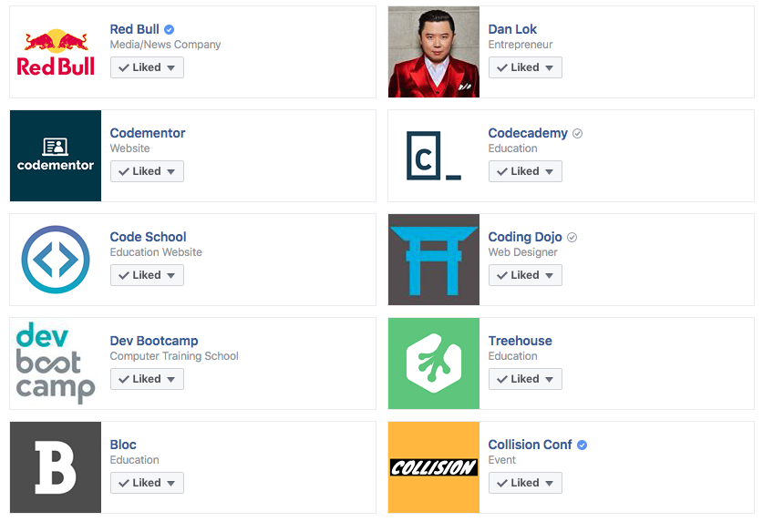

Figure 1 & 2:

(left) a suggested post from a user’s Facebook news feed that may result from (right) that user’s list of Liked pages, which include 6 out of 10 programming and coding related pages. A machine learning module will detect a pattern of frequently liked programming pages and, thus, will prioritize suggesting more programming-related pages.

Works Cited:

“Machine Learning”.Wikipedia.n.d.Web.May 31st 2017. <https://en.wikipedia.org/wiki/Machine_learning>

Raschka, Sebastian. “Machine learning – An introduction for programmers”. Jaxenter.com. Nov 13, 2015. Web. <https://jaxenter.com/machine-learning-an-introduction-for-programmers-122135.html>

Rouse, Margaret. “Machine Learning”. Whatis.com. Feb 2016. Web.

<http://whatis.techtarget.com/definition/machine-learning>