Proposal:

Additional

Distance Education Courses

for the

Faculty of Arts

*(Draft)*

For:

Faculty Members from the

University of British Columbia

By:

Robert Trigo,

ENGL 301

Technical Writing Student

**July 10, 2017**

**Contents**

**I. Definition, Description, and Background** **3**

Introduction 3

Stakeholders 4

Intended Audience 4

Problem Statement 4

Proposed Solution 4

Method of Inquiry 5

Limitations of Study 5

Scope of Inquiry 5

**II. Collected Data & Findings** **5**

Courses which satisfy Faculty of Arts degree requirements: 5

Demand & Availability for the above courses, for all semesters 5

Writing Component: 6

Descriptions and observations of overall class activity 6

Additional online tools and services supporting above activities and courses 7

**III. Conclusions** **7**

Summary of findings 7

Overall interpretations 7

Recommendations 7

**References** **8**

**Abstract**

# I. Definition, Description, and Background

## Introduction

A four-year degree is a colossal time and financial investment. Seemingly obscure but required costs to either study or teach is commuting to classes daily and living in relative proximity to the campus. This creates opportunity costs in terms of time (which would have been spent elsewhere), potential earnings (which would have been gained by additional working hours elsewhere), social and recreational experiences (instead of time spent excessively commuting or being required to live in Vancouver to study or teach), and more.

Metro Vancouver is ranked as one of the most heavily traffic-congested cities in North America. During traffic, drivers often have commute times 34% longer than average. Several thousand students and instructors commuting to and from the campus (the westernmost area in Greater Vancouver) are a sizable portion of lower mainland commuters.

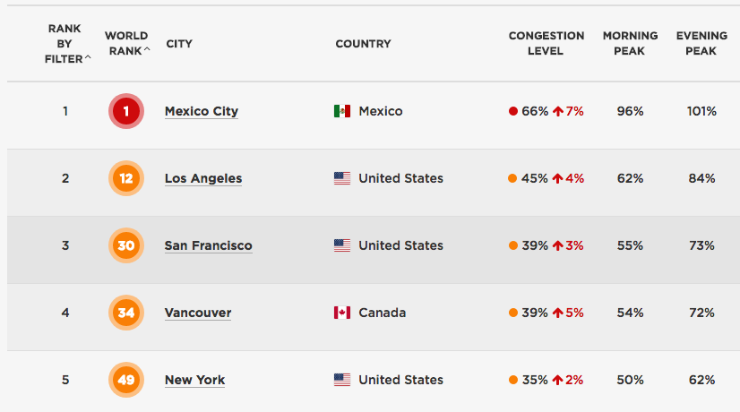

Figure 1: Top 5 congested cities in North America. Courtesy of TomTom.

Lengthy commute times heavily use up one’s waking hours, which reduce alternatives to time spent, such as additional jobs. With the high cost of living throughout Greater Vancouver, many often need to work part-time jobs to compensate living expenses.

There are also numerous international students and staff at UBC. Students may wish to complete parts of their degree requirements at their hometowns or somewhere with lower costs of living.

# 

## Stakeholders

Professors and other staff involved with the teaching process, as well as UBC students, are direct stakeholders that benefit from the additional online courses.

## 

## Intended Audience

The primary audience for this report are professors and other staff within the University of British Columbia Faculty of Arts. Key stakeholders are those involved in determining, planning, organizing, and facilitating distance education courses in the arts faculty.

## 

## Problem Statement

The availability and selection of UBC distance education courses are often very limited. Only a few online courses either qualify as Arts courses or satisfy specific degree requirements. Due to demand, these online courses often have limited or restricted available spots. Some courses require additional lower-level prerequisites, which increase a student’s total courses taken.

## Proposed Solution

However, distance education courses have certain shortcomings for Arts students. Additional offerings of distance education courses, most of which would satisfy degree requirements for the Faculty of Arts, would greatly benefit Arts students and professors alike.

There are numerous online tools which support and facilitate online courses. These include Blackboard, UBC Connect, UBC Blogs and websites. There are also plenty of tools which facilitate online discussions and communication, such as Facebook, Messenger, Slack, WhatsApp, and more. In-class lectures can easily be replaced with reusable online videos, PDF documents, images, recordings, and more. If necessary, there are also tools which can restrict access to materials, discussion, and activity to registered students only.

UBC distance education courses greatly reduce overall commutes, free up time, and introduce the opportunity of living or travelling elsewhere while studying or teaching at UBC.

## Method of Inquiry

## Limitations of Study

## Scope of Inquiry

# II. Collected Data & Findings

## Courses which satisfy Faculty of Arts degree requirements:

**Definition:**

**Findings:**

**Interpretation of Findings:**

## 

## Demand & Availability for the above courses, for all semesters

(Both Online & Classroom courses)

## Writing Component:

|  |  |  |  |  |
| --- | --- | --- | --- | --- |
| **Course** | **# of Sections Available**  Classroom *(Online)* | | **# of Sections Full/Waitlisted**  Classroom *(Online)* | |
|  | Summer ‘17 | Winter ‘17-’18 | Summer ‘17 | Winter ‘17-’18 |
| **ASTU 100** | XX  *(XX)* | XX  *(XX)* | XX  *(XX)* | XX  *(XX)* |
| **ASTU 101** | XX  *(XX)* | XX  *(XX)* | XX  *(XX)* | XX  *(XX)* |
| **WRDS 150** | XX  *(XX)* | XX  *(XX)* | XX  *(XX)* | XX  *(XX)* |
| **ENGL 100** | XX  *(XX)* | XX  *(XX)* | XX  *(XX)* | XX  *(XX)* |
| **ASTU 400A** | XX  *(XX)* | XX  *(XX)* | XX  *(XX)* | XX  *(XX)* |

Figure 2: Table listing section availability for courses which satisfy the Writing Component.

Both classroom and online sections are listed. Data acquired from UBC Course Schedule.

|  |  |  |  |  |  |
| --- | --- | --- | --- | --- | --- |
|  |  | **# of courses which satisfy degree requirements:**  Classroom *(Online)* | | | |
| **Subject** | **Total # of Courses** | **Upper-Level** | **Literature** | **Science** | **Language** |
| **ENGL\*** | XX  *(XX)* | XX  *(XX)* | XX  *(XX)* | XX  *(XX)* | XX  *(XX)* |
| **SPAN\*** | XX  *(XX)* | XX  *(XX)* | XX  *(XX)* | XX  *(XX)* | XX  *(XX)* |
| **ARTH\*** | XX  *(XX)* | XX  *(XX)* | XX  *(XX)* | XX  *(XX)* | XX  *(XX)* |
| **...** |  |  |  |  |  |

Figure 3: Table listing number of available courses which satisfy arts degree requirements,

beside total number of available courses. Both classroom and online sections are listed. Data acquired from UBC Course Schedule.

*denotes subjects within the Faculty of Arts

## Descriptions and observations of overall class activity

**CLASS 01:**

**CLASS 02:**

**CLASS 03:**

## Additional online tools and services supporting above activities and courses

# III. Conclusions

## Summary of findings

Based on the data above, I summarize the following points:

* Literature-based courses are easily viable for Distance Education sections
* Lectures can be replaced by online videos and web apps
* There are ample web services which can facilitate online courses, including UBC and 3rd-party sources

## Overall interpretations

## Recommendations

Based on the aforementioned findings, I confidently recommend the following courses of action for adding more distance education offerings:

- Introducing additional offerings for Distance-Education sections for:

- courses with high demand (i.e. plenty of sections or waitlisted students)

- courses with little to no student audience participation during lectures

- Using videos as suggested alternatives to lectures. Apply access/downloading restrictions when necessary in order to restrict or secure content.

- Using web apps such as Blackboard, Coursera, UBC Blogs, UBC sites, and others to facilitate class activity.

# 

# 

# 

# References

British Columbia, University of. “Course Schedule: UBC Student Services”. *UBC Student*

*Service Center.* 2017. Web.

<https://courses.students.ubc.ca/cs/main?pname=subjarea>

British Columbia, University of. “Degree Requirements: Arts Undergraduates”. *UBC*

*Faculty of Arts.* 2017. Web.

<http://students.arts.ubc.ca/advising/degree-requirements/>

TomTom. “TomTom Traffic Index: Measuring Congestion Worldwide”. *TomTom*. 2017.

Web.

<https://www.tomtom.com/en_gb/trafficindex/list?citySize=ALL&continent=NA&country=ALL>