Definitions

In this assignment I will practice the strategies to define a term. I will define the term ‘theory of change’ and will include the following elements in the definition:
- At least four of expansion strategies listed in the Technical Communications textbook
- At least one visual
- Refer to at least three external sources using MLA or APA style.

Situation
As someone who has worked for non-profit organizations for many years, I have decided to define the term ‘theory of change’, which is commonly used in social change circles. The situation is as follows:

I am the Major Donor Coordinator at a small non-profit organization and I am doing a pitch to a potential donor who recently received an inheritance. The donor does not have experience with philanthropy or social movements, but wishes to donate part of their inheritance. My organization needs funding for a strategic planning session to create a new theory of change for our organization, and it is up to me to explain what a theory of change is and why we need the funding.

What is a theory of change?
Every organization seeking to make social change, needs to have a well thought out theory of change (a detailed strategic plan to achieve their goal).

A theory of change is a strategic planning method that helps organizations and social movements lay out a detailed pathway to achieve social change. It illustrates your ultimate goal, all the intermediate goals that you have to achieve along the way, and a plan of how you will achieve those goals.

More specifically, you can break down the theory of change into a few specific components, the goal, the tactics and the assumptions. A good theory of change can use these basic components to create clear and concise statements that describe the overall strategy of an organization or movement. These statements often take the following form: if [action] then [reaction], because [assumptions].

The goal sets the direction, the tactic is the action to be taken, and the assumptions are the rationale that explains why that action will help you achieve your goal.

As an example, Sandy is hoping to end smoking in parks by asking her city to pass a bylaw to restrict smoking in parks. She has a few options to do this, one of which is to run for office. So, her goal is to pass a bylaw that bans smoking in parks, the action she will take is to run for a council seat, and her assumption is that as a councillor she can write and pass this bylaw.

Sandy can say her theory of change is:

If I get a seat in city council, then I can pass my local bylaw banning smoking in parks, because as a councillor I will be able to directly propose bylaws and work with council to get it passed.

This is a clear statement that states the tactic Sandy will take to pass her bylaw banning smoking in parks.

But, how is Sandy planning on getting elected? Does she have a plan for that? Does she have a campaign team? What about volunteers or supporters? What about a media strategy?

Mapping a theory of change
As you can probably tell, Sandy’s theory of change, as it’s listed above, does not give Sandy a detailed strategy to achieve change. It shows what road Sandy wants to take on her journey, but not a detailed view of this road.

A theory of change needs to be broken down and mapped into nested goals, tactics and assumptions.

We know Sandy’s goal is to pass a bylaw banning smoking and she will achieve this by getting elected. Now Sandy has to make a nested theory of change that maps how she will get elected. This theory of change statement reads something like this:

If I can convince 2,145 voters to vote for me, then I will win a council seat, because based on previous election data that is the number of votes I need to win a seat.

There are a few key things we can learn from the statement above. First, her goal in this statement is to get elected into office. This is not her ultimate goal, but it does act as a smaller nested goal that is necessary to achieve her ultimate goal of passing the bylaw.

Second, we can see it is very detailed. She is very specific about the number of votes she needs (2,145), which gives her a very clear target to reach and make plans around.

Third, she is stating her assumptions. She knows what her vote target is based on research she has made and she can have confidence on that target.

But now Sandy needs to figure out how she will get 2,145 votes, so she will need a new nested theory of change for that.

If my campaign team knocks on 215 doors per day, then I can identify at least 2,145 voters willing to support me, because based on my previous canvassing experience 1 out of every 3 households is likely to have voters willing to vote for me.

As you can see, these goals become increasingly more detailed and manageable. Sandy now has a clearer roadmap to achieve her goal. Figure 1 below shows a quick sketch of this roadmap.

Figure 1 Sandy's theory of change to end smoking in parks
As you can see, each goal has other nested goals that break down her lofty plan into small manageable chunks. Together, these small individual goals can help achieve her ultimate goal.

The more detailed and specific a theory of change can be the better. It is important to note that this is an illustrative example that does not take into account many missing steps, like building a campaign team, creating a media strategy, assigning roles, etc.

The following diagram is taken from the Center for Theory of Change, which provides training and resources for organizations and movements looking to develop their own theory of change. This diagram shows in a bit more detail the different branches a well mapped out theory of change can have. The goal of this organization is listed at the top of the diagram and the rest of their pathway to achieve this is mapped out under it.

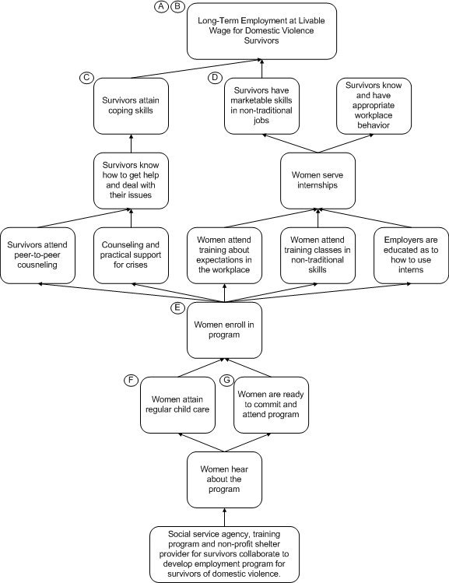
Figure 2 theory of change diagram from the Center for Theory of Change (2013)
Underpants Gnomes Theory of Change
A common mistake organizations or movement often make is to implement actions or tactics without a clear reason why. This is why the theory of change model calls for organizers to include their assumptions in their plan.

A common example used to show what a poor theory of change looks like is the underpants gnomes business strategy from South Park. This classic South Park clip shows gnomes that steal children’s underwear as a way to generate profit for themselves. But, when asked how that will generate profit, they cannot answer that question.

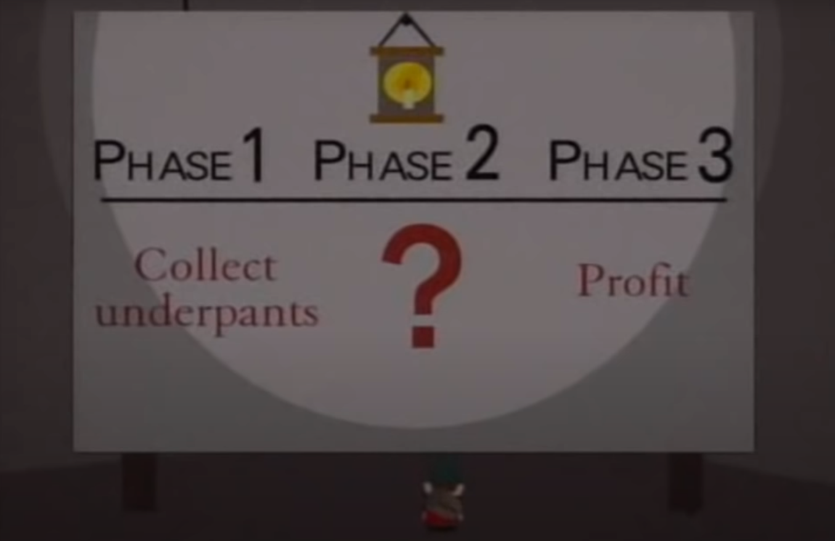
Figure 3 Underpants Gnomes theory of change (South Park 1997)
When an organization or movement decides to take action for social change, it needs to clearly state the process and assumptions that go into explaining why they picked that action.

Sandy, for example, could simply have lobbied existing city councillors to pass her bylaw. Instead she chose to run for office. In her theory of change, she needs to state why she chose that strategy over others.

Communicating your theory of change
Having a well-crafted theory of change is also a powerful communications tool. To bring people into your movement it is important for them to know how their actions are making a difference. By drafting a theory of change, you can explain to your supporters how their actions within your movement are making a difference.

Take, MoveOn’s campaign to support the Democrats during the US election as an example. They are not just asking their supporters to vote. They are asking them to organize their “friends, family, colleagues, class mates and community members to get out the vote in November.”

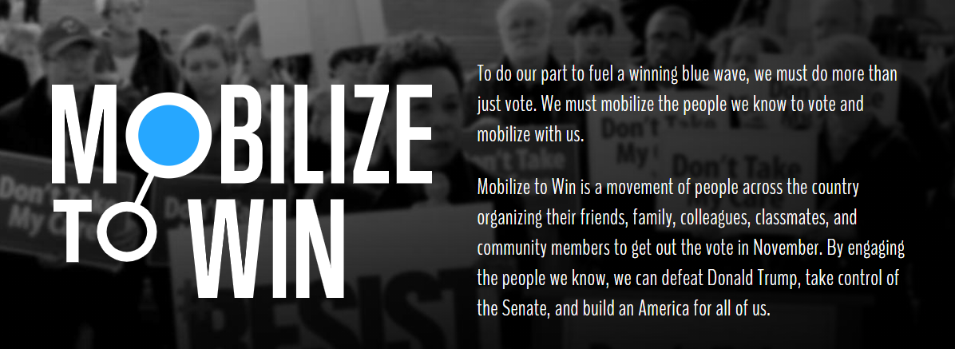
Figure 4 MoveOn's election campaign reader-focused theory of change

The front page of their campaign page states very concisely the campaign’s theory of change. Their goal is to “defeat Donald Trump [and] take control of the Senate.” Their tactic is to have their supporters “mobilize the people we know to vote.” Their assumption is that simply casting a vote is not enough and more peer-to-peer outreach is needed to get the votes to win the election.

In conclusion, a theory of change helps organizations create detailed maps of how they will achieve social change, it helps question the assumptions that went into selecting a specific strategy, and helps communicate how that strategy will lead to change.

References
Backwards Mapping and Connecting Outcomes. (2013, May 12). Retrieved October 01, 2020, from https://www.theoryofchange.org/what-is-theory-of-change/how-does-theory-of-change-work/example/backwards-mapping/
Parker, T., & Stone, M. (Writers). (1997). Gnomes [Television series episode]. In South Park. CBS.
Mobilize to Win. (2020, September 03). Retrieved October 01, 2020, from https://front.moveon.org/mobilize-to-win/

