Ruhani Grewal
Assignment 1:3:1
Definitions
May 27, 2015

Phenylketonuria
From my discipline of biochemistry, I have chosen to define a rare disease known as phenylketonuria (PKU). Three types of definitions for PKU will be given to a group of grade 12 biology students who are just beginning to learn about the biochemical processes in our body. The definition of phenylketonuria will be given in a parenthetical, sentence and expanded form. These different techniques of explanation will describe the importance of definitions in technical writing for a certain audience. In addition, this assignment will allow for the differentiation between the levels of detail in definition.

Parenthetical Definition:
The baby was diagnosed with phenylketonuria (inability to breakdown excess phenylalanine from food) after 5 days of birth, therefore his diet had to be changed.

Sentence Definition:
Phenylketonuria is an inherited genetic disorder in which the body is unable to breakdown part of a protein called phenylalanine.

Extended Definition:
What is Phenylketonuria?
Phenylketonuria (commonly known as PKU) is a rare metabolic disorder that causes an amino acid called phenylalanine to build up in the body. Phenylalanine is a building block of proteins that is obtained through the diet. It is found in all kinds of dietary protein and in some sweeteners such as Nutrasweet.
How does phenylketonuria affect metabolism?
Phenylketonuria is caused by a mutation that leads to the deficiency in the enzyme phenylalanine hydrolase (PAH). This enzyme converts phenylalanine to other essential compounds in the body, mainly tyrosine. Tyrosine is an essential amino acid that is the building block for several important brain chemicals called neurotransmitters. But without PAH enzyme (as shown in Figure 1), tyrosine cannot be produced in PKU patients through the breakdown on phenylalanine.
Phenylalanine hydrolase deficiency can cause classic phenylketonuria (PKU) and mild hyperphenylalaninemia (mild HPA) which is a less severe accumulation of phenylalanine. Patients with mild HPA have a somewhat functional PAH enzyme and can tolerate larger amounts of phenylalanine in their diet than those with classic PKU.
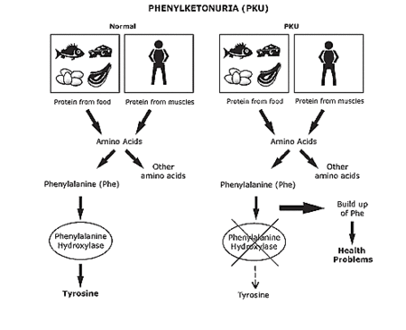
FIGURE 1. Comparison of a Person with PKU to a Normal Person.
Source: Minjung K. “Newborn Screening.” Tangient LLC, 2015.

What are the symptoms of phenylketonuria?
The symptoms of phenylketonuria appear in infants when they are a few days old. These children develop permanent mental disability. Seizures, slow development and behavioural problems are also common. In addition, children tend to have light skin and hair than unaffected family members and are susceptible to skin disorders such as eczema.
What are the treatments for phenylketonuria?
Phenylketonuria is not curable. However, if phenylketonuria is diagnosed early enough, an affected newborn can grow up with normal brain development by managing and controlling phenylalanine levels through diet, or a combination of diet and medication. People need to follow a low-phenylalanine diet and avoid high-protein foods such as eggs, meats, and cheese as shown in Figure 1.

Works Cited
- Sameer Patel. Phenylketonuria. U.S National Library of Medicine, 9 June 2013. Web. 26 May 2015. < http://www.nlm.nih.gov/medlineplus/ency/article/001166.htm>

- John Pope and Thomas M. Bailey. Phenylketonuria. Government of Alberta, 9 Sept. 2014. Web. 26 May 2015. < https://myhealth.alberta.ca/health/Pages/conditions.aspx?hwid=hw44745&>

- R. Williams and C. Mamotte. Phenylketonuria: An Inborn Error of Phenylalanine Metabolism, Feb. 2008. Web. 26 May 2015. < http://www.ncbi.nlm.nih.gov/pmc/articles/PMC2423317/>

