Introduction: Often times when we watch forensics television shows like CSI and Law and Order, DNA analysis places a valuable role in determining whether or not the perpetuator was at the scene of the crime. However, have you ever wondered which particular laboratory technique is employed in forensics that enables scarce, and often partially degraded DNA to be still valid for testing? Through this week’s ENGL301 assignment, I will introduce the term PCR, an abbreviation for Polymerase Chain Reaction, a widespread laboratory technique used in a myriad of fields requiring genetic analysis such as research, medicine, forensics, and infectious disease.
The definitions in this week’s assignment will be catered to a non-technical audience, whereby a parenthetical definition, sentence definition, expanded definition, and visual will be provided to explain a somewhat complex term comprehensively in more abstract layman terms. The objectives are to (as per the ENGL301 course website):
- Appreciate the importance and role of definitions in technical writing
- Understand how audience and purpose indicate the need for definition
- Differentiate between the levels of details in definition
- Select the right level of detail according to the situation
Before we delve into the definition, here are a few terms to review our understanding of DNA.
DNA: DNA, or deoxyribose nucleic acid, is a double-stranded molecule that stores an organism’s unique genetic information essential for development, survival, and reproduction.

Nucleotides: Each strand of DNA is made up of sequences of building blocks called nucleotides. Every building block consists of 4 possible nitrogen bases: adenine (A), thymine (T), guanine (G) and cytosine (C).

Complementary base pairing: Due to the chemical structure of DNA, base adenine (A) always pairs with base thymine (T) and base guanine (G) always pairs with base cystosine (C). Therefore, if the sequence of bases is known on one strand, the sequence of bases on the complementary strand is easily deduced through complementary base pairing.
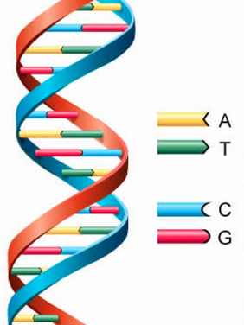

Figure 1. DNA double helix with complementary base pairing visual. (Tfscientist, 2011).
DNA Polymerase: When DNA is replicated in an organism’s body, the double-stranded DNA is separated, allowing a protein called DNA polymerase that binds to each separated strand and creates a new complementary strand by sequentially adding the correct bases through complementary base pairing.

Parenthetical definition:
Polymerase chain reaction (a technique used to generate large copies of a segment of DNA of interest from an initial small DNA sample) is often used in forensics to photocopy small amounts of DNA so that more tests can be performed on it.
Sentence definition:
Polymerase chain reaction (PCR) is a molecular biology technique that amplifies target DNA by repetitively following the cycle of first separating the double stranded DNA, then adding primers to each strand, and finally extending the primers using Taq polymerase under different temperatures.
Expanded Definition:
What is PCR (Polymerase chain reaction)?
Polymerase chain reaction (PCR) is a molecular biology technique whereby segments from the source DNA are selectively amplified hundreds of millions of times.
How was PCR discovered and why is it significant?
PCR was discovered by Kary Mullis in 1983 after he realized that DNA could be simulated to copy in a fashion much similar to how it is replicated in the natural world. Polymerase chain reaction was named that way because it utilized polymerase, analogous to a photocopier, to replicate DNA regions of the initial sample through a repetitive copying process (chain reaction). Before PCR was developed, many lab techniques working with DNA was labor intensive, time consuming, and difficult. In forensics and several other fields, a technique called RFLP (Restriction Fragment Length Polymorphism) was utilized prior to the discover of PCR but it was slow, tedious, expensive, and required a substantial amount of high quality DNA. For example, RFLP analysis requires a DNA sample about the size of a quarter and takes around a month to accomplish while PCR analysis only requires a few cells and takes only a few hours to accomplish. Therefore, PCR serves as a critical tool in cases where DNA is minimal and quality is compromised. Unfortunately, one drawback of PCR is that it is a highly sensitive process thus it can amplify contaminants in a DNA sample as well. However, a myriad of techniques have been developed that address this issue through lab procedures that separate potential DNA contaminants from the initial DNA to optimize PCR conditions.
What are the components required for PCR?
The components required for PCR are:
Template DNA: The original segment of DNA that you want to amplify.
Taq Polymerase: A type of DNA polymerase that can withstand high temperatures
Primers: Short segments of single-stranded DNA that binds to specific regions near the ends of the target DNA segment to initiate replication. It creates the starting point for Taq Polymerase to work from.
What are the steps in PCR?
Polymerase chain reaction follows consistent cycles of the following three steps:
1) Denaturation: The DNA is heated to 95° C to break the hydrogen bonds that hold double-stranded DNA strands together, forming single stranded molecules.
2) Annealing: The mixture is then cooled sufficiently depending on primer type and size so that primers bind to appropriate complementary strand.
3) Primer Extension: The temperature is raised to 72° C because that is the optimal temperature for Taq polymerase to operate at. Taq polymerase then synthesizes the complementary strand of DNA using the primer as a starting point and sequentially adding nucleotides, utilizing the template DNA for reference.
These steps are typically repeated multiple times to overnight in a thermal cycler, an instrument that instantly raises and lowers the temperature at appropriate time intervals. After 21 cycles, one molecule of DNA can be amplified to over a million copies!
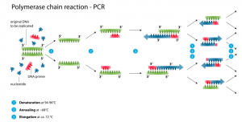
Figure 2. Schematic drawing of the PCR cycle. (Enzoklop, 2014).
How is PCR applied in genetic fingerprinting and what are some other applications?
In forensic science, PCR plays a major component in DNA profiling as it allows minute DNA from just a stray hair follicle to be amplified into millions of copy for certain segments. As every individual has unique STR (Short Tandem Repeats – short segments of DNA four to five base pairs long that are repeated multiple times in a row), forensic scientists are able attach dyes to the STR copies of the amplified DNA to visualize length of each STR and use that as a basis of comparison. In criminal investigations, thirteen STR regions are analyzed for their length, and thus when all thirteen STR regions match with suspect, you’ve got your culprit. For example, in figure 3, it is clear that the banding pattern for suspect two matches the crime scene DNA sample. Other applications of PCR include paternity testing, infection detection, and disease detection.
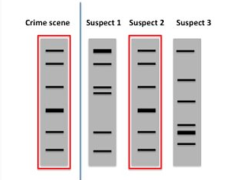

Figure 3. Diagram comparing STR regions between 3 suspects and the crime scene. (Kie, 2014).

Works consulted:
Enzoklop. (2014). Schematic drawing of the PCR cycle. Retrieved January 21, 2015 from:http://en.wikipedia.org/wiki/Polymerase_chain_reaction#mediaviewer/File:Polymerase_chain_reaction.svg

ExploredDNA. (2014). RFLP Analysis. Retrieved from:
http://www.exploredna.co.uk/rflp-analysis.html

Kie, Greg. (2014). DNA fingerprinting. Retrieved Jan 25, 2015 from: from:http://bitesizebio.com/19816/how-are-crimes-solved-by-pcr/

Phillip McClean. (1997). Polymerase Chain Reaction. Retrieved from: http://www.ndsu.edu/pubweb/~mcclean/plsc431/cloning/clone9.htm

Tfscientist. (2011). DNA structure diagram for kids. Retrieved Jan 25, 2015 from: http://imgarcade.com/1/dna-structure-diagram-for-kids/

University of Wisconsin-Madison. (2011). How DNA Profiling Works. Retrieved from: http://grow.cals.wisc.edu/health/how-dna-profiling-works

