Vulnerability and Affect

The Human Influence on Cyclone Nargis’ Destructibility

Sam Tuck

University of British Columbia

Dr. Barnes, Dr. Ley

Geog. 122

56294151

03/11/16

Natural disasters are in their nature represented in the relationship of Mother Nature to human populations. In analyzing the effect of natural disasters, we must therefore not focus on solely the physical forces that enable natural disasters to quite literally destruct, we must also analyze the effect that human populations have on this destruction. Different countries given economic, social and political factors create and destroy their surrounding geography as determined by the interdependent relationship between these factors. While their effect on their environment does not always have a negative effect, Geography scholars Blaikie et al. show in their book *At Risk,* that these factors are often as much a cause of the disaster as the environment. This paper will attempt to show the full picture of this relationship of man to nature in the context of the Burmese natural disaster that was Cyclone Nargis, which hit the southern coast of the country on May 2nd 2008. By first showing the geographical elements that precipitated the destruction of the storm we may then move to see how the human element can act as a catalyst for this destruction due to their effect on the vulnerability of the country as a whole. Through this analysis, and the understanding of other scholar’s contributions to the topic, we will be able to grasp an understanding of the intricate interdependencies that exist in the relationship of man to nature. By analyzing this in the context of Cyclone Nargis, we may come to realize that however destructive the forces of a natural disaster are, the key to understanding a disasters effect lies in the human factor of a societies vulnerability as determined by its economic, social and political nature.

In attempting to describe the effect of any natural disaster, we must begin with nature itself; forces which actually carried out physical destruction of Burma. In the case of Cyclone Nargis, the important natural factors are the geographical and the meteorological aspects that precipitated its destructibility. Burma itself is located in Mainland Southeast Asia, in the North Indian Ocean cyclone basin. It is separated into 14 regions or states, the southernmost of which; the Ayeyarwady Delta region was the hardest hit by the cyclone, and will be the main focus of this paper. Even though the North Indian basin is the most inactive worldwide, the Cyclone on May 2nd 2008 was one of the most destructive ever in the region, due to the path of the cyclone and southern Burma’s low lying topography. Data from the USDA Commodity Intelligence Report shows this: Cyclone Nargis was a category-3 tropical storm which swept across the southern coast of Burma, developing 190 km/h winds and a 12 foot high storm surge (wave). Due to the low lying topography of the delta regions as shown in Figure 1 below, and the multiple inlets that allow sea water to flow inland, cyclone Nargis left 2000 sq. miles (5172 km) flooded or destroyed by the surge; much of which included vital agricultural land. This area shown in figure one, and the correlating data shown in Figure 2, which represents the area most severely affected in blue, outlines how the combination of an unfortunate path of a powerful cyclone and the Ayeyarwady’s low topography could create large amounts of physical destruction. However, this physical destruction just touches the surface of how Burma was affected. Because in understanding the physical effects of a natural disaster we must also understand how the Burmese population’s manipulation of the surrounding environment influences the destruction caused, as well as what capability that country has for recovery, as determined by political, economic and social factors.

1: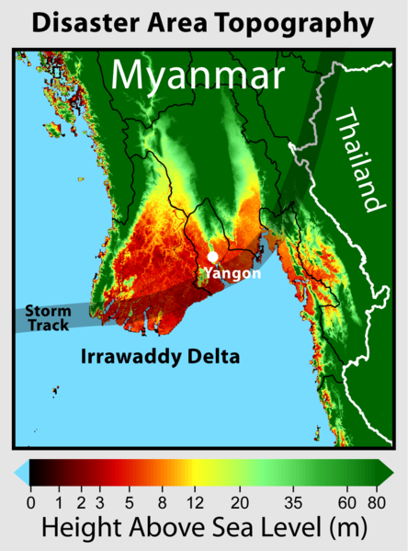 2: 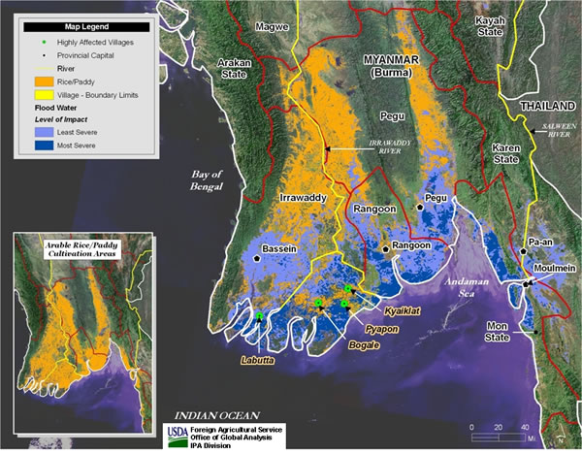

This paper will now move to address this human centered focus of the impact of Cyclone Nargis; how human factors contributed to cyclone Nargis’ destructibility. How does the human occupation of Burma account for the destruction? First of all, even though the Ayeyarwady region is the closest to sea level, it supports a massive amount of the population. In USDA’s report, the delta area contains a “population estimated by the United Nations of 24 million”, which based on the current population numbers in 2016 is roughly 44% of Burma’s population (*Myanmar*). Why is this? By looking at the geography of Burma, the land in the delta region is highly fertile soil which is used for agricultural and resource development. Furthermore, by looking at the Burmese economy, we see that the country relies heavily on the agriculture industry, which amounted to 38.1% of the country’s GDP in 1994-5 (Oo 218). Taking this into account, along with the fact that in 2005 the country’s GDP was 237 US$, and the urban population still only hovers at 33% (2014)(*Myanmar*), we may assume that a great number of the population live(d) in rural, poor areas most likely working on rice farms or other agricultural land. By drawing our attention to figure 2, shown above, we may gain an understanding of what the massive storm surge could do to a low lying, highly populated yet dispersed agricultural area. We see that the places in which there is a greatest density of orange on the smaller map, were transformed into areas with the greatest accumulation of blue, meaning most severe destruction on the larger map. Figures from the USDA support the evidence shown on the map; the 2000 miles that were affected by the storm surge account for “58 percent of the national rice crop”. We may therefore come to see how the accumulation of a large percentage of a Burma’s population in a low lying area could lead to the destructibility of the storm. Due to the large rural population it is hard to say how many people were killed exactly, however the estimates say roughly 140,000 people lost their lives to the cyclone from various causes (Seekins 718). This is not surprising when the cyclones path moved massive amounts of water into this poor, highly populated region; killing people and destroyed the land which Burma needs to stay alive and grow economically.

This factor of Burma’s economy is key. In gaining wealth to become more modern and keep up with the demands of a capitalist system, developing countries such as Burma might disregard important environmental issues, and thus sacrifice their population’s security in order to keep up with outside demands. In the case of Burma we can see evidence as to how the manipulation of a countries resources can both put them at risk through this manipulation, and determine the organization of their population as stated above. As Blaikie et al. state in their book, “[Natural Disasters] are also a product of the social, political and economic environments… because of the way these structure the lives of different groups of people.” (*At Risk* 4). One example of this in the context of Burma is the destruction of naturally occurring mangrove forests by the Burmese government. These mangrove forests occur where salt water and fresh water meet, and act as “bio-guards” due to their intricate root systems, preventing storm surge from damaging more inland, fertile soil (Kniver). The Ayeyarwady delta region is thus a prime habitat for Mangroves, however, a majority of these forests have been destroyed in that area by the Burmese government for various economic and political reasons, such as military demands in WWII, logging, shrimp farms and aforementioned rice paddies (Kniver). The destruction of these natural “bio-guards” left all aspects of the delta region incredibly vulnerable to wind and waves, as over 75 years (1924-1999) 82.76% of mangroves in the Ayeyarwady region were cleared (Quarto). Furthermore, those Mangrove forests which were cleared away to make way for economic growth for the country, ironically benefited the countries rural and urban populations “as a direct source of fuel-wood energy, both as firewood and charcoal” (Oo 219). Thus, in destroying their ecosystem to make way for economic growth the Burmese government both severed their population’s natural source of energy as well as destroying the only thing keeping those precious developed resources protected from outside natural events. Thus, through this example we can see the complex interdependencies of given societal and economic factors, and their relationship to the natural world. In this case, the relationship of these factors -- the severe nature of the storm surge presented above, and the vulnerability of the land due the human manipulation of natural, protective environment, led to the destructibility of Cyclone Nargis being greatly increased.

These economic and social factors, in combination with the physical forces which occurred on May 2nd, 2008 provide a picture of how the people were affected by the environment and their manipulation; but how were they affected by themselves? In other words, what demographic statistics can we look at to show how the population actually dealt with the destruction of their physical environment. Blaikie et al. in *At Risk* discuss this as a countries “vulnerability” which they define as “the characteristics of a person or group and their situation that influence their capacity to anticipate, cope with, resist and recover from the impact of a natural hazard” (*At Risk* 11). This vulnerability is directly connected to geography, for different countries economic, political and social status within an interconnected world economy determine that counties vulnerability. As already described, Burma’s economic situation led its social organization, and thus allowed for the large destruction the cyclone caused. But how can we view this from Blaikie et al’s idea of vulnerability? For one, through the data already presented, we can see that the population is very poor and dispersed geographically. Therefore they are much more vulnerable in the sense that they will have a much tougher time both anticipating a disaster, coping with the lack of resources it results in, and recovering from the destruction due to this lack of resources and infrastructure. One other key factor in terms of Burma’s vulnerability for recovery is its access to medical resources. To demonstrate this we may turn to Fatimah Lateef’s article on the vulnerabilities of Burma’s healthcare and community infrastructure. She observes that “The general level of healthcare awareness was very low and public health education was lacking. They generally have no access to clean drinking water and there is little sanitation services in the rural area.” (Lateef). Therefore, in the rural community areas which felt the main effect of cyclone Nargis in the Ayeyarwady region, the vulnerability of most people was huge due to their inability to help themselves. Furthermore, the state provided care is low to non-existent as access to doctors and sanitary healthcare was hugely lacking. Lateef found that “For every 1,000 population, there are currently 0.36 doctors, 0.2 nurses, 0.79 midwives, and 0.99 general health worker.” (Lateef). These numbers apply to the whole country, and assuming that most doctors operate in urban areas, the 70% of the population that lives in the rural areas of Ayeyarwady which was most affected by the cyclone had even less than 0.36 doctors per 1000 (Lateef). As such, we now see how not only a population’s manipulation of their environment affects their vulnerability, but also how the social and economic make up of that population influences their ability to help each other. In the case of Cyclone Nargis that capability being very low, thus also contributing to the cyclones destructibility through the people’s vulnerability.

This leads into a discussion of the final, and arguably most poignant element in the case of the Burmese natural disaster: the Political. In 1962, after becoming independent in 1948, the countries government was forcefully taken from power in a military coup led by Socialist leader Gen Ne Win. For the next 46 years the country remained in political turmoil between the government and pro-democratic groups (Myanmar profile -- Timeline). In 2008 however, the country was shocked by Cyclone Nargis, focusing massive global attention on Burma and how its government would react to help its people. However, what was so surprising in this context is the Burmese government’s slow, and arguably resistant reaction to allow foreign aid to help its people recover. Due to Burma’s economic situation, they “have very poor infrastructure (especially in the delta)” (Seekins 726) as discussed above, and their negative reaction to other countries rush to help raises questions of human rights issues in the context of Burma’s vulnerability. At the time, the Burmese government was dealing with preparing for elections in 2010, and its rationale behind refusing foreign aid from many countries was its insistence it could cope and provide its people with the massive demand for shelter, water, food and medicine (Mackinnon). However, an independent study showed that instead, Burmese officials and members of the army physically prevented some supplies from reaching coastal villages (Mackinnon). Moreover, instead of the government carrying out these relief efforts, in many cases “Buddhist monks and ordinary people carried out most of the early recovery” (Seekins 730). What was the reason behind this? And furthermore, how did Burma affect its own vulnerability through these political factors? Due to the context of Burma’s political history; the resistance the government has faced in the past from its citizens as well as western countries Seekins argues in his article *State, Society and Natural Disaster: Cyclone Nargis in Myanmar (Burma)* that the regime was afraid of foreign involvement in its internal affairs. However, by refusing foreign aid it not only increased the vulnerability of its citizens by actively standing by in the face of crisis but some might argue violated human rights laws as its people were dying from the governments lack of recognition and action. Thus we come to the final element that affected destructibility of Cyclone Nargis; the state itself. Due to the role of the state as a central organization which holds a monopoly of power within a given area (GPF), it can either work to minimize the vulnerability of its citizens, or as we see in this case actively work to increase the destruction that nature inflicts on its people through doing nothing about as well as working to elevate their populations vulnerability. As Seekins defines it: “The fundamental political attitude taken by a state towards its people… plays a very important role in the quality of natural disaster relief extended to victims – the difference between mitigating a tragedy caused by nature or making it worse.” (Seekins 734).

As we have seen throughout this paper, a countries society in intimately connected to the nature around it. In the case of Cyclone Nargis’ effect on Burma, we can see this interdependent relationship played out through the analysis of the factors that existed at the time. Burma’s low lying geography enabled the physical destruction of its Ayeyarwady region, which contained a majority if its population in poor, rural villages that dominate the agriculturally rich southern coast. These physical elements along with the government’s destruction of the deltas naturally occurring mangroves multiplied the natural destructibility of Cyclone Nargis. This human manipulation of the natural world, along with the corresponding amplification of the cyclone’s effects simultaneously crippled the country economically and socially due to the lack of needed natural food and energy resources. Furthermore, while the Burmese government’s response, could and should have led to quick and effective deployment of foreign aid for their population actually had the opposite effect of actively increasing their people’s vulnerability to harm. Through this interdependent relationship of human factors that has just been described, we can see how the development of a crisis like Cyclone Nargis is intimately related to Burma’s Economic, Social and Political nature in their effect on both its own population and the countries geography.

Works Cited

Blaikie, Piers, et al. *At Risk: Natural Hazards, People's Vulnerability and Disasters*. Routledge, 01/21/2014. Web. 11 Mar. 2016. 6 Mar. 2016.

*Death toll from disasters surged in 2008, UN reports. UN News Centre.* N.p. n.d. Web. 10 Mar. 2016

Foreign Agriculture Service Office of Global Analysis. Map. *Cyclone Nargis Flood Inundation Analysis Map: May 2008.* May 15, 2008. Web. 7 Mar. 2016.

Kniver, Mark. *Mangrove loss 'put Burma at risk'.* *BBC News*. N.p. May 6, 2008. Web. 1 Feb. 2016.

Lateef, Fatimah. “Cyclone Nargis and Myanmar: A Wake up Call.” *Journal of Emergencies, Trauma and Shock* 2.2 (2009): 106–113. *PMC*. Web. 9 Mar. 2016.

Mackinnon, Ian. *Burmese regime blocked international aid to cyclone victims, report says. theguardian.* N.p. Feb. 27, 2009. Web. 9 Mar. 2016

*Myanmar: Cyclone Nargis 2008 Facts and Figures.* *International Federation of Red Cross and Red Crescent Societies.* N.p. May 3, 2011. Web. 10 Mar. 2016

*Myanmar profile – Timeline.* *BBC News.* N.p. Nov. 17, 2015. Web. 8 Mar. 2016

Oo, Nay. “Present state and problems of mangrove management in Myanmar”*. Trees* 16.2 (2002): 218-223. Web. 1 Feb. 2016

Quarto, Alfredo. *Destruction of Mangrove Forests Increased Devastating Impact of Cyclone Nagris. Environmental News Network.* Mangrove Action Project. May 8, 2008. Web. 7 Mar. 2016

Rhode, Robert A. Map. *Disaster Area Topography.* Wikipedia. May 8. 2008. Web. 8 Mar. 2016

Seekins, Donald M.. “State, Society and Natural Disaster: Cyclone Nargis in Myanmar (burma)”. *Asian Journal of Social Science* 37.5 (2009): 717–737. Web. 8 Mar. 2016. 6 Mar. 2016

United States Department of Agriculture. Foreign Agriculture Service Office of Global Analysis. *BURMA: Widespread Cyclone Damage in Major Rice Production Regions.* May 15, 2008. Web. 7 Mar. 2016

World Statistics Pocket Book. *Myanmar.* UNdata. United Nations Statistics Division. n.d. Web. 9 Mar. 2016